MODULE
EQuIP for Science v3.0
9

Category III:
Monitoring
Student Progress
Module 9: Category III: Monitoring Student Progress
Module 9 builds on Modules 6, 7, and 8 by having participants continue examining the Common Lesson, this time using the criteria in Category III: Monitoring NGSS Student Progress. As with all standards, teaching to the NGSS is not sufficient. It’s about students learning. In the case of the NGSS, this should be three-dimensional learning. Examining a lesson or unit against the criteria in Category III determines whether a lesson or unit includes the kinds of assessments that allow all students to demonstrate understanding and that allow all teachers to monitor the progress and performance of all students.
If the meeting participants are not going to continue on to Module 10 to examine additional lessons and units, consider pulling reflection questions and closing ideas from slides 197–199.
Materials Needed
- Module 9 PowerPoint slides or slides 173–189 of the full PowerPoint
- Handout 10: Module 9, Slide 180, “Formative Assessment Vignettes.”
- Common Lesson: Urban Heat “Final” Version*
- Handout 7: Module 4, “EQuIP Rubric, Version 3.0”* or a computer or tablet with the electronic version of the rubric (At least one person per table should record their group’s findings electronically.)

*Introduced in a previous module.

Introduction to Module 9
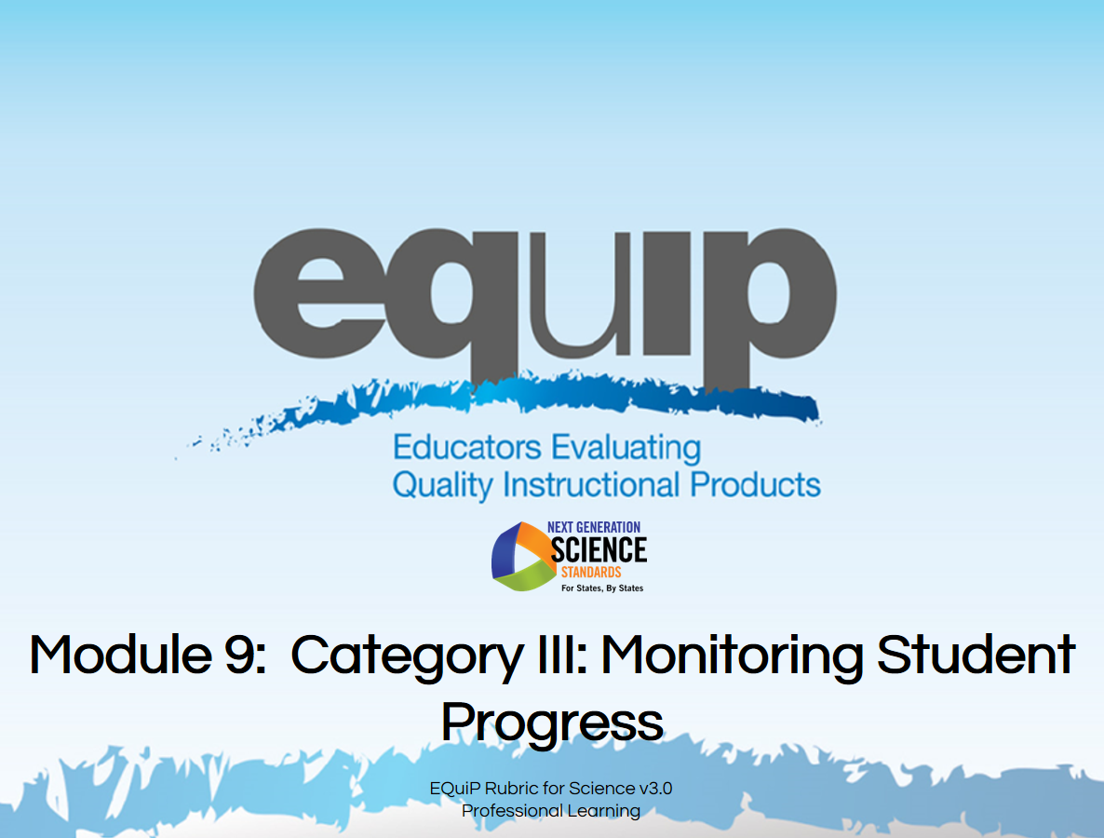
Slide 173
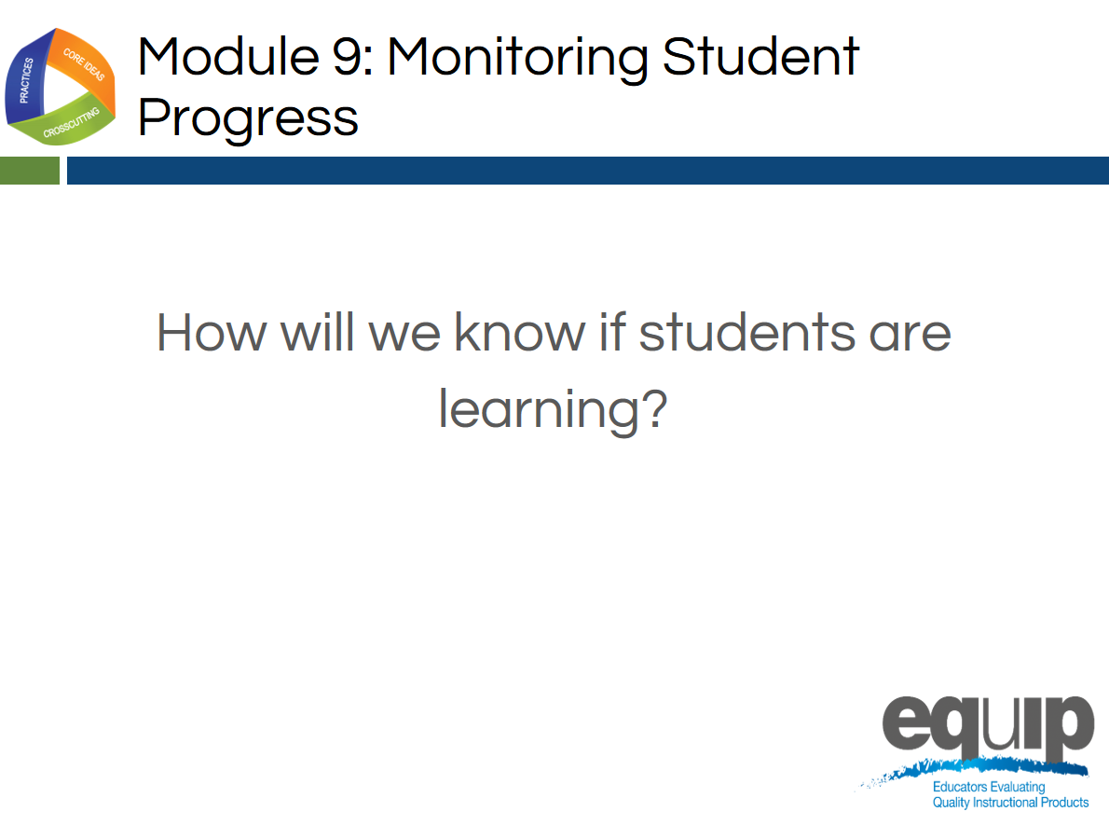
Slide 174
Talking Points
- In this module, we’ll be looking at Category III: Monitoring NGSS Student Progress.
- By the conclusion of this module, you should be able to use the EQuIP Rubric to determine whether a lesson or unit includes a variety of assessments that align to three-dimensional learning and provides multiple opportunities to elicit observable, unbiased evidence of student understanding through performance.
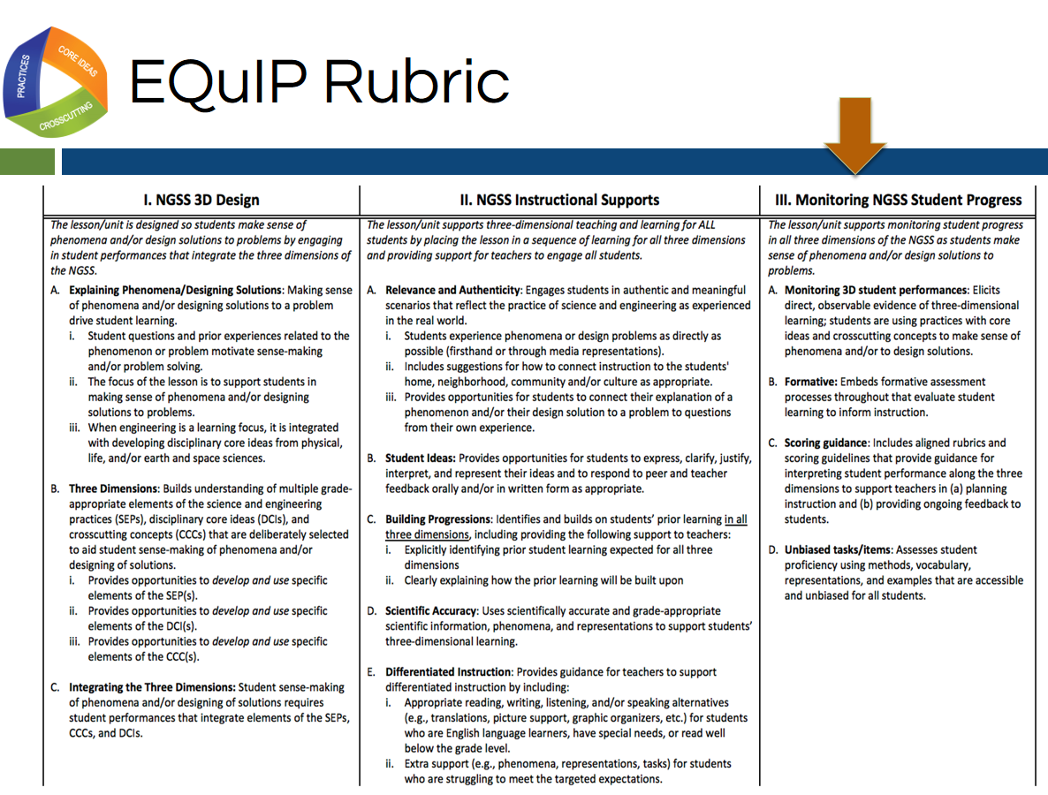
Slide 175
Talking Points
- Now, locate Category III on page twelve of your rubric document.
- Category III: Monitoring NGSS Student Progress focuses on examining lessons and units to determine whether they include the kinds of assessments necessary to assess student mastery of the NGSS accurately.
- Take a few minutes to read through Category III. [Note to facilitator: Allow three to five minutes.]
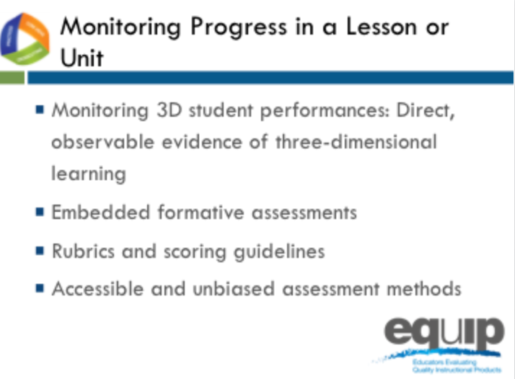
Slide 176
Talking Points
- The four criteria at the top of Category III focus on monitoring student NGSS progress in a lesson or unit.
- We’ve focused extensively on direct, observable evidence of three-dimensional learning; but before we can examine lessons or units to look for evidence of embedded formative assessments, we need to determine just what that looks like.

Formative Assessment
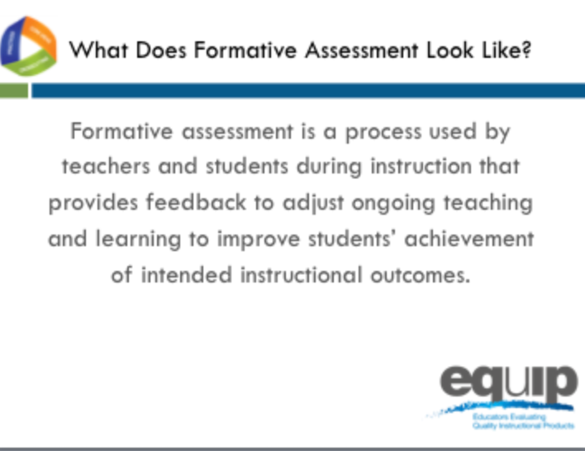
Slide 177
Talking Points
- According to a paper initiated by the Council of Chief State School Officers (CCSSO) in 2008 entitled, “Formative Assessment: Examples of Practice,” formative assessment is:
  - A process used by teachers and students during instruction that provides feedback to adjust ongoing teaching and learning to improve students’ achievement of intended instructional outcomes.
- Dylan Wiliam, who you may recall co-authored “Inside the Black Box,” the groundbreaking research report on the impact of formative assessment on student learning, says this about formative assessment in his 2011 book, “Embedded Formative Assessment”:
  - “An assessment functions formatively to the extent that evidence about student achievement is elicited, interpreted, and used by teachers, learners, or their peers to make decisions about the next steps in instruction that are likely to be better, or better founded, than the decisions they would have made in absence of that evidence.” (43)

Slide 178

Facilitator Notes
This video can be found at http://www.nextgenscience.org/resources/ngss-equip-rubric-evidence-student-learning
Talking Points
- This video highlights category 3 of the EQuIP rubric: Monitoring student progress.
- Let’s watch this video to better understand how we may approach looking for direct observable evidence of 3D student learning in a lesson.
- Note to Facilitator: After the video Ask participants: “How can the features of the NGSS offer ways to make student thinking visible?” Have a brief discussion (1–2 minutes).
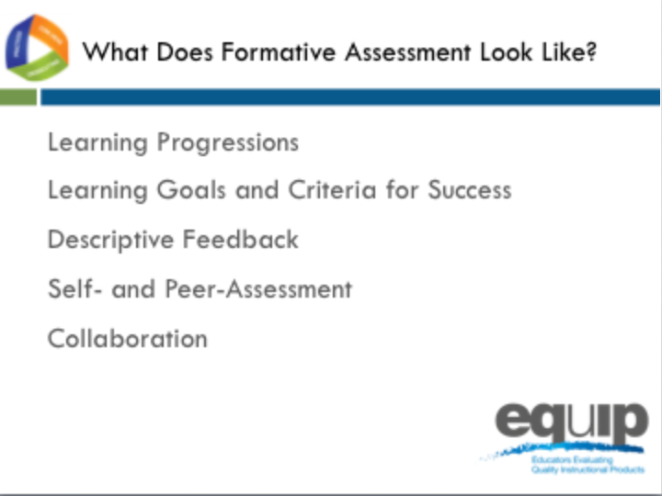
Slide 179
Talking Points
- According to the CCSSO paper, five attributes are associated with effective formative assessment:
  - [Note to facilitator: Click for animation.] Learning Progressions that clearly articulate the sub-goals of the ultimate learning goal [for a lesson or unit];
  - [Note to facilitator: Click for animation.] Learning Goals and Success Criteria that are clearly identified and communicated to students;
  - [Note to facilitator: Click for animation.] Descriptive Feedback provided to students that is evidence-based and linked to the intended instructional outcomes and criteria for success;
  - [Note to facilitator: Click for animation.] Self- and Peer-Assessment that provide students with opportunities to think meta-cognitively about their learning; and
  - [Note to facilitator: Click for animation.] Collaboration exemplified by a classroom culture in which teachers and students are partners in learning.
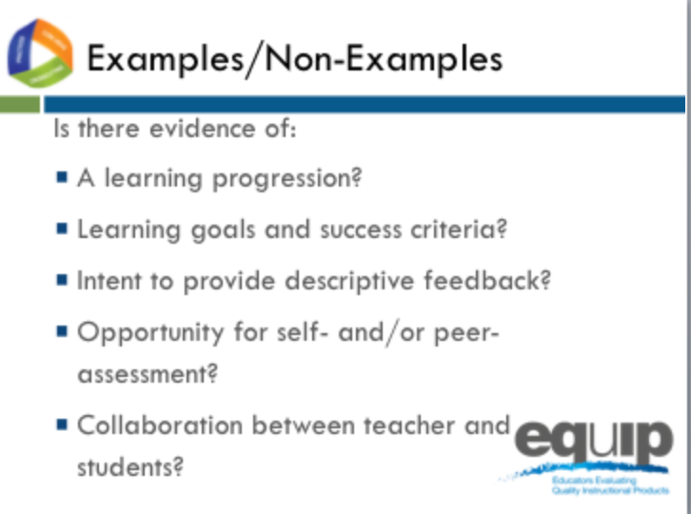
Slide 180
Facilitator Notes
Refer participants to Handout 10, Module 9, Slide 180, “Formative Assessment Vignettes.”
Talking Points
- You have a handout entitled, “Formative Assessment Vignettes,” which you need to take out.
- Read through the different vignettes to determine what evidence you see of the five attributes delineated by CCSSO or evidence you see that supports Wiliam’s definition of formative assessment. Please note that the examples presented in the vignettes are not necessarily three-dimensional.
- Once you’ve read through the vignettes individually, discuss your findings as a group to determine which vignettes are examples of formative assessment and which are non-examples. [Note to facilitator: These vignettes, as well as additional information about formative assessment, are available in the paper from the Council of State School Officers. Allow seven to ten minutes.]
- Now let’s take a look at these examples and non-examples.
- The first vignette is “Thumbs Up and Thumbs Down.” What do you think? Let’s see your thumbs up if you think this example provides evidence of formative assessment or thumbs down if you do not.
- What’s your reasoning? [Note to facilitator: Allow one or two people to share.]
- Here’s what the experts say about this first vignette: “This teacher is using a formative assessment approach to collect evidence to adjust instruction. This is, therefore, an instance of formative assessment.”
- Moving on to the second vignette, “Structured Pair Work,” again, let’s see your thumbs up if you think this example provides evidence of formative assessment or thumbs down if you do not.
- What’s your reasoning for this one? [Note to facilitator: Allow one or two people to share.]
- Here’s what the experts say about this second vignette: “This is an example of formative assessment where the posed questions and the peer conversations are used to elicit evidence of the students' understandings. In this context, the formative assessment process is embedded into the learning activity itself due to the teacher’s careful engineering of the activity. The students are able to self-reflect and get feedback from their peers. The teacher is able to listen to the conversations between students to note the current level of understanding for the class and for individual students. The teacher uses the information immediately to assist students in their learning by redirecting thinking, reinforcing ideas or providing cues.”
- Now for the third vignette, “Classroom Quizzes,” again, let’s see your thumbs up if you think this example provides evidence of formative assessment or thumbs down if you do not.
- What’s your reasoning for this one? [Note to facilitator: Allow one or two people to share.]
- Here’s what the experts say about this third vignette: “This is not an example of formative assessment because the teacher does not use the evidence from the quizzes to adjust instruction, nor does the teacher provide direction to students for them to think meta-cognitively about their own learning. The only information the students receive is a score for the number of correct answers. This is an example of ongoing summative assessment, not formative assessment.”
- Continuing on to the fourth vignette, “Shared Thinking,” again, let’s see your thumbs up if you think this example provides evidence of formative assessment or thumbs down if you do not.
- What’s your reasoning for this one? [Note to facilitator: Allow one or two people to share.]
- Here’s what the experts say about this fourth vignette: “In this example of formative assessment the teacher is provided with information about student learning, and the process used to gather that information also requires students to reflect on their own learning. This activity provides the teacher with information about how well the students understand the concept and how best to demonstrate that understanding. To fully participate in the activity, students must reflect on their own level of understanding as they analyze the work of others and provide reasons why they think there are gaps in understanding.”
- Finally, for vignette number five, “District-Developed Assessments,” let’s see your thumbs up if you think this example provides evidence of formative assessment or thumbs down if you do not.
- What’s your reasoning for this one? [Note to facilitator: Allow one or two people to share.]
- Here’s what the experts say about this fifth vignette: “In this example, we see neither teachers’ adjustment of their instruction nor students’ adjustment of their learning tactics. Thus, this probably well-intentioned distribution of the monthly exams’ results to parents would constitute a counter-example of formative assessment.”
- So, determining whether evidence of embedded formative assessment is present in a lesson or unit is not easy. Misconceptions regarding what is and what is not formative assessment are common. Hopefully these examples and non-examples from the CCSSO document, along with the expert commentary, help identify some of the more common misconceptions and clarify what we’re looking for in terms of evidence of embedded formative assessment.

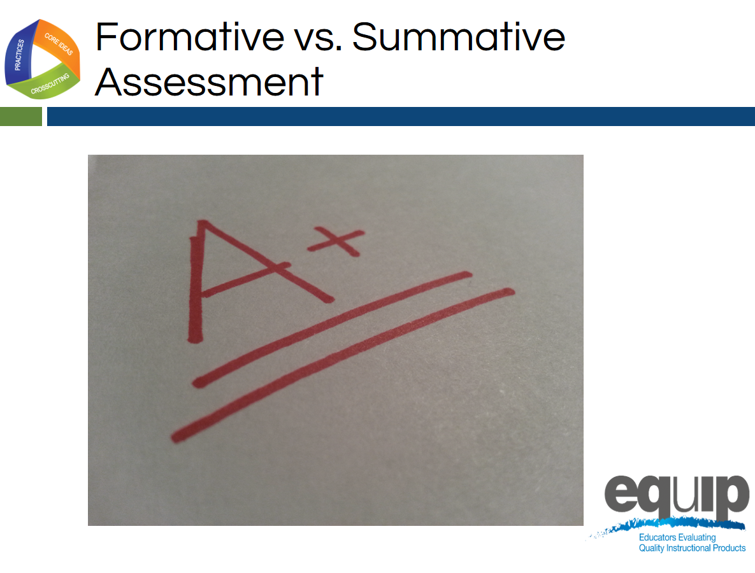
Slide 181

Talking Points
- Overall, whether an assessment is formative or summative depends on the purpose for which that assessment is being used.
- As Wiliam states, “An assessment functions formatively to the extent that evidence about student achievement is elicited, interpreted and used by teachers, learners or their peers to make decisions about the next steps in instruction.”
- Summative assessments, on the other hand, are those whose purpose is evaluation. Summative assessments provide grades or scores denoting overall mastery of the material.
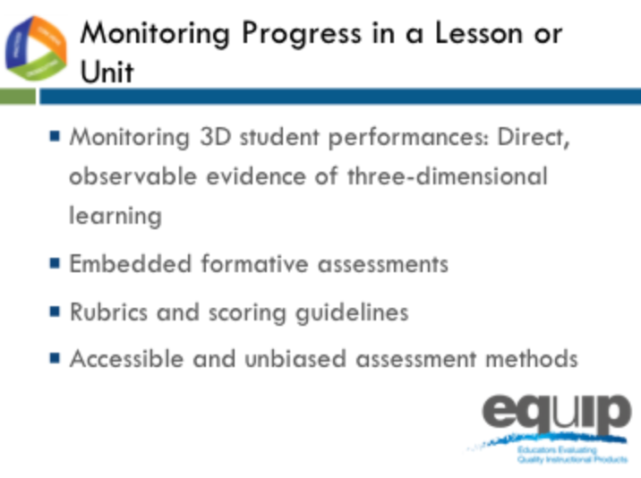
Slide 182
Talking Points
- As we prepare to look for evidence of the Category III criteria in an actual lesson, let’s quickly review criteria A through D for Category III.
- Keep in mind that you’ll be looking for direct, observable evidence of these criteria. This evidence must be explicitly stated in the lesson.
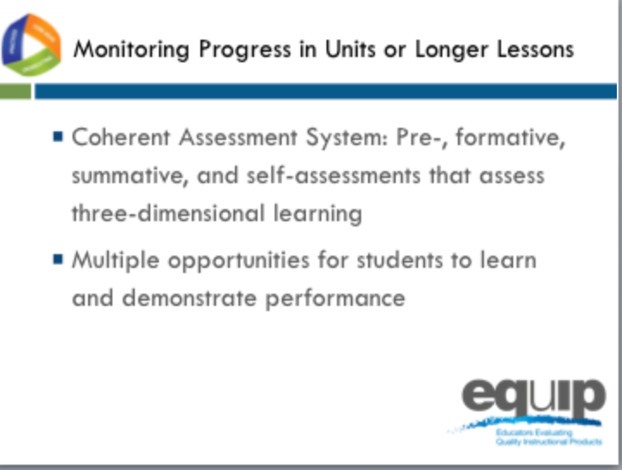
Slide 183

Talking Points
- The criteria at the bottom of Category III focus on monitoring student progress in a longer lessons or in a unit of instruction.
- Note that these criteria require multiple forms of assessment as well as multiple opportunities for students to demonstrate performance.
- Again, keep in mind that you’re always looking for direct, observable evidence of these criteria.
Monitoring Student Progress Practice
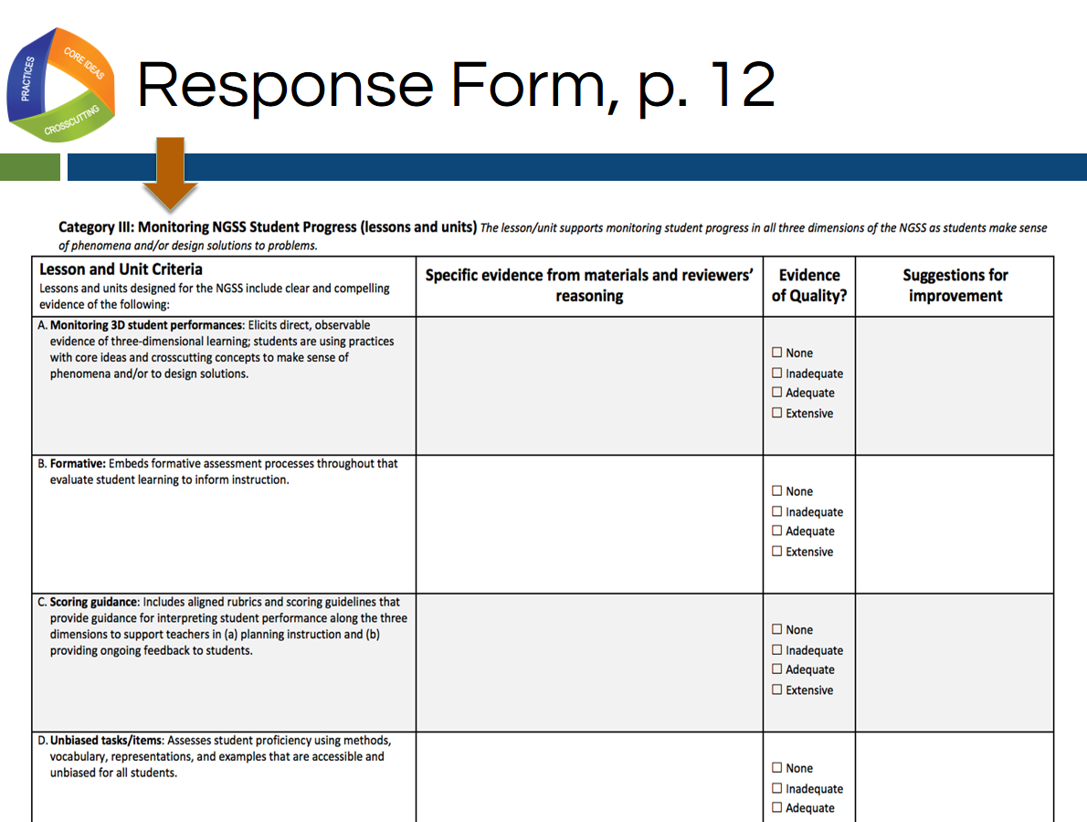
Slide 184
Talking Points
- For this quick practice you will need:
  - The response sheet for Category III, which is located on page twelve of your rubric document;
  - The Common Lesson Urban Heat final version; and
  - A pen, pencil, or a tablet or laptop with the electronic version of the rubric to record your findings.
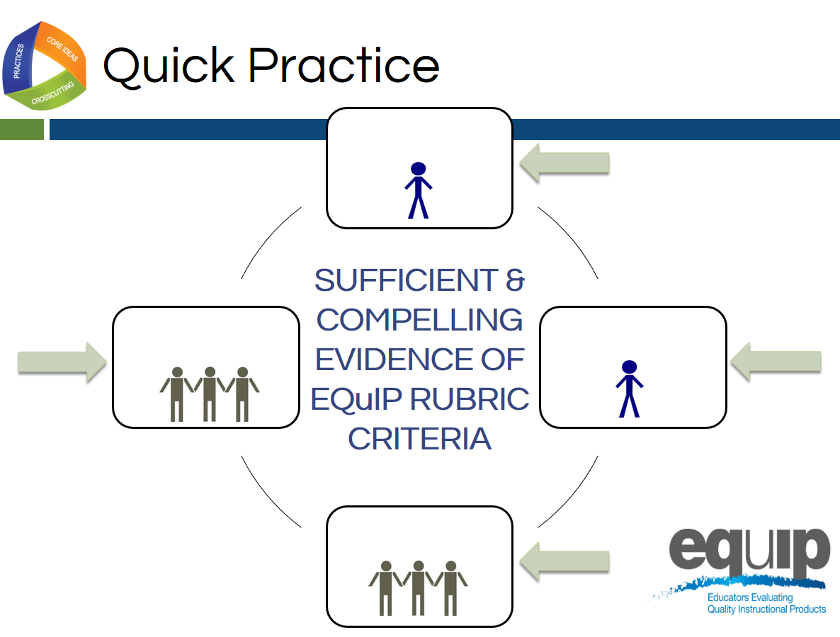
Slide 185

Talking Points
- As you work through this category, follow the same process you used earlier when examining a lesson or unit for Categories I and II:
  - First, work individually to look for the evidence in the Common Lesson.
  - Use the Arabic and Roman numerals associated with the rubric criteria to code the evidence you locate.
  - Next, still individually, determine how the evidence fits together and connects to one or more criteria.
  - Once you’ve made your individual determinations, work with your group to share and compare the evidence you’ve located in the Common Lesson.
  - Then, as a result of this evidence and reasoning, collaboratively evaluate whether or not the lesson or unit provides sufficient and compelling evidence of the criteria, and assign evidence of quality ratings for each of the criteria as well as for each category.
  - Finally, make suggestions for how the lesson or unit might be improved.
- You have 30 minutes for this task. [Note to facilitator: Set the timer, but monitor the groups to determine if they need more or less time to complete the practice before moving on.]

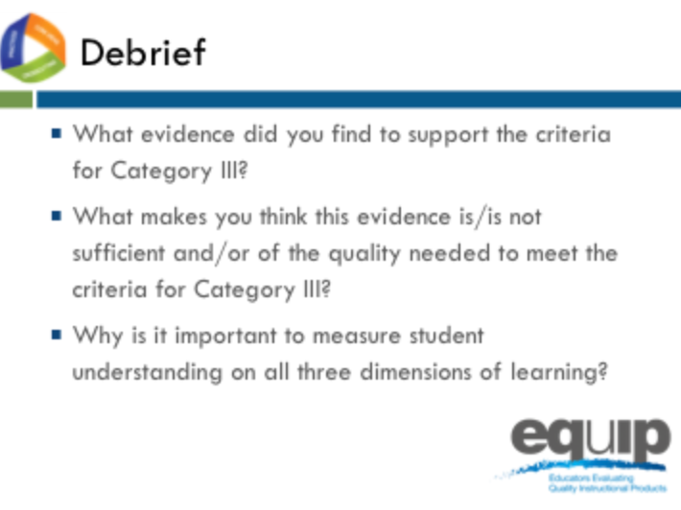
Slide 186
Talking Points
- So what determinations did you make at your tables? Does this lesson meet the criteria in Category III?
- How? Why or why not? [Note to facilitator: Allow several tables to share.]
- Why is it important to measure student understanding on all three dimensions of learning? [Note to facilitator: Allow several tables to share.]
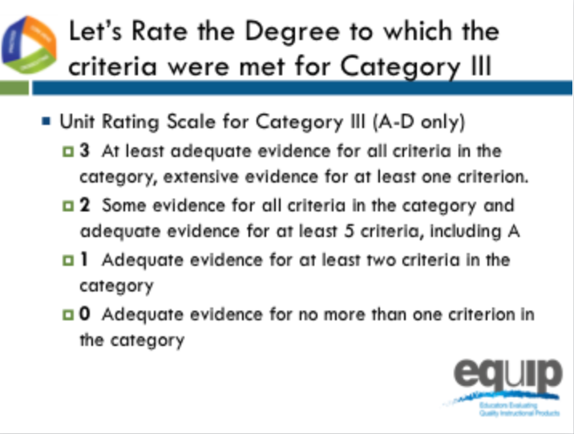
Slide 187
Talking Points
- Let’s rate the degree to which the criteria were met in Category III.
- Let’s only consider criteria A–D since we are examining a lesson, not a unit.
- At each table, let’s review the evidence of quality for categories A–D. Then, as a group, let’s determine a rating for Category III using the language on page 12 of the rubric.
- Notice that the possible ratings fall across a 0–3 scale.
- Facilitator, give groups about 5 minutes to discuss evidence of quality for each category A–C and determine a Category rating.
- By a show of fingers, would table facilitators indicate how many of the criteria you found at least adequate evidence of in the lesson? [Note to facilitator: Do a quick summary of the room and announce a consensus response.]
- Let's take a quick poll of the room, what rating did your group give to Category III? [Note to facilitator: Quickly survey the room by asking for a response from each group, and discuss a consensus answer.]
- Finally, would a few groups be willing to share specific evidence and reasoning for your evidence of quality rating? [Note to facilitator: Take a few group volunteers.]

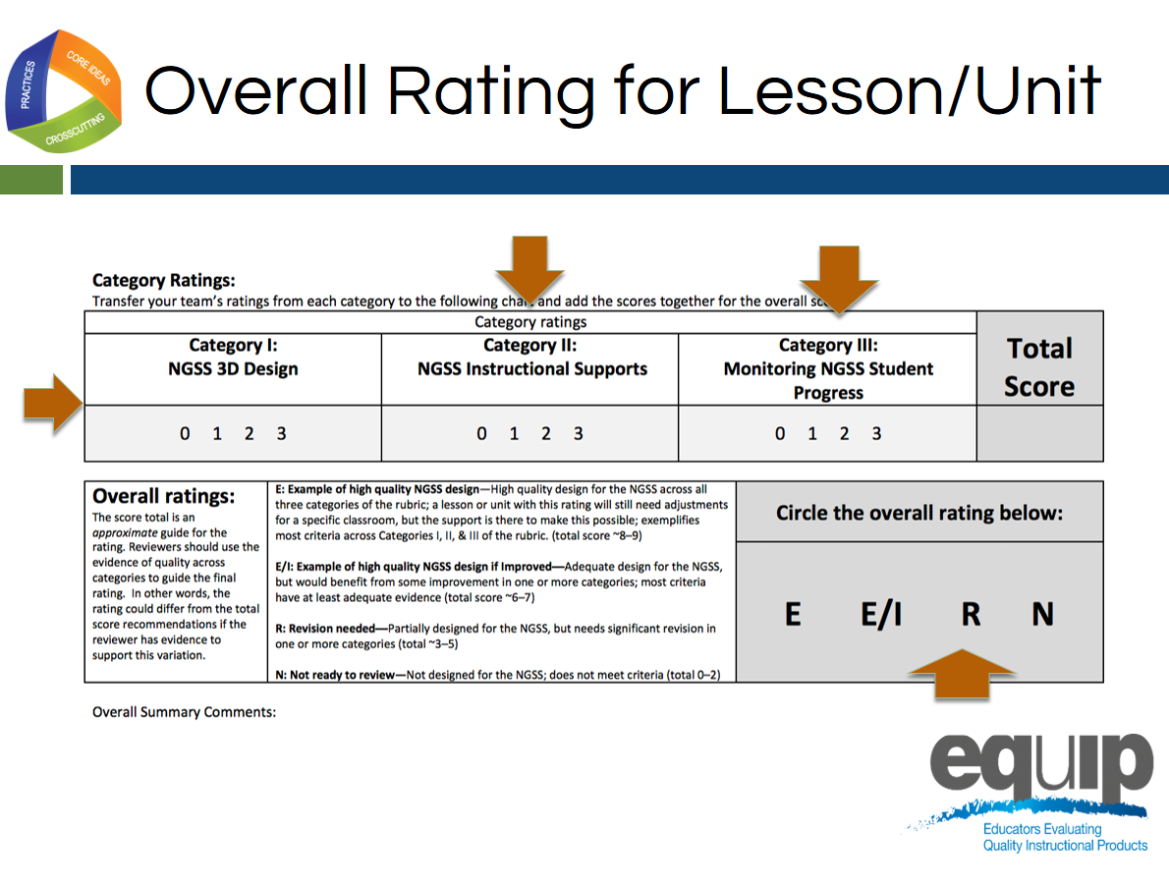
Slide 188

Facilitator Notes
If there is time available, have groups share their overall ratings and a comment after the 10-minute time allotted for this task.
Talking Points
- Let’s determine an overall rating and share summary comments.
- Let’s turn to page 14 of our rubric, pictured on this slide.
- At our tables, let’s review our ratings for categories I. [Note to facilitator: click animation II, click animation and III click animation one at a time.]
- As you look back at each category in the rubric and share the category rating, try to record at least one summary comment in the Overall Summary Comments for the category.
- Total your category ratings and reflect on the overall quality of the lesson and record your overall rating. [Note to facilitator: Click animation.]
- Notice that total scores of 8–9 are examples of high quality design.
- Scores of 6–7 are examples of high quality design if improved.
- Scores of 3–5 indicate that revision is needed since these lessons are only partially designed for the NGSS.
- Scores of less than 3 indicate that this lesson was not ready for review since it does not reflect NGSS Design.
- You will have ten minutes to complete this task.
Concluding Slide for Module 9
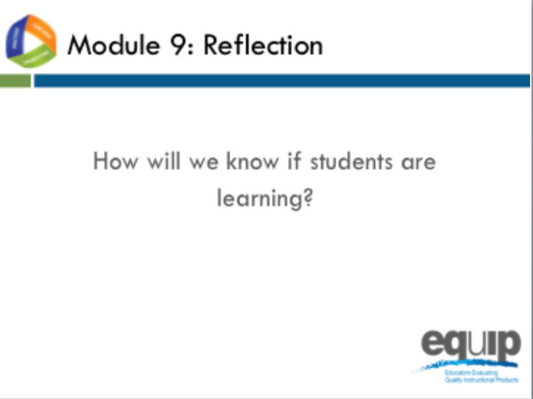
Slide 189
Talking Points
- As with all standards, teaching to the NGSS is not sufficient. It’s about students learning—in the case of the NGSS, three-dimensional learning. Examining a lesson or unit against the criteria in Category III determines whether that lesson or unit includes the kinds of assessments that allow all students to demonstrate understanding and for all teachers to monitor the progress and performance of all students.
- As a result of this module, you should feel comfortable using the rubric to determine whether or not a lesson or unit meets the criteria in Category III.
- Are there any questions or additional comments about the criteria in Category III? [Note to facilitator: Address question or comments if they arise.]
- You have now completed the first nine modules of this professional learning.
- You’ve applied the EQuIP Rubric criteria to examine a common lesson to determine whether this lesson contains evidence of sufficient quality to meet the criteria for:
  - NGSS 3D Design;
  - Instructional Supports; and
  - Monitoring NGSS Student Progress.
- Now that you’ve had practice with each category of the rubric separately, you’re ready for the culminating task where you will put what you’ve learned into practice to examine a lesson or unit that has been developed for your grade, grade band and/or specific science discipline.
- [Note to facilitator: Ask each of the following questions one at a time, allow participants to answer, and provide follow up as needed before proceeding to the culminating task.]
  - Do you feel ready to use the EQuIP Rubric to examine NGSS instructional materials?
  - What have been the strengths of the training?
  - Is there anything you need to review or revisit before the culminating task?

