Using the
EQuIP Rubric for Science v3.0

Professional Learning
Facilitator’s Guide

About This Professional Learning
The Educators Evaluating the Quality of Instructional Products (EQuIP) Rubric for science is a tool that provides criteria by which to examine the alignment and overall quality of lessons and units with respect to the Next Generation Science Standards (NGSS). Completing this professional learning will provide science educators with the processes and procedures necessary to use the EQuIP Rubric to review science lessons and units, to provide effective feedback and suggestions for improvement to developers of these instructional materials, to identify model or exemplar lessons and units, and to inform the development of new instructional materials. In addition, this professional learning also helps educators understand the NGSS, identify shifts in instruction that may be needed to better target the NGSS, and transition teaching and learning.
As noted by Joe Krajcik, professor of science education and director of the CREATE for STEM Institute at Michigan State University, “Many developers and publishers of science materials claim that their materials align with the NGSS and feature the NGSS performance expectations. And while some publishers will make legitimate attempts at modifying their materials to do an appropriate alignment, you will need to have the appropriate tool to judge which materials better represent the intent of the NGSS and which materials just really don’t match up” (http://nstacommunities.org/blog/2014/04/25/equip/). The EQuIP Rubric serves as this tool not only for published materials, but also for educator-developed lessons and units.
This professional learning consists of an Immersion and Introduction module followed by 10 modules that may be used separately or with two or more modules grouped together. These modules are designed sequentially to build participants’ proficiency in using the EQuIP Rubric version 3.0.
All modules include one or more specific learning outcomes.
Most modules will take 15 minutes to an hour to complete; however, Modules 6 and 10 will take longer. Timing is important, so Craig Gabler, regional science coordinator and co-director of LASER Alliance, explains more about thoughtful timing of the training in this video.
After completing the immersion, introduction and first nine modules, participants will apply their learning and complete a culminating task in Module 10.
Note: This guide accompanies EQuIP rubric 3.0. A summary of changes and revisions from version 2.0 to version 3.0 can be found here. All EQuIP materials can be accessed online at nextgenscience.org/equip.
The Modules
- Immersion and Introduction Module
- Module 1: Overview of the Framework for K–12 Science Education
- Module 2: Overview of Performance Expectations
- Module 3: Three-Dimensional Learning
- Module 4: Overview of the EQuIP Rubric
- Module 5: Providing Feedback, Evaluation, and Guidance
- Module 6: Category I: NGSS 3D Design
- Module 7: Determining Coherence and Connections
- Module 8: Category II: Instructional Supports
- Module 9: Category III: Monitoring Student Progress
- Module 10: Culminating Task
The Facilitator’s Guide
This guide includes each slide from the professional learning PowerPoint, talking points for each slide, and instructions for all tasks (the learning tasks and the culminating task). When appropriate, facilitator notes are included to set up and support the discussion of the activity or slide. In addition, participant takeaways highlighting points of emphasis may be included.
A number of symbols are used throughout the Facilitator’s Guide to signal specific features of the training:
The clock signals a timed task.
!
The exclamation mark signals a very important point that needs to be emphasized.

The video camera signals a video clip.

The double arrow signals an opportunity to differentiate to meet the needs of your audience.
Materials and Other Considerations
- Participants should have an understanding of the Framework for K–12 Science Education and the Next Generation Science Standards (NGSS). Modules 1 and 2 do provide a brief background on these topics, but ideally participants will not need to spend much time on these modules since they should already be comfortable with the Framework and the NGSS. If the facilitator determines the audience does not need to review the information in modules 1 and 2, then the facilitator should begin with the Immersion and Introduction modules and then proceed directly to module 4. If the facilitator determines that the audience would benefit from a review of the Framework for K–12 Science Education and the Next Generation Science Standards (NGSS), then the facilitator should begin with the Immersion and Introduction module and then proceed to modules 1, 2, and 3.
- Participants will need hard copies of the following handouts:
  - Handout 1: Module 1, “The Framework” (4 pages)
  - Handout 2: Module 1, Using Phenomena in NGSS-Designed Lessons and Units (3 pages)
  - Handout 3: Module 2, “Format of Performance Expectation” (1 page, preferably color copies)
  - Handout 4: Module 2, “How to Read the NGSS” (5 pages, preferably color copies)
  - Handout 5: Module 3, “Sample Performance Expectation” (1 page, preferably color copies)
  - Handout 6: Module 4, “EQuIP Agreements with Table Facilitator Guidelines on back” (2 pages)
  - Handout 7: Module 4, “EQuIP Rubric, Version 3.0” (14 pages)
  - Handout 8: Module 7, “Graphic Example of Coherence” (1 page, preferably color copies)
  - Handout 9: Module 7, “Debriefing Questions for Module 7” (1 page)
  - Handout 10: Module 9, “Formative Assessment Vignettes” (2 pages)
  - Handout 11: Module 10, “Culminating Task Debriefing Questions” (1 page)
  - Common Lesson for use in Module 6: Intermediate version of Urban Heat (12 pages, shared with participants prior to training)
  - Common Lesson for use in modules 7, 8, and 9: “Final” Version of Urban Heat (10 pages)
- Participants may want to have laptops in order to be able to type into the rubric. This is highly recommended. It will allow them to capture more of their ideas and group discussions. A fillable PDF version and a Microsoft Word version of the EQuIP rubric can be found at www.nextgenscience.org/equip).
- Participants may want to have blue, green, and orange highlighters to highlight the three dimensions when examining a lesson or unit.
- Participants will need to be able to look up standards and NGSS appendices.
- The facilitator will need to prepare the Storyline Cards for the task in Module 7, Slide 154 These cards are located on the Facilitator’s Resource—Storyline Cards, which is included with the handouts.
- Ideally, participants will be in teams of four to six members. This size gives everyone an opportunity to be part of the team discussion. Each team will need to have an assigned Table Facilitator. The roles and responsibilities of the table facilitator can be found on the back of Handout 6.
- If the resources are available to provide each group with a projector, the group can then see what the recorder is writing, allowing the group to more fully engage in the process and ensuring that recorded feedback, evaluation, and guidance represent the group’s consensus. Screen-sharing applications also can be used for this. With or without a projector, it is helpful to have a recorder to type a consensus response into the rubric. It can be helpful to assign the Table Facilitator and Recorder roles to different participants at a table.
- For Module 10, materials to be evaluated by teams will need to be coordinated. The professional learning facilitator will need to make instructional materials available for groups of participants to examine or ensure that participants will be bringing the appropriate number and types of materials. Ideally, participants will have the opportunity to evaluate lessons and units for their respective grade bands and disciplines. Additionally, the ideal materials will state the NGSS performance expectations to which they are aligned and, if possible, the foundation boxes and any additional practice, core idea and crosscutting concept elements that are included; however, this is not required. Finally, the facilitator should be thoughtful about grouping participants for the culminating task.

Handouts and Materials for Optional Introduction and Immersion Module
- If the Facilitator chooses to do the optional introduction and Immersion module with participants (description on page 10), participants will need hard copies of the following handouts:
  - Immersion Handout A, B, C, D Student Work Samples
  - Immersion Handout E: MS-PS4-2
  - Immersion Handouts F and G: Grade-banded views of the science and engineering practices (2 pages each MS and HS)
- Participants will also need post-it notes (1–2 per person), Light boxes (1 per table), adhesive chart paper (4 sheets plus 1 per table group of 4–6 people), and 11 by 18-inch paper (1 per person)

Acknowledgements
In a process coordinated by Achieve, the following team wrote, adapted, and contributed to the EQuIP v2.0 Professional Learning Facilitator’s guide:
Jennifer Arnswald Educational Consultant, Kent ISD, Michigan
Kristoffer R. Carroll K–12 Regional Science Trainer, Southern Nevada Regional Professional Development Program
Mary Colson Earth Science Teacher, Horizon Middle School, Minnesota
Zoe Evans Assistant Principal, Central Middle School, Georgia
Mike Fumagalli Science Teacher and Assistant Dean, Leyden High School, Illinois
Craig Gabler Regional Science Coordinator and LASER Alliance Co-Director
Joe Krajcik Professor of Science Education and Director of the CREATE for STEM Institute at Michigan State University
Sally Pardue Associate Professor of Mechanical Engineering at Tennessee Technological University and Director of the Oakley STEM Center
Tricia Shelton Science Teacher, Boone County Schools, Kentucky
Cynde Snider Consultant, Cynde Snider Consulting, LLC
Reviews and feedback for the v2.0 Facilitator’s Guide were provided by the National Science Teachers Association (NSTA), members of the Council for State Science Supervisors, and science education experts in Delaware, Minnesota, and Rhode Island.
The EQuIP Rubric was revised in 2016 to add scoring guides and incorporate feedback from educators. A full description of the changes made to the EQuIP v3.0 rubric is online here. To reflect the rubric changes, this Facilitator Guide was revised and adapted in 2017 by Tricia Shelton.

Contents
About This Professional Learning 2
The Modules 2
The Facilitator’s Guide 3
Materials and Other Considerations (Modules 1-10) 3
Materials for Optional Introduction and Immersion Module 4
Acknowledgments 5
Introduction and Immersion Module (optional) 7
Module 1: Quick Overview of the Framework for K–12 Science Education 41
Module 2: Quick Overview of Performance Expectations 54
Module 3: Three-Dimensional Learning 63
Module 4: Overview of EQuIP Rubric 73
Module 5: Providing Feedback, Evaluation and Guidance 84
Module 6: Category I: Determining Alignment to NGSS 94
Module 7: Determining Coherence and Connections 115
Module 8: Category II: Instructional Supports 130
Module 9: Category III: Monitoring Student Progress 138
Module 10: Culminating Task 152

MODULE
EQuIP for Science v3.0
Immersion and Introduction

NGSS 3D Design
Immersion and Introduction Module: NGSS 3D Design
This module sets the foundation for the collaboration that drives the EQuIP review process. The NGSS lesson immersion experience serves as a kind of formative assessment for the facilitator. The facilitator will gain an understanding of where the participants are in their understanding of the three dimensions of the NGSS. The participants will work to establish productive review teams as they begin the EQuIP process with an activity where they take on roles of learner and evaluator using the elements of the three dimensions. This lesson immersion will also serve as a touchstone experience for 3 dimensional learning in service to phenomena that the facilitator may use later to build understanding of the rubric criteria.
Facilitator Notes
In the immersion lesson, students are trying to explain why perception does not match reality when it comes to optical illusions. This phenomenon was chosen because it resonated with 9th students in the classroom, and it could be connected to multiple disciplinary core ideas. The immersion lesson was chosen as a touchstone experience for NGSS 3D Design for the following reasons:
- This unit was taught at the beginning of the school year to students who had very little experience with the NGSS. In the lesson used in our training today, scaffolding is provided to support students in the practice of developing and using models. Participants in this EQuIP training may productively struggle as the students in the classroom do, and see the importance of that scaffolding.
- The phenomenon in this lesson was interesting to the students in the room. Because they were engaged, they were able to generate many questions to drive their inquiry and persistence. This lesson and phenomenon were chosen to provide participants an opportunity to see how questions can be used to drive both unit and lesson discovery and thinking.
- This phenomenon has complexity and requires multiple disciplinary core ideas to be explained. There are opportunities for teachers to see how to facilitate an explanation of a phenomenon that crosses the domains of the NGSS as well as spans grade bands. In this particular example, it was determined that students did not come to this 9th grade classroom demonstrating proficiency in the middle school DCIs needed as foundational knowledge in this unit. This became an opportunity to combine middle school and high school elements of the dimensions in one unit, which can be a common situation at this stage in implementation in many classrooms.
- This lesson was chosen because it has student work samples matching the participant work samples they will create in the lesson. This can give training participants a lens into how to evaluate student work, give feedback, and use student work to inform next steps. At the same time, participants are engaged in deepening an understanding of the elements of the dimensions and integration of the 3 dimensions that are needed for using the EQuIP rubric evaluation process.
Note: The lesson and student work are not considered to be exemplars, but are used to facilitate discussion among participants for areas where NGSS may be evident as well as areas that need improvement.
Participant Takeaway
Participants will gain an understanding of how to use the elements of the three dimensions to inform instruction and assessment while they experience what the integration of the three dimensions can look like in the classroom. Participants will also see examples of some qualities of good phenomena that drive instruction.

Slide 1
Talking Points
- This professional learning is designed to provide participants with the knowledge and conceptual understanding necessary to examine teaching and learning materials related to the NGSS.
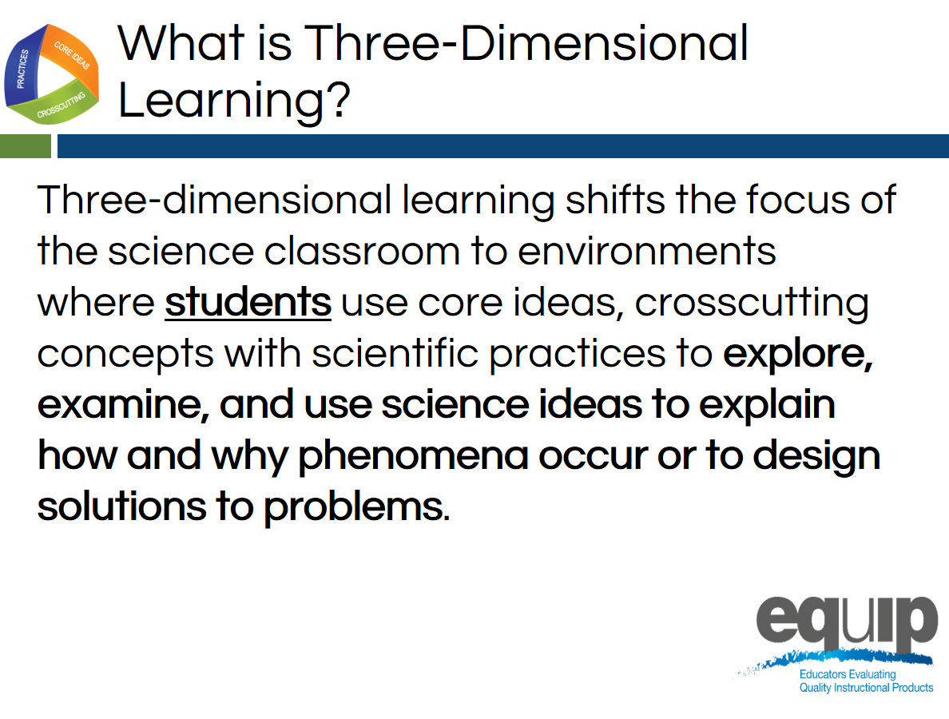
- The training is divided into an optional introduction and immersion module followed by 10 modules. These are divided into nine instructional modules followed by a culminating task in Module 10 where participants apply what they’ve learned through the first nine modules.

Slide 2
Talking Points
- We are going to begin our day thinking about a major innovation in the NGSS, 3-dimensional learning.
- Please take a moment to read the description of 3-dimensional learning pictured in the screen. [Note to facilitator: pause for 30 seconds.]
- We are going to provide you with an opportunity to experience 3-dimensional learning today.
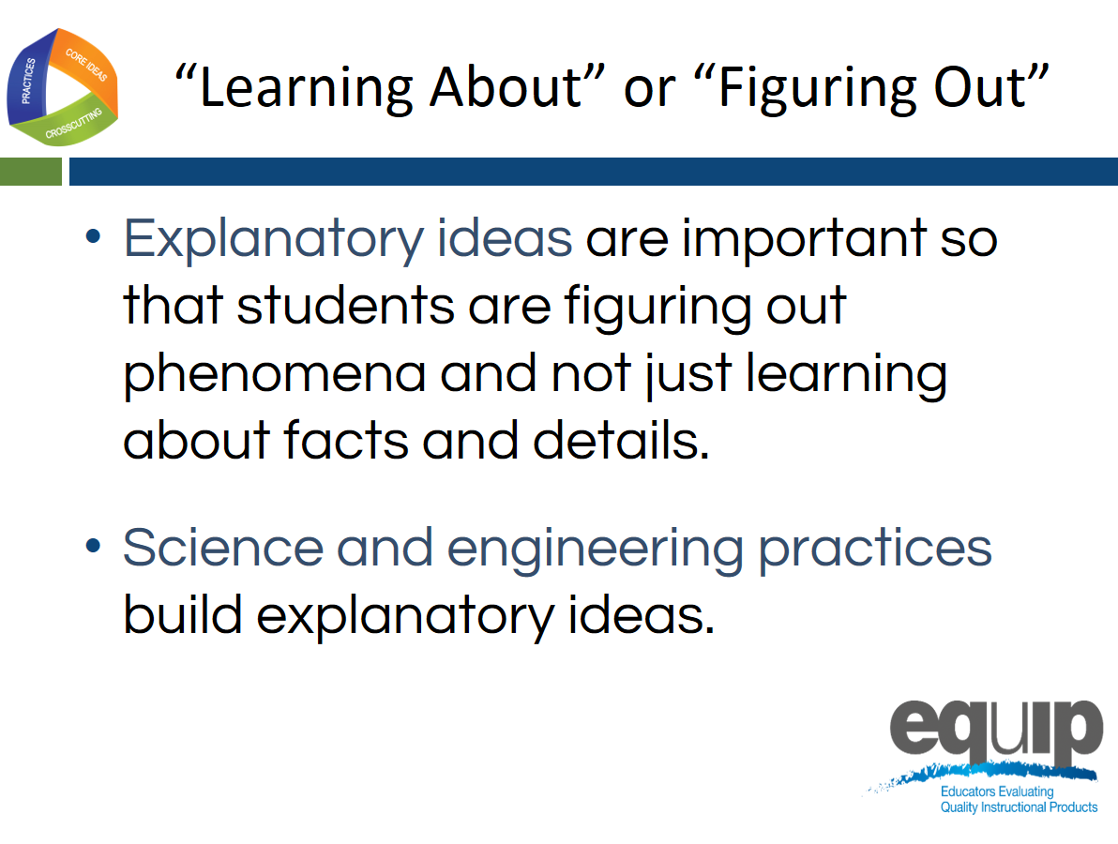
Slide 3
Talking Points
- In an NGSS classroom, the focus shifts from simply learning about science ideas that students often have difficulty applying to real-world contexts to figuring out or making sense of phenomena in the world that students are motivated to explain.
- Students are not just learning about a topic, but figuring out why or how something happens in the world.
- Students can then use these explanations to make sense of new contexts and transfer this working knowledge to new situations.
- Students build this working knowledge by engaging through the practices, by using the crosscutting concepts to organize and connect thinking, and by using the disciplinary core ideas to explain their world and develop solutions to problems.
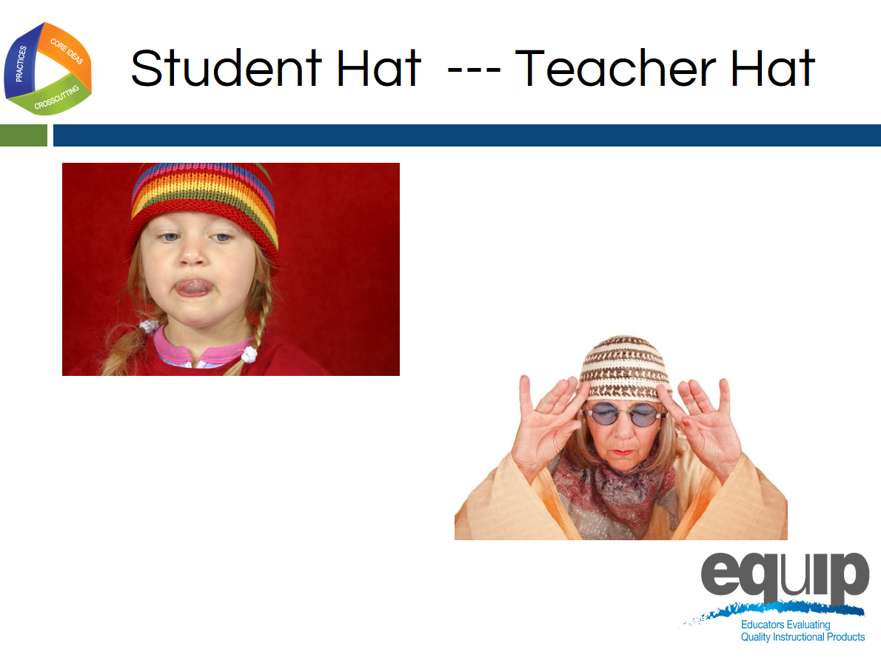
- Figuring out or making sense of phenomena supports 3-dimensional learning.

Slide 4
Talking Points
- Let’s experience figuring out by engaging in 3-dimensional learning together.
- In this immersion experience into the 3 dimensions, you will be wearing two hats.
- First we will wear our student hat as we productively struggle with a phenomenon.
- Second, we will put on our teacher hat, and look of evidence of student thinking and learning in student products.
- Examining the three dimensions from both the creation and evaluation perspective will deepen our understanding of how students build an understanding that they can use to explain the world.

Slide 5
Talking Points
- As the vision A Framework for K-12 Science Education suggests, students need to be active constructors of their understanding by engaging in the SEPs while applying one or more CCC to make connections between discrete pieces of knowledge using disciplinary core ideas, to create that full picture of why or how something is happening in the world.
- Today, as we engage in this immersion experience, let’s ask ourselves: “How does the lesson help students make meaning of the phenomena as they engage in the three dimensions targeted by the lesson and build toward proficiency of the performance expectations?”
- Just as we are motivated to experience the next event in a story, when instruction is anchored in figuring out phenomena through active engagement in the 3 dimensions, students are hungry for more evidence to explain their world in a way that is personally relevant to them.
Slide 6
Facilitator Notes
- Slides 6–10 provide an opportunity for participants to engage with the phenomena (3 optical illusions) and to generate their own questions about what we need to figure out to be able to explain why we cannot trust our eyes. Student-generated questions will create multiple lines of inquiry that will create multiple lessons or opportunities for learning.
Talking Points
- Due to time constraints, we will experience the introduction and first lesson of a unit where students are working to explain optical illusions.
- This unit used a common phenomenon to make connections between the physical and life science domains.
Participant Takeaway
The world is interdisciplinary, meaning the phenomena we observe often need multiple domains of science to be explained. This is an opportunity to encourage participants to consider the value in not narrowing our focus of instruction to one domain when there are opportunities to provide students with a more interdisciplinary experience.
Slide 7
Facilitator Notes
- When participants view this slide, they should see moving circles.
- It is important to test this slide in your presenting space prior to the presentation.
- Sometimes, depending on the projector and the size of the projected image, the movement of the circles is not obvious.
- If this happens, you can provide a link to the image, and ask participants to view the image on their personal device, which works very well: http://bluestar209.deviantart.com/art/Spinning-Circle-Illusion-71755761
Talking Points
- As we know, acting and thinking like scientists has a foundation in making careful observations and recording this data to reference later.
- As students, I would you like you to make observations:
  - What do you see?
  - Do you observe anything moving or changing?
- Please record these observations on a piece of paper or on a document on your device.

Slide 8
Facilitator Notes
- This is a video clip from ASAP Science: Can You Trust Your Eyes? (https://youtu.be/ZflIMBxyIak).
- Play the video with the sound off.
- The video has been cut to start at 51 seconds and end at 1:51.
Talking Points
- Let’s make observations of a second optical illusion.
- As you view the image, please consider this question: Are squares A and B the same shade of gray? Record your observations. [Note to facilitator: play the video and leave the 2 squares side by side on the screen at the end of the video clip so participants can make observations.]
- Now that the green cylinder has been removed, record observations after this subtraction.
- Are squares A and B the same shade of gray? Record your observations.
Slide 9
Facilitator Notes
- The final video in the series shows an image where Marilyn seems to change to Einstein. The video can be found at this link https://www.youtube.com/v/gfvMU36fgKw
Talking Points
- Let’s consider one more optical illusion.
- After start the video, I would like you to record your observations about the changes in this optical illusion. What do you notice? [Note to facilitator: Show the video so that the participants see the image approach and then return to starting position in the distance. Ask them to record what they noticed. Then continue with the talking points.]
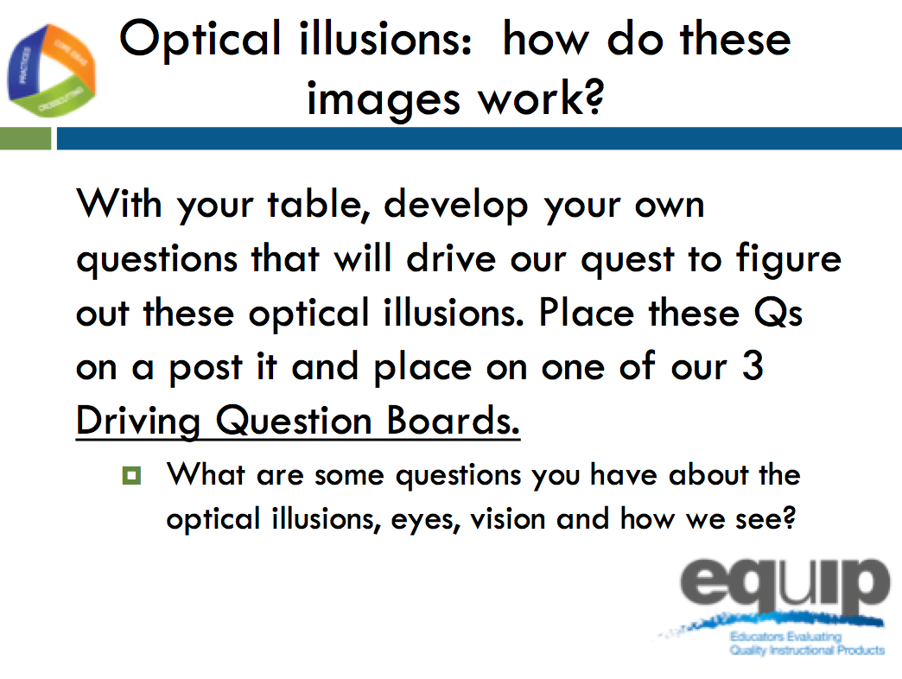
- I am going to show you the approaching image again. This time, I would like you to indicate by yelling out “NOW” when you see Einstein change back to Marilyn on the return (fade). Record what you notice about the “yells” from individuals. Do you notice any differences? [Note to facilitator: play video a second time.]

Slide 10
Facilitator Notes
- For this slide, you will need to prepare 3 driving question boards and a 4th “outlier” board on chart paper. Label the chart paper with the following questions written along the top of the chart paper leaving ¾ of the space for participants to place post it notes.
  - Chart Paper 1: label What do you need to see an object?
  - Chart Paper 2: label How does light get into our eyes? How does light allow vision?
  - Chart Paper 3: label How does the brain process signals?
  - Chart Paper 4: label Outlier board
- Hang the chart paper in a common area where participants can easily leave their seat and post their questions.
- Post-it notes are needed on each table for participants to use to record questions. Each participant will need approximately 1–2 post it notes.
Participant Takeaway
The point of using phenomena to drive instruction is to help students engage in practices to develop the knowledge necessary to explain or predict phenomena. Therefore, the focus is not just on the phenomena itself. It is the phenomena plus the student-generated questions about the phenomena that guides the teaching and learning. The practice of asking questions or identifying problems becomes a critical piece in trying to figure something out. This paragraph is an excerpt from the NGSS resource Using Phenomena in NGSS-Designed Lessons and Units, which is also Handout 2.

Talking Points
- After observing the three optical illusions, how would you answer the question: Can you trust your eyes? How do you know?
- Can you provide an explanation for optical illusions?
- Take a minute and generate questions stemming from observing these three optical illusions. Generate questions that are specific enough such that if you figured each of them out, you would be closer to answering the big question: Can we trust our eyes and thus explain optical illusions?
- Place each question on a separate post-it note. I am asking that everyone create at least 1 question from your observations.
- After you construct your question, come up to the driving question boards and place your question on the board that you think it could best connect with.
- After careful consideration, if you feel your question does not fit nested under any of these 3 questions (pointing to area with the 4 boards), then place your question on the outlier board.
- After placing your question on one of the 4 boards, please return to your seat. [Note to facilitator: Give participants 3–4 minutes to construct at least 1 question and place it on the Driving Question Board.]
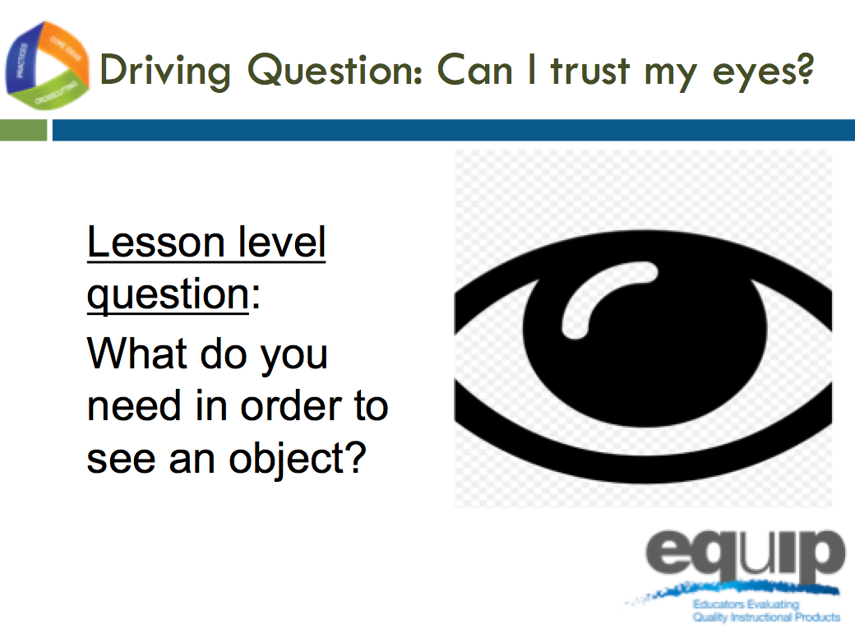
Slide 11

Facilitator Notes
- Slides 11–23 are the slides that guide lesson 1 of the optical illusions unit. Training participants should be reminded to put on their “student hat” and engage in this lesson as a learner.
Talking Points
- Not all phenomena need to be used for the same amount of instructional time. The optical illusions are our anchoring phenomena that drive the whole unit.
- Just as the students did in class, you generated science questions, which will drive our learning in each lesson and which are now posted on our driving question boards.
- We will now participate in the first lesson of this unit.
- The lesson level question is: “What do you need in order to see an object?”
- You will notice that this was one of the questions at the top of one of the driving question boards. We will begin to answer your questions posted on this board with this lesson.
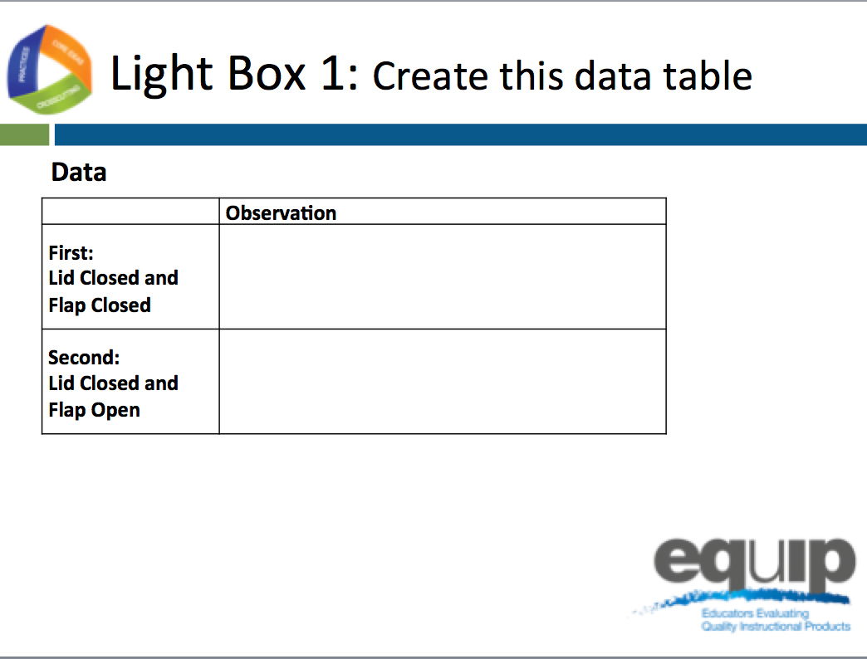
Slide 12
Talking Points
- We will work to find an answer to our lesson-level question: “What do you need in order to see an object?” by making observations with a light box.
- Before we begin, please create this data table on your paper. [Note to facilitator: Give participants 1 minute to create the table.].
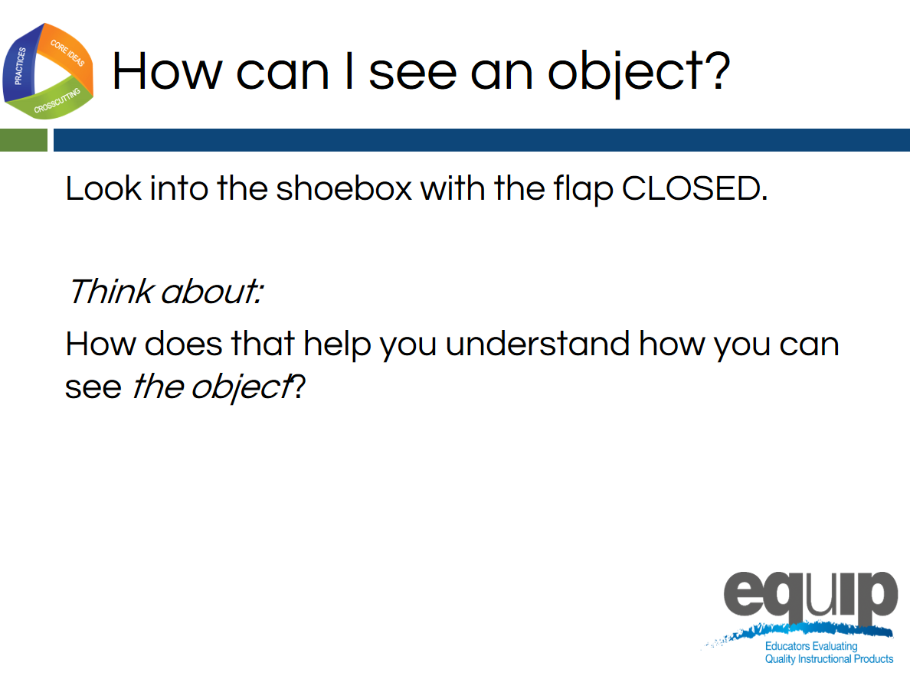
Slide 13
Facilitator Note
- Please distribute the light boxes at this time.
- Be sure that each light box has an upright object placed in one end of the box according to the directions provided, and that the divider is not placed in the box.
- The participants should keep the lid on the shoebox at all times and for slide 13, and keep the side flap closed so no light enters the box.
- You will need 1 light box for every 4–8 participants.
Talking Points
- I have provided you with a light box.
- It is important that you keep the lid on the box at all times.
- Right now, be sure to keep the side flap closed.
- One at a time, please look through the hole at the end of the box and record in words what you notice or observe.
- Record your observations in your data table in the row labeled “Lid closed flap closed”.
- After you make your observations, please pass the light box to the next person at your table without talking.
- You may place the box in different orientations or positions as you explore and make observations as long as the lid stays on and the flap stays closed.
- Note to Facilitator: After each person in the group has had an opportunity to observe the light box with the flap closed, click forward on the animation to step into the next statement on the slide. Ask the participants to think about (not record) how what they just observed helps them understand how we see.
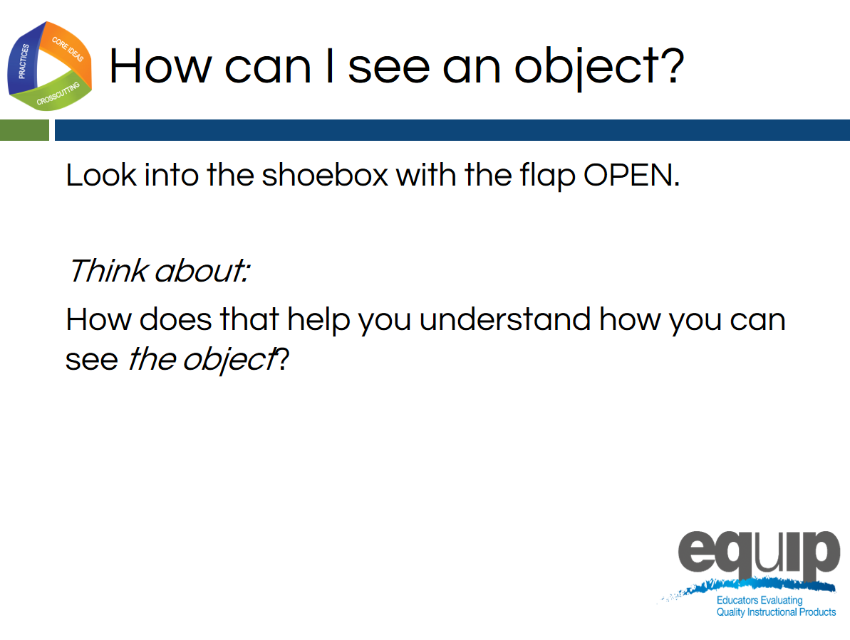
Slide 14
Talking Points
- Now I am asking you to open the side flap on your box.
- One at a time, please look through the hole at the end of the box and record in words what you notice or observe.
- Record your observations in your data table in the row labeled “Lid closed flap open”.
- After you make your observations, please pass the light box to the next person at your table without talking.
- You may place the box in different orientations or positions as you explore and make observations as long as the lid stays on and the flap stays open.
- Note to Facilitator: After each person in the group has had an opportunity to observe the light box with the flap open, click forward on the animation to step into the next statement on the slide. Ask the participants to think about (not record) how what they just observed helps them understand how we see.
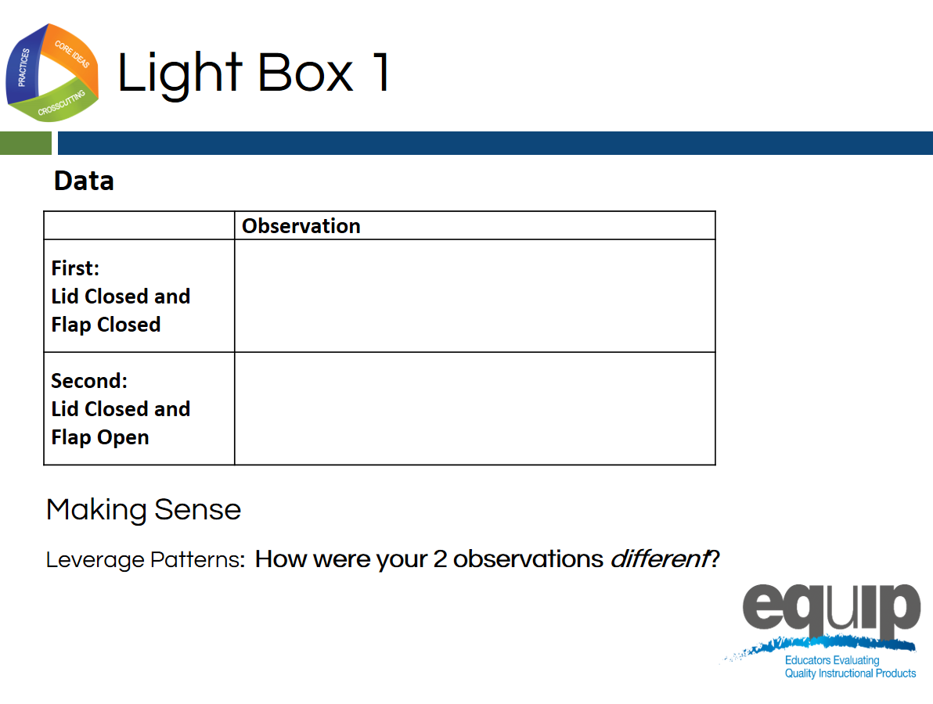
Slide 15
Talking Points
- Now that you have recorded observations with the flap closed and the flap open, let's make sense of our observations before moving on.
- Let’s use the concept of patterns to record how these 2 observations are different.

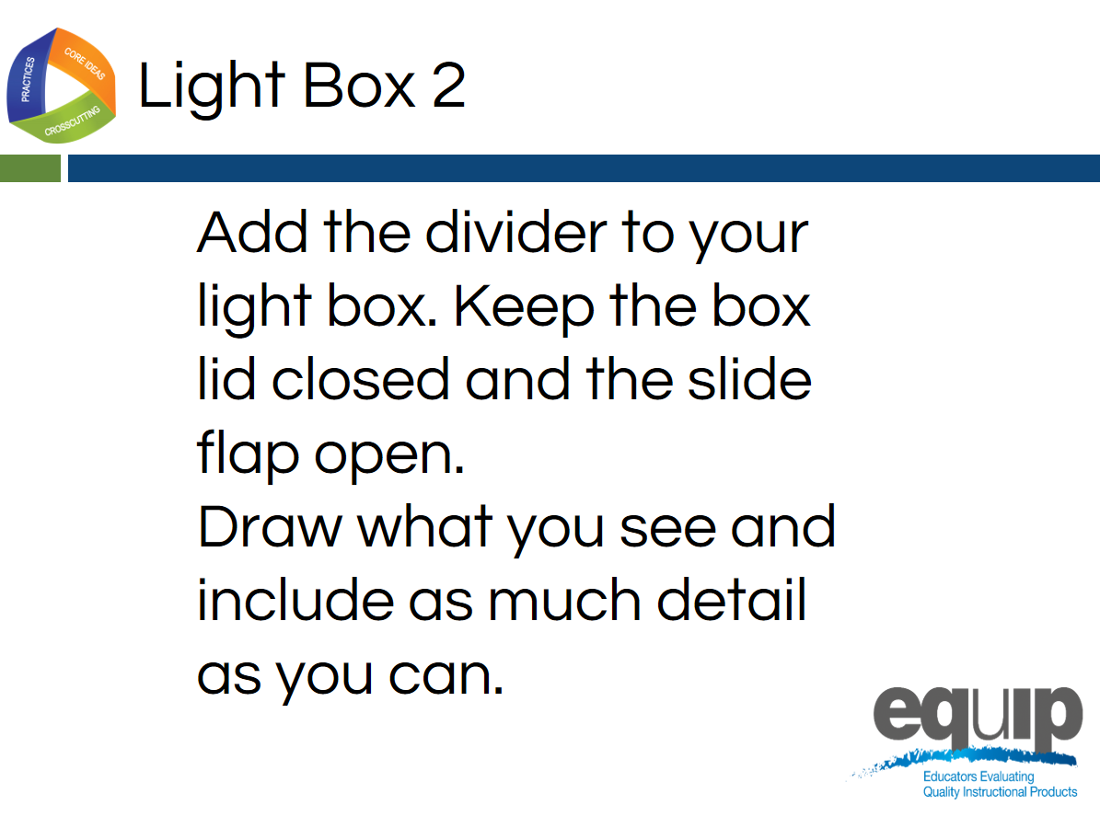
Slide 16
Facilitator Notes
- Before participants can make the next set of observations, the dividers must be added to the light boxes.
Talking Points
- Now let’s add the dividers to the light boxes.
- Remove the lid and add the divider. On the slides of the box, there should be guide lines made with a hot glue gun. Slide the divider in between these guides and put the lid back on the box.
- With the flap open, the lid closed, and the divider in place, make your observations.
- This time, draw what you see on your paper instead of describing it in words. [Note to facilitator: Give participants time to examine the light box with the divider in and the flap open.]

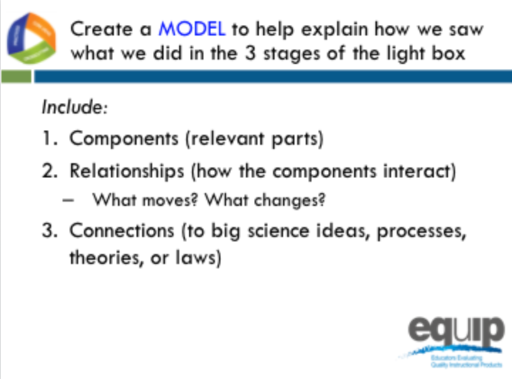
Slide 17

Facilitator Notes
- For this part of the lesson, each participant will need a piece of 11 by 18-inch paper.
- Participants will most likely struggle with knowing what to draw.
- Be patient and wait at least 2 minutes before giving them guidance.

Talking Points
- It is time to make sense of our observations and create a model to help explain how we see an object.
- We are creating a model that represents the process of vision using the observations and thinking we did during the 3 stages of the light box.
- These three stages were: flap closed, flap open, and divider in with flap open.
- Using the piece of 11 by 18 inch drawing paper provided, please represent your model of vision, including the criteria on the screen.
- Your model should contain the components or relevant parts required for us to see.
- Your model should include the relationships between these relevant parts. When thinking about relationships, you may want to consider the questions: What moves? What changes?
- Finally, think about the how your representation could connect to and use science ideas. [Facilitator Note: Participants may really struggle here and want more guidance. Please wait at least 2 minutes before moving to the next slide, which provides some support for sense-making.]
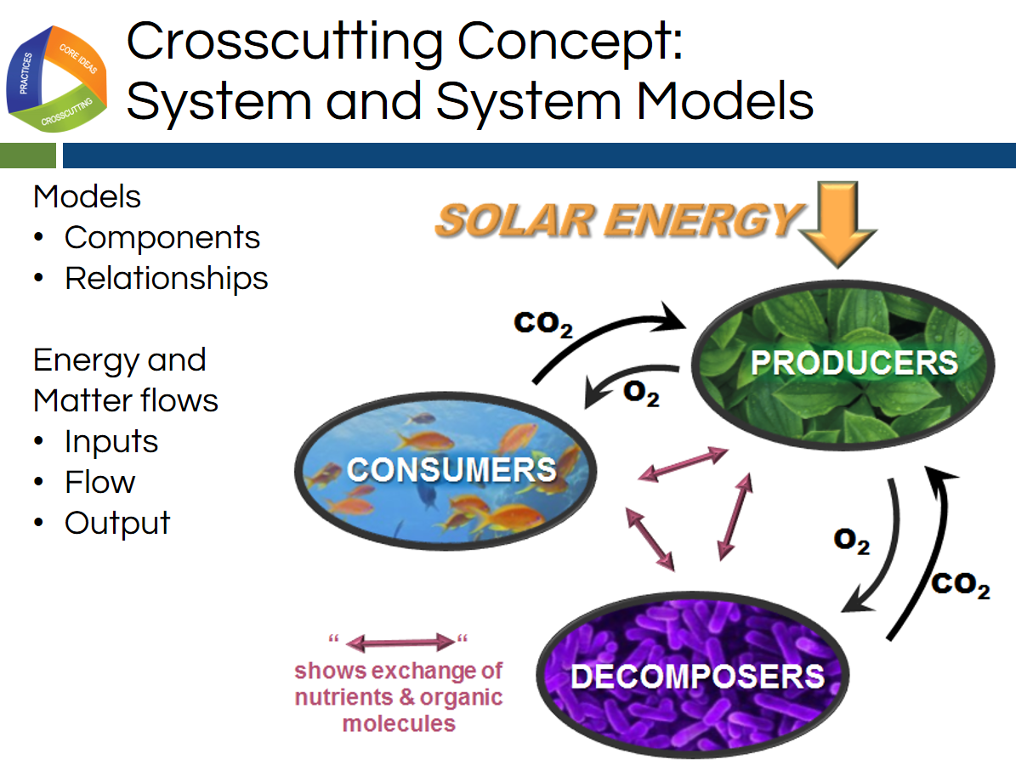
Slide 18

Facilitator Notes
- This slide provides support for drawing the model of the process of vision using the observations from the light box.
- This slide also serves to make the crosscutting concept of system and system models more explicit for the learner.
Talking Points
- We have used this light box lesson with hundreds of students and hundreds of adults. One thing is the same all around: most of the group struggles with this task.
- This struggle probably is a result of lack of experience with this kind of thinking, and in using scientific models to make sense of phenomena.
- Let’s first articulate our purpose for using the model. We are using the model to make our thinking visible to ourselves. By doing this, we are deepening our understanding of both the crosscutting concept of a system and the disciplinary core ideas we need to use to explain vision.
- Let’s consider this model on the screen. A model is a representation of a system that makes its central features visible and explicit.
- Let's consider the commentary to the side of the model on the screen. [Facilitator note: use a laser pointer to point this out on the slide.] First, it is reminding us that NGSS models have components or relevant parts and that the model should make visible the relationships between the components.
- To help learners with thinking about a system and a model, let's consider the commentary about energy and matter flows as we respond to the following questions.
  - How did this model’s creator show the relationships between components of this system? (arrows)
  - What similarities and differences (patterns) do you notice about the arrows? (some are purple, some are black, one is orange, some are labeled, they are different sizes, some arrows are double sided and some single, etc.…)
  - What is the model creator trying to communicate to us about this system based on this representation? [Note to facilitator: Discuss the reasons for this intentionality, emphasizing that every decision, every line, color, and label is intentionally and deliberately communicating the thinking of the model creator as it relates to the phenomenon.]
  - What are the components of this model? How does the creator show us these are the parts that are relevant and important to understand? How do the components interact in this system? (labels)
- Now that we have used a model in another context to understand how we might think about representing a system and making our thinking visible to ourselves and others, let’s return to our task.
Slide 19
- Let's remember, we are creating a model that represents the process of vision using the observations and thinking we did at the 3 stages of the light box.
- These three stages were: flap closed, flap open, divider in and flap open.
- Use your observations and our discussion about components and relationships to create your model of vision. [Facilitator note: give participants another 2–3 minutes of struggle. Most participants will begin to draw something, but a few may still be hesitant.]
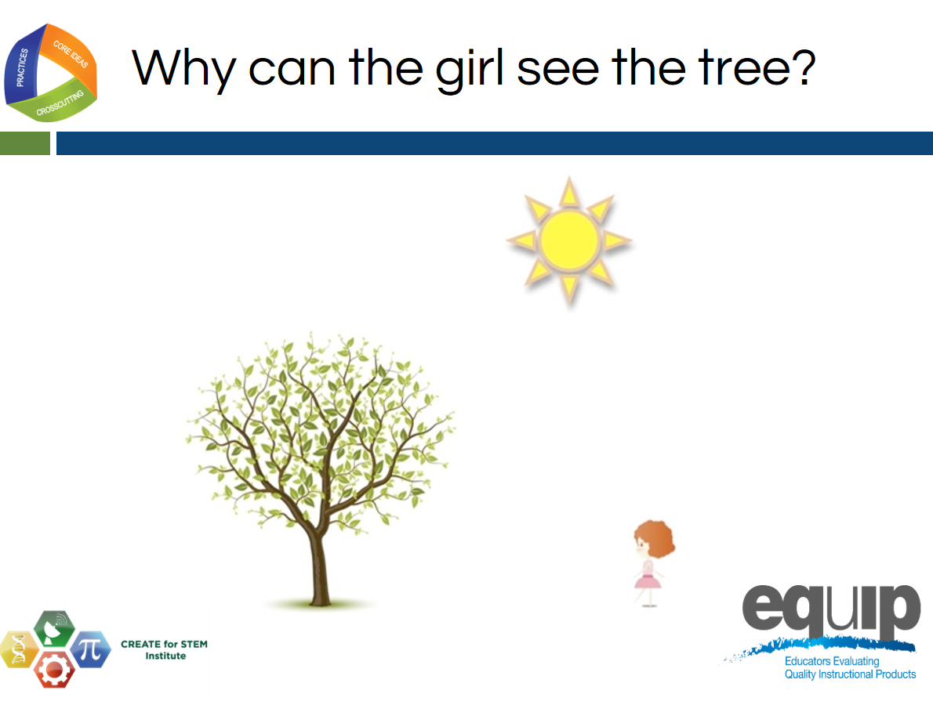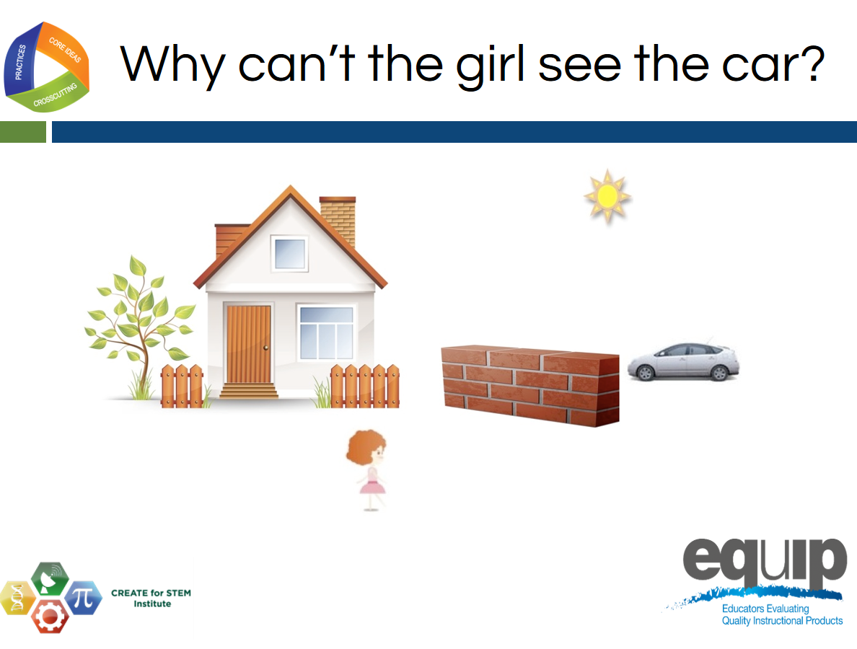
Slides 20–21
Talking Points
- Let's provide one more piece of guidance for affirmation or for support for those still struggling.
- For the next 2 slides, I want you to think about the question written at the top of each slide as well as the differences between the pictures.
- You may notice a Create for STEM Institute logo on the corner of the slide. We want to thank them for permission to use these images.
- [Facilitator Note: Show slide 20 and 21, reading the question at the top of the slide for each. Toggle back and forth between them a few times.]
Slide 22
Talking Points
- Let's take a few more minutes to complete our models.
- We will be bringing these models into a group discussion with our table. [Note to facilitator: give participants a few more minutes to finish the models. Move on to the next part when most have finished working.]
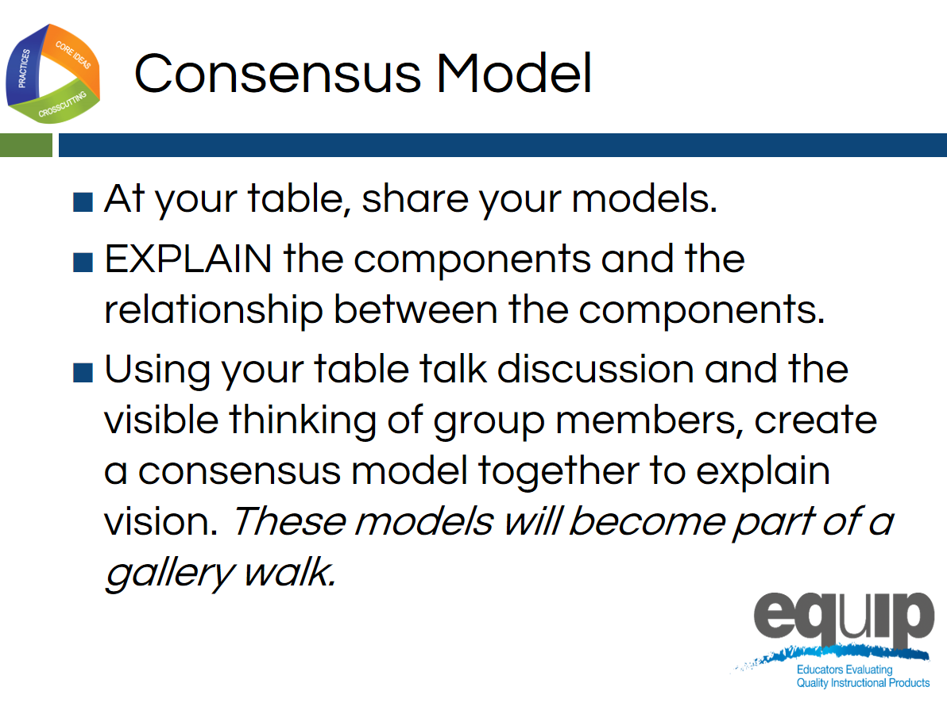
Slide 23
Facilitator Guide
- Each group will need a piece of chart paper (the paper with adhesive already present works best).
- This is a good time for groups to take a break after displaying their consensus model in a gallery walk and before the debrief of the immersion.
Talking Points
- Let's share our thinking with our table with the purpose of offering our thinking and ideas to our community and accepting what the community offers us.
- Our goal is to create a consensus model representing vision.
- Please follow this protocol. Each person should take a minute or two to share their model by holding it up to the group and talking about how he or she chose to represent the components and relationships within the system.
- After each person shares, the group should use the chart paper to create one consensus model that will be displayed in a gallery walk.
- Once you hang up your group’s chart paper consensus model, your group may take a break.
- Please return for discussion at ____________.
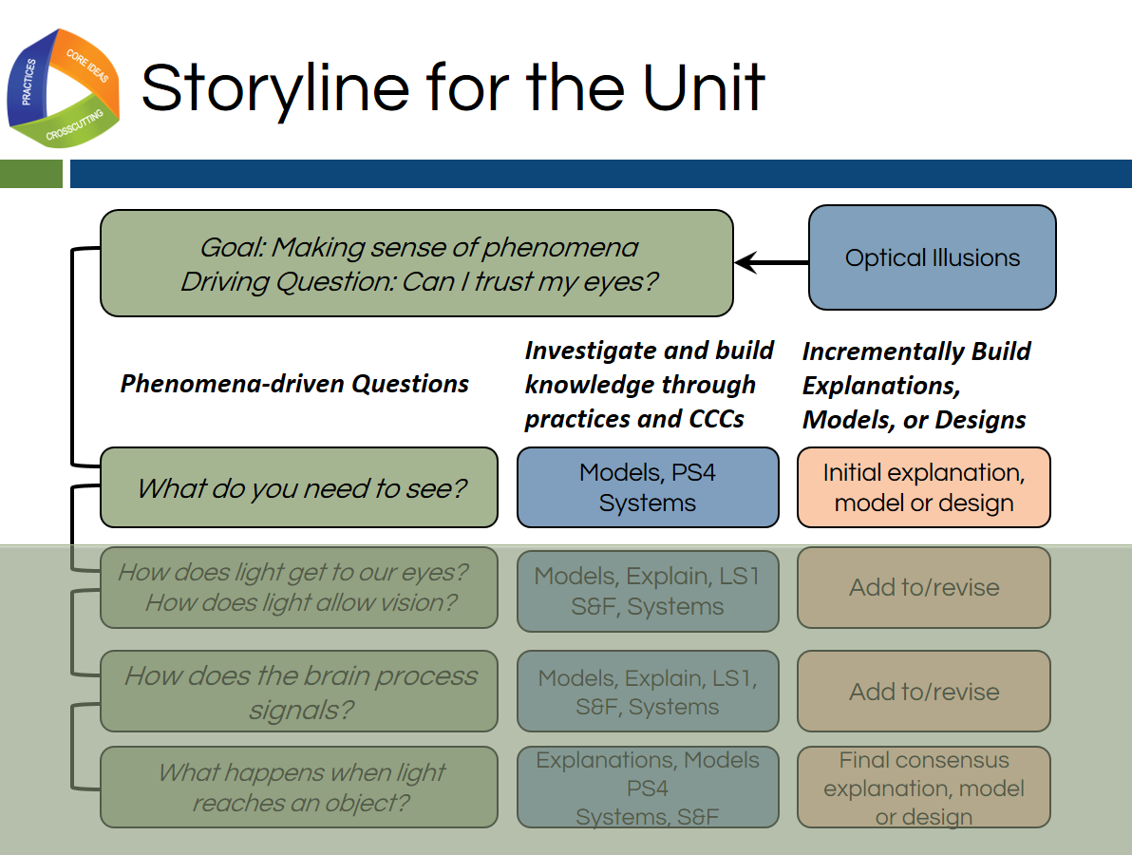
Slide 24
Talking Points
- Let's think about where we started today. Our immersion experience gives us an example of how working to explain phenomena is the central reason why students engage in 3-dimensional learning.
- Since we could not immediately explain the phenomena of optical illusions, we had many questions about them that are still displayed on our Driving Question Board.
- These questions drive the lessons, learning, and monitoring throughout the unit.
- We can see that idea represented here in this graphic organizer.
- Each row of the organizer is a different lesson in the unit.
- Today, we experienced lesson one using the light box.
- As learners, we created an artifact of that learning in our individual models as well as our group consensus models.
!
- Sense-making and making thinking visible through the models enabled us to further our understanding of both the core ideas and concepts as well as the practice of modeling itself.
- Let’s evaluate some examples of the models created by 9th grade students in order to deepen our understanding of the 3 dimensions and how students use the dimensions together to build usable knowledge.
Facilitator Notes
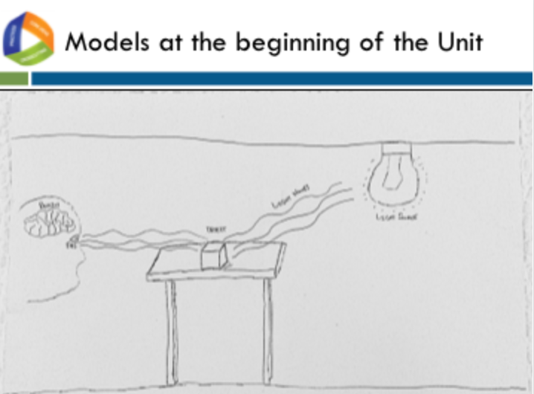
Each group will need a set of models (A–D) for the evaluation of student understanding section of this module starting with slide 25. The models are included as Immersion and Introduction Handouts A, B, C, and D.

Slide 25
Talking Points
- You will be provided with a set of models.
- The first model marked “Beginning” is the consensus model developed by a group suing the same lesson you experienced today.
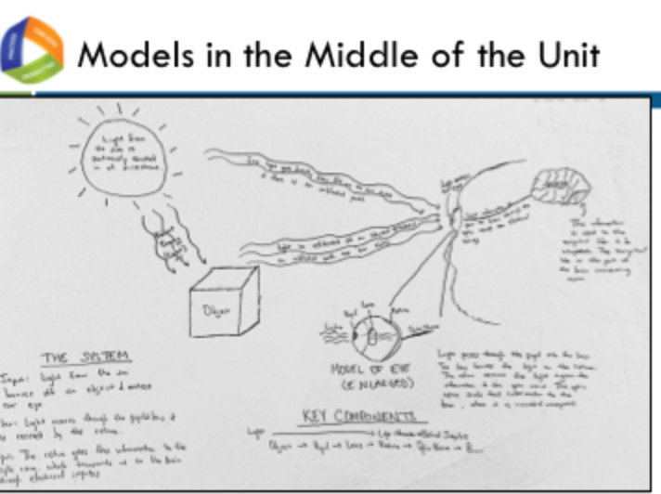
Slide 26
Talking Points
- The second model (marked mid-unit), is an individual model made after 3 lessons where students were working to build an understanding of optical illusions so that they could explain why their perception was different from reality.
- The sets were formed by combining the individual model with the consensus model of which the individual student was a member. For example, you could have Joey’s model that is a mid-unit model and the consensus model for which Joey was a member at the beginning of the unit.
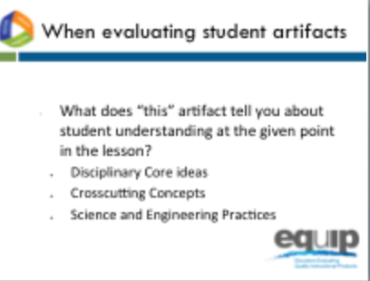
- The model sets are identified as A through D. Each table has all 4 sets.

Slide 27
Talking Points
- When evaluating each model, we need to ask ourselves “What does this artifact tell us about student understanding at a given point in the lesson?”
- We have 2 data points for each student: a beginning consensus understanding and an individual mid-unit understanding.
- We will look to the appendices of the NGSS for guidance about how to determine observable evidence of 3-dimensional learning.
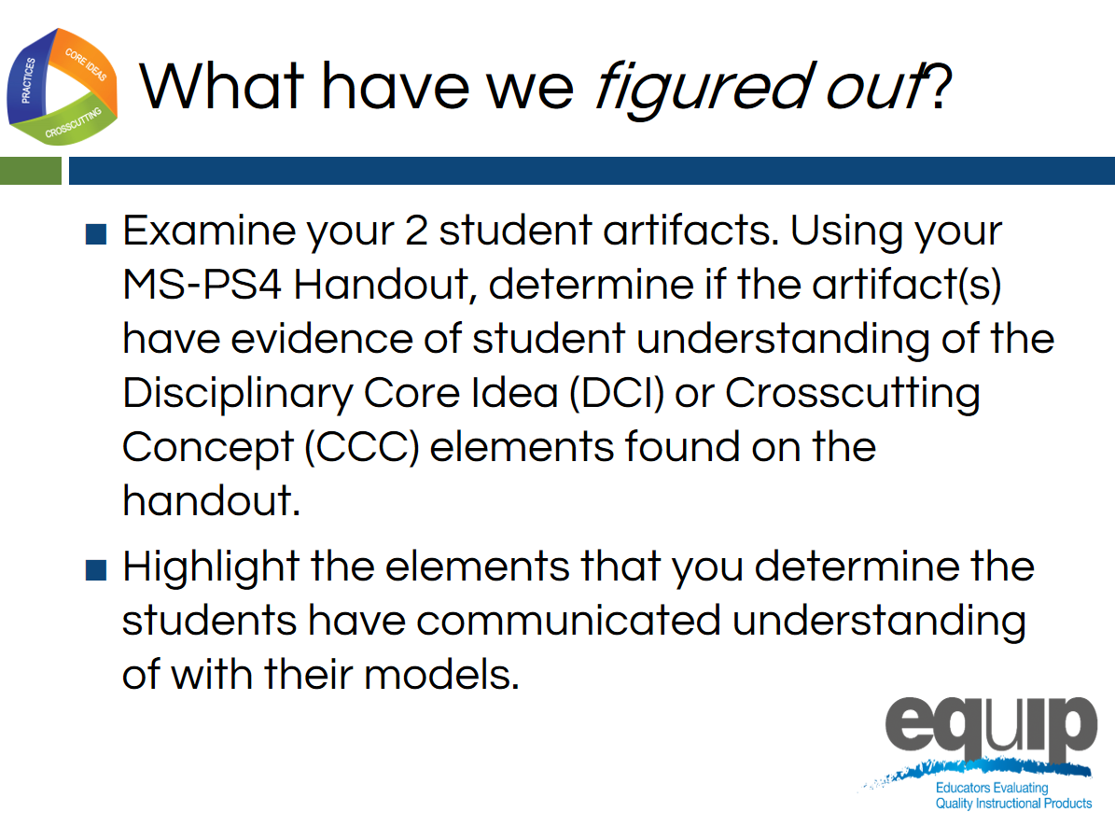
Slide 28
Talking Points
- Please find a partner and as a pair, examine your 2 student artifacts. Using your Middle School disciplinary core idea and crosscutting concept handout (MS-PS4-2 Handout), determine if your student artifacts can count as evidence of student understanding of any of the bullets in the handout.
- Each one of these bullets is called an element in the NGSS.
!
- The NGSS identifies the capabilities students should demonstrate when using each dimension (science and engineering practices, crosscutting concepts, and disciplinary core ideas) by the end of each grade band. These capabilities are called elements, and are represented by the bullets in your handout.
- Your job is to work with your partner and highlight the elements that you determine there is some evidence of in the student work.
- Facilitator Note: Give participants about 10 minutes to complete this task.

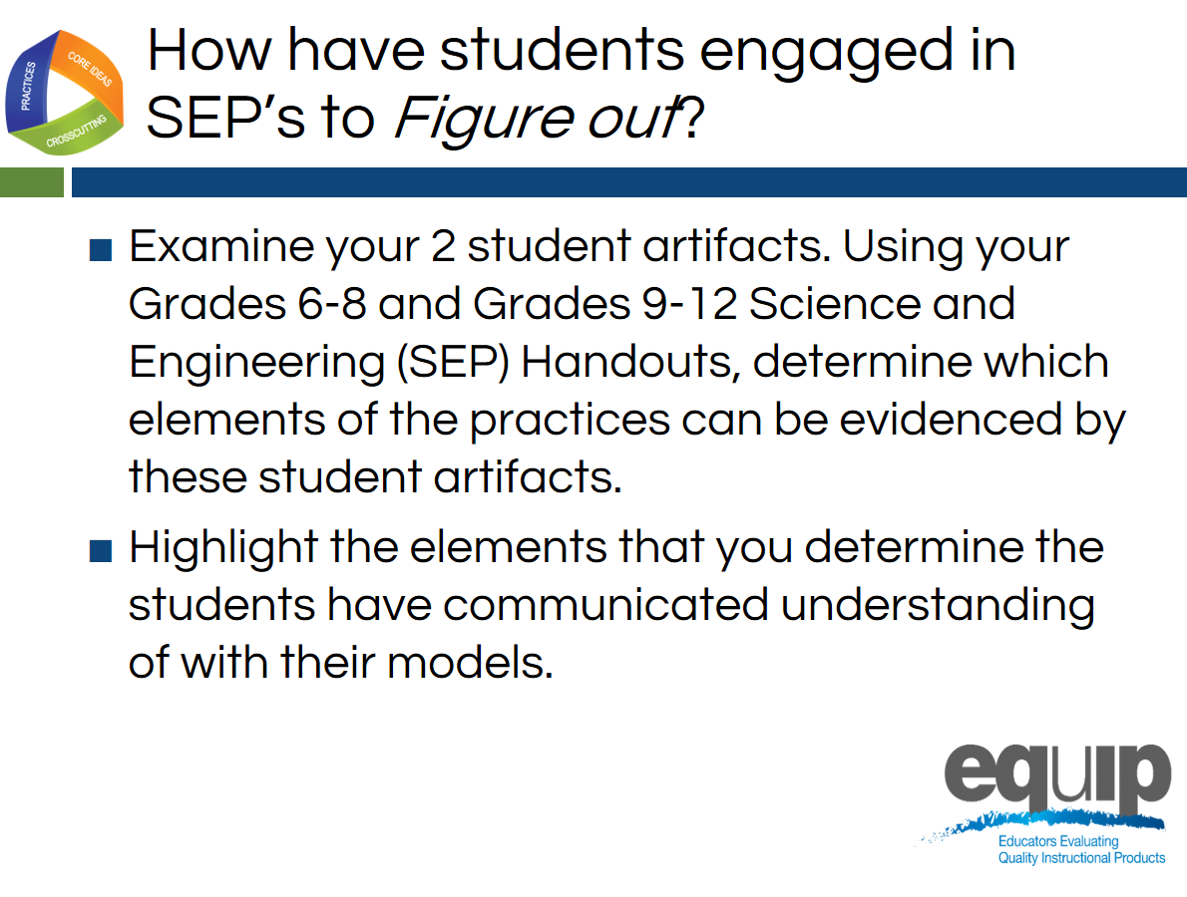
Slide 29
Talking Points
- Let’s take a look at the dimension of science and engineering practices.
- This unit was taught in a 9th grade Integrated Science class.
- Through pre-assessment, the conclusion was made that the students did not have the foundational knowledge of the disciplinary core ideas and concepts from middle school necessary to explain the phenomenon of optical illusions. Because of this, the teacher made the decision to use elements of both middle school and high school DCIs and CCCs in this unit.
- Most of the students in this class were new to the NGSS. They did not have prior experience with using and developing scientific models. Because of this, the teacher made decisions to provide scaffolding of this science and engineering practice within the lesson,
- Your task is to determine if the student used elements from the science and engineering practice of developing and using models at the middle school grade band, at the high school grade band, or both.
- Please have a discussion with your partner and evaluate your set of artifacts to determine which elements of the science and engineering practice of modeling you see evidence of in the student work.
- In addition, please discuss any other evidence of other science and engineering practices at the element level that you feel you experienced in the lesson today.
- Facilitator Note: Give participants an additional 5 minutes to conclude their discussion.

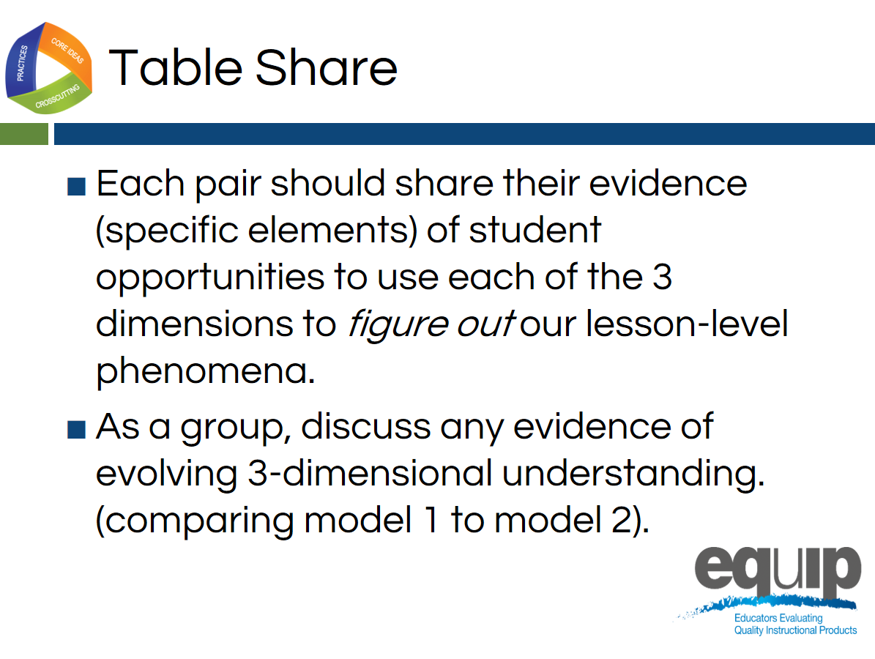
Slide 30
Talking Points
- Now let’s have a brief table level discussion. Since there are 4 sets of student work available at each table, a whole group discussion will enable the group to consider the evidence of student learning at both the individual and the whole class level with a table conversation.
- Each pair should take about a minute or so to share their takeaways from this experience and any conclusions they discussed about the set of student artifacts they evaluated. [Note to facilitators: Give participants 5–7 minutes to have a table discussion.]
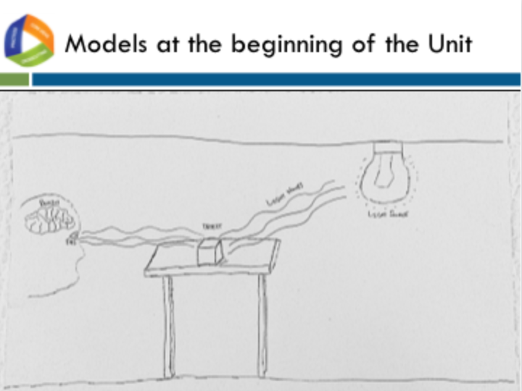
Slide 31
Talking Points
- Let’s discuss our immersion experience into 3-dimensional learning as well as the evaluation of student products.
- The focus of this discussion will be on the innovation of 3D learning as well as the student products as a means for students to make their thinking visible to themselves and others and to receive feedback to move further in their learning.
- The effectiveness of our NGSS-design planning and implementation of that plan is directly tied to student evidence of learning.
- What did that evidence tell us today? How can we use the guidance provided in the NGSS to evaluate these student products and improve our NGSS design?
- When we observe the initial consensus model on the screen, we see some misconceptions that were common in these models.
- For example, are those waves coming out of the eye or going in? What are the waving lines? Are all of the components of vision represented?
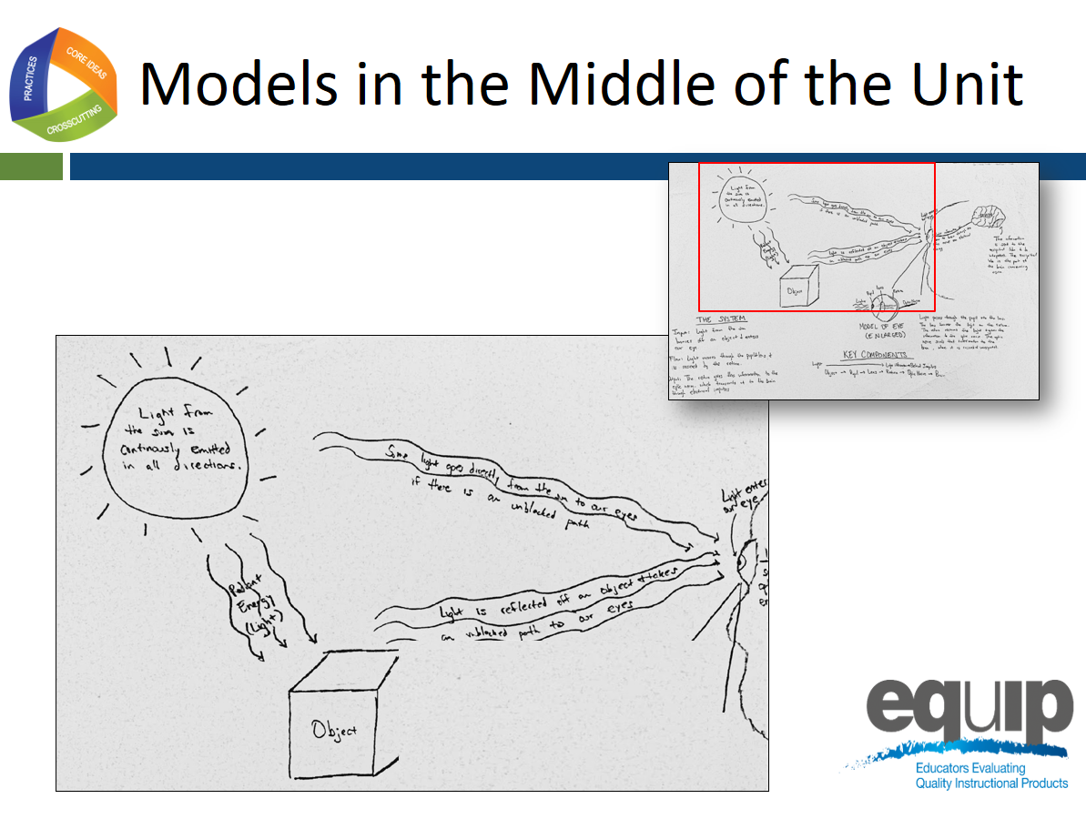
Slide 32

Talking Points
- Let’s look at the mid-unit models.
- The area in the red box has been enlarged to take up most of slide so we can discuss the components and relationships that the students made visible in their models to communicate how vision works.
- Comparing this mid-unit model to the initial model we just observed, we notice right away that the student has more commentary and is using more language to make his or her thinking visible.
- The language and commentary demonstrates some understanding of how light or radiant energy is emitted in all directions from a light source, how light is reflected off of objects, and how light must travel in a straight path to the eye in order to see.

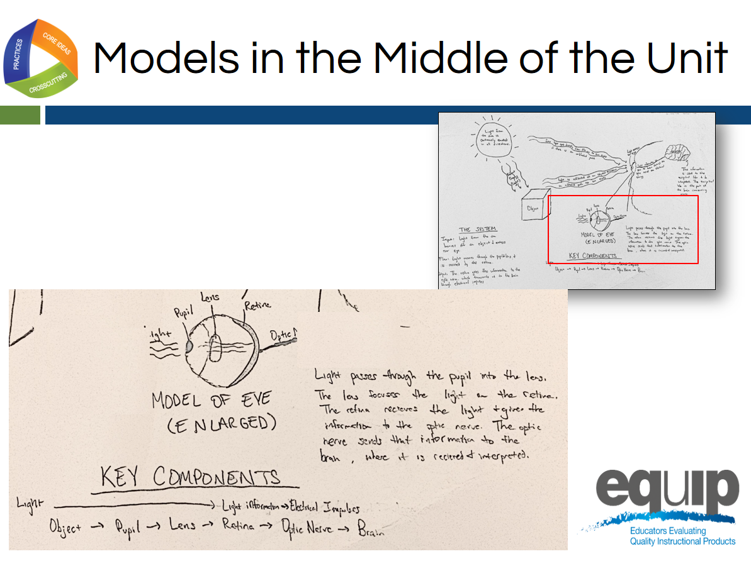
Slide 33
Talking Points
- In this model, the student felt it was essential to communicate the hierarchical organization of the eye itself, or in other words, that the eye is a part that is made up of sub-parts, and that each plays a role in vision.
- The student did not label all of the parts of the eye that might be learned through a typical study of this sensory organ. He or she only included the relevant parts, thus being very intentional. The commentary next to this labeled eye also communicates an understanding of the crosscutting concept and core idea of energy, indicating that light energy is being converted into electrical impulses by the eye on its way to the brain.

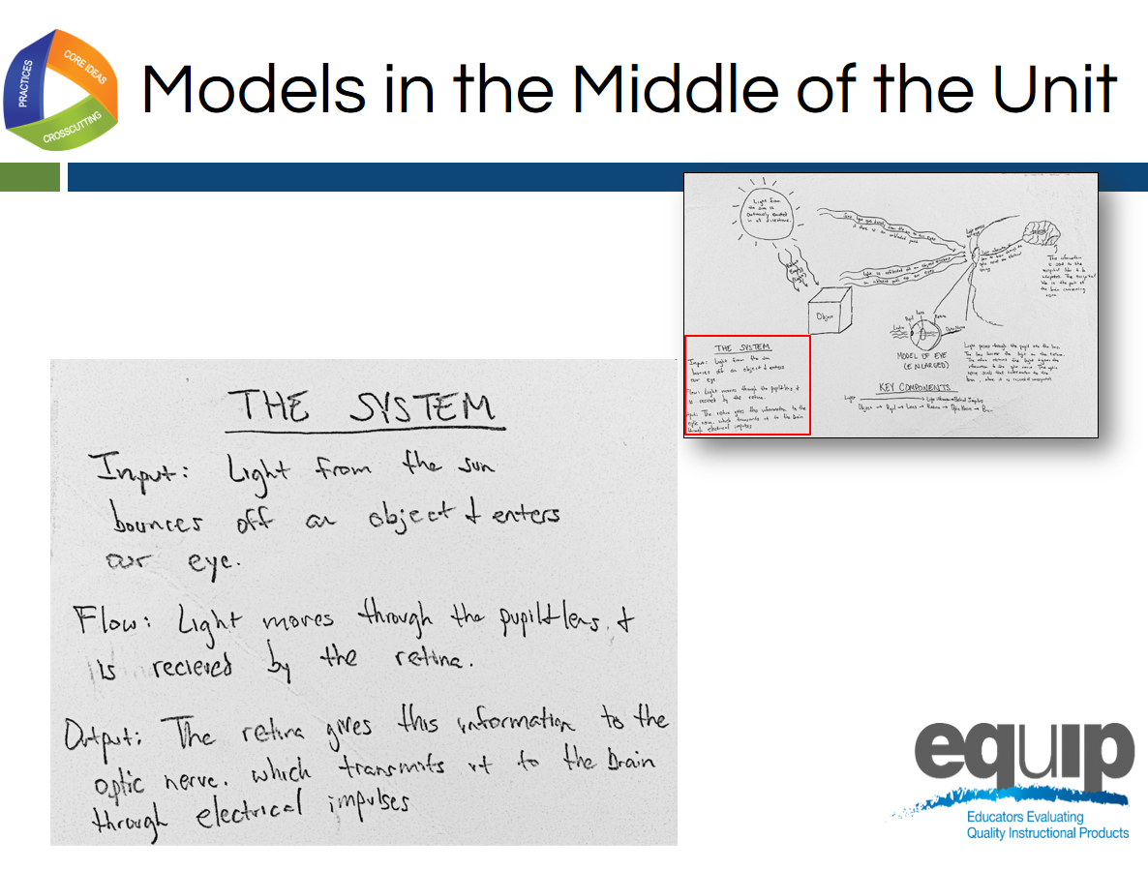
Slide 34
Talking Points
- This student model shows a similar understanding of energy concepts and core ideas as well as the crosscutting concept of system and system models as he or she identifies the relationships between the components as involving input, output, and flow of energy.
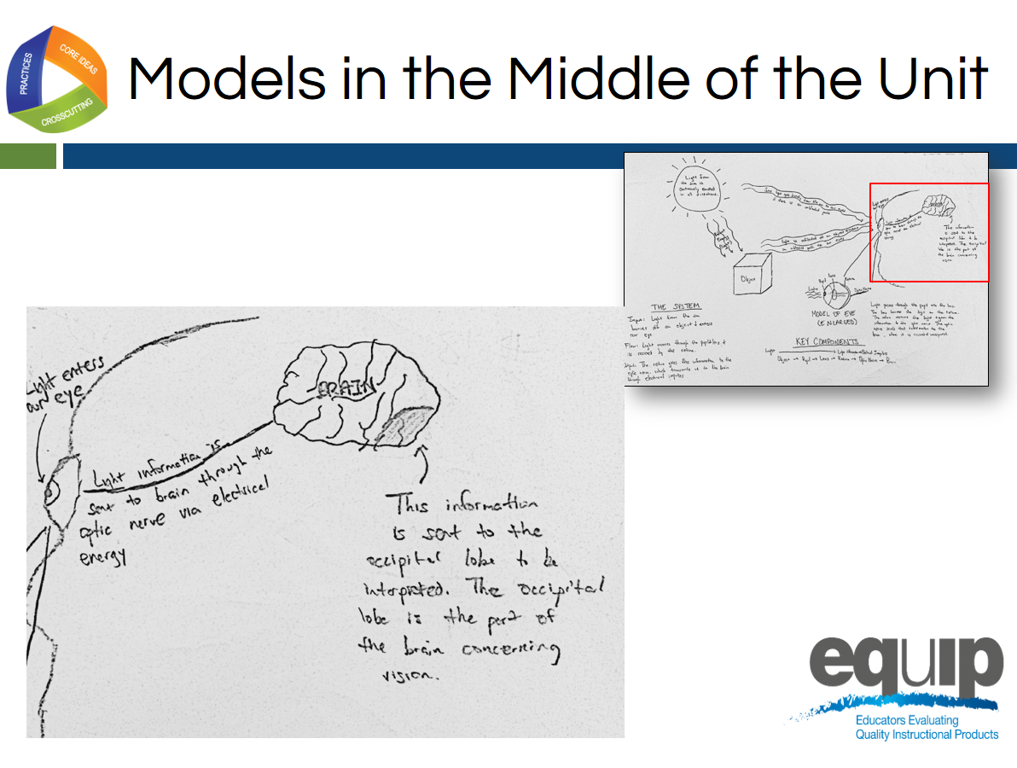
Slide 35
Talking Points
- In this final example, the student communicates a similar understanding of energy concepts and core ideas in conjunction with an understanding of hierarchy and how parts work together with specific reference to the specific part of the brain responsible for vision (the occipital lobe).

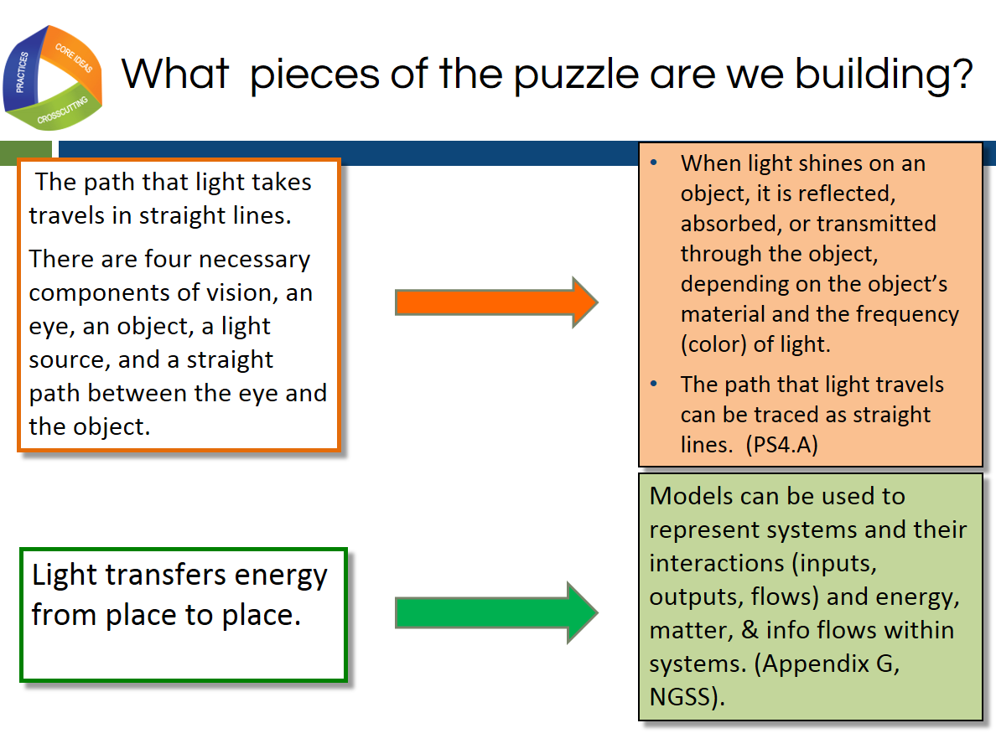
Slide 36
Talking Points
- How can we use the evidence we saw in the models to draw conclusions about student understanding and the quality of the lesson in regards to NGSS?
- Lesson 1 engages us with the anchor phenomenon of optical illusions by focusing on how we see, raises additional questions, and helps us to build some pieces of the disciplinary core ideas and crosscutting concepts.
- Each lesson should be necessary to students in constructing pieces of the puzzle to assemble later on and build an explanation of the phenomena.
!
- In order to build a scientific explanation about living things changing over time, we will need these pieces of science understanding.
  - The path that light takes travels in straight lines.
- There are 4 necessary components of vision, an eye, an object, a light source, and a straight path between the eye and the object.
- These four pieces are needed to explain optical illusions can be directly tied to the elements of disciplinary core ideas (PS4) and crosscutting concepts pictured on the screen.
!
- For a phenomenon to be instructionally productive, it must be connected to DCI’s and/or CCC’s.
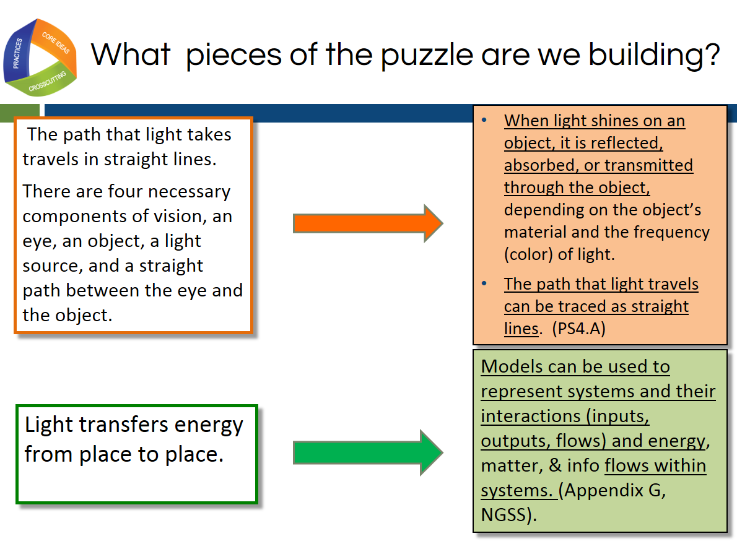
Slide 37

Talking Points
- Your table discussions may have concluded that there were some elements of the dimensions where you determined there was evidence of only a portion of that element.
- This slide shows that in this lesson, students were only using the underlined portions of these elements.
- It is important to document the evidence this way to give a clear communication of what evidence was or was not observed in the lesson or student product.
- This is acceptable in NGSS design. It is just essential that the teacher have an explicit awareness of which portion of the element has not been addressed so that it can be addressed in later lessons or units.
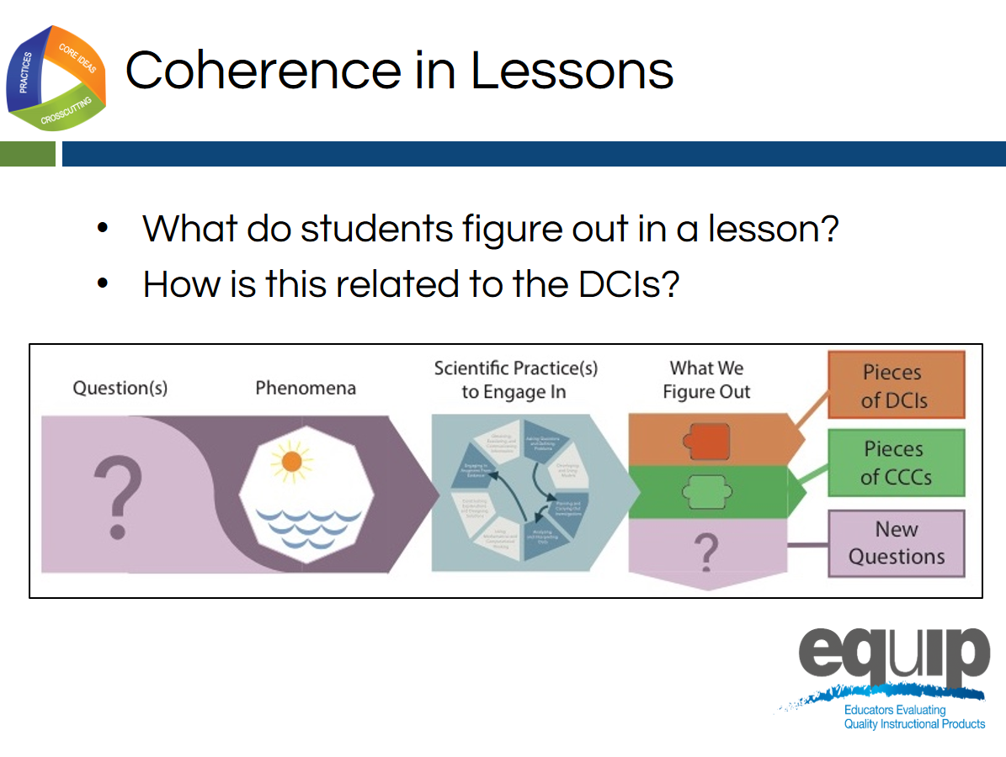
Slide 38
Talking Points
- This slide helps us think about the analogy of the elements of the DCIs and CCCs being like puzzle pieces that the student connects in their thinking so that he or she can ultimately explain the phenomenon.
- The last column of the storyline represents the pieces of the science we have figured out in each lesson that can be used to explain the world.
- A single row is a single lesson of a storyline.
- The four conditions for vision represented in the consensus model are a starting point to understand how light waves are reflected, absorbed, or transmitted through various materials.
- The students are engaged in the practice of developing and using models to build this understanding represented by the puzzle pieces or DCI and CCC elements.
- Data analysis is an important link between observations and claims. We used patterns found in observations to determine the evidence needed to explain the lesson-level phenomenon in our lesson: people can see objects.
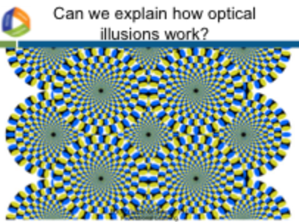
Slide 39
Talking Points
- Students have built some pieces of understanding in lesson one by investigating with the light box.
- However, can they construct an explanation about how optical illusions work? Were there other pieces of understanding evident in the student work that we did not experience in our immersion today?
- What do you think the lessons that came after the light box were focused on according to the student mid-unit models?
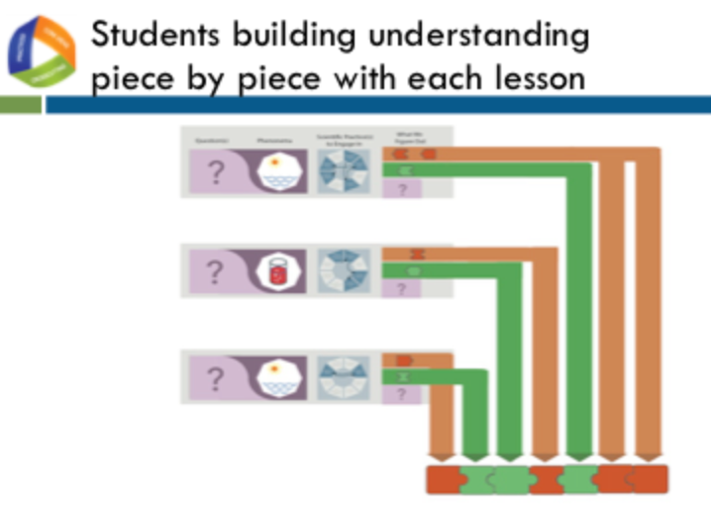
Slide 40
Talking Points
- The student models indicated that they engaged in investigations centered on the eye and brain.
- A full understanding of optical illusions involves the brain and the way it interprets signals sent from the eye from light receptors.
!
- This illustrates another important criterion about anchor phenomena that are instructionally productive. Students should be able to make sense of anchor phenomena, but not immediately or without investigating it using a sequence of science and engineering practices as indicated in this graphic organizer.
- Each lesson indicated by arrow in this graphic contributes critical pieces of information needed to explain the phenomena.
- With instruction and guidance, students should be able to figure out the phenomenon over time by connecting the pieces of the puzzle together in their own mind and communicating their understanding through a product like a model.
- The student models will evolve as their understanding evolves. Students will, with teacher guidance, confront their own misconceptions and gaps in understanding, as evidenced today in our evaluation and discussion.
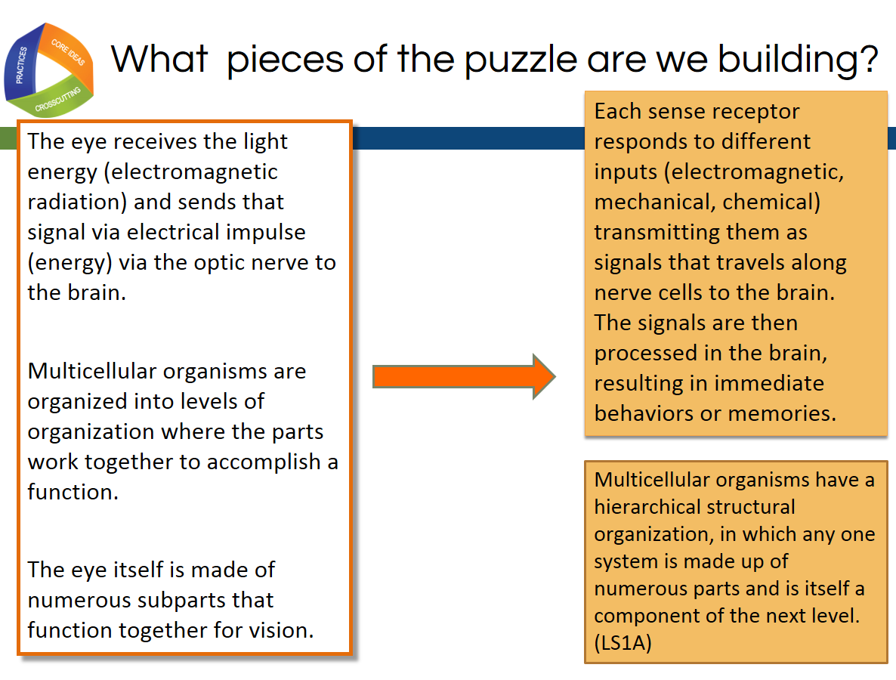
Slide 41
Talking Points
- This slide shows how, after lesson 1, the focus DCIs shifted from the physical sciences to the life sciences domain as indicated in the student products.
- This particular phenomenon required students to take an integrated approach to building the knowledge necessary to explain the phenomenon.
- This slide also emphasizes again how this lesson used DCI elements from the middle school (indicated in the top orange box) as well as high school (bottom orange box).
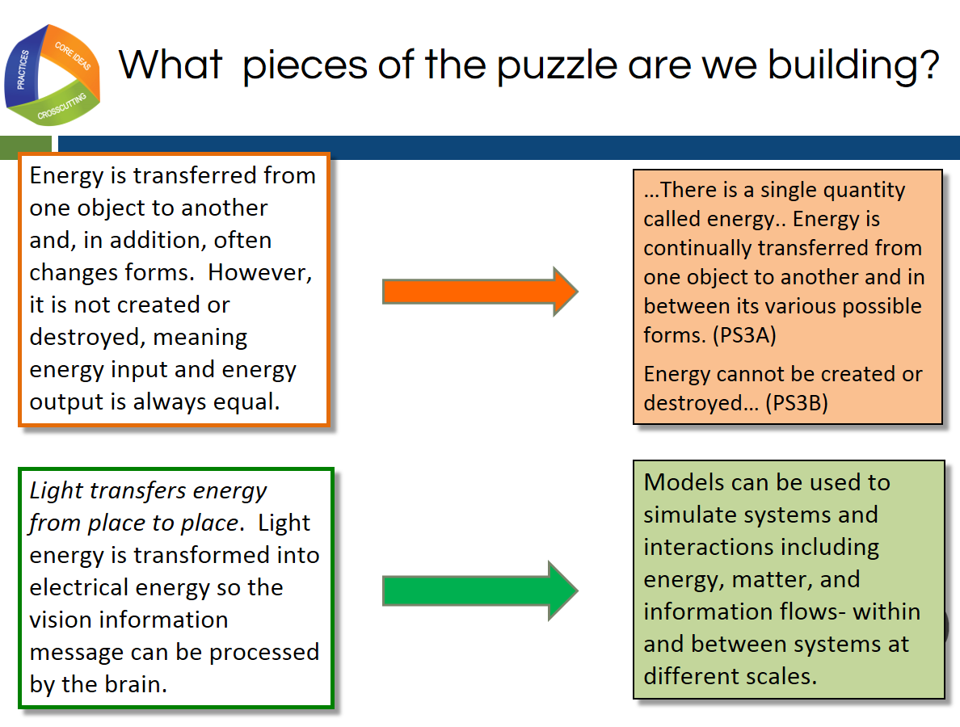
Slide 42
Talking Points
- In lesson one, we discussed how we were building middle school elements of physical sciences disciplinary core ideas (PS4).
- This slide shows that as the unit progresses, we also build understanding of high school physical sciences elements (PS3 and PS4).
- Anchor phenomena have complexity that results in the bundling of NGSS performance expectations.
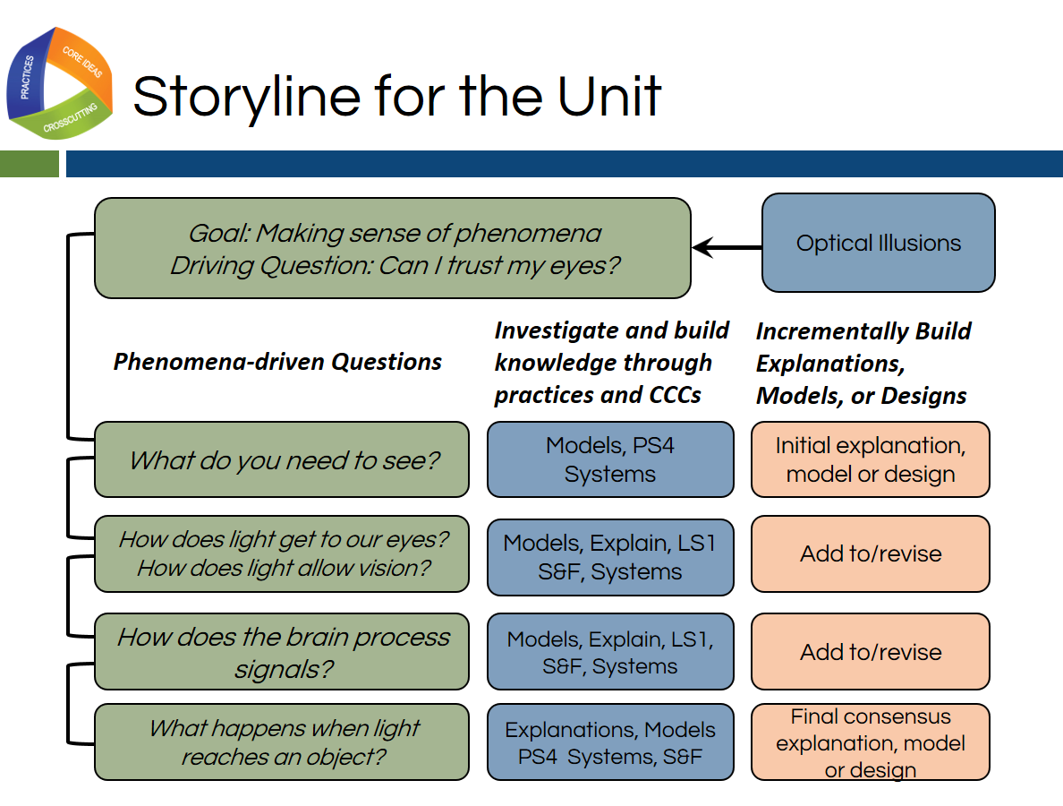
Slide 43
Talking Points
- When we look at the full unit in this graphic organizer, we can see how our initial observations of our anchor phenomenon and the questions we generated and nested under the sub questions on the driving question boards drive the teaching and learning in this classroom.
- This teacher selected a phenomenon that interested and engaged the students and built on their everyday experience.
- Although the students will not be able to fully explain the optical illusions phenomena by the end of the unit, they will understand the phenomena at a grade-appropriate level and will be equipped to ask more targeted questions in future neuroscience courses.
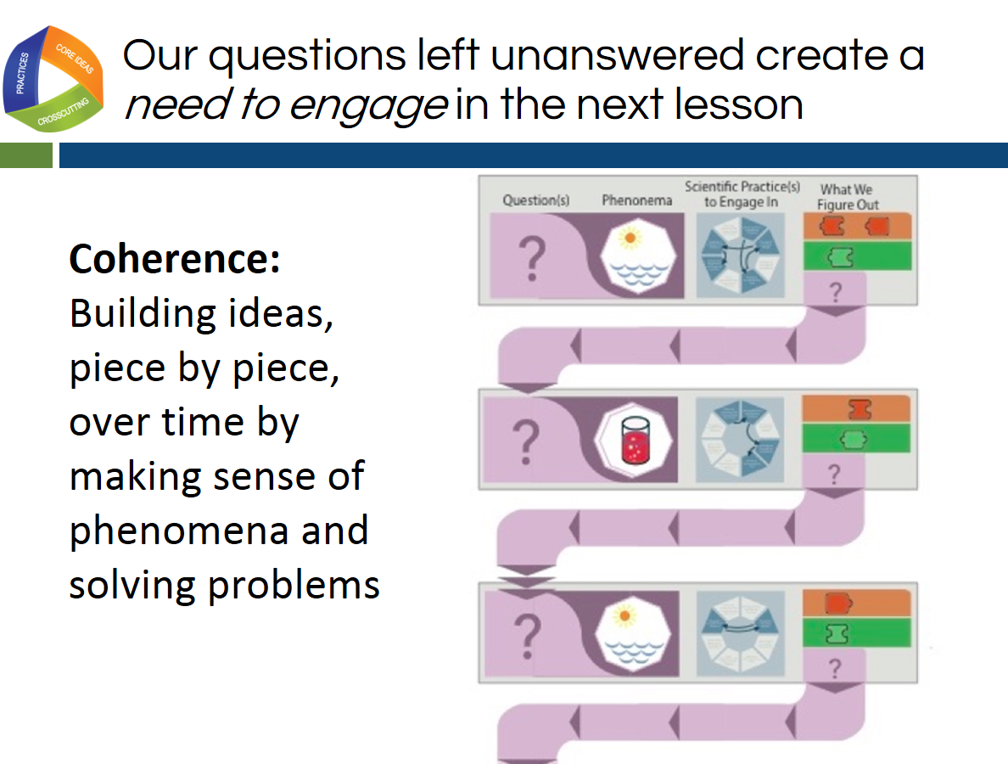
Slide 44
Talking Points
- This slide gives us another way to think about how students move between lessons indicated by the rows in this organizer.
- In each row or lesson, students have an investigative phenomenon that they are trying to make sense of in order to eventually build knowledge so they can explain the anchor phenomena.
- This lesson is driven by a question.
- By engaging in the science and engineering practices, students build knowledge of the DCIs and CCCs as indicated by the puzzle pieces.
- In addition to this new knowledge, students are left with new or unanswered questions that result in a need to engage in the next lesson.
!
- It is not just about lessons flowing together in an order, but about students hungering for that next piece of the story or piece of the explanation of phenomena.
- We can call this building ideas piece-by-piece over time “coherence”.
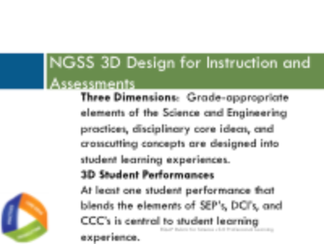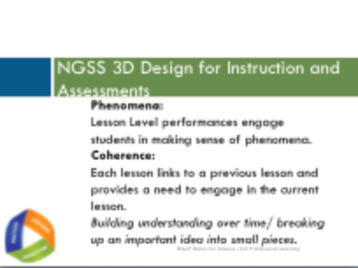
Slide 45 Slide 46
Talking Points
- Let’s close our immersion experience and debrief reminding ourselves about the elements of 3-dimensional lesson design that we experienced today.
- The biggest innovation in the NGSS is 3-dimensional learning.
- We design lessons that integrate the 3 dimensions so students can make sense of phenomena or develop solutions to problems.
!
- We can evaluate student performances and products that serve as direct observable evidence of 3D learning.
- Lesson level performances engage students in making sense of phenomena and creating these observable evidences of student learning.
- Units, however, build student ideas and understanding over time. This building understanding targeted to elements of all 3 dimensions over a unit driven by student questions about anchor phenomena is called coherence.
- Let’s transition from our immersion activity to an introduction to the EQuIP rubric as a tool for evaluating NGSS 3D Design.

Slide 47
Talking Points
- The implementation of the NGSS requires instructional materials that align with the shifts and increased rigor of these new standards.
- While there may be a shortage of high-quality materials thoughtfully designed for the NGSS, educators have found themselves inundated with materials claiming to be NGSS-aligned.
- As noted by Joe Krajcik, professor of science education and director of the CREATE for STEM Institute at Michigan State University, “Many developers and publishers of science materials claim that their materials align with the NGSS and feature the NGSS performance expectations. And while some publishers will make legitimate attempts at modifying their materials to do an appropriate alignment, you will need to have the appropriate tool to judge which materials better represent the intent of the NGSS and which materials just really don’t match up” (http:// nstacommunities.org/blog/2014/04/25/equip/).
!
- Case in point, Bill Schmidt of Michigan State University reviewed roughly 700 mathematics textbooks used by 60% of U.S. public school children and found that many claiming Common Core alignment were “page by page, paragraph by paragraph” the same as older versions, resulting in textbooks that reflect the standards minimally, if at all. In some of the texts, less than a quarter of the content matched the standards of the grade in question. As Schmidt notes, “It’s hard to imagine how this could support instruction” (http://www.hewlett.org/blog/posts/curriculum-core).
- As this research indicates, too often, new labels may be placed on old materials without any substantive changes having been made to those materials.
- To ensure the quality of the teaching and learning materials used with the NGSS, we need a basis for examining and evaluating these materials.
- The EQuIP Rubric provides this basis and allows educators to select the best and most appropriate instructional materials—whether commercially-published or educator-generated—for effective teaching and learning.
- The development of the EQuIP Rubric for NGSS was managed by Achieve in partnership with the NSTA. It was written and reviewed by groups of educators in several states, English Language Arts (ELA)/literacy and math EQuIP developers, standards writers, and other science and engineering education experts.
- Feedback from the thousands of educators across the United States using the EQuIP rubric version 2.0 over the last two years to evaluate lessons combined with feedback from those leading professional learning using the rubric led to the changes in the current version, the EQuIP rubric version 3.0.
- We want science educators to be critical evaluators and/or developers of quality science materials. Consequently, we want to train as many science educators as feasible to use the EQuIP Rubric effectively.
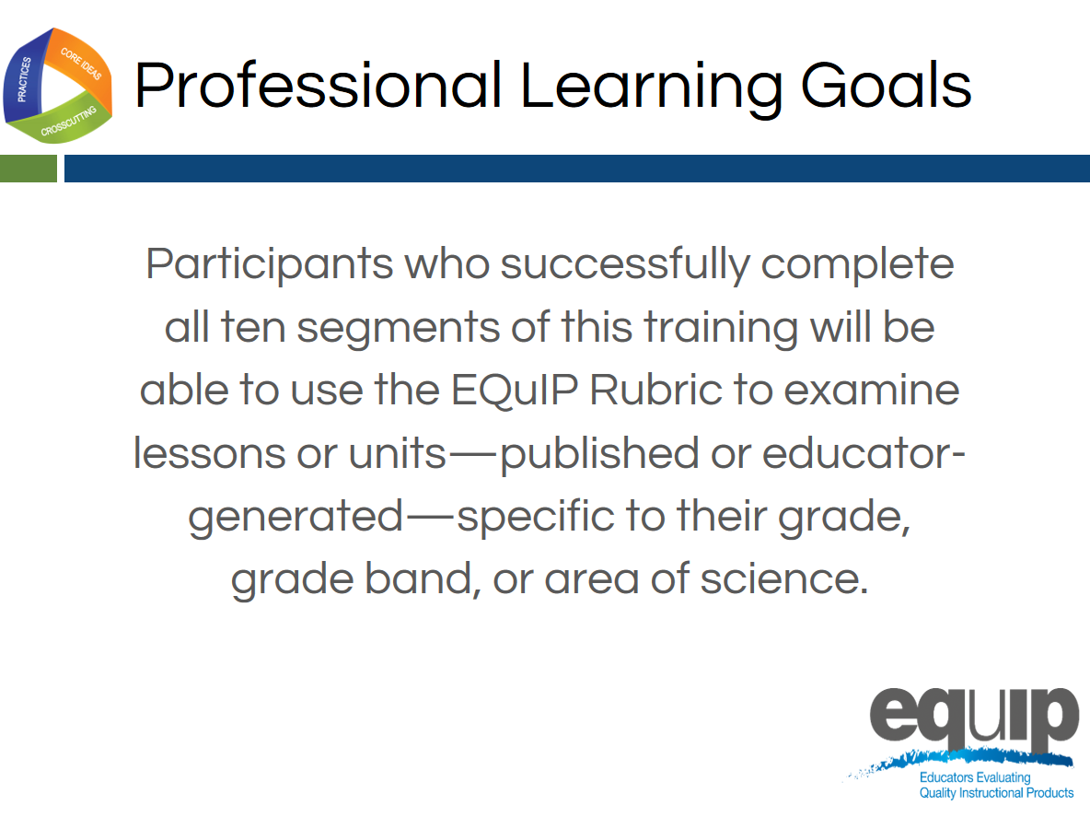
Slide 48
Talking Points
- Now that we have experienced 3-dimensional learning in service to phenomena, let’s consider our next professional learning goal that will involve us working with a common lesson.
- For the remainder of the training, all participants should work together with a single common lesson or unit. However, the knowledge, skills, and understandings acquired are transferable to materials in all disciplines and grade bands of science.
- Throughout this training, when we refer to the different disciplines of science, we mean physical sciences; life sciences; Earth and space sciences; and engineering, technology, and applications of science.
- Finally, the training provides participants with a process for reviewing materials and engaging in meaningful discussions about materials with their peers. These are rich discussions that require reviewers to use evidence and reasoning.
Slide 49
Talking Points
- The NGSS are not just new; they are innovative in how we expect students to demonstrate their understanding of science.
- Before we continue, let’s, take a couple of minutes to list what you think are the biggest innovations in the NGSS. [Note to facilitator: Allow two or three minutes for participants to document their thinking. If your participants participated in the introduction and immersion activity, you can ask them to reflect back on their experiences so far in the training when they were participating in the immersion experience and debrief.)

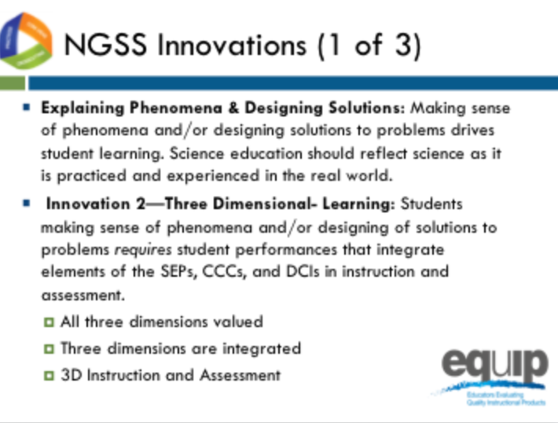
Slide 50
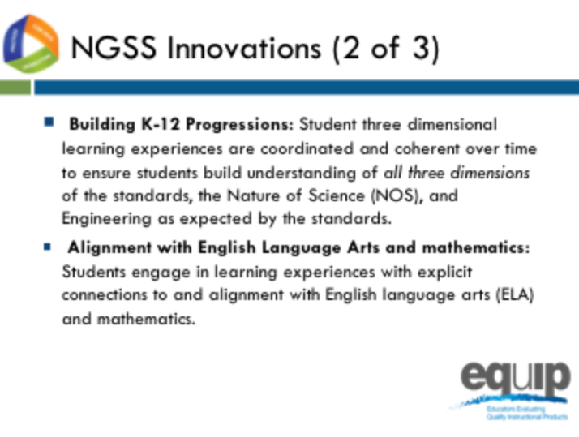
Slide 51
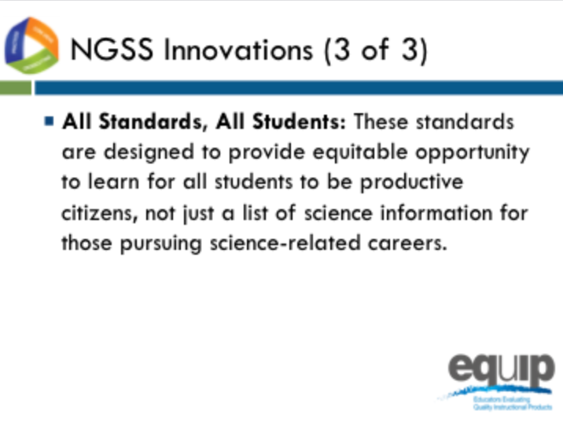
Slide 52

Talking Points slides 50–52
- Some of the major innovations of the NGSS compared to past standards are displayed on slides 50–52. Please compare your list with the list displayed on these slides.
- Note to facilitator: briefly discuss each innovation as you progress through slides 50–52.
- As we work together today, we will not only learn about a tool and evaluation process so we can select and design better units and lessons, but we will also identify these innovations that shift instruction that may be needed to better target the NGSS.

MODULE
EQuIP for Science v3.0
1

A Quick
Overview of the Framework for K–12 Science Education
Module 1: A Quick Overview of the Framework for K–12 Science Education
This module provides a brief background on the Framework for K–12 Science Education and should not be considered a thorough review of the Framework. Participants should have an understanding of the Framework and the NGSS before engaging in this professional learning. While this module does provide a brief background on these topics, ideally participants will not need to spend much time on it since they should already be comfortable with the Framework and the NGSS. If this module is skipped or given to participants prior to the meeting, the first introductory slides may need to be pulled and added to a later module.
Materials Needed
- Module 1 PowerPoint slides or slides 53–69 of the full PowerPoint
- Handout 1: Module 1, “The Framework”
- Handout 2: Using Phenomena in NGSS-Designed Lessons and Units
Slide 53
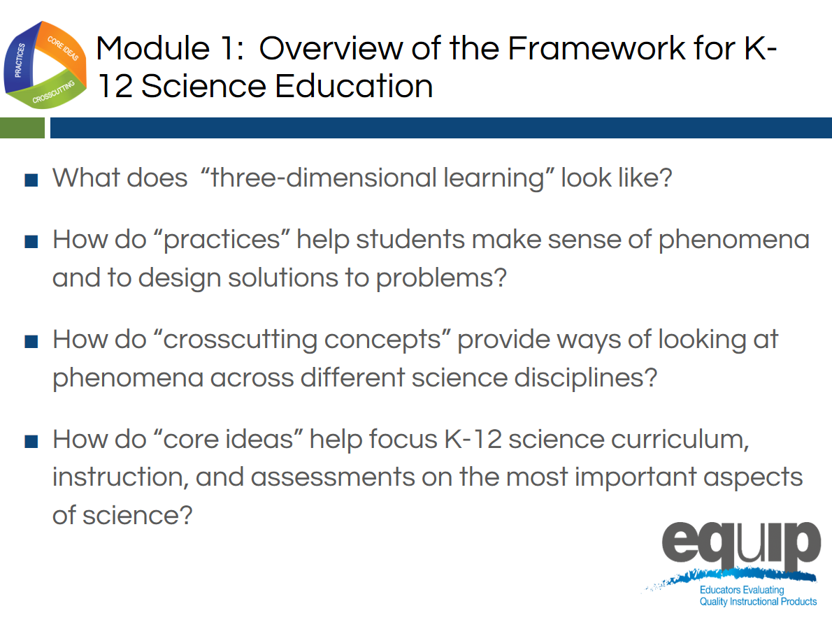
Slide 54
Facilitator Notes
Much of Modules 1 and 2 may constitute a review for many participants and be fairly new information for others. Facilitators may speed up or slow down the delivery of these two modules as determined by the needs of the participants.
Talking Points
- This module includes questions about the Framework that participants should be able to answer by the end of this module:
  - What does “three-dimensional learning” look like?
  - How do “practices” help teachers and students make sense of phenomena or design solutions to problems?
  - How do “crosscutting concepts” provide ways of looking at phenomena across different science disciplines?
  - How do “core ideas” help focus K–12 science curriculum, instruction, and assessments on the most important aspects of science?

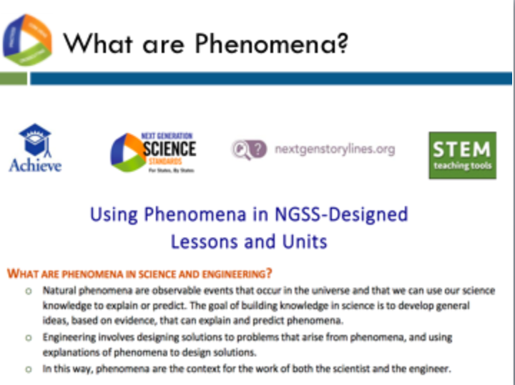
Slide 55
Talking Points
- Both the NGSS and the Framework focus on the innovation of 3-dimensional learning.
- 3D learning supports students in figuring out phenomena or developing solutions to problems.
- As we proceed through this training, we will be emphasizing this focus in the NGSS many times. Let’s define phenomena using Handout 2, which is a resource developed by Achieve and partners called Using Phenomena in NGSS-Designed Lessons and Units.
- This resource defines natural phenomena as observable events that occur in the universe and that we can use our science knowledge to explain and predict. The goal of building knowledge in science is to develop general ideas, based on evidence, that can explain and predict phenomena.
- Engineering involves designing solutions to problems that arise from phenomena, and using explanations of phenomena to design solutions.

Slide 56

Talking Points
- The NGSS and the Framework are about science for all students.
- In today’s world, science, engineering, and technology are not a luxury to be experienced by only some students.
- A strong science education equips students with skills necessary for all careers. Science develops students’ abilities to think critically and to innovate. All students need strong foundational knowledge in science to tackle difficult and/or long-term issues that face both our generation and future generations.
- Science, engineering, and technology:
  - Serve as cultural achievements and a common good across societies;
  - Permeate modern life and as such are essential at the individual level;
  - Are critical to participation in public policy and good decision-making; and
  - Are essential for ensuring that future generations will live in a society that is economically viable, sustainable, and free.

Three-Dimensional Learning
Facilitator Notes
Participants will need Handout 1, Module 1, “The Framework,” for the remaining portion of Module 1.
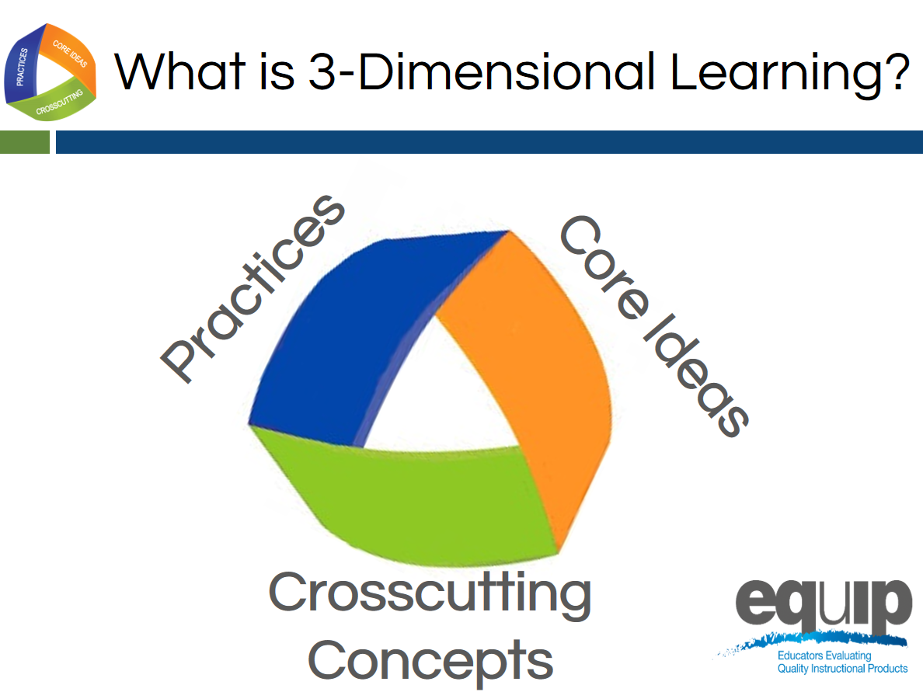
Slide 57
Talking Points
- Perhaps the most important shift in the NGSS is three-dimensional learning. This shift is defined here in Module 1; however, it is addressed in more detail in the third module of the professional learning.
- The three dimensions are practices, crosscutting concepts, and disciplinary core ideas.
- When you hear the term “three-dimensional learning,” what does it mean to you? Take two or three minutes to talk about this at your tables. Be prepared to share. [Note to facilitator: Allow two to three minutes, and then ask a few tables to share.]
- Three-dimensional learning is when these three dimensions work together to support students in making sense of phenomena or designing solutions to problems.
- Before looking at how the dimensions work together, we’ll look at the three separately to ensure our common understanding of each.

Practices
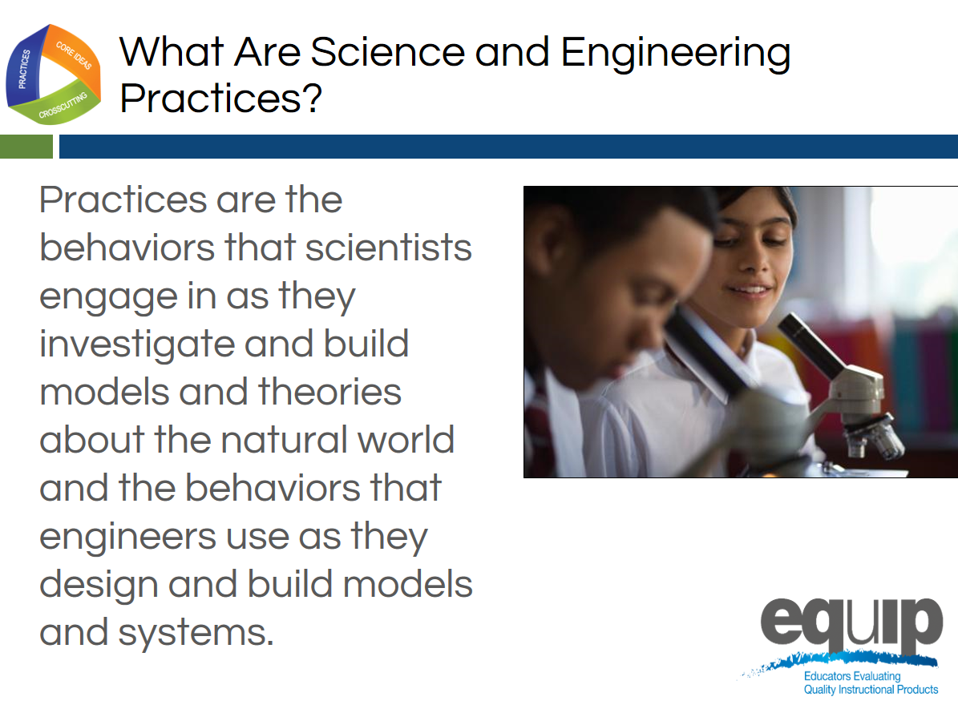
Slide 58
Talking Points
- Practices are the behaviors that scientists engage in as they investigate and build models and theories about the natural world, as well as the behaviors that engineers use as they design and build models and systems.
- The term practices is used instead of “skills” to emphasize that engaging in scientific investigation requires not only skill but also knowledge that is specific to each practice.
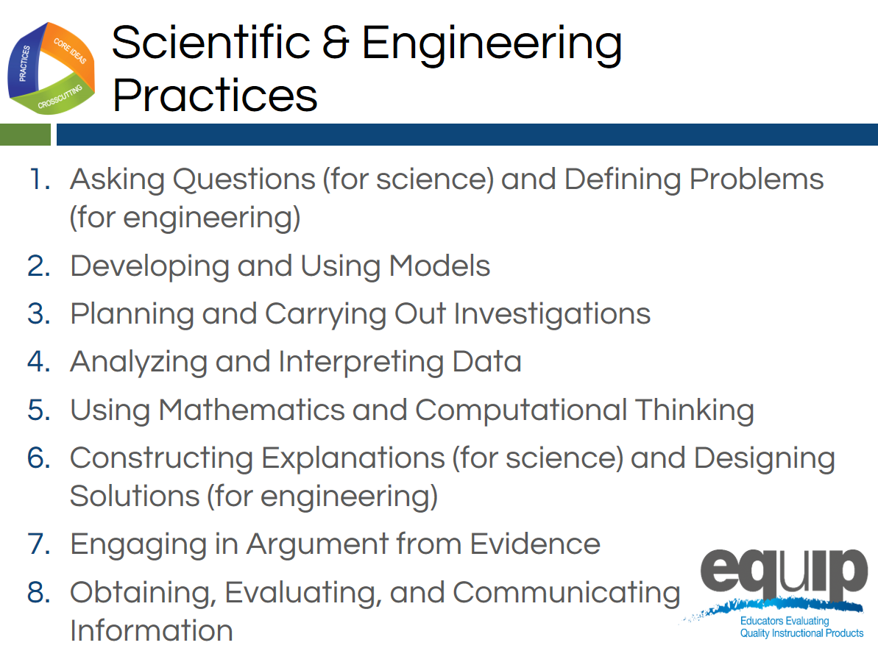
Slide 59
Talking Points
- The Framework identifies scientific and engineering practices that occur throughout the different disciplines of science. Descriptions of these practices and how they should become more complex over time can be found in the Framework and the NGSS.
- These practices are:
  - Asking questions (for science) and defining problems (for engineering);
  - Developing and using models;
  - Planning and carrying out investigations;
  - Analyzing and interpreting data;
  - Using mathematics and computational thinking;
  - Constructing explanations (for science) and designing solutions (for engineering);
  - Engaging in argument from evidence; and
  - Obtaining, evaluating, and communicating information.
- Let’s watch Joe Krajcik in this video explain how practices work together.
- Now, take five minutes at your table to discuss how you’ve observed these practices in science lessons and units. [Note to facilitator: After five minutes, have a few tables share.]
Crosscutting Concepts
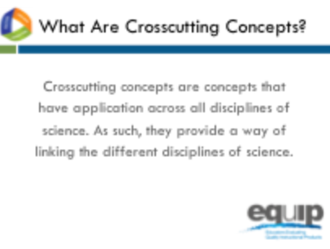
Slide 60
Talking Points
- Crosscutting concepts have applications across all disciplines of science. As such, they are a way of linking the different disciplines of science by providing ways of looking at and making sense of phenomena and/or of designing solutions to problems.
!
- The Framework emphasizes that these concepts need to be made explicit for students because they provide an organizational schema for interrelating knowledge from various science fields into a coherent and scientifically-based view of the world.
Slide 61
Talking Points
- Think, for example, about weather, a phenomenon in nature.
- Could you describe this phenomenon through the lens of:
  - Patterns? How/why or why not? [Note to facilitator: Allow one or two participants to respond.]
  - Cause and effect? How/why or why not? [Note to facilitator: Allow one or two participants to respond.]
  - Scale, proportion, and quantity? How/why or why not? [Note to facilitator: Allow one or two participants to respond.]
  - Systems and system models? How/why or why not? [Note to facilitator: Allow one or two participants to respond.]
  - Energy and matter? How/why or why not? [Note to facilitator: Allow one or two participants to respond.]
  - Structure and function? How/why or why not? [Note to facilitator: Allow one or two participants to respond.]
  - Stability and change? How/why or why not? [Note to facilitator: Allow one or two participants to respond.]
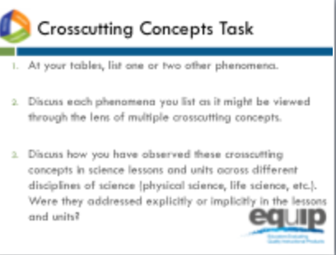
Slide 62

Talking Points
- Refer back to Handout 1 where you’ll see that the Framework lists the following crosscutting concepts:
  - Patterns;
  - Cause and effect;
  - Scale, proportion, and quantity;
  - Systems and system models;
  - Energy and matter;
  - Structure and function; and
  - Stability and change.
- Now, take 10 minutes at your table to:
  - List one or two other phenomena.
  - Discuss each phenomenon you list as it might be viewed through the lens of multiple crosscutting concepts.
- Finally, discuss how you have observed these crosscutting concepts in science lessons and units across different disciplines of science (physical sciences, life sciences, etc.). Were they addressed explicitly or implicitly in the lessons and units? [Note to facilitator: After 10 minutes, have a few tables share.]

Disciplinary Core Ideas
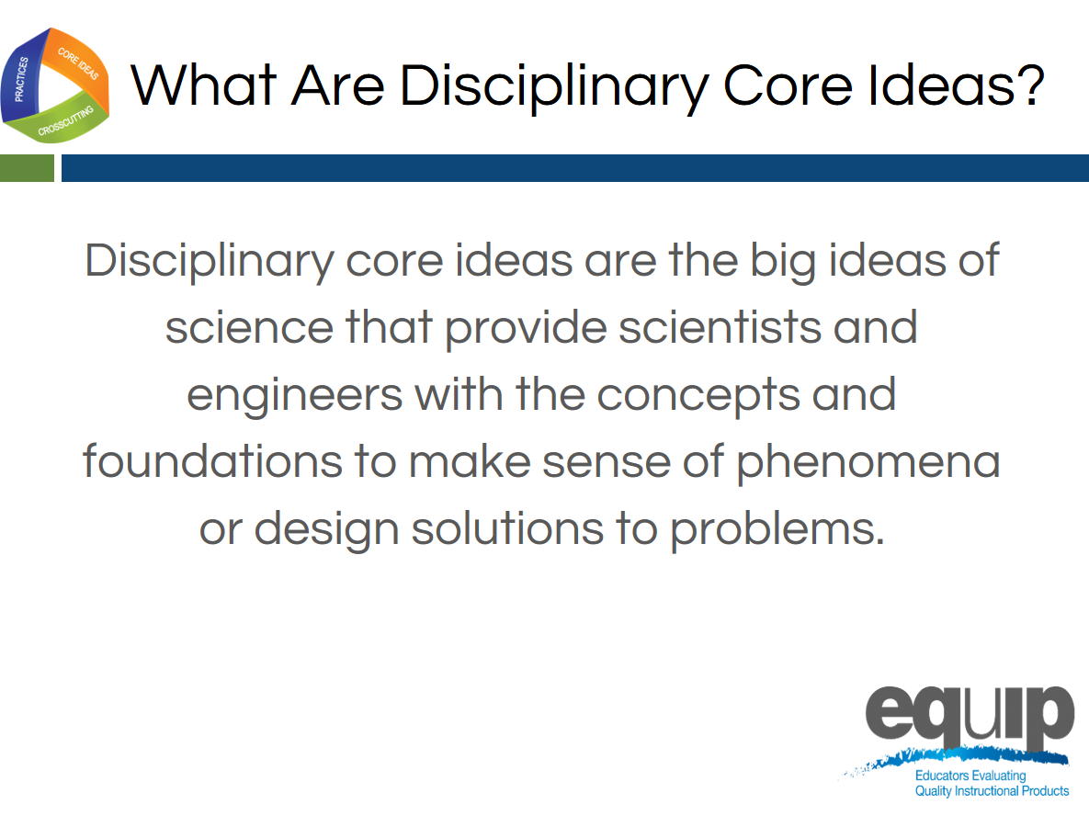
Slide 63
Talking Points
- Disciplinary core ideas are the big ideas—the most important aspects—of science that provide scientists, engineers, and students with the concepts and the foundations to make sense of phenomena and/or to design solutions to problems.
- They can be used to focus K–12 science curriculum, instruction, and assessments on the most important aspects of science.
- According to the Framework, to be considered core, the ideas must meet at least two of the following criteria and ideally all four:
  - Have broad importance across multiple sciences or engineering disciplines or be a key organizing concept of a single discipline.
  - Provide a key tool for understanding or investigating more complex ideas and solving problems.
  - Relate to the interests and life experiences of students or be connected to societal or personal concerns that require scientific or technological knowledge.
  - Be teachable and learnable over multiple grades at increasing levels of depth and sophistication.
- Disciplinary core ideas are grouped into four disciplines:
  - The physical sciences;
  - The life sciences;
  - The Earth and space sciences; and
  - Engineering, technology, and applications of science.
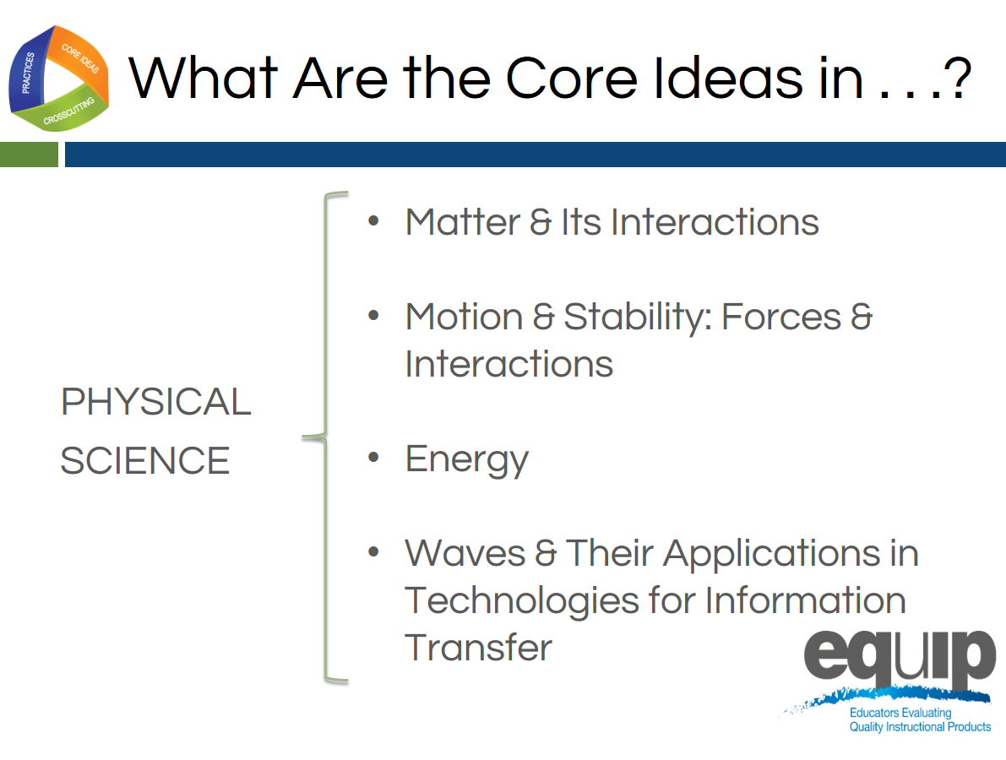
Slide 64
Talking Points
- The physical sciences include four core ideas:
  - Matter and its interactions;
  - Motion and stability: forces and interactions;
  - Energy; and
  - Waves and their applications in technologies for information transfer.
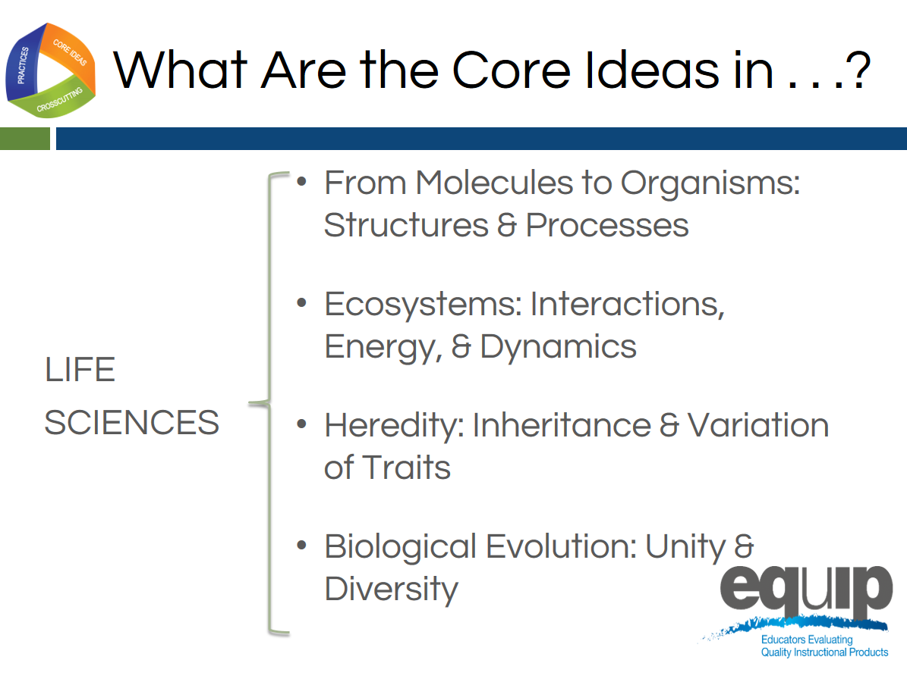
Slide 65
Talking Points
- The life sciences include four core ideas as well:
  - From molecules to organisms: structures and processes;
  - Ecosystems: interactions, energy, and dynamics;
  - Heredity: inheritance and variation of traits; and
  - Biological evolution: unity and diversity.
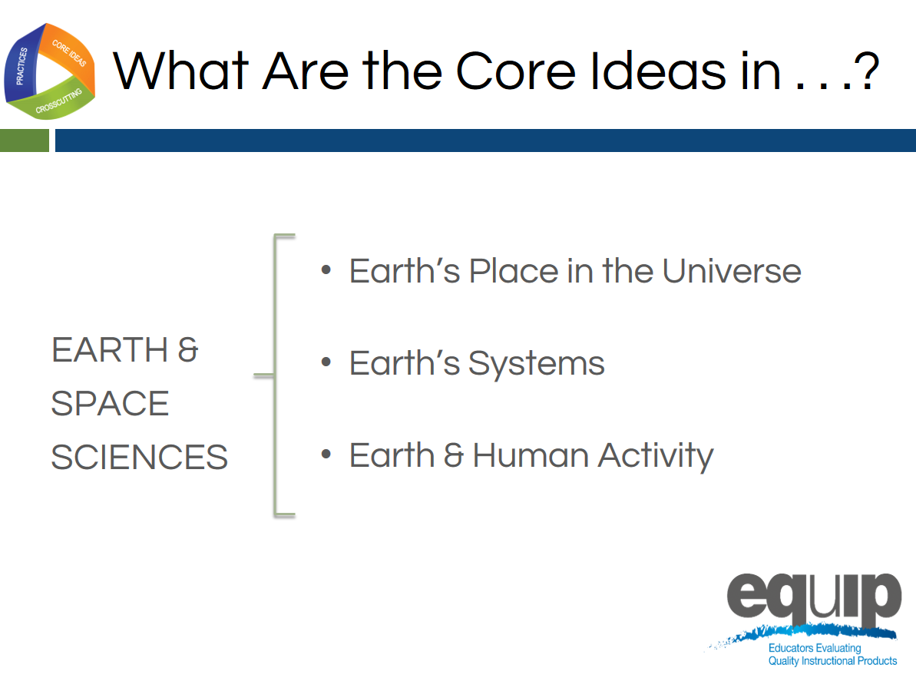
Slide 66
Talking Points
- The Earth and space sciences include three core ideas:
  - Earth’s place in the universe;
  - Earth’s systems; and
  - Earth and human activity.
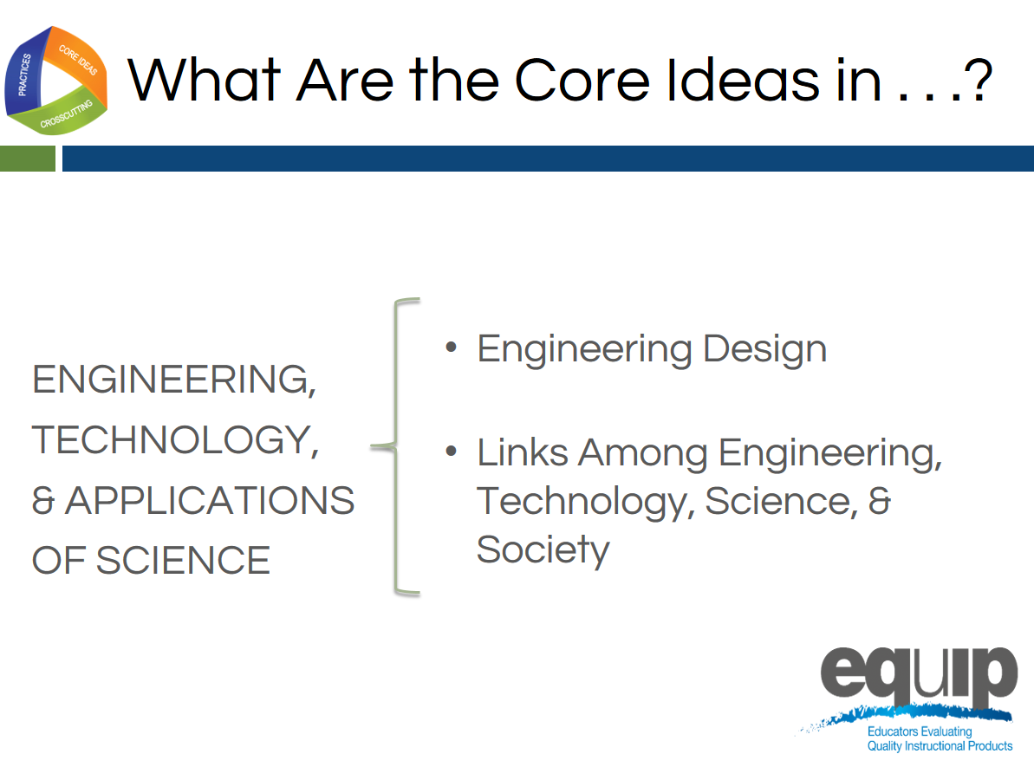
Slide 67

Talking Points
- Engineering, technology, and the applications of science include two core ideas:
  - Engineering design; and
  - Links among engineering, technology, science, and society.
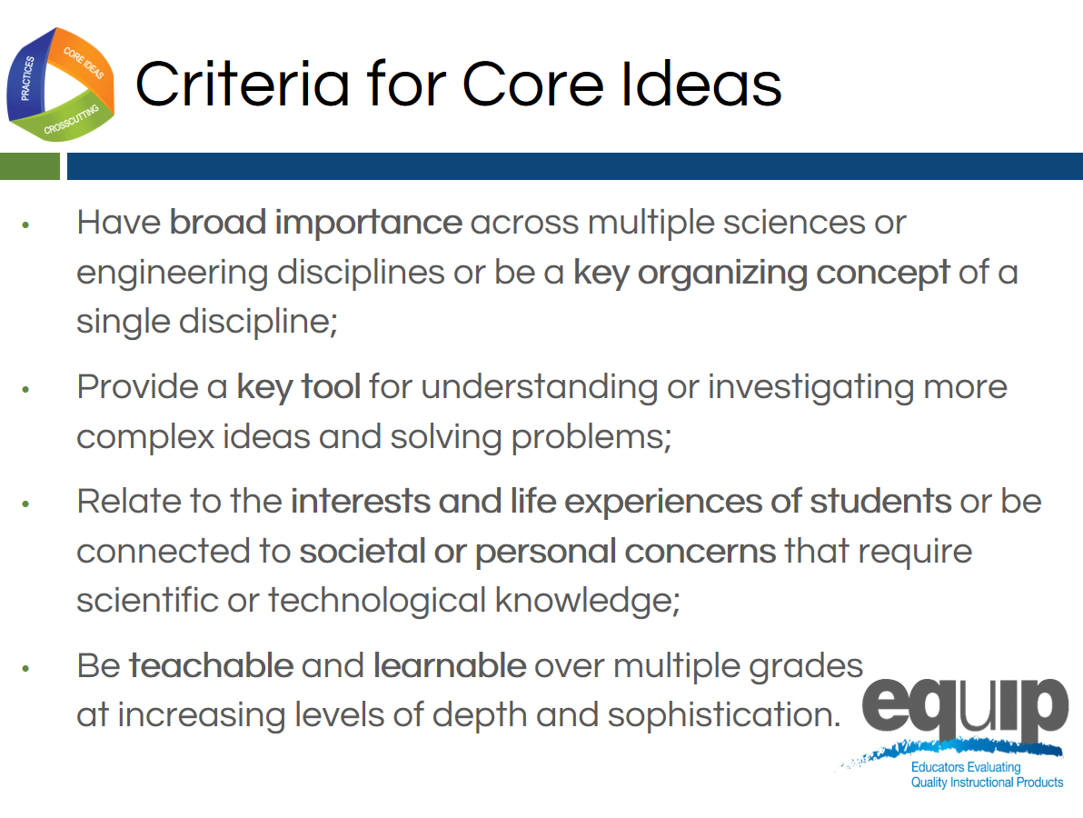
Slide 68
Facilitator Notes
Remind participants that the core ideas for the different science disciplines are listed on the handout for this module. They may wish to refer to this handout for this task.
Talking Points
- Now take 10 minutes at your table to discuss how the core ideas in one discipline of science meet two or more of the criteria for a core idea:
  - Have broad importance across multiple sciences or engineering disciplines or be a key organizing concept of a single discipline.
  - Provide a key tool for understanding or investigating more complex ideas and solving problems.
  - Relate to the interests and life experiences of students or be connected to societal or personal concerns that require scientific or technological knowledge.
  - Be teachable and learnable over multiple grades at increasing levels of depth and sophistication.
[Note to facilitator: After 10 minutes, have a few tables share.]

Concluding Slide for Module 1
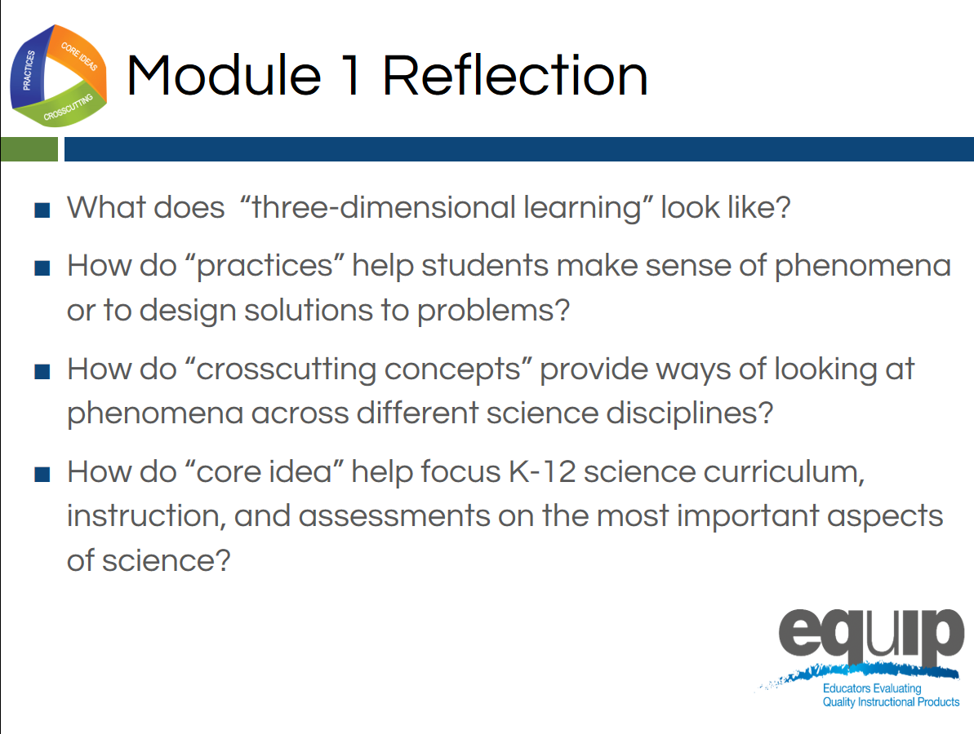
Slide 69
Talking Points
- In order to use the EQuIP Rubric to examine and evaluate NGSS lessons and units, it’s imperative that we have a common understanding of the practices, crosscutting concepts, and disciplinary core ideas as they relate to the Framework.
- Look back at the questions we began with in this module. Where are you now in terms of being able to respond to these questions with confidence?
- Take five minutes to jot down your reflections and your takeaways from this first module:
  - Where are you now in terms of being able to respond to these four questions with confidence?
  - Has your thinking changed as a result of this module?
  - What did you hear that was new?
  - What’s still rolling around in your head that you need to know more about?
[Note to facilitator: After five minutes, ask a few people to share their reflections.]
- As we conclude this first module, keep in mind that practices, crosscutting concepts, and disciplinary core ideas do not function in isolation.
- The key shift in the NGSS is three-dimensional learning. That is, lessons and units where practices, crosscutting concepts, and disciplinary core ideas work together to help students make sense of phenomena or to design solutions to problems.
- We’ll talk more about three-dimensional learning and phenomena in a subsequent module.
- If you would like more information about the Framework, visit the NGSS website: www.nextgenscience.org/.
- Keep in mind that you may wish to refer to the handout from Module 1 when you begin to use the rubric itself.

MODULE
EQuIP for Science v3.0
2

A Quick Overview of Performance Expectations
Module 2: A Quick Overview of Performance Expectations
This module provides a brief background on the performance expectations of the NGSS but should not be considered a thorough review of the NGSS. Participants should have an understanding of the Framework for K–12 Science Education and the NGSS before engaging in this professional learning. While this module does provide a brief background, ideally participants will not need to spend much time on it since they should already have an understanding of the Framework and the NGSS. If Module 2 is skipped or given to participants prior to the meeting, it may still be appropriate to emphasize some of the ideas in this module, such as the talking points identified with exclamation marks, throughout the professional learning.
Materials Needed
- Module 2 PowerPoint slides or slides 70–78 of the full PowerPoint
- Handout 3: Module 2, “Format of Performance Expectations” (1 page, preferably color copies)
- Handout 4: Module 2, “How to Read the NGSS” (5 pages, preferably color copies)
Introduction to Module 2
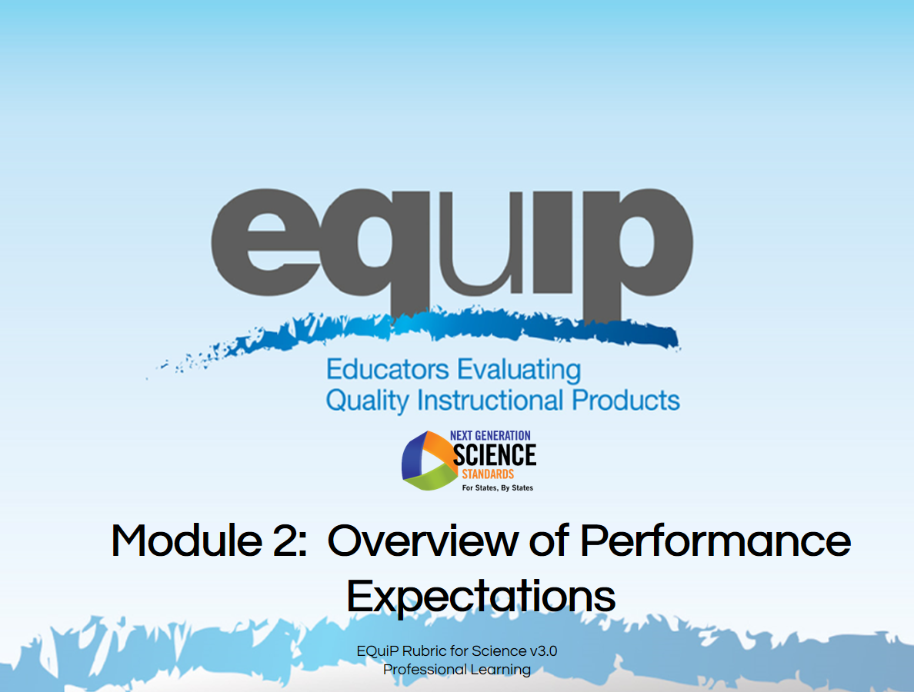
Slide 70
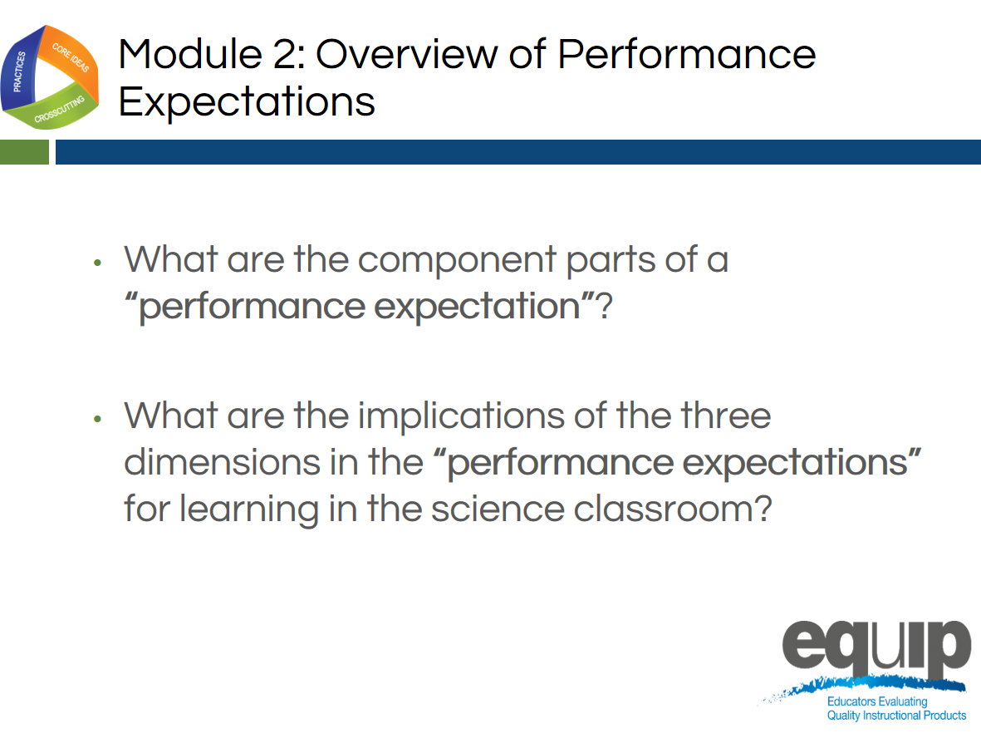
Slide 71
Talking Points
- By the conclusion of this module, all participants should be able to respond confidently to the following questions:
  - What are the component parts of a performance expectation?
  - What are the implications of the three dimensions in the performance expectations for learning in the science classroom?
- Having a thorough conceptual understanding of performance expectations and their implications for teaching and learning NGSS is exceedingly important when using the EQuIP Rubric to examine and evaluate NGSS learning materials and resources.

Defining and Explaining Performance Expectations
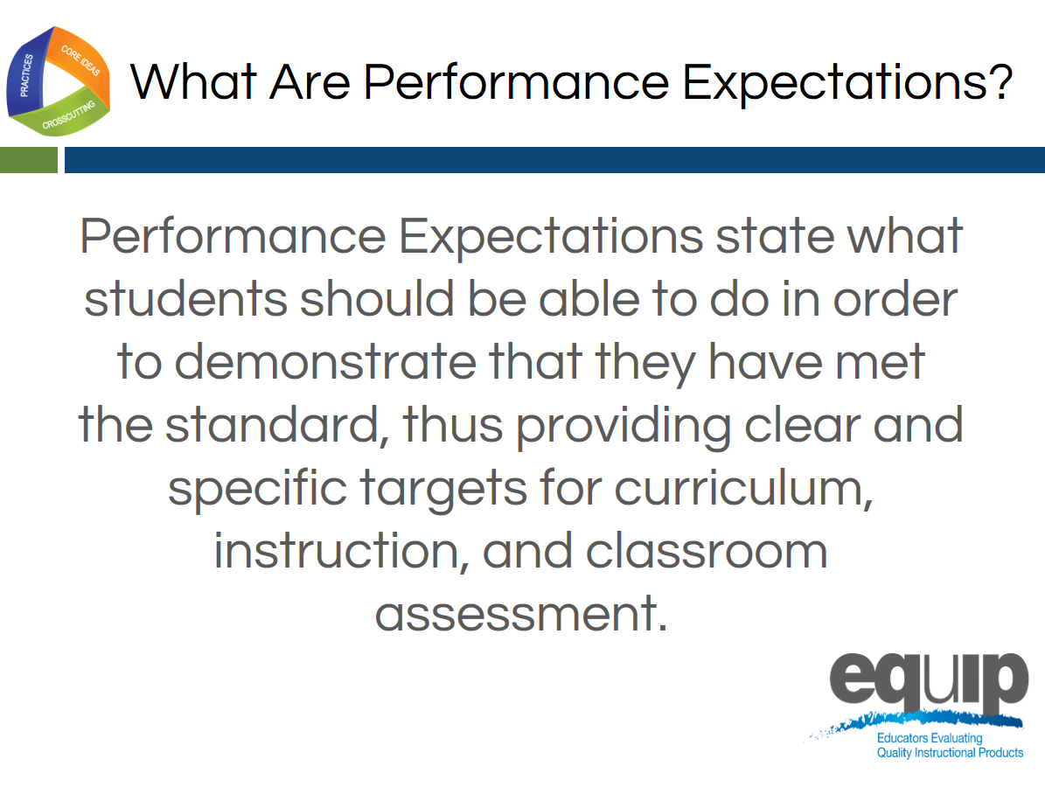
Slide 72
Talking Points
- Essentially, a performance expectation states what students should be able to do in order to demonstrate understanding of the three dimensions.
- Performance expectations, however, go beyond the knowledge, skills, and understandings generally seen in previous standards documents.
- NGSS performance expectations require students to demonstrate conceptual understanding by applying the knowledge and understanding inherent in a standard.
- In addition, performance expectations require students to transfer knowledge and understanding to new or somewhat different situations.
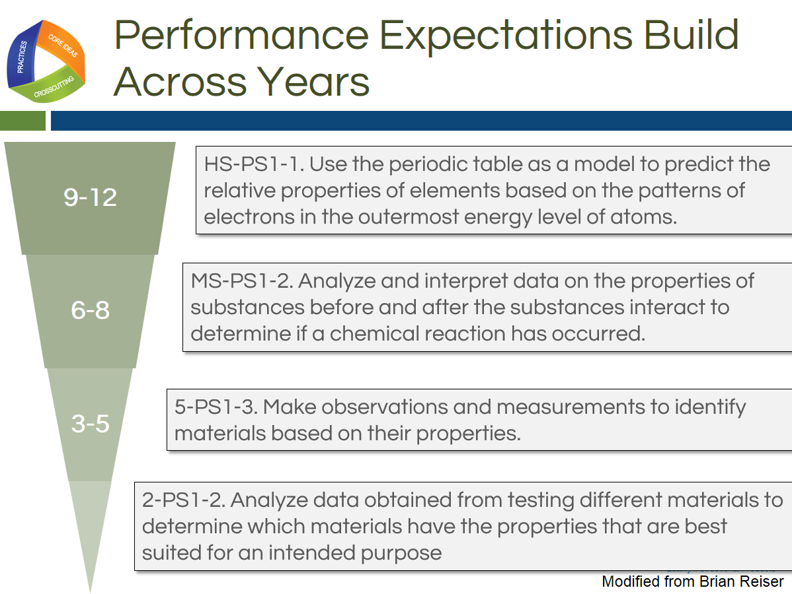
Slide 73
Talking Points
!
- Performance expectations are not learning tasks or instructional strategies. They are statements of what students should be able to do after instruction.
- Multiple lessons and/or multiple units of instruction experienced over time may be required for students to acquire the conceptual understanding needed to demonstrate mastery of standards via the performance expectations.
- In addition, as represented in this slide, student learning and the performance expectations that demonstrate this learning will build as students move through the grades.
Slide 74
Talking Points
- The Framework takes the position that a scientifically literate person understands and is able to apply all of the core ideas in each of the major science disciplines in the Framework, so all students should be held accountable for demonstrating their achievement of all performance expectations.
- This is especially important in high school where traditionally students may have taken courses in some but not all science disciplines.
- Consequently, the disciplinary core ideas included in the performance expectations are limited to only those core ideas listed in the Framework.
- Performance expectations allow for an emphasis on coherence within lessons and units and across the years and grade levels—it’s all about learning progressions. When students demonstrate achievement via performance expectations, we can no longer say, “Students didn’t get it last year, so they can’t possibly get it this year.”
!
- Overall, it’s about what the students are doing and not what the teachers have done.
- The performance expectations should not, however, limit the curriculum. Students interested in pursuing science further via more advanced coursework or through additional concepts of interest and relevance to the student or the community should have the opportunity to do so.

How to Read a Performance Expectation
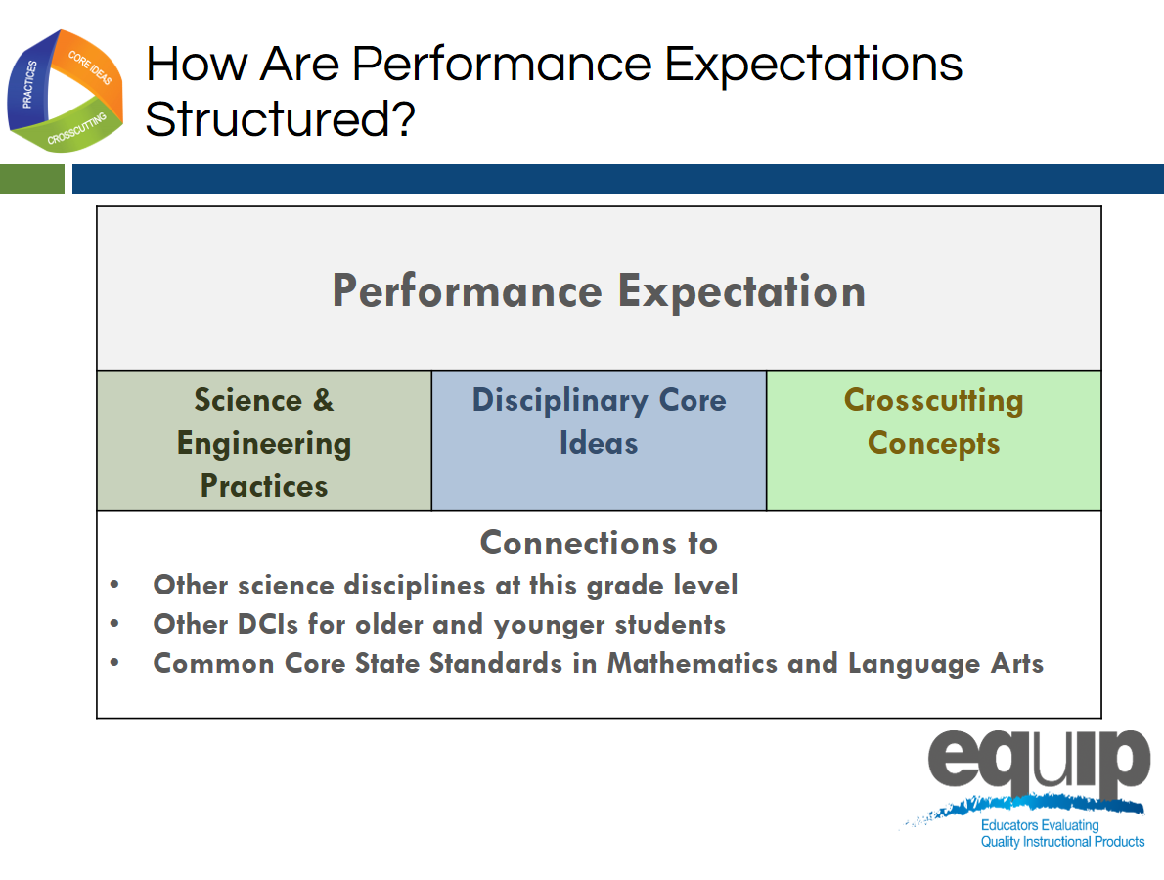
Slide 75
Talking Points
- We’re going to look now at the foundation boxes of the performance expectation. Although the foundation boxes are not the assessed piece of the performance expectation, they are necessary for students to perform the assessable the three-dimensional performance expectation.
- Irrespective of grade level or discipline of science, every performance expectation has the following three parts:
  - The statement of the actual performance expected;
  - The foundations for this performance or, in other words, the practices, disciplinary core ideas, and crosscutting concepts that constitute this performance (again, it’s important to note that students are not assessed on the foundation boxes or on a single dimension individually); and
  - The connections to other science disciplines, to other grades or grade bands, and to CCSS in ELA/literacy and mathematics, which contribute to coherence and will be addressed in a later module.
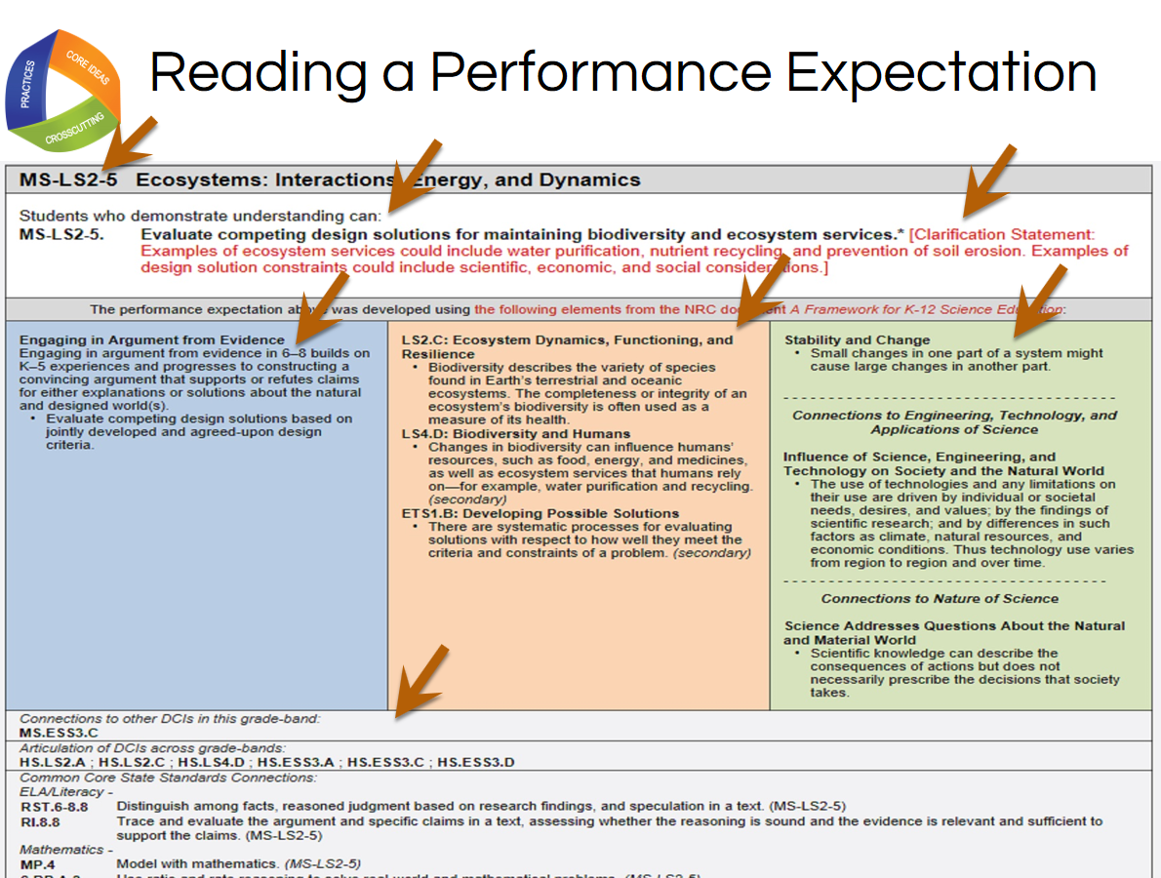
Slide 76

Facilitator Notes
In order to complete specific learning tasks, participants will need Handout 3, Module 2, “Format of Performance Expectations,” which is displayed on this slide.

Talking Points
- Now take a look at an actual performance expectation.
!
- Performance expectations may be viewed either by topic or by core idea. The specific example on this slide is grouped by core idea.
- As noted in the top row [Note to facilitator: click for animation.], this performance expectation is MS-LS2-5—Middle School, Life Science Core Idea 2 (Ecosystems: Interactions, Energy and Dynamics), Performance Expectation 5. This notation is the same regardless of whether the performance expectations are viewed by topic or core idea.
- The actual performance expectation appears in the second row following “Students who demonstrate understanding can...” [Note to facilitator: click for animation.]
- The performance expectation is sometimes followed by a clarification statement or assessment boundary, which appear in red. [Note to facilitator: click for animation.] Here, the clarification statement elaborates on what is meant by properties that could be predicted from patterns, and the assessment boundary provides specific information regarding what this performance expectation does not include for large-scale assessment. It should be noted that while assessment boundaries do limit large-scale assessment, they do not necessarily limit instruction.
- While the performance expectations can stand alone, a more coherent and complete view of the standards can be seen when the performance expectations are viewed in tandem with the contents of the foundation boxes that lie just below the performance expectations.
- These blue, orange, and green foundation boxes delineate the three dimensions. That is, the practices [Note to facilitator: click for animation.], disciplinary core ideas [Note to facilitator: click for animation.] and crosscutting concepts [Note to facilitator: click for animation.] derived from the Framework that were used to construct this set of performance expectations.
- Finally, [Note to facilitator: click for animation.] connections are made to other disciplinary core ideas within this grade band, across grade bands, and to the CCSS in ELA and mathematics.
- Now, individually circle the words or phrases in the performance expectation that directly relate to the specific practice(s), core idea(s), and crosscutting concept(s) listed in the blue, orange, and green boxes.
- Next, draw arrows to connect your circled words and phrases directly to the specific practice, core idea and crosscutting concept in the colored boxes.
- When finished, share and compare at your table. What general statement about performance expectations can you make as a result of the connections you just made? [Note to facilitator: Allow approximately five minutes for this task, and then have one or two tables to share. Elicit responses that show how the performance expectation is three-dimensional.]

Note to facilitator: Please give credit for the photo on this slide to http://blogs.wsj.com/photojournal/2009/07/10/pictures-of-the-day-216/.
Slide 77
Talking Points
- Remember, instruction, over time, builds the structures—the practices, disciplinary core ideas and crosscutting concepts which students need to meet the performance expectations.
- It also is important to note that while the practices, disciplinary core ideas, and crosscutting concepts specified in the performance expectations describe how students are asked to demonstrate understanding at the end of instruction, this does not limit what practices can or should be used in instruction. For example, if a performance expectation calls for students to construct an explanation, this merely indicates the assessment expectation for students. In the classroom, a teacher also will have students engage in additional practices, such as asking questions and analyzing data.
!

Concluding Slide for Module 2
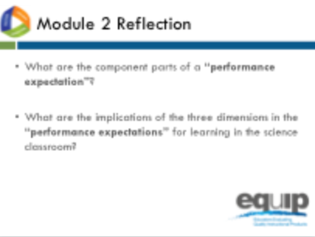
Slide 78

Facilitator Notes
Refer participants to Handout 4, Module 2, “How to Read the NGSS,” where they will find more information on this topic
Talking Points
- At your tables, quickly think about how you would respond to the two questions for Module 2 to ensure your understanding before going on to Module 3.
- Identify and be prepared to ask any questions you still have about performance expectations. [Note to facilitator: Allow approximately five minutes, and then address any remaining questions.]
- For more information about the performance expectations, refer to the handout for Module 2, Slide 27, “How to Read the NGSS.”

MODULE
EQuIP for Science v3.0
3

A Three-
Dimensional
Learning

Module 3: Three-Dimensional Learning
This module addresses what three-dimensional learning is, what it looks like in a classroom, and why it is essential for students to engage in three-dimensional learning to help them build toward proficiency of performance expectations. This is an important module, as understanding how to determine whether or not a lesson or unit provides an opportunity for students to engage in three-dimensional learning is crucial to using the EQuIP Rubric to examine lessons and units and their alignment to the NGSS. Three-dimensional learning will be emphasized again in Module 6 and will be discussed in all the remaining modules.
Materials Needed
- Module 3 PowerPoint slides or slides 79–89 of the full PowerPoint
- Handout 5: Module 3, “Sample Performance Expectation” (1 page, preferably color copies)
Facilitator Notes
This module has an optional immersion experience where participants will be able to experience 3 dimensional learning within a lesson, create a student product, and then analyze products from the K–12 students to gain an understanding of the integration of the three dimensions. The focus on phenomena and use of student products also provides connections between the 3 segments of the training (3D Design, instructional supports, and monitoring student progress). In this way, this optional immersion experience engages the participant, provides a context for asking questions, and serves as a touchstone that can be revisited throughout the training. If, due to time constraints or other issues, the facilitator chooses not to use the immersion experience, he or she should use the non-immersion discussion of 3-dimensional learning. Facilitators who open the day with the Introduction and Immersion module can choose to skip this module or use it for review.
Introduction to Module 3
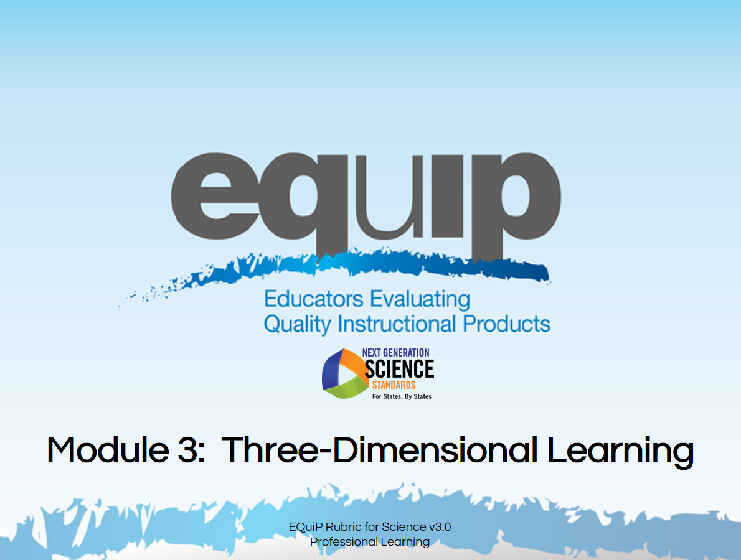
Slide 79
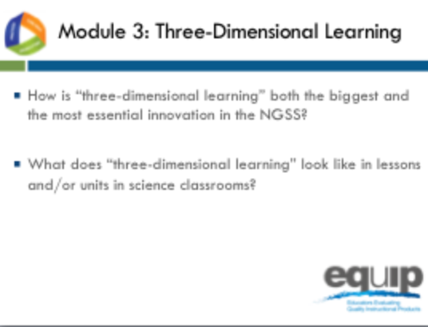
Slide 80
Talking Points
- The third module of this EQuIP training includes two essential questions that all participants should be able to answer by the conclusion of the module:
  - How is three-dimensional learning both the biggest and the most essential shift in the NGSS?
  - What does three-dimensional learning look like in lessons and units in science classrooms?
- Understanding how to determine whether or not a lesson or unit embodies three-dimensional learning is crucial to using the EQuIP Rubric to examine lessons’ and units’ alignment to the NGSS, as well as to the development of aligned lessons and units.

What is Three-Dimensional Learning?
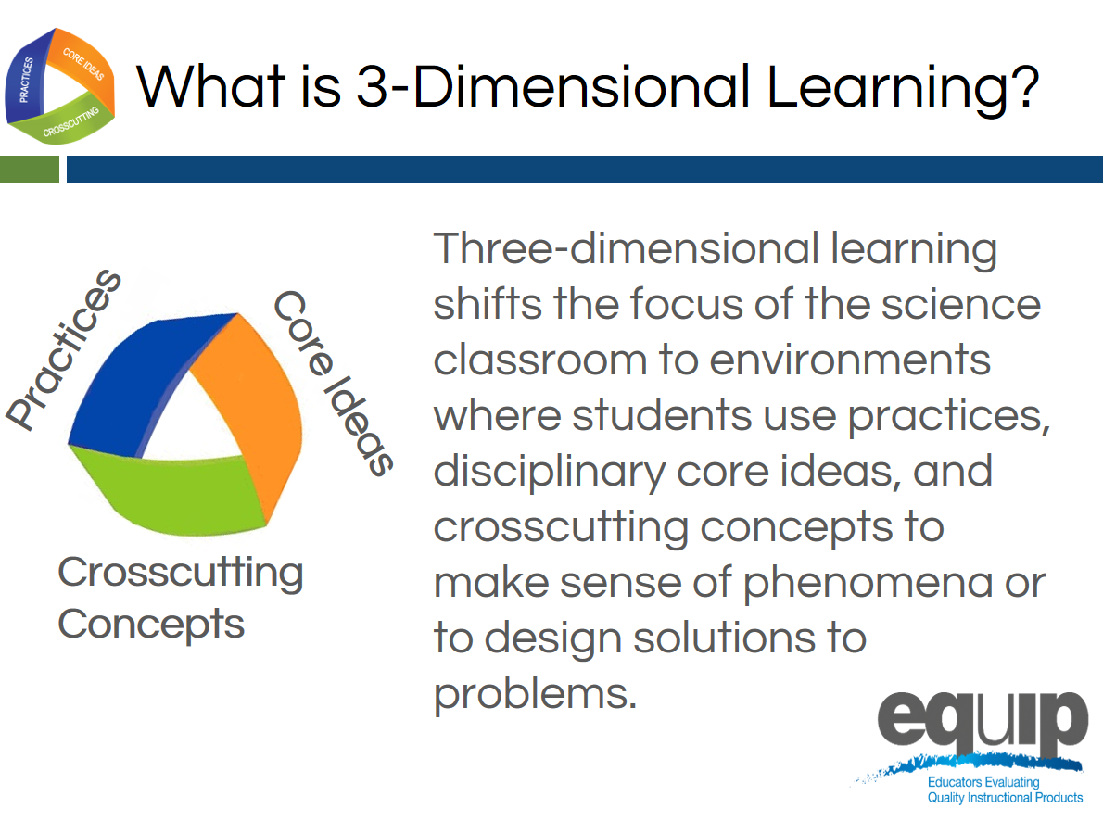
Slide 81
Talking Points
- As discussed in Module 1, three-dimensional learning happens when the three dimensions—practices, core ideas, and crosscutting concepts—work together.
!
- Three-dimensional learning shifts the focus of the science classroom to environments where students use practices, disciplinary core ideas, and crosscutting concepts together to make sense of phenomena or to design solutions to problems.

Why is Three-Dimensional Learning Essential to the NGSS?
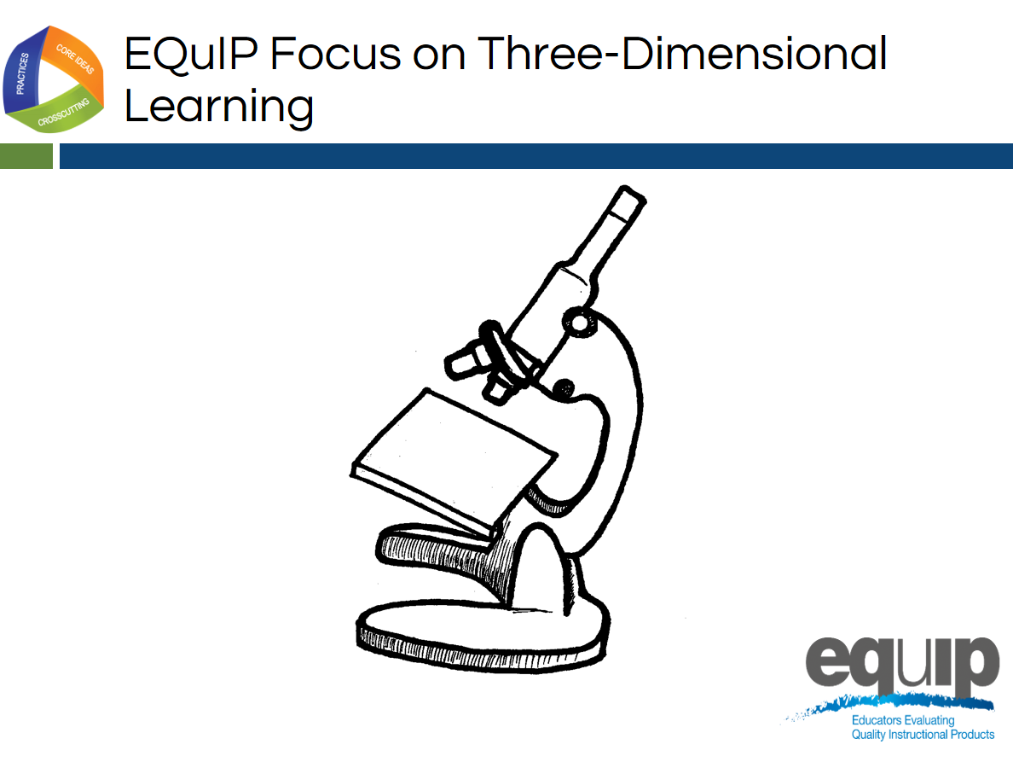
Slide 82

Talking Points
- Just as we use tools to examine objects carefully and in detail, we will use the EQuIP Rubric to examine NGSS materials—lessons and units—carefully and in detail to determine whether or not they align with one or more of the conceptual shifts of the NGSS.
- As noted by Joe Krajcik, “If the lessons or units you are judging don’t meet this criterion, there is no need to go on with an evaluation to discern if the materials align with NGSS or not. As such, you really need to understand the concept of three-dimensional learning. It represents an entirely new way of thinking about and enacting science teaching. It’s not as simple as using the practices and crosscutting concepts to help students understand the disciplinary core ideas. Rather, the three work together to help students make sense of phenomena or design solutions. Making sense of phenomena and designing solutions drives the teaching and learning process.” (http://nstacommunities.org/blog/2014/04/25/equip/).
- Consequently, before actually using the EQuIP rubric to examine lessons and units, we need to have a deep understanding of three-dimensional learning.

Analogies: Three-Dimensional Learning is Like...
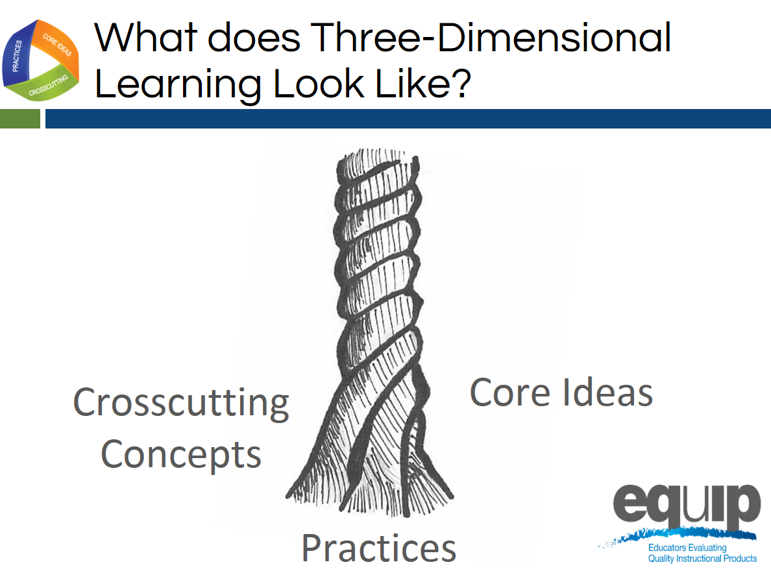
Slide 83
Talking Points
- Think of the three components of three-dimensional learning as three intertwining stands of a rope. While the rope can be separated into its three different strands, the strength of the rope is determined by the strands working together; separating the strands weakens the rope so that it is no longer effective for our intended use.
- Likewise, while in the past we may have separated out the knowledge and skills students need in the study of science, in actuality, knowing and doing cannot be separated if our goal is the kind of usable, conceptual understanding students need to think, act, and learn like scientists.
- Three-dimensional learning—practices, core ideas, and crosscutting concepts working together—is therefore a non-negotiable for NGSS lessons and units.
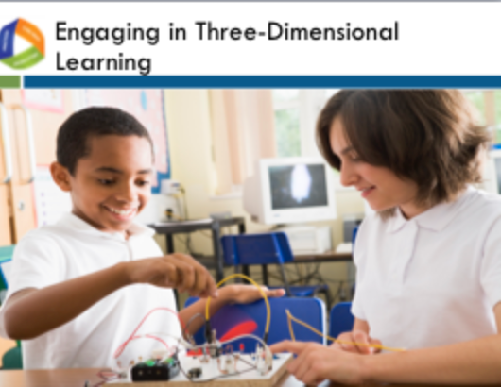
Slide 84
Talking Points
- Scientific ideas are best learned when students engage in practices.
- Three-dimensional learning allows students to use core ideas, through the lens of crosscutting concepts, while engaging in practices to solve problems, make decisions, explain real-world phenomena, and integrate new ideas.
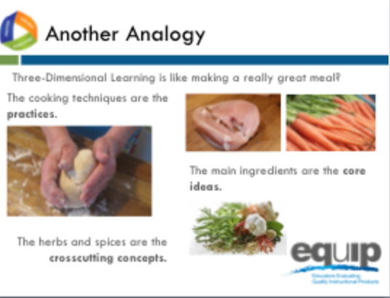
Slide 85
Talking Points
- Let’s continue thinking about three-dimensional learning metaphorically for a minute.
- As stated by Joe Krajcik, “To use the EQuIP rubric, you first need a solid understanding of the disciplinary core ideas, science and engineering practices, and crosscutting concepts, each of which is described in detail in the Framework and NGSS Appendices. Understanding each of these dimensions is essential, but real transformation comes with understanding how these dimensions blend and work together; this is the critical and perhaps most important shift in the NGSS. The EQuIP rubric refers to this blending of DCIs, practices, and CCCS as three-dimensional learning” (http://nstacommunities.org/blog/2014/04/25/equip/).
- Borrowing an idea from Ted Willard at NSTA, Joe often compares three-dimensional learning to making a really good meal.
- As Joe says so well, “Think of knowing how to do various techniques in the kitchen like kneading bread, cutting tomatoes, beating an egg, frying or roasting, and so forth as the practices. You could know how to do all of these things and still not be able to prepare a really good meal.

“Now think of picking out really good ingredients for the meal. You want to pick out a high-quality piece of fish or poultry or excellent pasta for the meal. These are your core ideas. A disciplinary core idea is essential to explaining a number of phenomena. Your main ingredient is essential to the meal. But just as the [disciplinary core idea] works with practices to make sense of phenomena and design solutions, you need to know how to cook that main ingredient. But something is still missing. The meal tastes bland. What is missing? To make a really good meal, we need to use spices and herbs to enhance the flavor of the main ingredients.”

Crosscutting concepts are like these spices and herbs—they enhance learning by providing a familiar lens to use to examine and understand phenomena. Because the same spices and herbs are used in many different dishes, we recognize them even when we have them in a new or unfamiliar dish. Consequently, we can use our familiarity with a spice or herb to examine a new meal and understand what was used to make it. Likewise, crosscutting concepts can be found in all scientific disciplines, and we can use our familiarity with crosscutting concepts in one discipline of science to examine phenomena and enhance understanding and learning in other disciplines of science.

“To make a really wonderful meal, good main ingredients are necessary, but you need to know how to use various techniques to prepare them, and you must have the spices and herbs to enhance the flavors. All three work and blend together to make a great meal. Similarly, to foster three-dimensional learning where all learners can make sense of phenomena and design solutions, all three dimensions need to work and blend together” (http://nstacommunities.org/blog/2014/04/25/equip/).
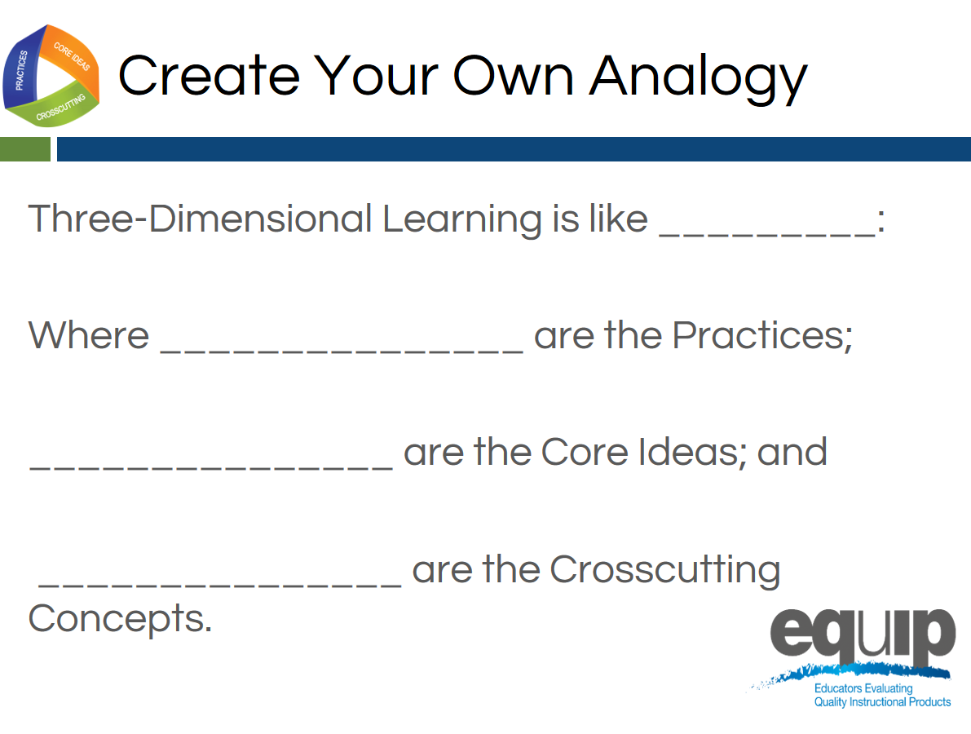
Slide 86
Talking Points
- Now, take a few minutes and create your own analogy for three-dimensional learning. [Note to facilitator: Allow 10–15 minutes for participants to create an individual analogy and share out at their tables, and then ask for a few to share their analogies with the whole group.]

Visualizing Three-Dimensional Learning
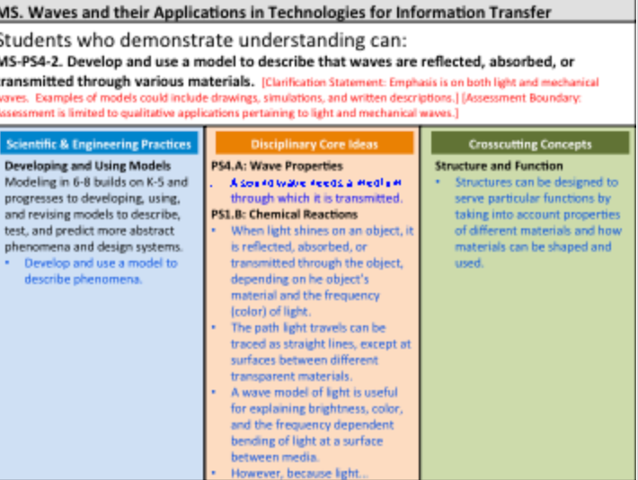
Slide 87
Facilitator Notes
- These talking points reference the immersion experience within the text that is in parentheses. If you did not present the immersion and introduction module, then omit these portions of the talking points.
- For slide 87, refer participants to Handout 5, Module 3, “Sample Performance Expectation,” which is displayed on this slide.
Talking Points
- Thinking back to Module 2 (and our immersion experience), three-dimensional learning will support students in demonstrating the understanding demanded by the performance expectations. (The immersion experience lesson was using this performance expectation.)
- So, let’s analyze a performance expectation to see how the three dimensions provide its essential structure.
- First, let’s look at the actual expectation [Note to facilitator: Click for animation.]: “Students who demonstrate understanding can… Develop and use a model to describe that waves are reflected, absorbed, or transmitted through various materials.” MS-PS4-2
- Being able to do this requires students to incorporate practices, disciplinary core ideas, and crosscutting concepts.
- [Note to facilitator: Click for animation.] So, in order to meet this performance expectation, students are required to incorporate the specific science and engineering practice of “developing and using models to describe phenomena”, which is an element of the science and engineering practice of developing and using models. As noted previously, however, during instruction, other practices will also be used.
- In addition, students must incorporate disciplinary core ideas. [Note to facilitator: Click for animation.] This performance expectation specifies two component ideas of the disciplinary core idea MS-PS4 Waves and their Applications for Technologies for Information Transfer. What are these two component ideas? [Note to facilitator: Solicit responses from participants. Refer them to the handout if necessary.]
- Finally, to meet this performance expectation, students will need to incorporate the specific crosscutting concept of “structures can be designed to serve particular functions by taking into account properties of different materials, and how materials can be shaped and used”, which is an element of the crosscutting concept of Structure and Function. [Note to facilitator: Click for animation.]
- You can see, then, that for all performance expectations, the whole is truly greater than the sum of its parts.
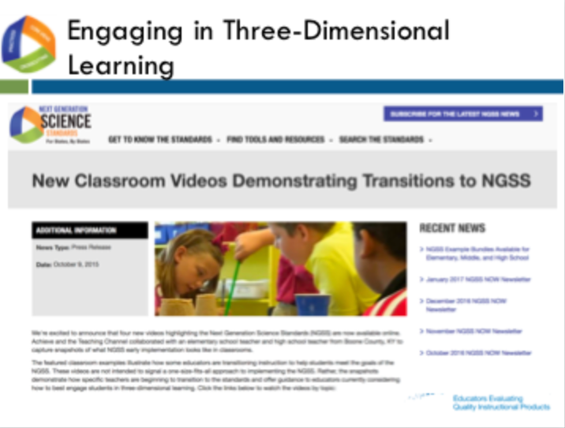
Slide 88
Facilitator Notes
- For the video clip, please choose between the high school video (9th grade classroom) or Elementary video (2nd grade classroom) and cue the video from the links below:
  - High School: http://www.nextgenscience.org/resources/video-energy-matter-across-science-disciplines
  - Elementary: http://www.nextgenscience.org/resources/video-making-claims-evidence
Talking Points
- Now, let’s take a look at what this looks like in an actual classroom. This is a classroom that is beginning to transition to the NGSS, so all of the components might not be implemented yet. As you watch this short video clip, note how and where you see students engaged in three-dimensional learning. Remember, it’s not enough to have practices, disciplinary core ideas, and crosscutting concepts. These must work together to help students make sense of phenomena or design solutions to problems. [Note to facilitator: Show video of classroom that illustrates steps toward three-dimensional learning. Depending on time constraints, you may elect to show all or a portion of the video. Following the video clip, ask participants to share what they noted in the video and explain how the three dimensions work together.]
- Finally, let’s move to your own experiences.
- Where have you seen students engaged in three-dimensional learning in science lessons and units? What did that look like? How did the practices, disciplinary core ideas, and crosscutting concepts work together so that students could make sense of phenomena or design solutions to problems?
- Take about three minutes to think of lessons or units you’ve seen or experienced where practices, disciplinary core ideas, and crosscutting concepts have worked together for effective learning to occur. Again, this does not mean that students passively receive content, and then apply it, or that there is an implicit crosscutting concept that does not support student learning. Rather, all three dimensions work together. [Note to facilitator: After about three minutes, ask participants to take an additional five to seven minutes to share and compare at their tables, and then ask two or three table groups to provide examples of three-dimensional learning from their experiences.]

Concluding Slide for Module 3
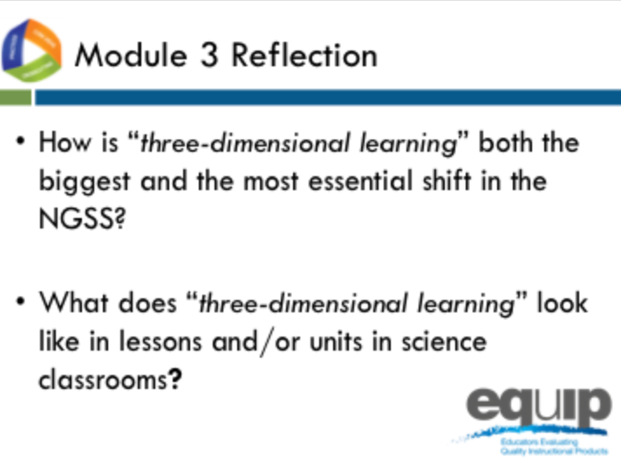
Slide 89
Talking Points
- At your tables, quickly review two essential questions from Module 3 to ensure your understanding before going on to Module 4.
- Identify and be prepared to ask any clarifying questions you still have. [Note to facilitator: Allow approximately five minutes, and then address any remaining questions. If it is apparent that participants are still having trouble clearly understanding three-dimensional learning, do not move on until they have reached this understanding.]

MODULE
EQuIP for Science v3.0
4

Overview of
the EQuIP Rubric
Module 4: Overview of the EQuIP Rubric
Module 4 provides an overview of the EQuIP Rubric including a background on its development, the purposes of the rubric, and basic information about its structure and contents. This module also includes information on the quality review process—a collegial process that centers on the use of the criteria-based rubric for examining science lessons and units—including the agreements required for participating in the review.
Materials Needed
- Module 4 PowerPoint slides or slides 90–101 of the full PowerPoint
- Handout 6: Module 4, “EQuIP Agreements”
- Handout 7: Module 4, “EQuIP Rubric, Version 3”

Introduction to Module 4
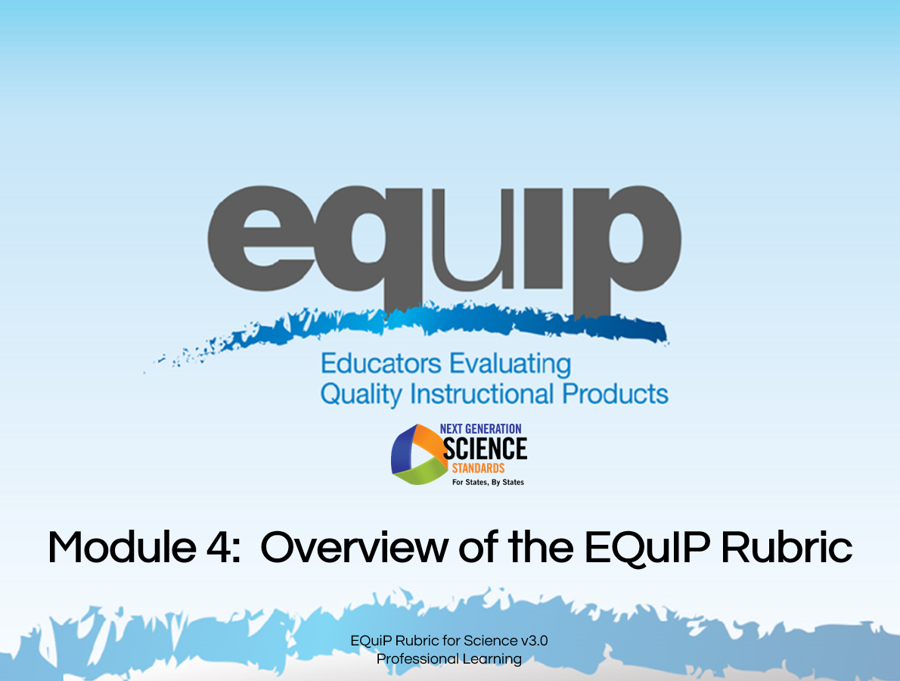
Slide 90
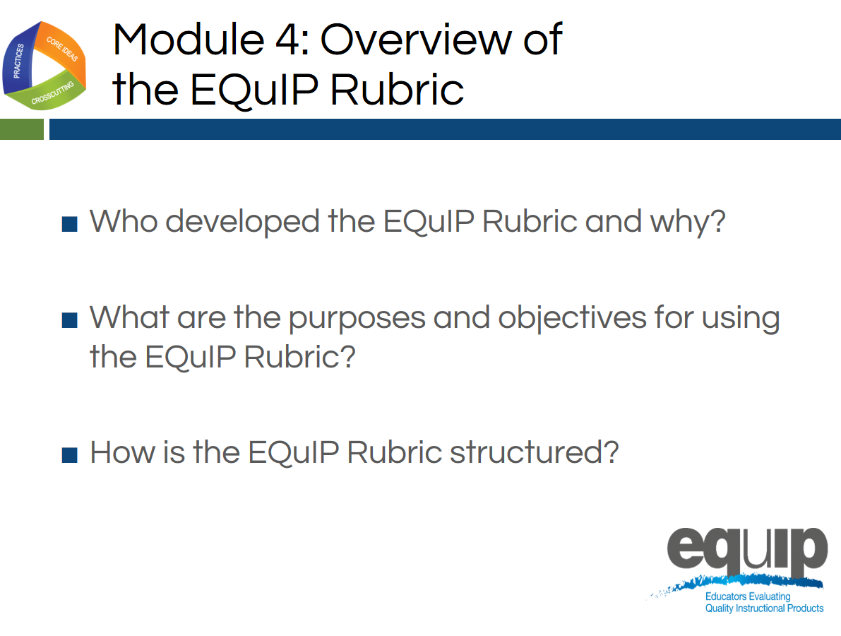
Slide 91
Talking Points
- In Module 4, we will begin looking at the EQuIP Rubric so that all participants will be able to answer the following questions confidently:
  - Who developed the EQuIP Rubric and why?
  - What are the purposes and objectives for using the EQuIP Rubric?
  - How is the EQuIP Rubric structured?

History of the EQuIP Rubric
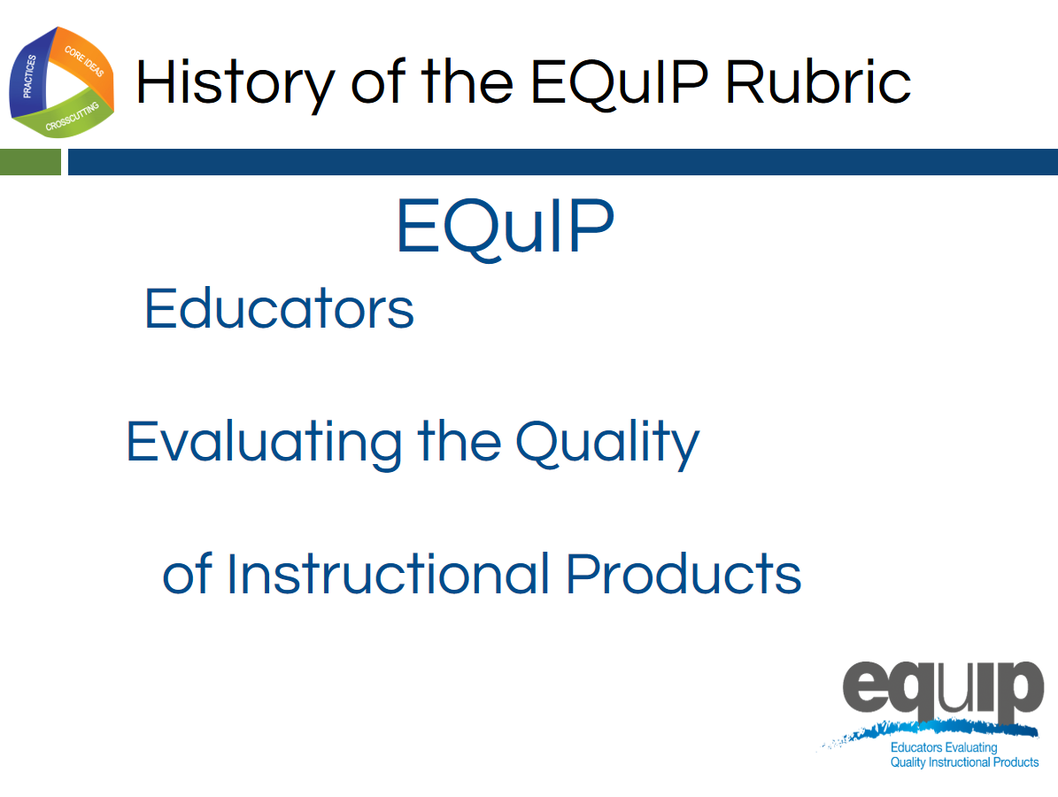
Slide 92
Talking Points
- EQuIP stands for Educators Evaluating the Quality of Instructional Products.
- The original criterion-based rubrics and review processes were developed to evaluate the quality of lessons and units for the CCSS for ELA/literacy and mathematics.
- The original ELA/literacy and mathematics rubrics were known as the Tri-State Rubrics because they were developed through a collaborative effort by Massachusetts, New York, and Rhode Island.
- This initial collaboration was facilitated by Achieve. There was so much interest in the rubric that Achieve facilitated a convening of states that wanted to learn more about the rubrics and use them to identify high-quality, aligned materials. The original states using the rubric were deemed the EQuIP Collaborative and the rubrics became known as the EQuIP Rubrics. Many more states have learned about and used the EQuIP Rubrics for ELA/literacy and mathematics since the original collaborative.
- EQuIP for NGSS builds on the work of EQuIP for CCSS and has been developed to be similar to the EQuIP Rubrics for CCSS while, at the same time, addressing the specific needs of the science standards.
- The development of the EQuIP Rubric for NGSS was managed by Achieve in partnership with NSTA. It was written and reviewed by science education experts in several states, CCSS EQuIP developers, standards writers, and other science and engineering education experts.
- The EQuIP Rubric for NGSS also has been tested with teacher focus groups.

Purposes and Objectives of the EQuIP Rubric
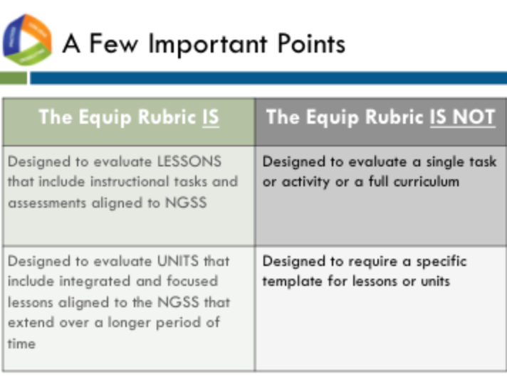
Slide 93
Talking Points
!
- As defined by the EQuIP Rubric:
  - A lesson is a coherent set of instructional activities and assessments that may extend over a few to several class periods or days; and
  - A unit is a coherent set of lessons that extend over a longer period of time.
- An integrated instructional sequence is rooted in an explanatory question aimed at making sense of a phenomenon or designing a solution to a problem.
- With these definitions in mind, it is important to note that the lessons the EQuIP Rubric is designed to evaluate may extend over a few class periods or days.
- Any single task, activity, or mini-lesson would not be suitable for use with the EQuIP Rubric as it would likely not include instructional supports and assessments, two of the categories of the rubric.
!
- Likewise, the EQuIP Rubric is not appropriate for reviewing a full curriculum; however, the rubric could be used to review specific lessons or units within the curriculum. A tool is currently being developed to look at full curricula.
- Finally, the EQuIP Rubric does not require that lessons or units be put into a specific format in order to be evaluated against the rubric criteria.
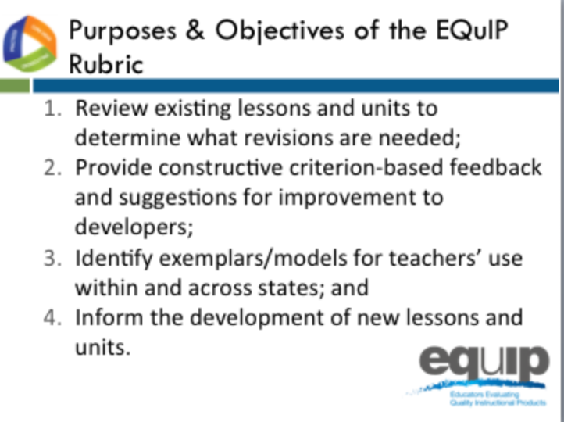
Slide 94
Talking Points
!
- The EQuIP quality review process is a collegial process that centers on the use of the criterion-based rubric for examining science lessons and units.
- While an individual certainly might use the rubric to examine a lesson or unit, the effective evaluation of lessons and units is the product of examination and discussion by a group of people using the rubric collaboratively.
- The specific, stated purposes of the EQuIP rubric are to:
  - Review existing lessons and units to determine what revisions are needed;
  - Provide constructive criterion-based feedback and suggestions for improvement to developers;
  - Identify exemplars/models for teachers’ use within and across states; and
  - Inform the development of new lessons and units.
- Other implicit goals of the rubric include:
  - Assisting teachers and district staff in the selection of high-quality instructional materials that are designed for the NGSS; and
  - Serving as a professional learning tool for analyzing lessons and units and deepening understanding of the NGSS.
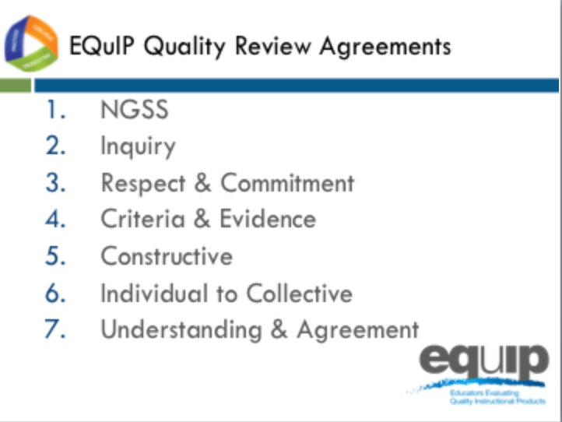
Slide 95
Facilitator Notes
Refer participants to Handout 6, Module 4, “EQuIP Agreements.”
Talking Points
- Everyone using the EQuIP Rubric to examine NGSS lessons and units should commit to the following agreements:
  - NGSS Understanding: Before beginning a review, all members of a review team have an understanding of the NGSS and the Framework.
  - Inquiry: Review processes emphasize inquiry (seeking to understand) rather than advocacy and are organized in steps using a set of guiding questions.
  - Respect and Commitment: Each member of a review team is respected as a valued colleague and contributor who makes a commitment to the EQuIP process.
  - Criteria and Evidence: All observations, evaluations, discussions, and recommendations are criterion- and evidence-based.
  - Constructive Feedback: Lessons and units to be reviewed are seen as “works in progress.” Reviewers are respectful of contributors’ work and make constructive observations and suggestions based on evidence from the work.
  - Individual to Collective Reviews: Each member of a review team independently records his/her observations prior to discussion. Discussions focus on understanding all reviewers’ interpretations of the criteria and the evidence they have found.
  - Understanding and Agreement: The goal of the process is to compare and eventually calibrate evaluations to move toward agreement about quality with respect to the NGSS.
- A rule of thumb for maintaining a respectful, collegial discussion might be to behave as if someone at your table has written or collaborated on a lesson or unit you are examining. Sometimes this may even be the case.

The Three-Category Structure of the Rubric
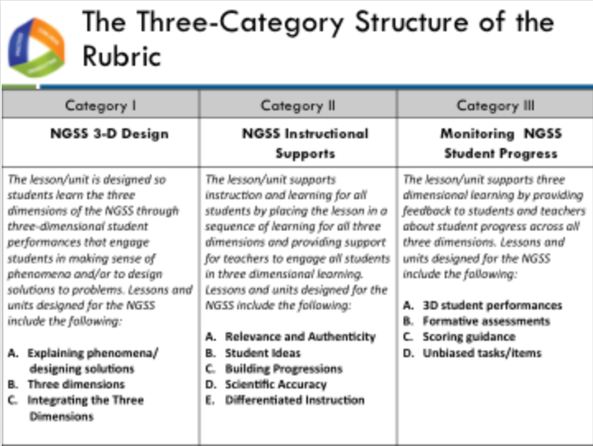
Slide 96
Facilitator Notes
Refer participants to their copy of the EQuIP Rubric version 3.0.
Talking Points
- Get out your copy of the EQuIP Rubric.
- Before we begin talking about the structure of the EQuIP Rubric version 3.0, turn to page two of the rubric—the back of the first page—and take a few minutes to circle important terms that jump out at you as you read through the document. [Note to facilitator: Allow three to five minutes for participants to circle terms then ask several to share. Keep this sharing non-evaluative and avoid responding to participants with words such as “good” or “great,” which tend to signify right or wrong answers.]
- Now let’s dive deeper into the rubric.
- All educators will examine instructional materials against the criteria in each category.
- As you can see, each category is structured with criteria for a lesson or unit at the top and additional criteria for a unit or longer lesson at the bottom.
- Within each category, specific criteria and sub-criteria are delineated, with uppercase Arabic letters (A, B, C, etc.) representing the main criteria and lowercase Roman numerals (i, ii, iii, etc.) representing the sub-criteria.
- Working collaboratively, educators are able to use common standards for quality and to generate evidence-based commentary on the quality and alignment of materials.
- A rating scale is found for each category as well as category ratings and a total score for the entire rubric.
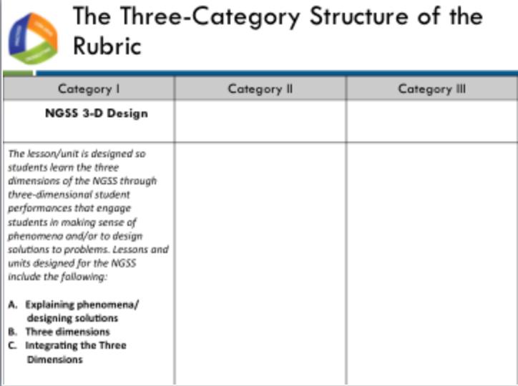
Slide 97
Talking Points
  - The first category is NGSS 3D Design. This includes supporting students in three-dimensional learning to explain phenomena or design solutions and ensuring lessons fit together coherently and develop connections.
- We will use the EQuIP Rubric to examine NGSS materials—lessons and units—carefully and in detail to determine whether or not they align with the conceptual shifts of the NGSS, including Category I, which states that “the lesson/unit is designed so that students make sense of phenomena and/or design solutions to problems by engaging in student performances that integrate the three dimensions of the NGSS.
- Examining a lesson or unit against the criteria in Category I: NGSS 3D Design, may reveal evidence related to Category II: NGSS Instructional Supports and/or Category III: Monitoring NGSS Student Progress; however, the EQuIP process involves examining a lesson or unit against the criteria for Category I before moving on to Category II and finally to Category III.
- If, as a result of examining a lesson or unit in relation to the criteria for Category I, we determine this NGSS alignment exists, we will then examine that lesson or unit further in relation to the criteria for Categories II and III.
- If, however, we determine this alignment does not exist, we may elect to discontinue any examination of the lesson or unit; or, if we determine that a lesson or unit has the potential to align with specific, targeted revisions, we may continue with our examination and provide guidance for the lesson or unit designer or user in regard to the changes that need to be made to bring the lesson or unit into alignment.
- Tricia Shelton, science teacher at Boone County Schools in Kentucky, explains this further in this short video.
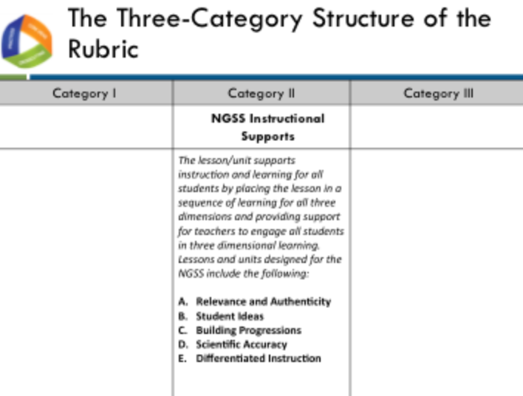
Slide 98
Talking Points
  - Now let’s look more closely at Category II: NGSS Instructional Supports. Category II focuses on supporting three-dimensional teaching and learning for all students by placing the lesson in a sequence of learning for all three dimensions and providing support for teachers to engage all students. Criteria and sub-criteria focus on engaging students in three-dimensional learning that is relevant, authentic, and connected to students’ experiences.
  - In addition, this category includes criteria related to providing guidance to help teachers build coherence and to provide and adjust supports for students in order to make students increasingly responsible for their learning.
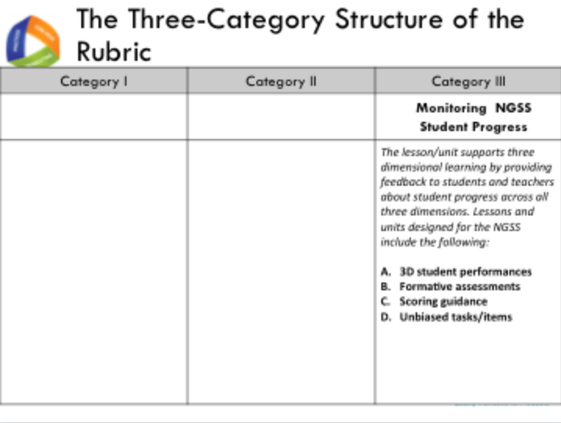
Slide 99
Talking Points
  - The third category, Monitoring NGSS Student Progress, ensures that assessments elicit observable evidence of three-dimensional learning, include formative assessments, and are accessible and unbiased.
  - It also ensures that all assessments—pre-, formative, and summative—are aligned to three-dimensional learning.
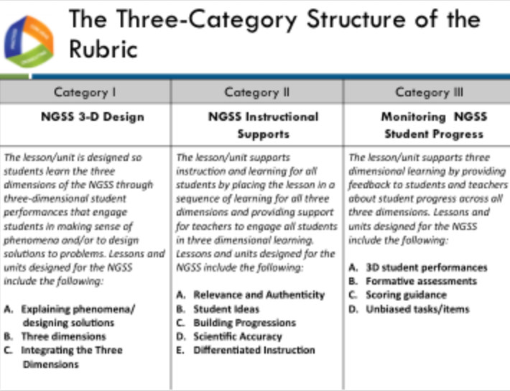
Slide 100
Talking Points
- By working collaboratively, educators can use common definitions of quality to generate evidence-based commentary on the quality and alignment of materials.
- We’ve just begun looking at the EQuIP Rubric by examining how it’s structured. Each of these three categories of the EQuIP Rubric will be discussed in greater detail in subsequent modules.

Concluding Slide for Module 4
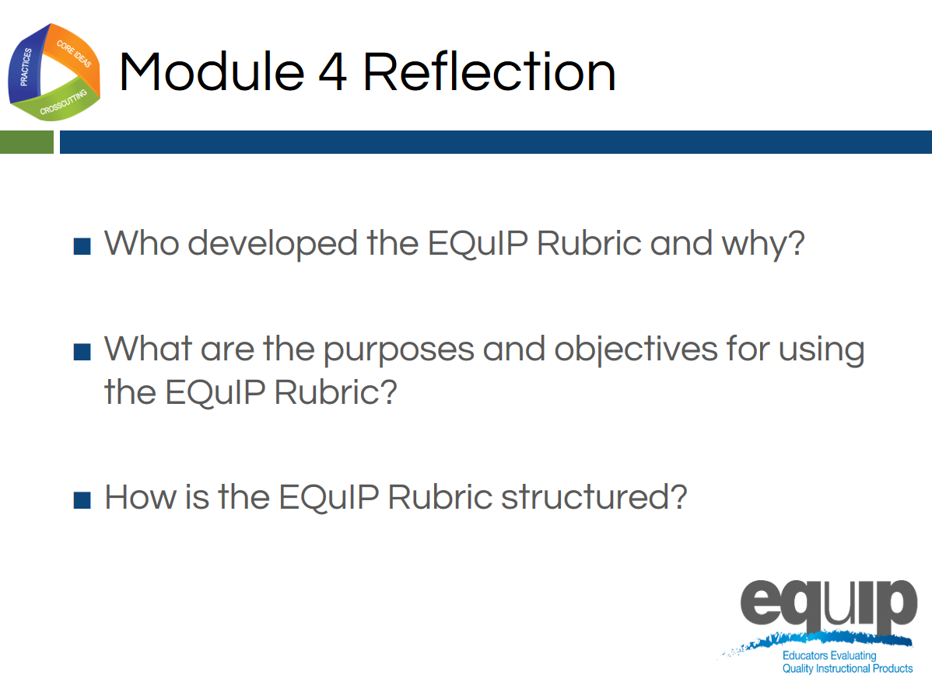
Slide 101
Talking Points
- Take a minute or two to look over the EQuIP Rubric again, noting the words you circled at the start of this module.
- Would you still circle the same words? Are there words you wouldn’t circle? Are there more words you would circle? Why or why not?
- How has what you’ve learned in this module informed your understanding of the EQuIP Rubric? What questions do you still have? [Note to facilitator: After three to four minutes, allow participants to share their thoughts and ask any remaining questions.]
- In the next module, we’ll take a look at what we mean when we talk about such things as evidence and reasoning in relation to using the EQuIP Rubric.

MODULE
EQuIP for Science v3.0
5

Providing Feedback,
Evaluation, and Guidance
Module 5: Providing Feedback, Evaluation, and Guidance
Module 5 provides common language that is essential for using the rubric. The terms evidence, reasoning, feedback, evaluation, and guidance are often used in the rubric and in the remaining modules; therefore, it is important for all participants to have a common understanding of these terms before moving on.
Materials Needed
- Module 5 PowerPoint slides or slides 102–113 of the full PowerPoint
- Handout 7: Module 4, “EQuIP Rubric, Version 3.0”*

*Introduced in a previous module.
Introduction to Module 5
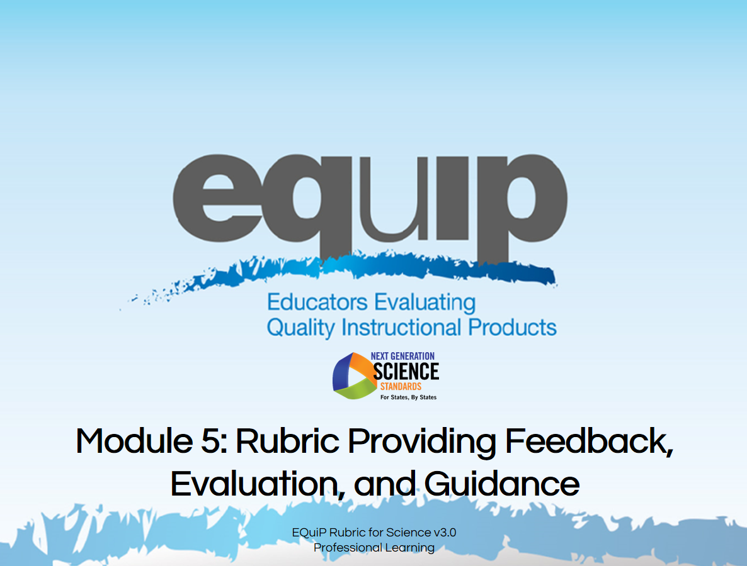
Slide 102
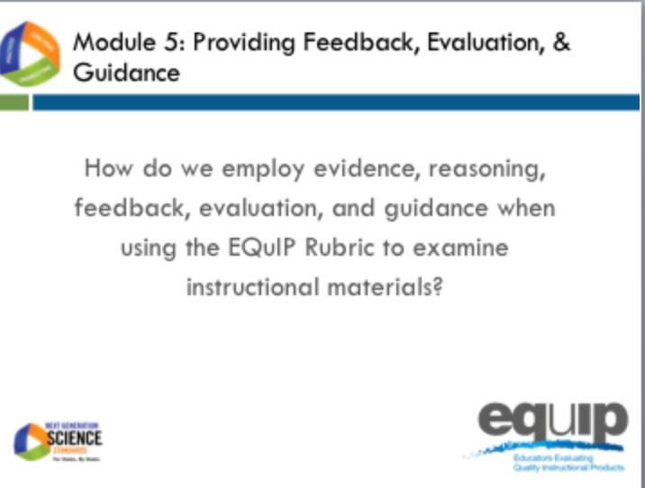
Slide 103
Talking Points
- Before we actually use the rubric to examine a lesson or unit, it’s important to take time to agree on what we mean by some of the language we’re using.
- While it’s easy to assume that everyone means the same thing when, for example, we talk about evidence, in reality, people often have different ideas about what constitutes evidence and what does not.
- So, for the purpose of using the EQuIP Rubric to examine lessons and units, we need to develop a common understanding of specific terminology.
- Once we have a common understanding of the terms we’ll be using frequently, we can then begin to use the rubric to examine lessons and units.
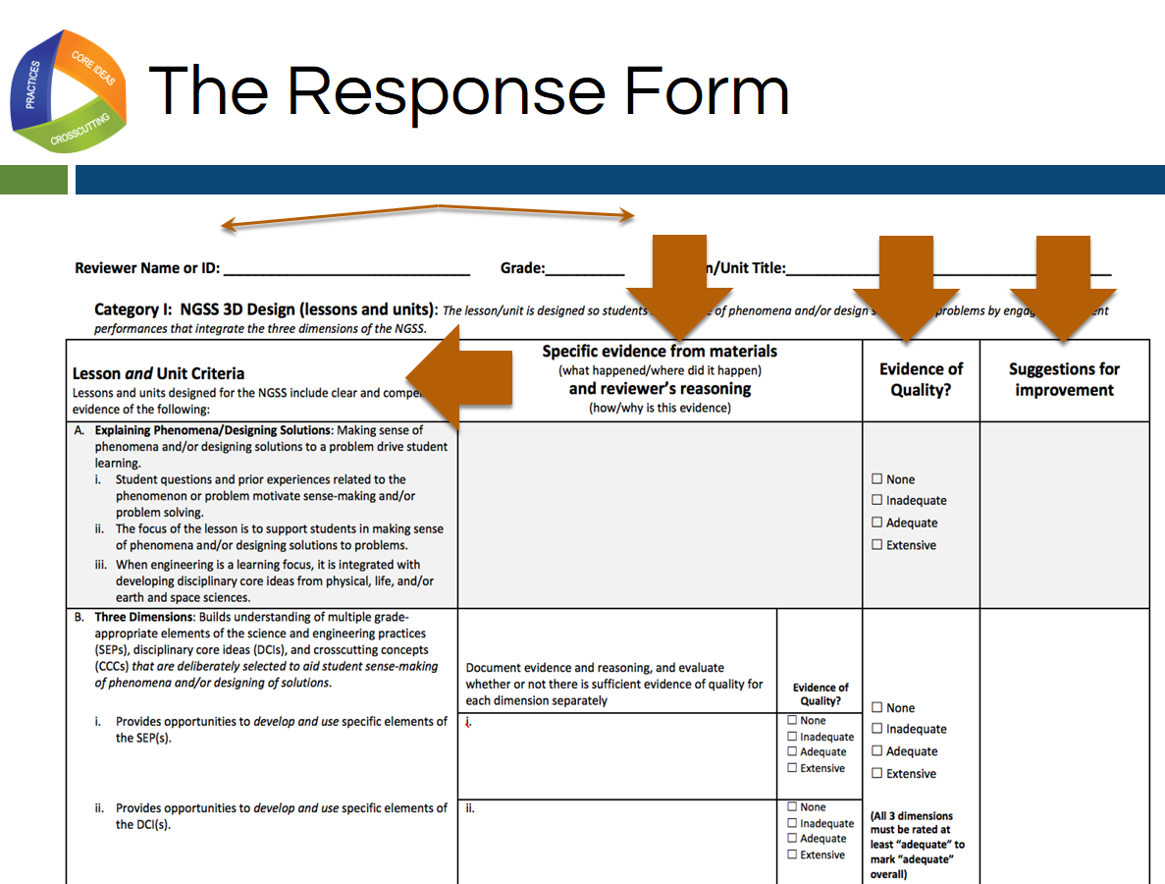
Slide 104
Talking Points
- Before we talk about the language of the rubric, let’s take a quick look at the response form section of the rubric. This begins on the page six of the rubric document.
- When using the response form, you will first record your name as the reviewer, the title of the lesson or unit, and the grade level for which the lesson or unit is intended at the top of the form. [Note to facilitator: Click for animation.]
- The first column of the response form lists the category and the criteria to which you are responding. [Note to facilitator: Click for animation.] The example on this slide shows Category I. Subsequent pages of the response form have Categories II and III.
- As you examine instructional materials, the second column of the response form is used to record evidence and reasoning. [Note to facilitator: Click for animation.]
- After examining the instructional materials and recording evidence from the lesson as well as why or how this evidence is an indicator of the rubric criterion being met (the reasoning), the third column is for recording the degree to which the evidence could be identified. [Note to facilitator: Click for animation.]
- Finally, the last column of the form is used to record suggestions for improvement. [Note to facilitator: Click for animation.]

Defining Terms
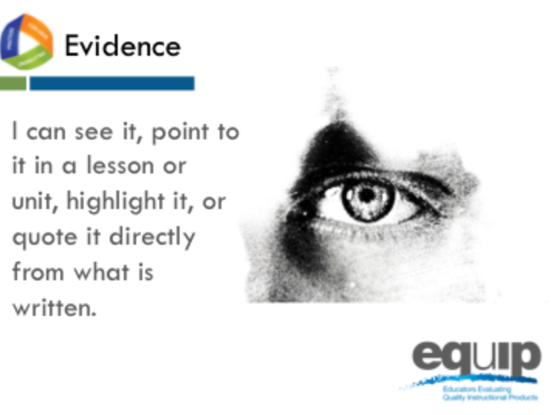
Slide 105
Talking Points
- Now we’re ready to determine a common understanding of what we mean when we talk about evidence.
- What should we be recording when we’re looking for evidence?
!
- Evidence is what is stated or described explicitly in a lesson or unit. If it is evidence, you can see it, point directly to it in the lesson or unit, highlight it, cite it, or quote it directly from what is written.
- When using the EQuIP Rubric, it is essential look for evidence of the different criteria in the lesson or unit itself before we start putting that evidence together to evaluate the lesson or unit.
- On a cautionary note, it is very common to want to “fill in the blanks” in a lesson or unit and add what we think the developer intended or what we would do if teaching the lesson and call it evidence; but to be very clear, we can only examine what we can see. If it’s not there, we cannot add it in and call it evidence. Think, for example, of asking a student to evaluate an argument. Students should only evaluate the argument as it exists and not “fill in the blanks” about what they think the person who made the argument intended. It is tempting for students to want to apply their own experiences and understanding to fill in the blanks, but the application of their expertise is better suited for making suggestions about how to improve the argument. Likewise, you cannot make assumptions about a lesson or unit developer’s intentions. Evidence must be explicitly stated in the materials you are examining. Later in the process, you will use professional judgment to decide whether the evidence is sufficient to say the criteria have been met and to make criterion-based suggestions for improvement. But for the purpose of finding evidence, it is essential to consider only what is explicit in the lesson or unit.
!
!
- In addition, it’s also common to skip right over the evidence and move directly to making judgments about whether or not a lesson or unit meets the rubric criteria or to offering suggestions on how to improve the lesson. We need to be careful to avoid this pitfall.
- Before we go on, let’s listen to Joe Krajcik address the importance of identifying evidence before determining whether a criterion has been met in this video.
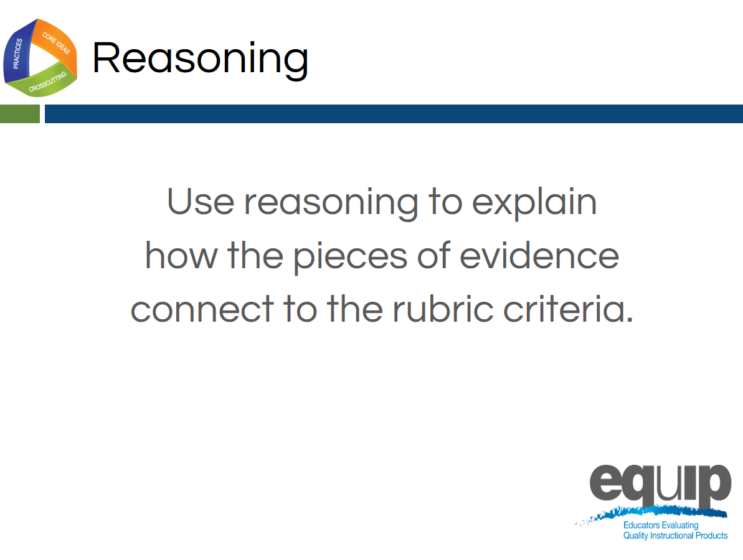
Slide 106
Talking Points
- Once we’ve located evidence of the criteria we’re looking for in a lesson or unit, we then use reasoning to explain how that evidence connects to the criteria in the rubric.
- Again, at this point we’re not yet evaluating whether the evidence is sufficient to say that the lesson or unit aligns to the NGSS in terms of three-dimensional learning or other criteria. We’re just stating that “x is an example of modeling at the element level”; “this element is part of the modeling science and engineering practice at the appropriate grade level”; “so, therefore, this lesson/unit includes a science and engineering practice.”
- It’s important to reason through these connections because it’s not at all uncommon for different people to see the same exact thing in a lesson or unit without making the exact same connections to the rubric criteria.
- We use reasoning to put the different pieces of evidence we find in the lesson or unit together and then to connect that evidence to the rubric criteria so that we can, ultimately, work collaboratively to evaluate the lesson or unit.
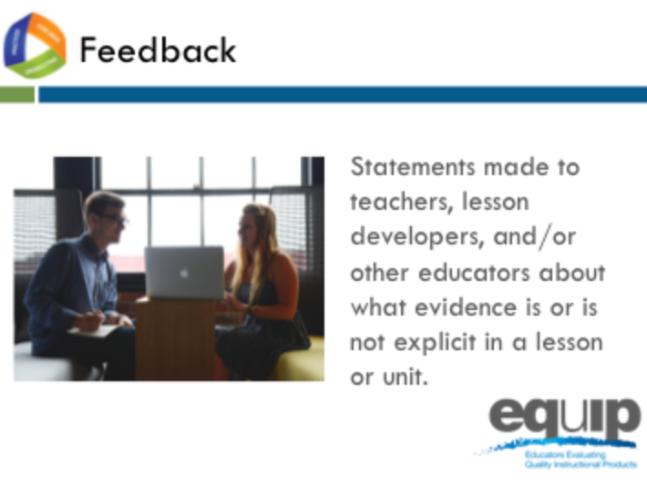
Slide 107
Talking Points
- In essence, feedback refers to statements made to teachers, lesson and unit developers, or other educators about what evidence is or is not explicit in a lesson or unit. Feedback is always criterion-based.
- Feedback may also include reasoning that explains how the evidence we see connects to one or more criteria in the rubric itself. For example, we might say something like, “Having the students develop a representation that presents a causal account to show that plants have similar life cycles is an example of X element of the modeling practice, therefore this lesson does include practices.” We may have similar evidence and reasoning for core ideas and crosscutting concepts.
- It also is critical to address whether the three dimensions are working together. For example, we might say something like, “Though each of the dimensions is present, they are each in isolation. I see no evidence that they are working together for three-dimensional learning.” In both of these examples we’re just stating what is or what is not explicit in the lesson or unit but not yet concluding whether or not the evidence is sufficient or of the quality necessary to state whether or not the lesson aligns with the NGSS.
- While it’s not uncommon to lump feedback, evaluation, and guidance together when making comments about a lesson or unit, it is important to be cognizant of how they are different from one another. We’ll talk more about evaluation and guidance in this module.
- For now, if we want to provide good feedback, we need to locate evidence determine how that evidence connects to the criteria on the rubric, and share this with the developer of the lesson.
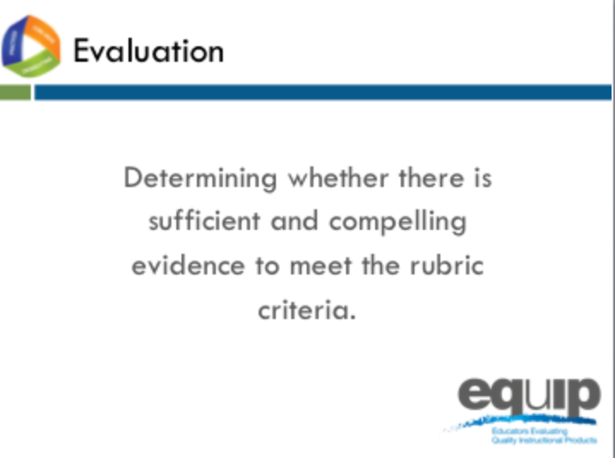
Slide 108
Talking Points
- Only after a group of people has individually examined a lesson or unit, identified the evidence of specific criteria in that lesson or unit, and used reasoning to establish the connections between the evidence and the criteria, can these individuals share their findings with the group. Then they can collaboratively determine whether they have sufficient and compelling evidence to say that the lesson or unit meets the rubric criteria and to evaluate the degree to which the rubric criteria are met.
- These evaluations can range from none, to inadequate, to adequate, and finally extensive. As a team, you will discuss the criteria and determine the degree to which clear and substantial evidence was found that the criteria have been met. Then, the group will enter a 0–3 rating for the category, for example, Category 1: NGSS 3D Design.
!
- Note that evaluation differs from reasoning as we defined it previously. Reasoning just makes the connection between the explicit evidence and what that evidence represents—for example, practices, disciplinary core ideas, or crosscutting concepts. In this step, we evaluate whether the evidence is sufficient and compelling enough to say, for example, that the practices, disciplinary core ideas, and crosscutting concepts work together to support students in three-dimensional learning to make sense of phenomena or design solutions to problems—in other words, sufficient and compelling enough to meet the stated rubric criteria.
Slide 109
Talking Points
- Finally, guidance refers to those suggestions for improvement that we provide to the developer of the lessons or units we are examining. These suggestions for improvement go in the final column of the response form. Feedback—statements about what is or is not in the lesson or unit—often provides the basis for suggestions for improvement.
- These suggestions should be stated positively as actions to be taken rather than statements about what is wrong with the lesson or unit.

Example Slides for Module 5
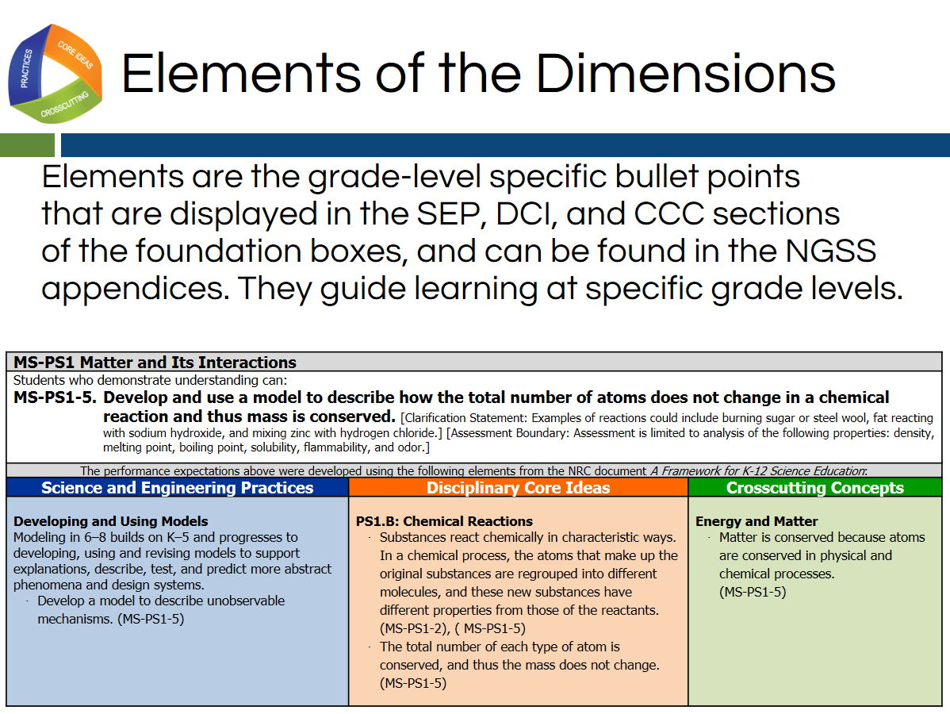
Slide 110
Talking Points
- As we close our discussion about the common language of the EQuIP rubric, let’s take a minute to define what we mean by the elements of the dimensions.
- Please take a minute to read the definition of an element of dimensions that is displayed in this slide.
- It is important that our evidence and guidance be recorded at the element level.
- We can find the elements of the science and engineering practices in NGSS Appendix F, and the elements of the crosscutting concepts in NGSS Appendix G.
- We will use the orange foundation boxes as shown here in this slide for the elements of the disciplinary core ideas.
- Let’s take a look at some examples of feedback using the elements of the dimensions.
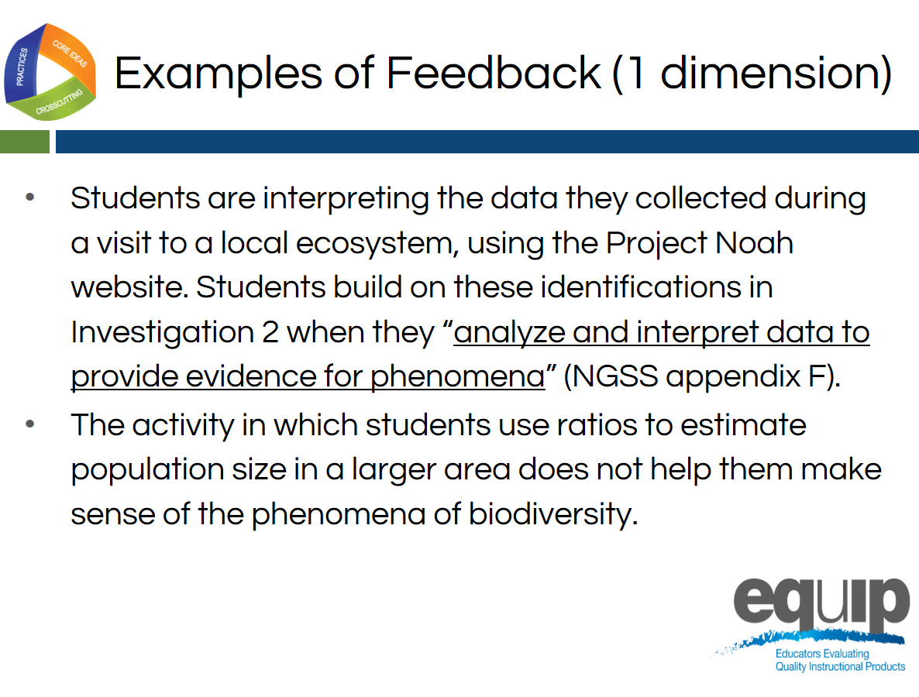
Slide 111
Talking Points
- This slide shows an example of feedback that could be recorded in column 2.
- The feedback provides evidence from the lesson about what happened in the lesson and where it happened.
- The element of the science and engineering practice of analyzing and interpreting data is found in the underlined portion of this slide.
- By connecting the lesson evidence with an element of the science and engineering practice “analyze and interpret data to provide evidence for phenomena”, the reviewer is providing reasoning for how this lesson evidence is evidence for Criterion B1, indicating that students are provided opportunities to develop and use specific elements of the science and engineering practices.

Concluding Slides for Module 5
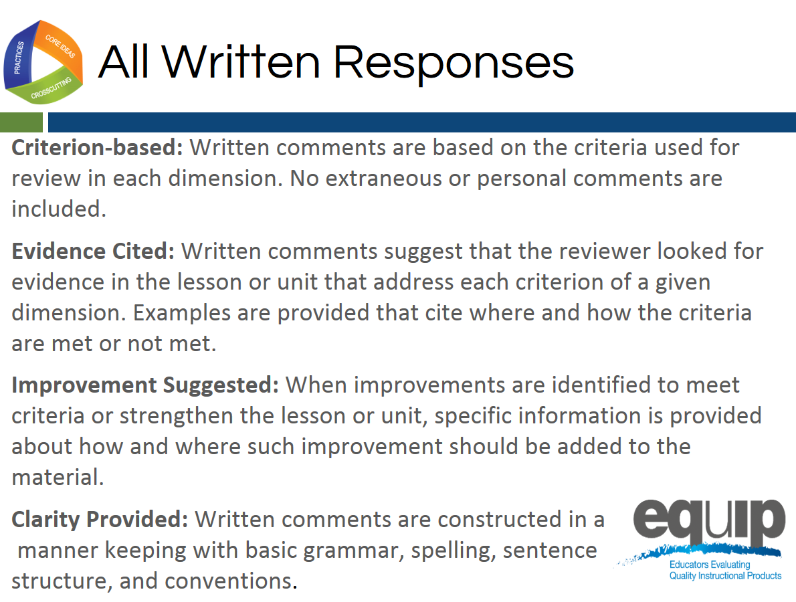
Slide 112
Talking Points
- Regardless of whether the comments provided on the response sheet are feedback, evaluation, or guidance, all comments should adhere to the following guidelines:
  - Be Criteria-Based: Written comments are based on the criteria used for review in each dimension. No extraneous or personal comments are included.
  - Cite Evidence: Written comments suggest that the reviewer looked for evidence in the lesson or unit that address each criterion of a given dimension. Examples are provided that cite where and how the criteria are met or not met.
  - Suggest Improvement: When improvements are identified to meet criteria or strengthen the lesson or unit, specific information is provided about how and where such improvement should be added to the material.
  - Provide Clarity: Written comments are constructed in a manner keeping with basic grammar, spelling, and sentence structure conventions.
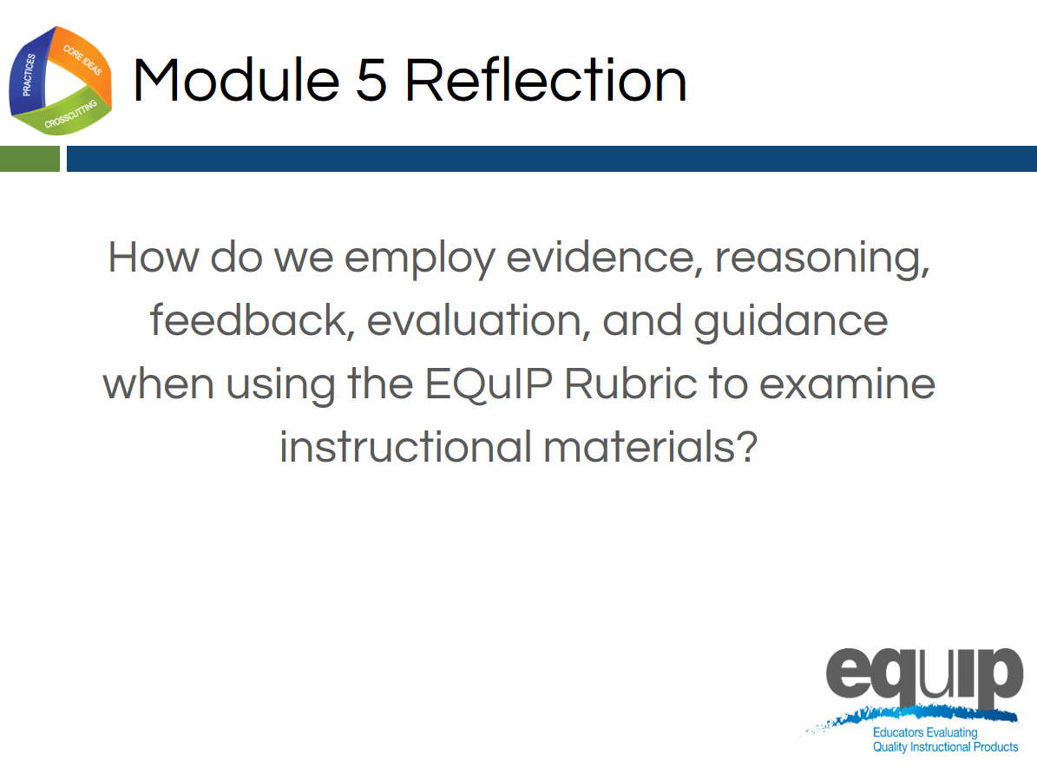
Slide 113
Talking Points
- In the next module, we’ll actually apply these definitions and examine a short lesson.

MODULE
EQuIP for Science v3.0
6

Category I:
Determining
Alignment
to the NGSS
Module 6: Category I: Determining Alignment to the NGSS
Module 6 dives deeper into three-dimensional learning by having participants examine a short video to help us understand how to determine whether the three dimensions are present and if they work together to support students in making sense of phenomena or designing solutions to problems. After this first task, participants begin examining a common lesson using criteria in Category I: NGSS 3D Design.
Materials Needed
- Module 6 PowerPoint slides or slides 114–144 of the full PowerPoint
- Common Lesson: Urban Heat Intermediate Version (Ideally this lesson will be shared with participants before the professional learning so they can review it)
- Blue, orange, and green highlighters.
- Handout 2: Using Phenomena in NGSS Lessons and Units*
- Handout 6: Module 4, “EQuIP Agreements and Table Facilitator Guidelines”*
- Handout 7: Module 4, “EQuIP Rubric, Version 3.0”* or a computer or tablet with the electronic version of the rubric (at least one person per table should record their group’s findings electronically)
Optional: Because participants will want to consider the elements of the three dimensions, it may be necessary to have copies of the standards as well as Appendix F and Appendix G . Alternatively, participants can find the standards and appendices at www.nextgenscience.org if Internet access is available.

*Introduced in a previous module.
Introduction to Module 6
Slide 114
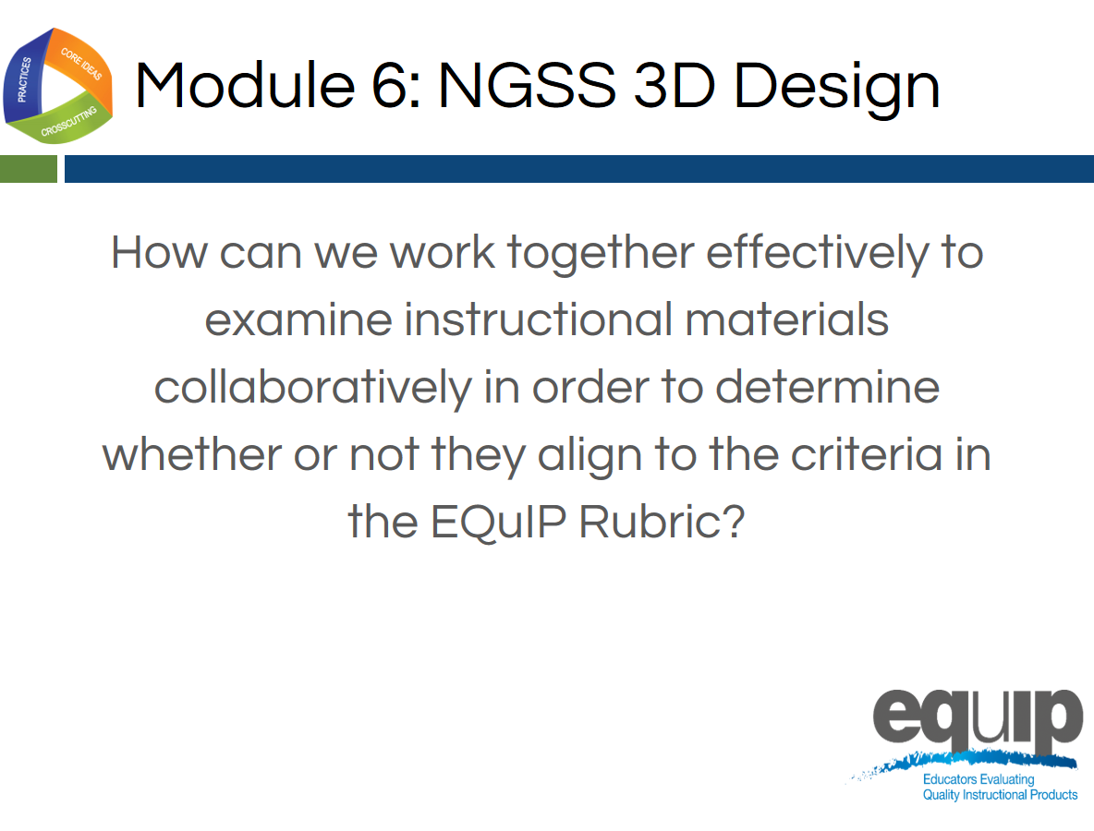
Slide 115
Talking Points
- In this module, we’re going to apply everything we’ve learned to this point and actually work together to examine a common lesson using the EQuIP Rubric.
- As we use the EQuIP Rubric in this module to examine instructional materials, you will:
  - Apply the common definitions we discussed in the last module.
  - Locate evidence of specific rubric criteria and use reasoning to explain how or why this evidence meets or does not meet rubric criteria.
  - Evaluate whether the evidence you’ve located is sufficient to demonstrate NGSS 3D Design.
  - Provide guidance regarding how a lesson or unit might be revised in order to meet rubric criteria.

Category I: NGSS 3D Design
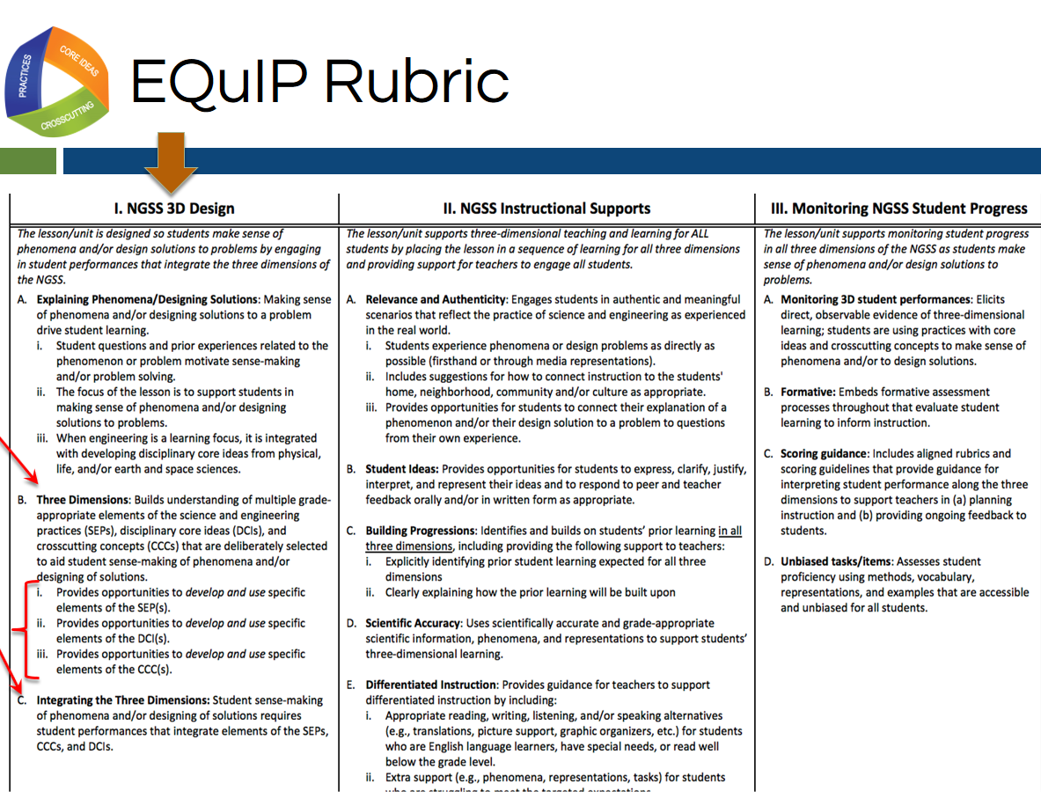
Slide 116
Talking Points
- Please get out your EQuIP Rubric and turn to page 2 of the rubric document where you’ll see all three categories of the rubric.
- For the lesson we are going to examine in this module, we will only be looking at the first major criteria in Category I and their component parts. [Note to facilitator: Click for animation.]
- We are going to start with Criterion B. Three Dimensions and C. Integrating the Three Dimensions, which was the focus of module 3 (as well as our immersion activity).
- [Note to facilitator: Click for animation once for B and a second time for C.]
- We will be looking at Criteria B and C along with the three sub-criteria under Criterion B. [Note to facilitator: Click for animation.]
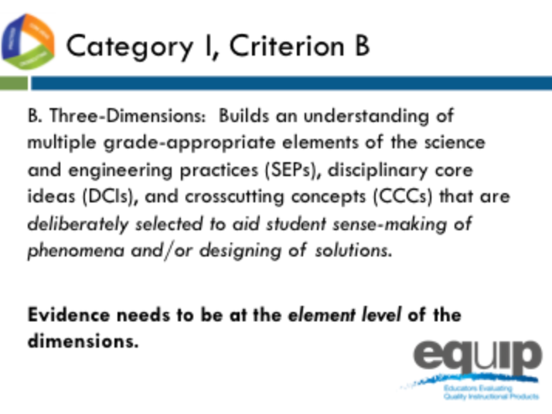
Slide 117
Talking Points
- Criterion B states about the three dimensions that they, “Build an understanding of multiple grade-appropriate elements of the science and engineering practices (SEPs), disciplinary core ideas (DCIs), and crosscutting concepts (CCCs) that are deliberately selected to aid student sense-making of phenomena and/or designing of solutions.”
!
- Here the term “elements” is used to represent the relevant, bulleted practices, disciplinary core ideas, and crosscutting concepts that are articulated in the foundations boxes of the standards, as well as in the NGSS appendices on each dimension. Looking at the elements ensures that each dimension is grade or grade-band appropriate.
- It is important to note that evidence recorded in the rubric needs to be at the element level of each dimension: practices, core ideas, and crosscutting concepts.
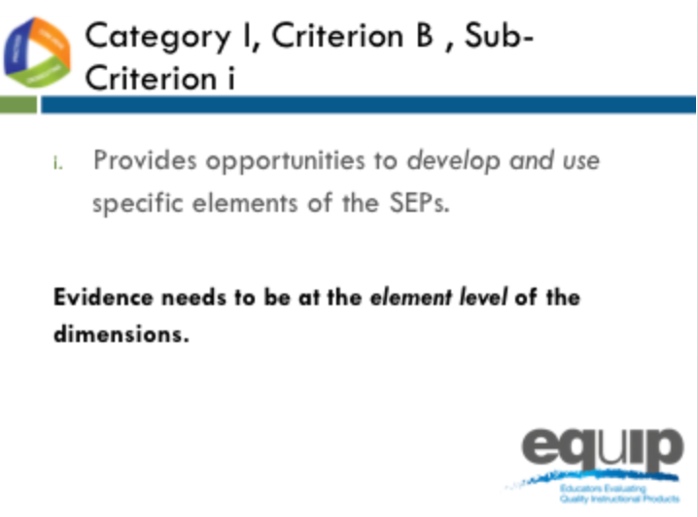
Slide 118
Talking Points
- We’ll also be looking at the sub-criteria under this overall criterion.
- Category I, Criterion B, Sub-Criterion i:
  - Provides opportunities to develop and use specific elements of the SEPs.

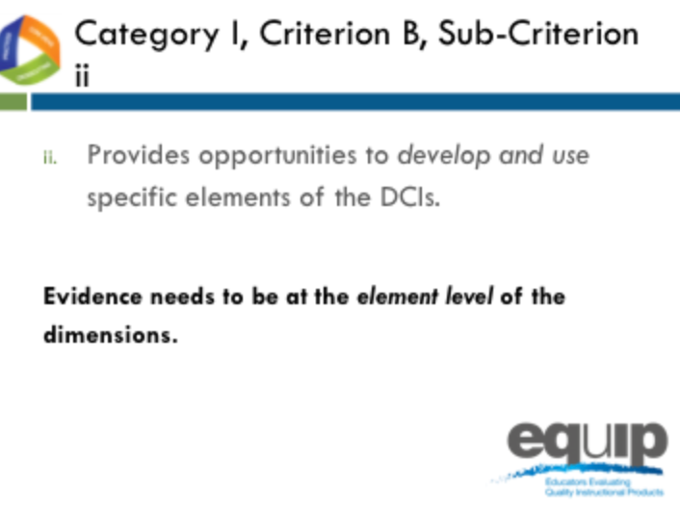
Slide 119

Talking Points
- Category I, Criterion B, Sub-Criterion ii:
- Provides opportunities to develop and use specific elements of the DCIs.
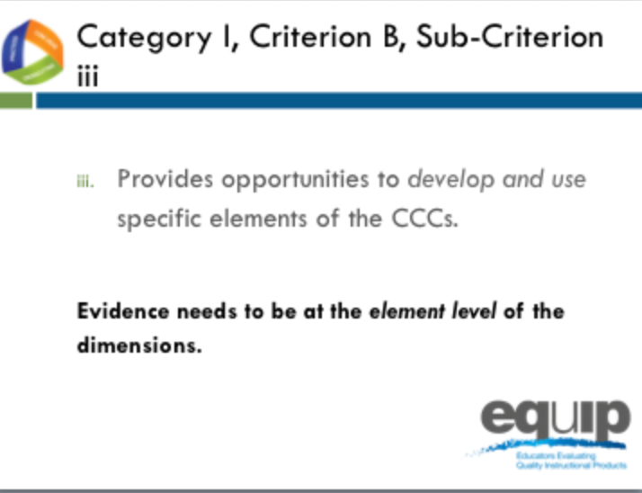
Slide 120
Talking Points
- Category I, Criterion B, Sub-Criterion iii:
- Provides opportunities to develop and use specific elements of the CCCs.
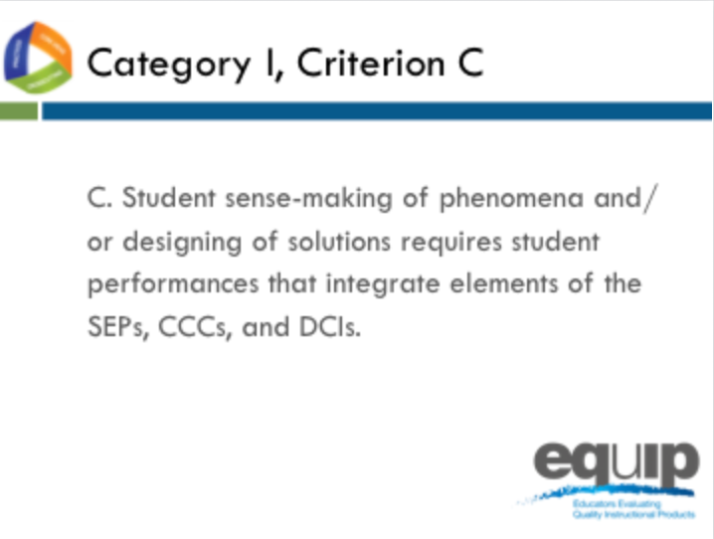
Slide 121
Talking Points
- And Category I, Criterion C:
Student sense-making of phenomena or designing of solutions requires student performances that integrate elements of the SEPs, CCCs and DCIs.
- Has everyone located Category I, Criteria B and C on the EQuIP Rubric?

Slide 122
Facilitator Notes
- The video can be found at the following link: http://www.nextgenscience.org/resources/ngss-equip-rubric-3-dimensional-learning
Talking Points
- This video highlights Category 1, Criterion B and C of the EQuIP rubric, three-dimensional learning.
- Let’s view this video together to help us determine whether the three dimensions are present and if they work together to support students in making sense of phenomena or designing solutions to problems.
- Note to facilitator: After the video Ask participants: “What kinds of changes do you think three-dimensional classrooms will require for teachers?” Have a brief discussion (1–2 minutes).
- [Note to facilitator: After discussion about the first question, ask “What are some major look-fors in a lesson to determine if it is three-dimensional? Have a brief discussion (1–2 minutes).
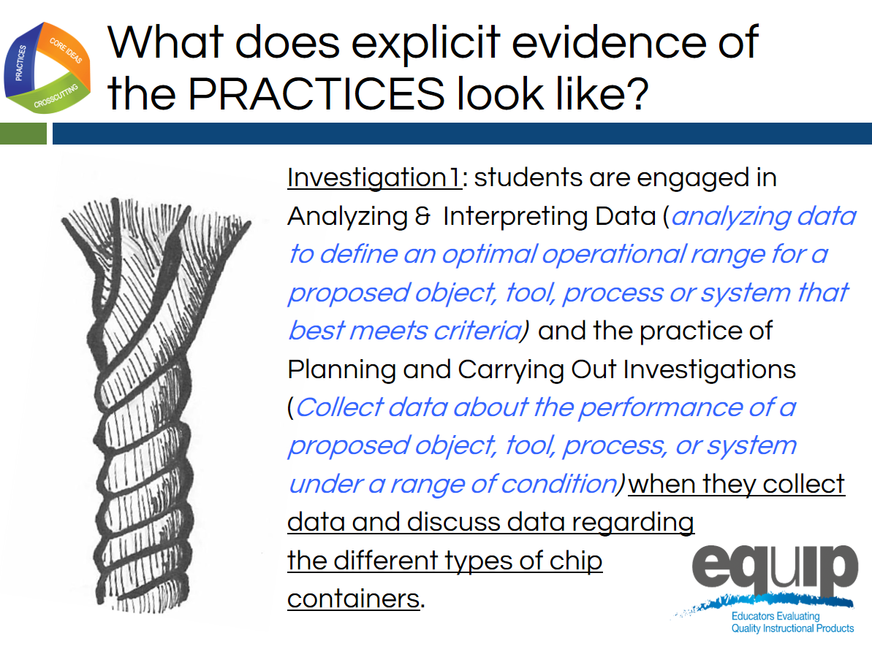
Slide 123
Talking Points
- Now, let’s look at some examples of how we can record evidence of these “look-fors” in a lesson in column 2 of the EQuIP response form together.
- This feedback should include evidence from the lesson, evidence from the NGSS for this dimension at the element level, and your reasoning of WHY or HOW this evidence connects to the rubric criteria.
- Let’s remember that the criterion for Category 1B sub criterion I is “Provides opportunities to develop and use specific elements of the SEPs.”
- When we look at this slide, we see that the reviewer cites specific details about where the evidence of the SEPs was found in the lesson by indicating “Investigation 1” and “when they collect data and discuss data regarding the different types of chip containers”, which are both underlined on this slide.
- In addition, the reviewer cites evidence of the SEPs by indicating the name of the practices (analyzing and interpreting data and planning and carrying out investigations) as well as the elements of the practices that this lesson addresses. For analyzing and interpreting data, the element identified is analyzing data to define an optimal operational range for a proposed object, tool, process or system that best meets criteria) and the element of the practice of planning and carrying out investigations is collect data about the performance of a proposed object, tool, process, or system under a range of condition).
- It is important when providing feedback that both lesson evidence and element level NGSS evidence from the appendices be connected in column 2 when giving feedback about this sub-criterion.
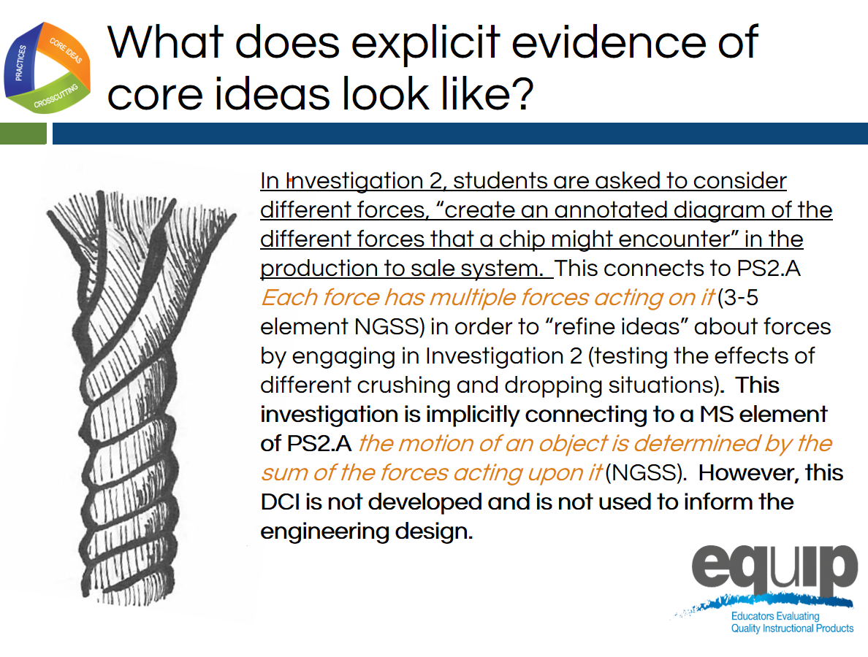
Slide 124
Talking Points
- Category 1B sub criterion ii is “Provides opportunities to develop and use specific elements of the DCIs.”
- When we look at this slide, we see that the reviewer cites specific details about where the evidence of the SEPs was found in the lesson by indicating “In Investigation 2, students are asked to consider different forces, “create an annotated diagram of the different forces that a chip might encounter in the production to sale system,” which is underlined on this slide.
- The reviewer makes a claim that this serves as evidence for PS2.A Each force has multiple forces acting on it. This is an element of the disciplinary core idea PS2.A at the 3–5 grade band and only implicitly connects to the middle school elements of this core idea.
- Because the evidence is explicit for a grade band below the lesson target AND this science is not used to inform the engineering design (which is critical when a lesson contains an engineering task), this evidence would not be adequate to say that students had opportunities to develop and use specific elements of the disciplinary core ideas.

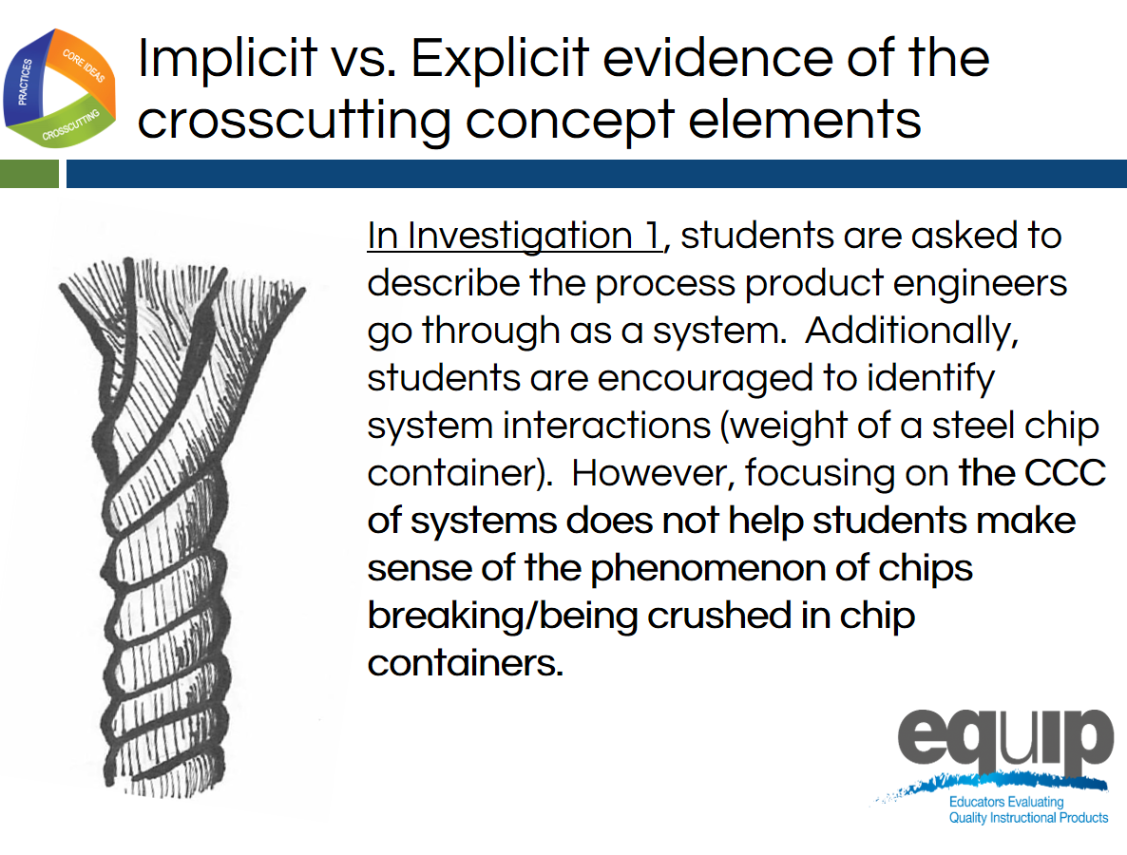
Slide 125
Talking Points
- This slide describes implicit evidence of the crosscutting concept.
- In this case, the evidence is implicit since on the CCC of systems does not help students make sense of the phenomenon of chips breaking/being crushed in chip containers.
- What is the difference between implicit and explicit evidence?
- Remember, for the purposes of the EQuIP Rubric, evidence is what is stated or described explicitly in a lesson or unit. If it is evidence, you can see it, point directly to it in the lesson or unit, highlight it, cite it, or quote it directly from what is written.
- For lesson evidence to be explicit for Category 1, Criterion B, students need to have the opportunity to use the element of the dimension to make sense of the phenomenon or to develop a solution to a problem.
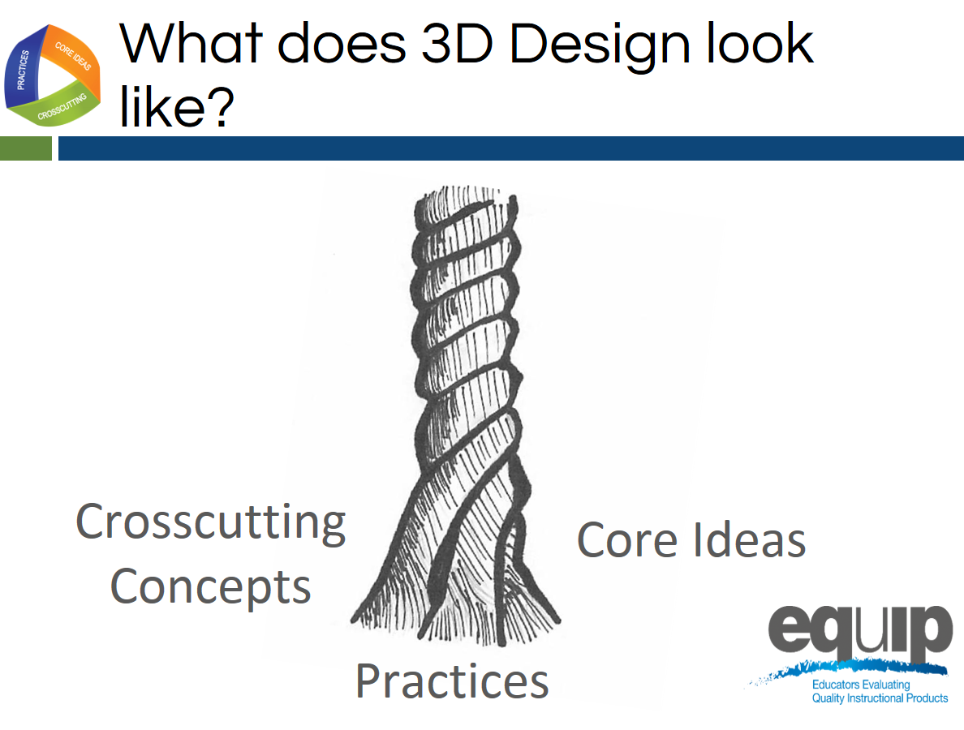
Slide 126
Talking Points
- After we look for evidence of each of the three dimensions separately so we can provide very specific feedback and guidance to the lesson or unit developer, we look for evidence of integration of the three dimensions for Criterion 1C.
- When looking for evidence of this criterion, we can ask ourselves: Do the students have an opportunity to engage in three-dimensional learning to help them make sense of phenomena or design solutions, OR Do the three dimensions occur in isolation?
- Our goal throughout this training is to develop a common understanding of alignment and quality among those persons or groups reviewing lessons and units.
- We’re going to practice this with a common lesson now.
Learning Task: Working Through the Process
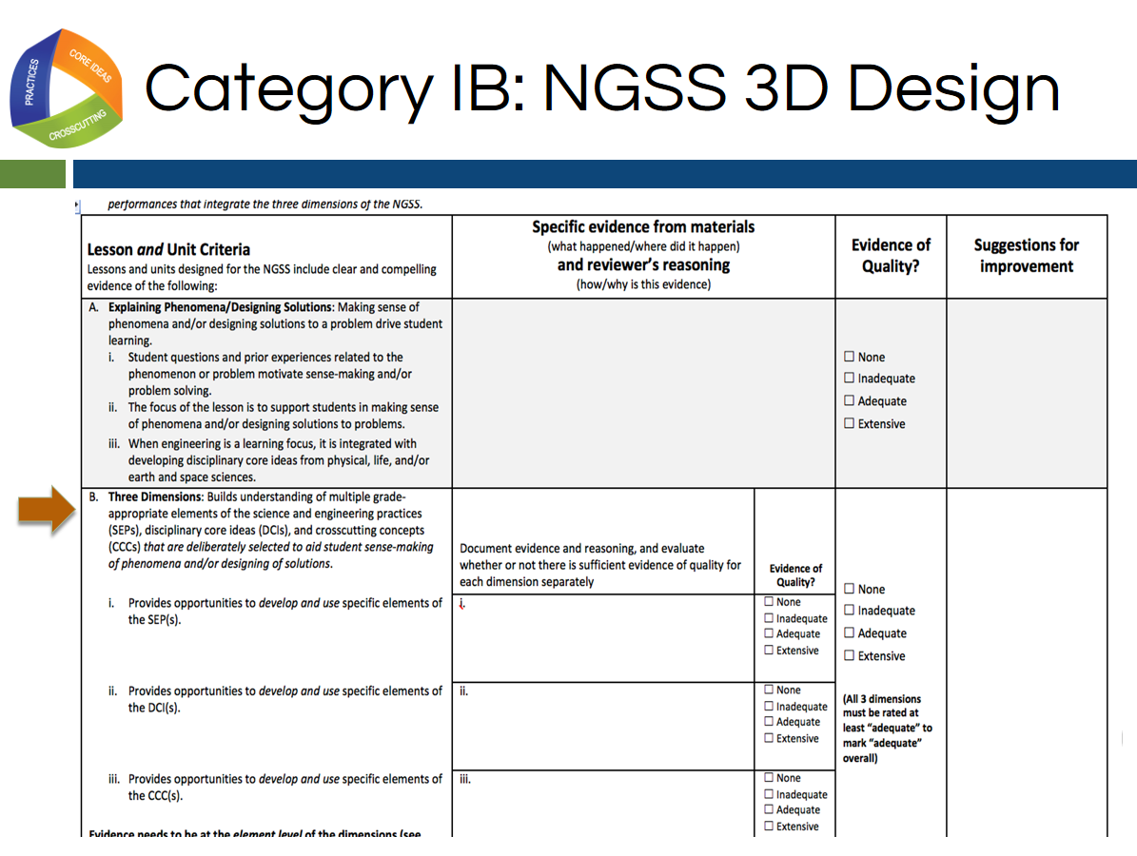
Slide 127
Talking Points
- For this task you will need:
  - An electronic or a hard copy of the EQuIP Rubric version 3.0;
  - Common Lesson Urban Heat [Note to facilitator: Intermediate version]; and
  - Blue, orange, and green highlighters.
- [Note to facilitator: Specific entities using this training may elect to examine their own or other different materials. If this is the case, however, the trainers/facilitators should take time to examine the common lesson included with this training thoroughly to ensure that the training with these different materials is consistent with what is intended.]
- For this task, you will only be working with the second section of Category I of the EQuIP Rubric, starting with Criterion B that is pictured on this slide. It’s the same criterion we just looked at with the example.
- This task is designed to acquaint you with the process for using the rubric to examine lessons and units. This examination involves the seven processes and agreements discussed in the previous module, so you may want to pull out that handout and look over it again.
- Before we get started let’s listen to Tricia Shelton discuss how much evidence is sufficient in this video. Joe Krajcik also discusses one example of thinking about how much evidence is sufficient – how student and teacher materials should work together – in this video.
- As you peruse the lesson to make these determinations, you will be locating and marking the actual evidence in the lesson that supports the rubric criteria.
- Because you have a limited amount of time for this task, you may not be able to list all of the evidence that supports a criterion; rather, you may need to cite examples.
- As you work through this common lesson, it is essential that you follow the instructions exactly in order to experience the process as it should be followed in later modules.
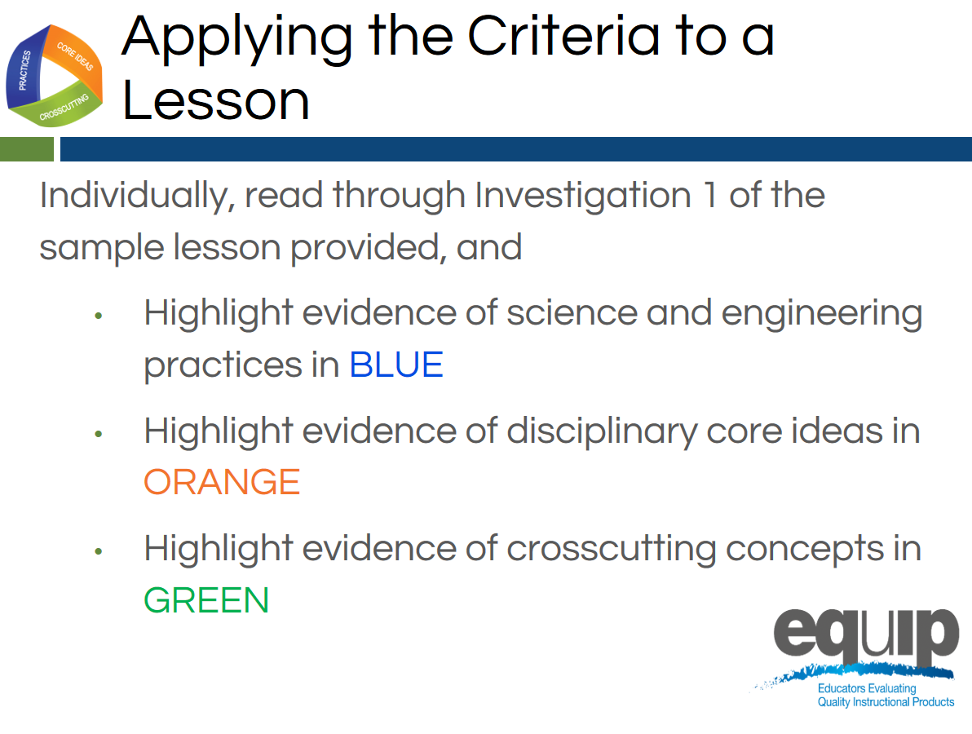
Slide 128
Talking Points
- First, examine the common lesson Urban Heat Intermediate version for evidence of science and engineering practices, core ideas, and crosscutting concepts. Don’t forget to refer back to the elements of the dimensions found in the foundation boxes and the appendices.
- Initially, we will only examine Investigation 1, highlighting evidence of the three dimensions according to the key on the screen: evidence of the science and engineering practices in blue, evidence of the disciplinary core ideas in orange, and evidence of the crosscutting concepts in green.
- We will stop and briefly discuss this evidence before continuing the evaluation of the common lesson.
- This is completed individually without any discussion between or among group members. Even if you complete this part before other tables are finished, do not discuss your findings before being instructed to do so.
- As you locate evidence, use the Arabic and Roman numerals associated with the rubric criteria to code the evidence you locate.
- Remember, evidence is what you can see explicitly in the lesson or unit.
- You can use the second column of the response form to summarize your evidence.
- You have 15 minutes to do this. [Note to facilitator: Set a timer for 15 minutes, on the screen for all to see if possible. When the timer sounds, ask if participants need more time before moving on.]
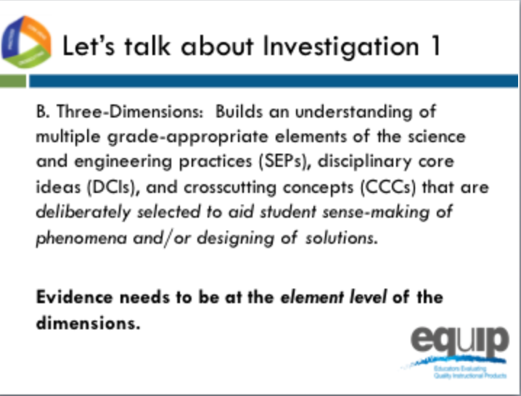
Slide 129
Facilitator Notes
Below are some examples of feedback (evidence and reasoning) from column 2 of the rubric for the Urban Heat intermediate version. This may be helpful in supporting a discussion about evidence and reasoning for Investigation 1. The purpose of this discussion is to help participants have confidence when continuing their evaluation of the common lesson.
Here is a link to a sample rubric created for this intermediate version that may be helpful for module 6 only since in module 7, we switch to the final version of the lesson
Science and Engineering Practices
- On page 1 students are “defining what the independent and dependent variable will be for the experiment” providing an opportunity for students to, “identify independent and dependent variables” which is part of an element of Planning and Carrying out Investigations (NGSS Appendix F). However, this is the only element of this practice, providing limited evidence of this practice
- On page 2, students are asked to communicate their understanding of “temperature variance on different surfaces” through an explanation in the “assessment” section. However, there is not enough guidance to be sure this meets the elements of Constructing Explanations and Designing Solutions
Disciplinary Core Ideas
- In investigation 1, students are developing and using elements of PS4.B. Specifically, they are seeing that when light shines on an object, it is reflected, absorbed, or transmitted though the object, depending on the object’s material and the frequency (color) of the light.
- In investigation 1, students are developing and using elements of PS3.A. Specifically, “temperature is a measure of the average kinetic energy of particles of matter. The relationship between the temperature and the total energy of a system depends on the types, states, and amounts of matter present.”
Crosscutting Concepts
- On page 1 students are engaged by posing the question “why it is so much cooler on the grass at a park than on the pavement?” setting up the investigation of a cause and effect relationship involving surface temperature and urban development.

Talking Points
- Let’s share some evidence from Investigation 1 that may meet the sub-criteria for IB.
- Let's start with evidence of the science and engineering practices. Were students given an opportunity to develop and use specific elements of the science and engineering practices in Investigation 1? [Note to facilitator: Accept some responses from participants and emphasize some points from the facilitator notes.]
- Were students given an opportunity to develop and use specific elements of the disciplinary core ideas in Investigation 1? [Note to facilitator: Accept some responses from participants and emphasize some points from the facilitator notes.]
- Were students given an opportunity to develop and use specific elements of the crosscutting concepts in Investigation 1? [Note to facilitator: Accept some responses from participants and emphasize some points from the facilitator notes.]
- Does anyone have any questions about finding evidence in a lesson and connecting it to both the criteria for IB and the elements of the dimensions?
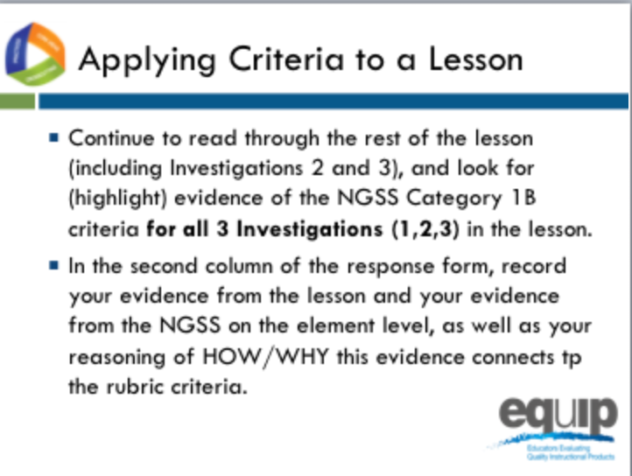
Slide 130
Talking Points
- Now, let's continue to read and highlight the rest of the common lesson for evidence of science and engineering practices, core ideas, and crosscutting concepts. Don’t forget to refer back to the elements of the dimensions found in the foundation boxes and the appendices.
- This is completed individually without any discussion between or among group members. Even if you complete this part before other tables are finished, do not discuss your findings before being instructed to do so.
- As you locate evidence, use the Arabic and Roman numerals associated with the rubric criteria to code the evidence you locate from the lesson, and the evidence from the NGSS at the element level using the appendices.
- Remember, evidence is what you can see explicitly in the lesson or unit.
- You can use the second column of the response form to summarize your evidence and your reasoning of HOW/WHY this evidence connects to the rubric criteria and sub-criteria for Category 1B.
- Reasoning is the bridge connecting the evidence to the rubric criteria and to how the practices, core ideas, and crosscutting concepts work together
- You have fifteen minutes to do this. [Note to facilitator: Set a timer for fifteen minutes, on the screen for all to see if possible. When the timer sounds, ask if participants need more time before moving on.]
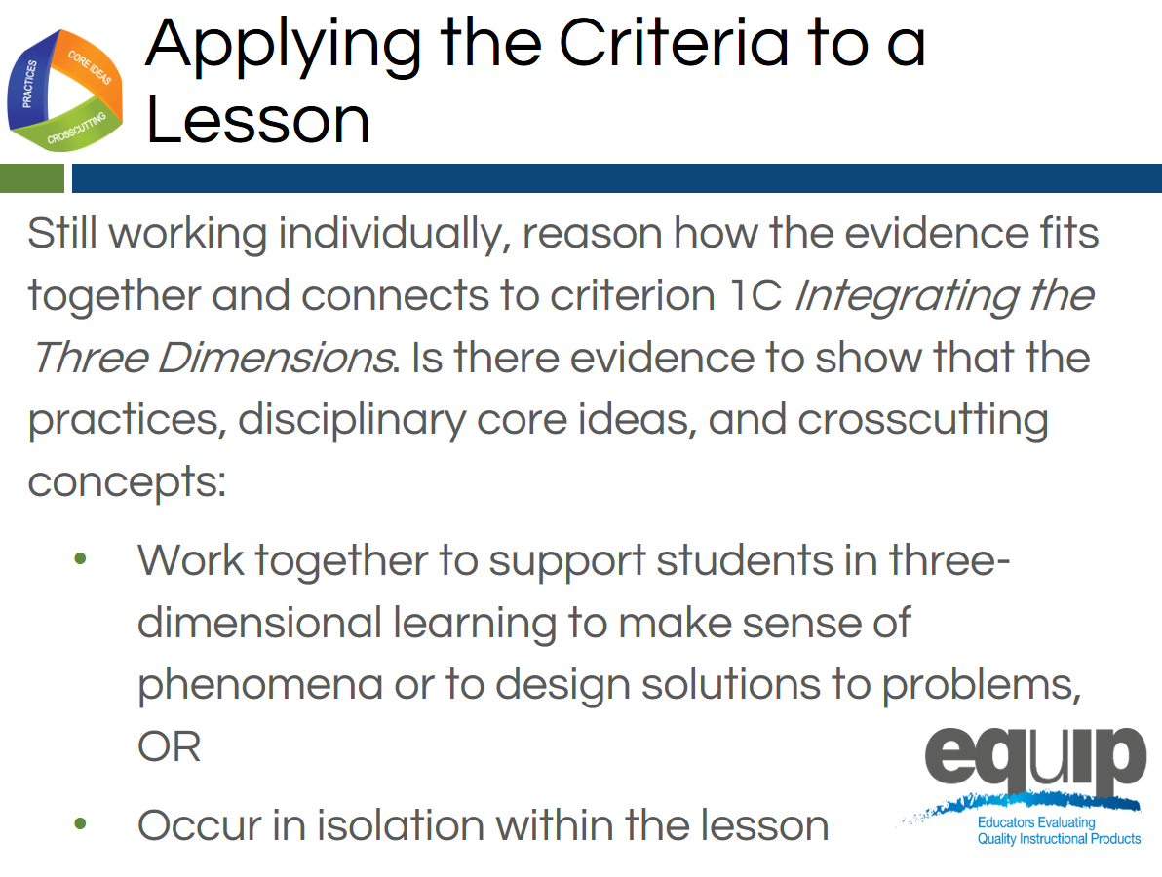
Slide 131
Talking Points
- Still working as individuals, let's consider Category 1, Criterion C: Integrating the Three Dimensions.
- Remember, the three dimensions need to work together to support student sense-making of phenomena or designing solutions to problems.
- For the dimensions to work together, student performances that integrate the elements of the SEPs, DCIs and CCCs are required.
- As you consider evidence for this criterion, ask yourself “Do the students have an opportunity to engage in three-dimensional learning to help them make sense of phenomena or design solutions, OR Do the three dimensions occur in isolation?”
- Again, you can use the second column of the response form for this.
- You have five to seven minutes to do this. [Note to facilitator: Set the timer but ask if participants need more time before moving on.]
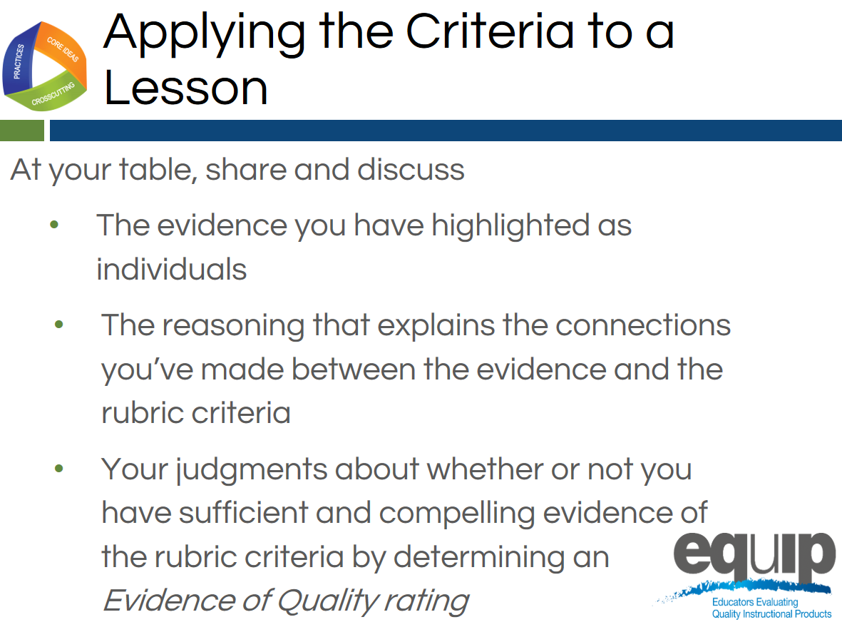
Slide 132

Facilitator Notes
At this point ask that the note takers record their group’s findings electronically on the response form. In addition, if available, provide each group with a small projector so that the information being inputted can be seen by all group members. A screen sharing application also could be used.
Talking Points
- Now you finally get to share and compare.
- Before you begin the group discussion, designate a table facilitator and recorder for your group and take a minute to review the Table Facilitator expectations on the back of Handout 6.
- Making sure everyone contributes his/her findings, share and discuss:
  - [Note to facilitator: Click for animation.] The evidence you highlighted;
  - [Note to facilitator: Click for animation.] The reasoning that explains the connections you made between the evidence and the rubric criteria; and then
  - [Note to facilitator: Click for animation.] Collaboratively evaluate whether this lesson or unit includes sufficient and compelling evidence of three-dimensional learning and whether or you see evidence of NGSS 3D Design according to Criteria IB and IC.
- Attempt to reach consensus as a table group and determine an evidence of quality rating for Category IB and Category 1C. Be prepared to share your evaluation and support them with evidence and reasoning.
- You have 30 minutes for this discussion. [Note to facilitator: Set the timer for 30 minutes but monitor the table groups and provide more or less time as needed to complete this. When the table groups are ready, have two or three share their determinations and then allow for questions and comments related to the determinations before moving on.]
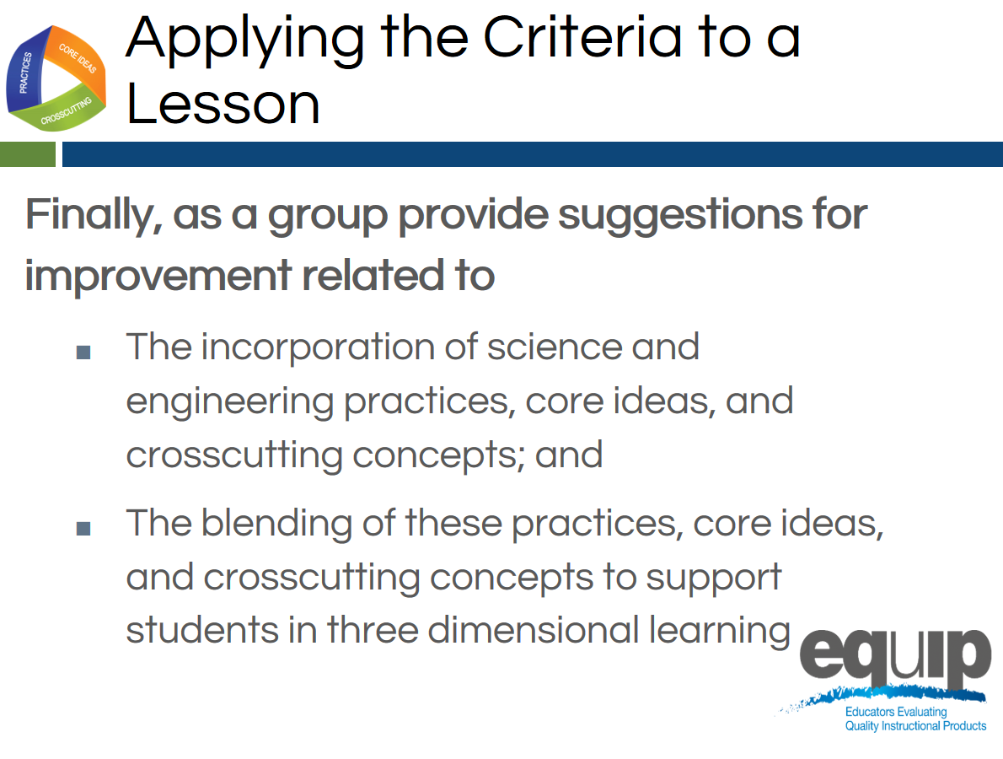
Slide 133
Talking Points
- This part of the task involves providing guidance or suggestions for how the lesson developer can improve the lesson.
- This guidance should be at the element level. Again, when using the EQuIP Rubric, the term “element” refers to the relevant, bulleted practices, disciplinary core ideas, and crosscutting concepts that are articulated in the foundations boxes of the standards, as well as in the NGSS appendices on each dimension.
- Remember to state these suggestions as positive actions for the developer to take rather than as negative statements of what’s missing, etc.
- You have five minutes for this. [Note to facilitator: Set the timer for five minutes. When it sounds, ask for two or three suggestions for improvement before moving to the next slide.]
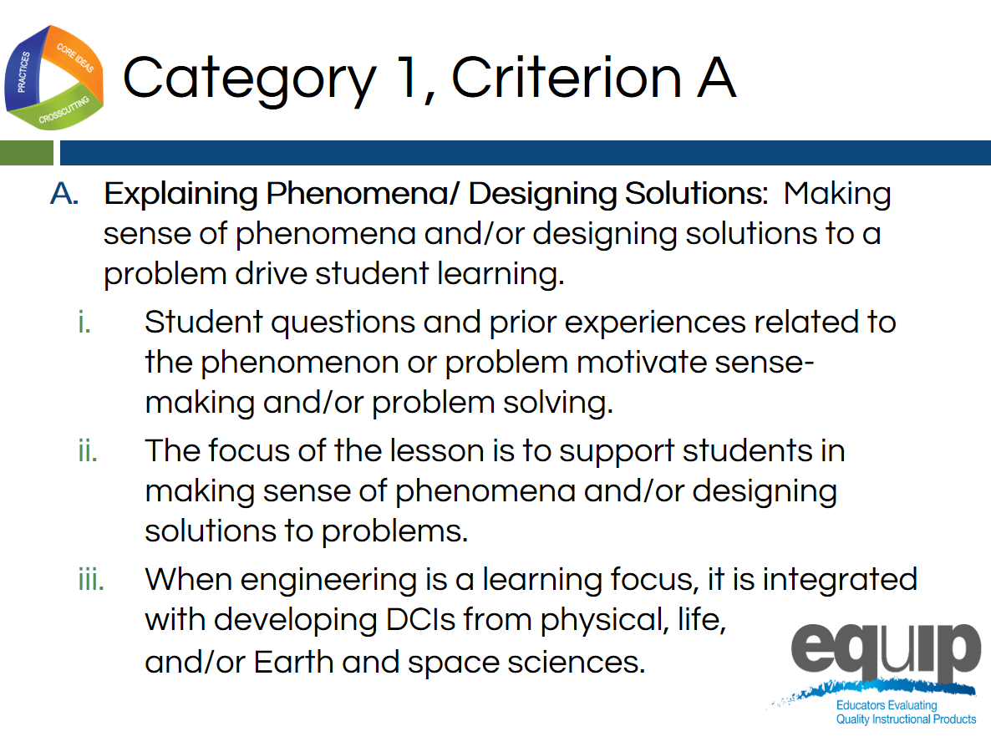
Slide 134
Talking Points
- Now that we have first individually and then collectively determined if there was evidence of three-dimensional learning, let’s consider Criterion A of Category 1: Explaining Phenomena and Designing Solutions.
- This criterion focuses on how making sense of phenomena or designing solutions to problems drives the three-dimensional learning evaluated thus far in the training.
- Before we return to the evaluation of our common lesson, let’s establish some common language and understandings about phenomena and how they are important to NGSS design.
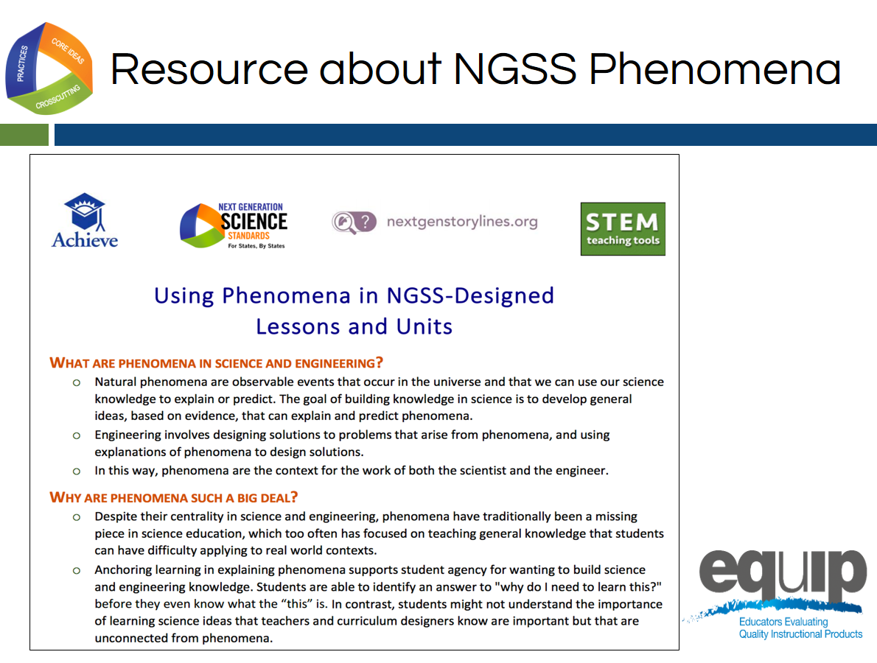
Slide 135
Talking Points
- Phenomena are an essential piece if NGSS 3D Design.
- Please find Handout 2: Using Phenomena in NGSS-Designed Lessons and Units.
- Please take a few minutes to read this resource developed by Achieve and some of its partners.
- You have five minutes for this task. [Note to facilitator: Set the timer for five minutes. If this handout was already reviewed in Module 1, this step can be changed to a review.}.
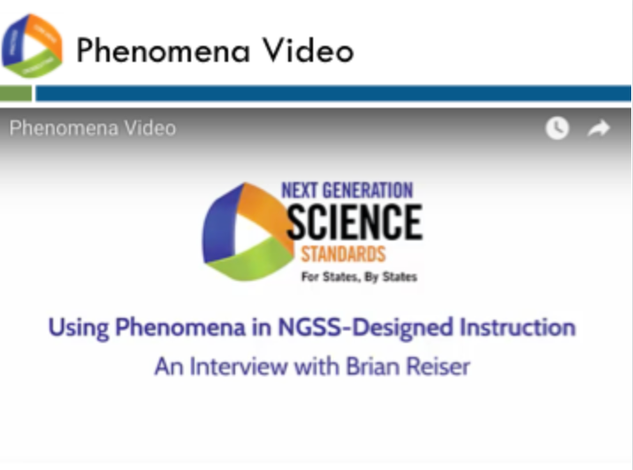
Slide 136
Talking Points
- Now that we have a better understanding of phenomena and how they can be used in NGSS-Designed instruction, let’s view this brief video from Dr. Brian Reiser that introduces phenomena and their connection to NGSS 3D learning. [Note to facilitator: The video is at http://nextgenscience.org/resources/phenomena]
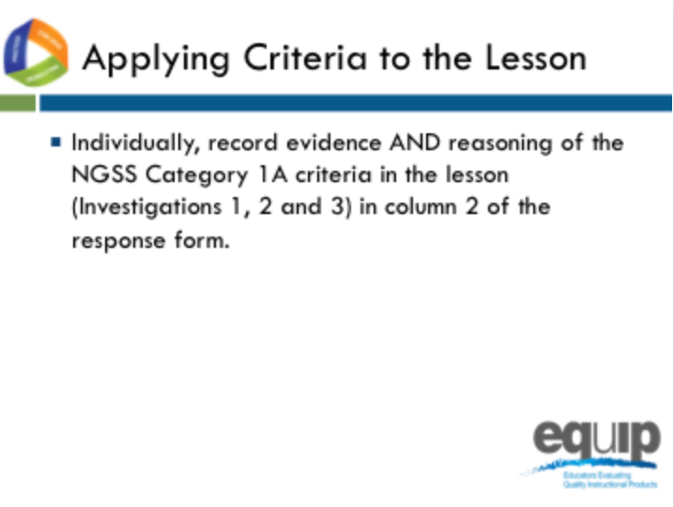
Slide 137
Talking Points
- Now that we have an established a foundational understanding of phenomena in NGSS Design, let’s go back to our common lesson Urban Heat, the intermediate version.
- Please re-read the whole lesson, Investigations 1, 2 and 3 to find evidence of Category 1A.
- This is completed individually without any discussion between or among group members. Even if you complete this part before other tables are finished, do not discuss your findings before being instructed to do so.
- As you locate evidence, use the Arabic and Roman numerals associated with the rubric criteria 1A to code the evidence you locate from the lesson.
- Remember, evidence is what you can see explicitly in the lesson or unit.
- You can use the second column of the response form to summarize your evidence and your reasoning of HOW/WHY this evidence connects to the rubric criteria and sub-criteria for Category 1A.
- Reasoning is the bridge connecting the evidence to the rubric criteria and to how the practices, core ideas, and crosscutting concepts work together.
- You have ten minutes to do this. [Note to facilitator: Set a timer for ten minutes, on the screen for all to see if possible. When the timer sounds, ask if participants need more time before moving on.]

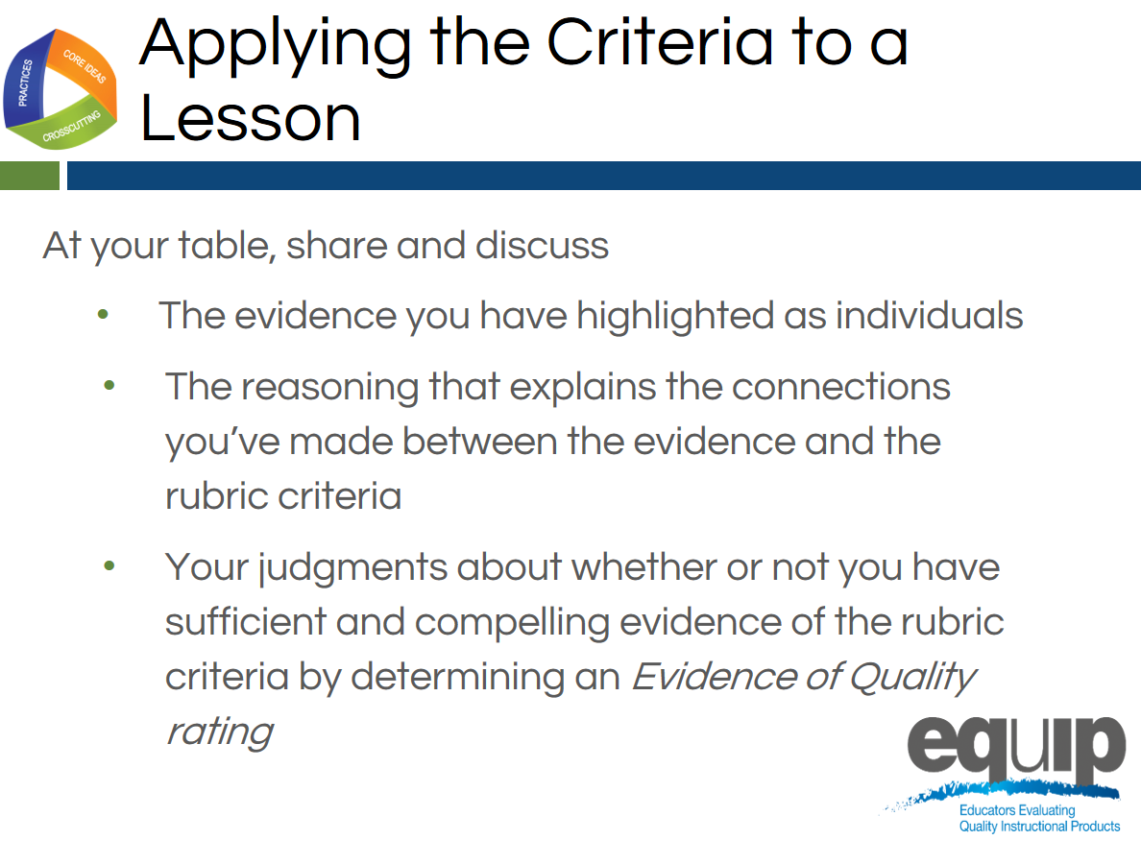
Slide 138
Talking Points
- Now it’s time to share and compare.
- Before table facilitators begin the group discussion, designate a recorder for your group and remember the Table Facilitator expectations on the back of Handout 6.
- Making sure everyone contributes his/her findings, share and discuss:
  - [Note to facilitator: Click for animation.] The evidence you highlighted;
  - [Note to facilitator: Click for animation.] The reasoning that explains the connections you made between the evidence and the rubric criteria; and then
  - [Note to facilitator: Click for animation.] Collaboratively evaluate whether this lesson or unit includes sufficient and compelling evidence of three-dimensional learning and whether or you see evidence of NGSS 3D Design according to Criteria IA.
- Attempt to reach consensus as a table group and determine an evidence of quality rating for Category IA. Be prepared to share your evaluation and support them with evidence and reasoning.
- You have 10 minutes for this discussion. [Note to facilitator: Set the timer for10 minutes but monitor the table groups and provide more or less time as needed to complete this. When the table groups are ready, have two or three share their determinations and then allow for questions and comments related to the determinations before moving on.]

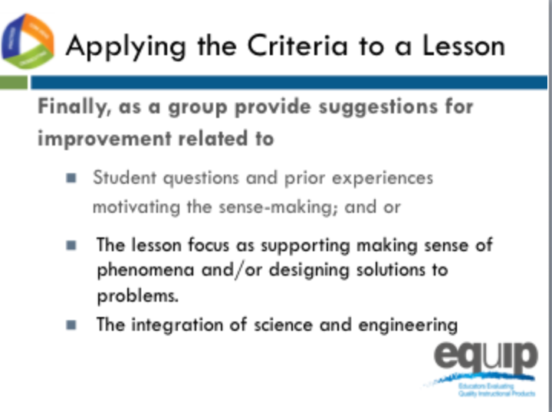
Slides 139–140
Talking Points
- This part of the task involves providing guidance or suggestions for how the lesson developer can improve the lesson.
- This guidance should be at the element level. Again, when using the EQuIP Rubric, the term “element” refers to the relevant, bulleted practices, disciplinary core ideas, and crosscutting concepts that are articulated in the foundations boxes of the standards, as well as in the NGSS appendices on each dimension.
- Remember to state these suggestions as positive actions for the developer to take rather than as negative statements of what’s missing, etc.
- You have five minutes for this. [Note to facilitator: Set the timer for five minutes. When it sounds, discuss the feedback in column 2 for Category IA and ask for two or three suggestions for improvement before moving to the next slide.]
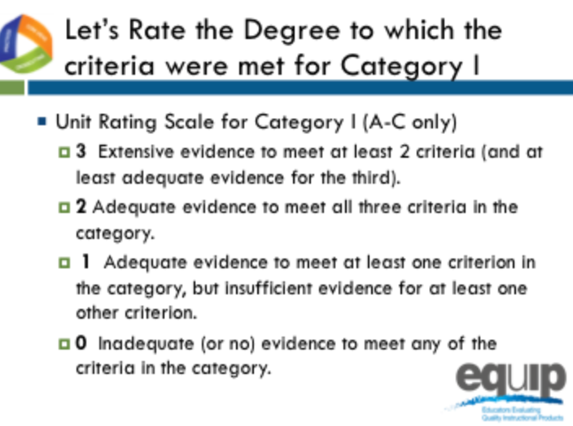
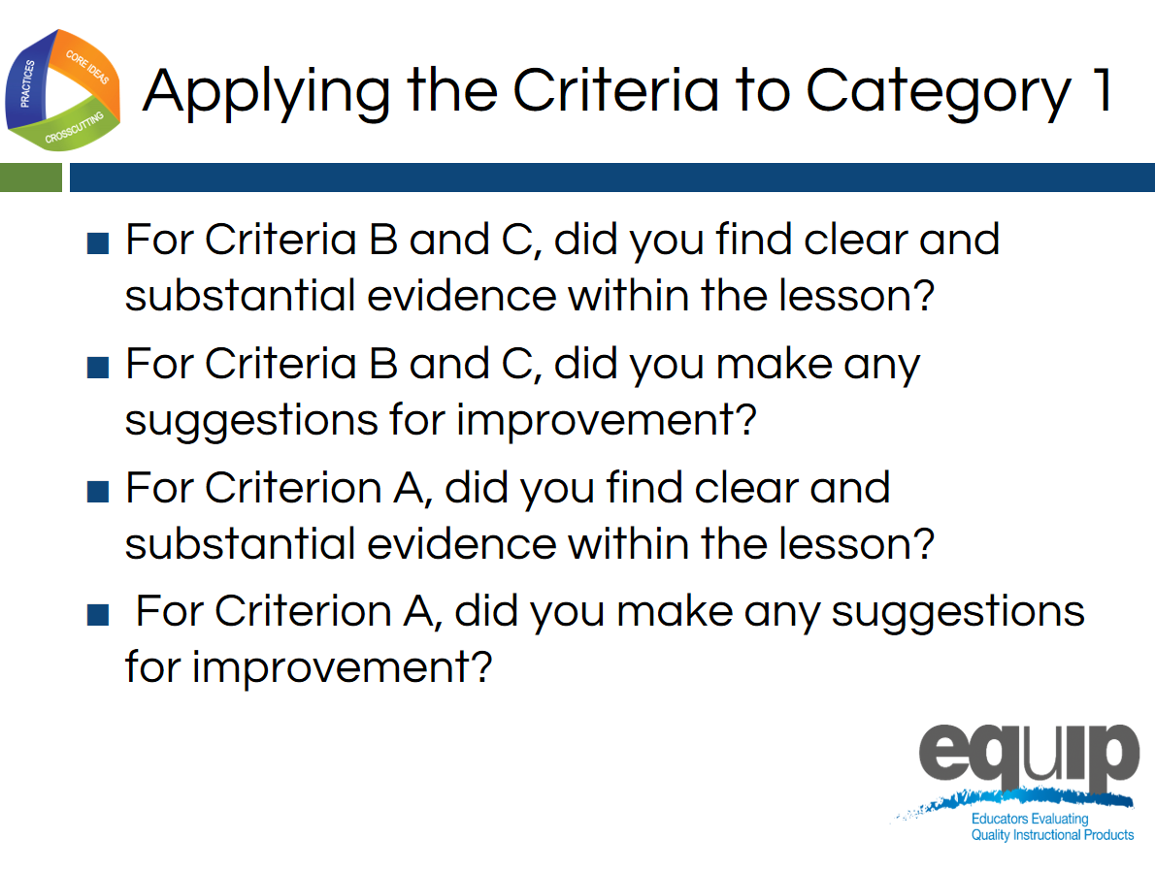
Slides 141–142
Talking Points
- Let’s rate the degree to which the criteria were met in Category I.
- Let’s only consider criteria A–C since we are examining a lesson, not a unit.
- At each table, let’s review the evidence of quality for categories A, B, and C. Then, as a group, let’s determine a rating for Category I using the language on page 7 of the rubric.
- Notice that the possible ratings fall across a 0–3 scale.
- Facilitator, give groups about 5 minutes to discuss evidence of quality for each category A–C and determine a Category rating.
- By a show of fingers, would table facilitators indicate your rating for Category I? [Note to facilitator: Do a quick summary of the room and announce a consensus response.]

Debriefing the Task
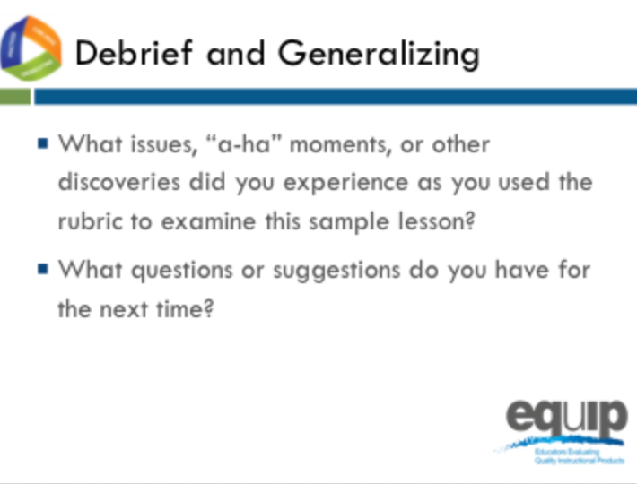
Slide 143
Talking Points
- So, how did it go? What did you experience using the rubric for the first time to determine alignment to the NGSS?
- Do you have any issues related to using the rubric to determine NGSS 3D Design that need to be addressed? Any “aha” moments? Other discoveries that might be important for others to hear? What questions do you have? Do you have any suggestions for improving the process? [Note to facilitator: Have people share as time allows.]
- Why is it important to first use the rubric individually to examine a lesson or unit?
- Why is it important to discuss your individual findings collaboratively as a group in order to make decisions about whether or not a lesson or unit aligns to the NGSS?
- [Note to facilitator: Refer participants to Handout 6, Module 4, “EQuIP Agreements.”] Look back over the agreements we discussed earlier. Why are these so important? [Note to facilitator: Allow two to three people to respond.]
!
- It is essential to understand that the EQuIP quality review process is a collegial process that centers on the use of the criteria-based rubric for science.
!
- While an individual certainly might use the rubric to examine a lesson or unit, the effective evaluation of lessons and units is the product of examination and discussion by a group of people using the rubric collaboratively.
- While using the EQuIP Rubric to examine instructional materials should lead to consensus regarding the overall lessons or units, group members may not always agree about every individual piece of evidence within a lesson or unit.
- The process we just followed to examine the common lesson is the same process we’ll use in examining other lessons and units regardless of whether we’re looking for 3D Design, coherence, access for all learners, or assessment practices.
- First we look for the evidence in the lesson or unit. Next we determine how the evidence fits together and connects to one or more criteria. From this evidence and reasoning we then make evaluations collaboratively about the lesson or unit. And then, finally, we make suggestions for how the lesson or unit might be improved.

Concluding Slide for Module 6

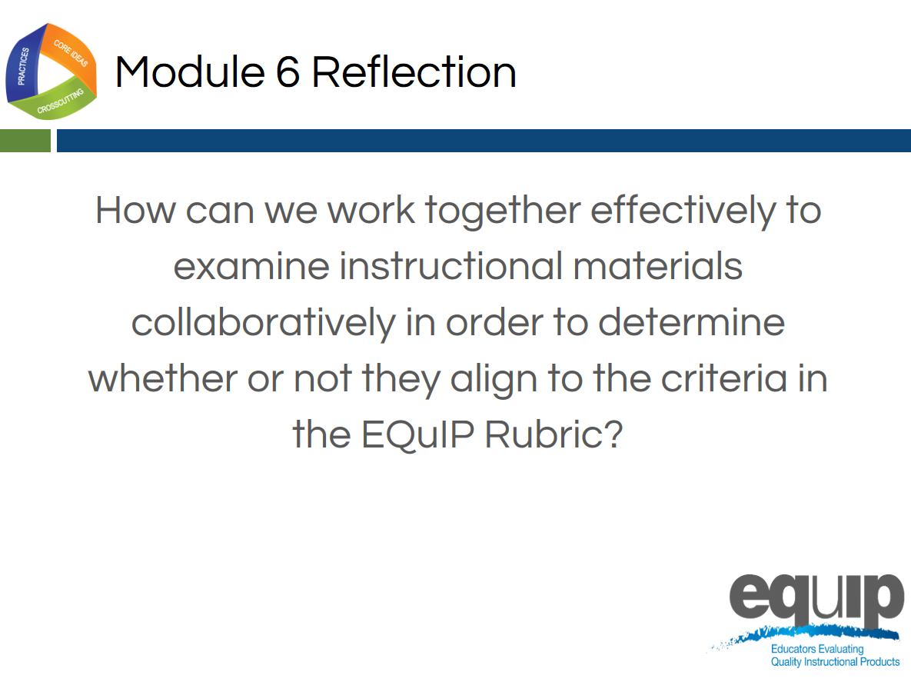
Slide 144
Talking Points
- With your table group, reflect on the process you just used to examine the common lesson.
- Determine where your group is on a scale of one to four, with four indicating that you feel confident that you all understand the process and can now use it to determine whether other instructional materials provide sufficient, explicit evidence to meet EQuIP Rubric criteria. [Note to facilitator: Allow five minutes, and then ask representatives to hold up one to four fingers for their table. Survey the room and address any tables holding up one or two fingers by asking, “What do you still need to move to a three?”]
- In the next module, we’ll take a look at the other criteria in Category I related to NGSS 3D Design.

MODULE
EQuIP for Science v3.0
7

Determining
Coherence
and Connections
Module 7: Determining Coherence and Connections
Module 7 builds on Module 6 by having participants discuss the remaining criteria in Category I: Alignment to the NGSS, which deal with coherence and connections. Participants will engage in an activity to think about coherence—specifically, the coherence of a set of questions in a series of lessons. Then they will continue examining the Common Lesson using the remaining criteria in Category I.
Materials Needed
- Module 7 PowerPoint slides or slides 145–162 of the full PowerPoint
- Handout 8: Module 7, “Graphic Example of Coherence” (1 page, preferably color copies)
- Handout 9: Module 7 “Debriefing Questions for Module 7” (1 page)
- Facilitator’s Resource—Storyline Cards. [Note to facilitator: Prior to beginning this module, prepare the envelopes for the coherence Storyline Cards task, slide 154.]
- Common Lesson: Urban Heat “Final” Version
- Handout 7: Module 4, “EQuIP Rubric, Version 3.0”* or a computer or tablet with the electronic version of the rubric (at least one person per table should record their group’s findings electronically)

*Introduced in a previous module.

Introduction to Module 7
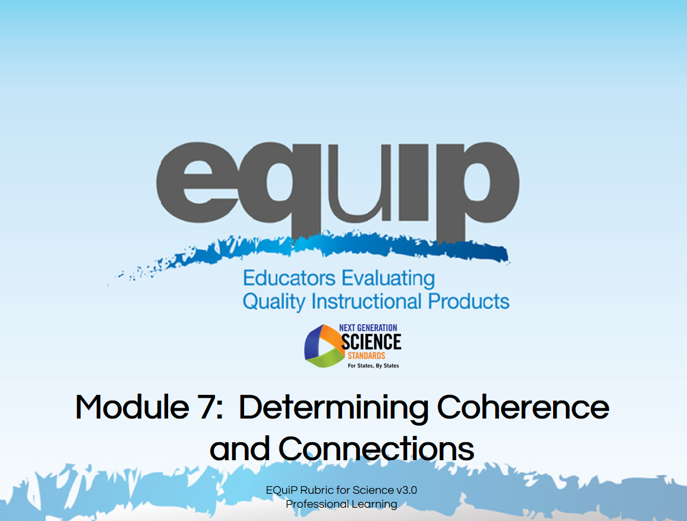
Slide 145
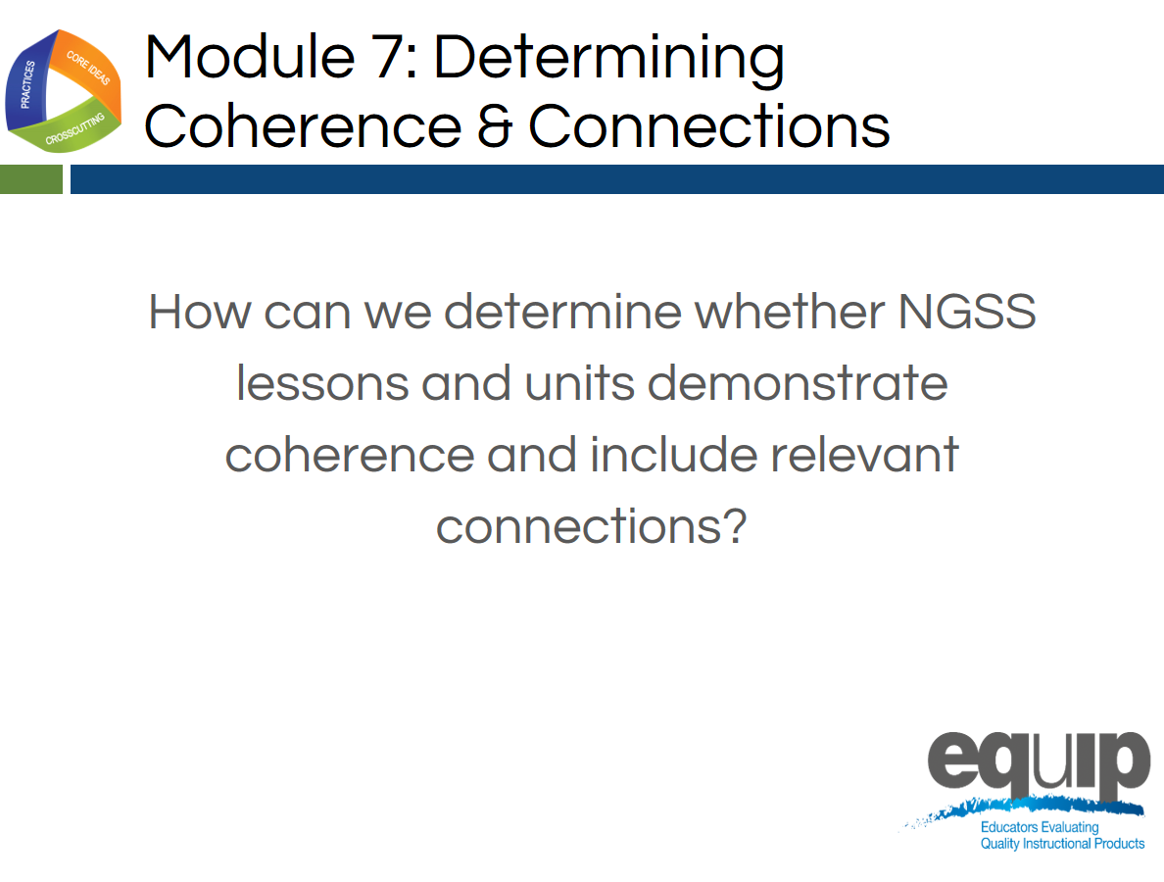
Slide 146
Talking Points
- In this module we’re going to move to the next part of Category I and look at coherence and connections in longer lessons or units.
- By the end of this module, you should be able not only to explain coherence in terms of the EQuIP Rubric, but also to explain how a graphic representation of a series of lessons demonstrates coherence, and to determine whether or not the common lesson shows explicit evidence of coherence.
- And you should be able to determine whether or not a lesson or unit includes connections to other science disciplines and/or to ELA/literacy or mathematics.
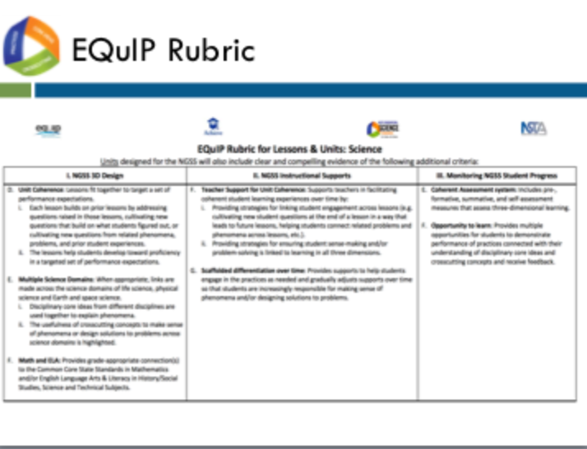
Slide 147
Talking Points
- Locate the criteria for coherence and connections on page 3 of your rubric.
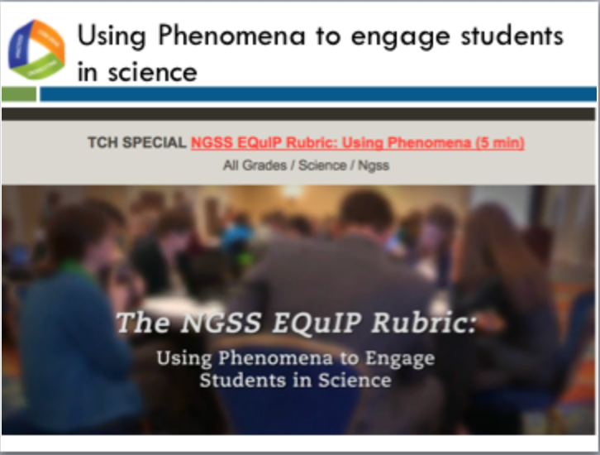
Slide 148
Facilitator Notes
- The video can be found at the following link http://www.nextgenscience.org/resources/ngss-equip-rubric-using-phenomena
Talking Points
- This video highlights the role of phenomena in multiple criteria of the EQuIP rubric, using phenomena to engage students in science.
- Let’s view this video together to help us determine how phenomena can support student engagement and drive instruction.
- Note to Facilitator: After the video Ask participants: “What is a phenomenon? How is it engaging? How can it be instructionally productive or drive a lesson?” Have a brief discussion (1–2 minutes).
- Note to Facilitator: After discussion about the first series of questions, ask “How can you leverage an engaging phenomenon to provide access points for all students? Have a brief discussion (1–2 minutes).

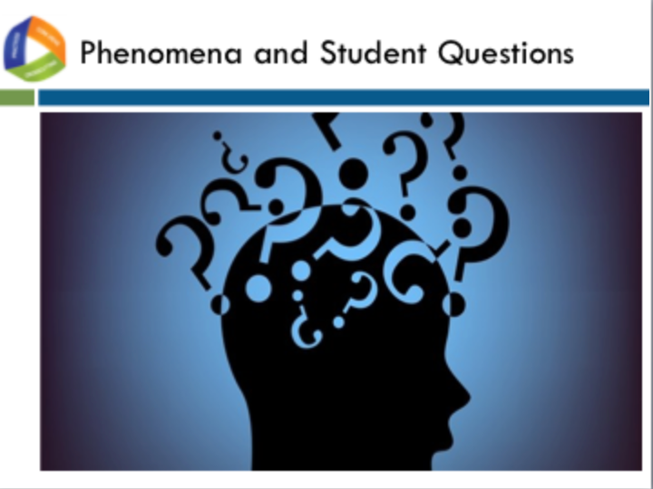
Slide 149
Talking Points
- As we saw in the video, the point of using phenomena to drive instruction is to help students engage in the practices to develop the knowledge necessary to explain and predict phenomena. Therefore, the focus is on both the phenomena and the student-generated questions about the phenomena that drive instruction.
- Let’s see how phenomena fit into the criteria about unit coherence.

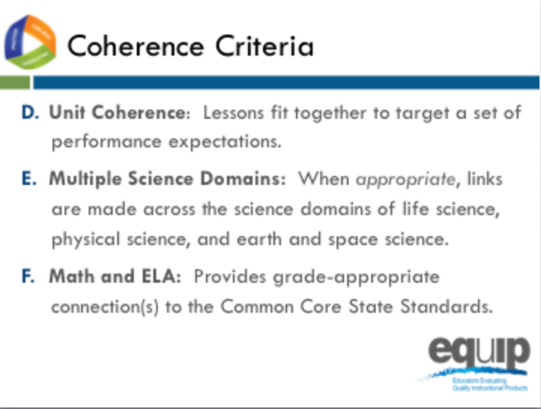
Slide 150
Talking Points
- Note how each of the bullets delineates different possibilities for coherence and connections:
  - [Note to facilitator: Click for animation.] Coherence can refer to how lessons fit together coherently to target a set of performance expectations.
  - [Note to facilitator: Click for animation.] Where appropriate, disciplinary core ideas from different disciplines are used together to explain phenomena.
  - [Note to facilitator: Click for animation.] Where appropriate, crosscutting concepts are used in the explanation of phenomena from a variety of disciplines.
  - [Note to facilitator: Click for animation.] Provide grade-appropriate connection(s) to the CCSS in ELA/literacy and mathematics and in history/social studies, science and technical subjects.

What is Coherence?
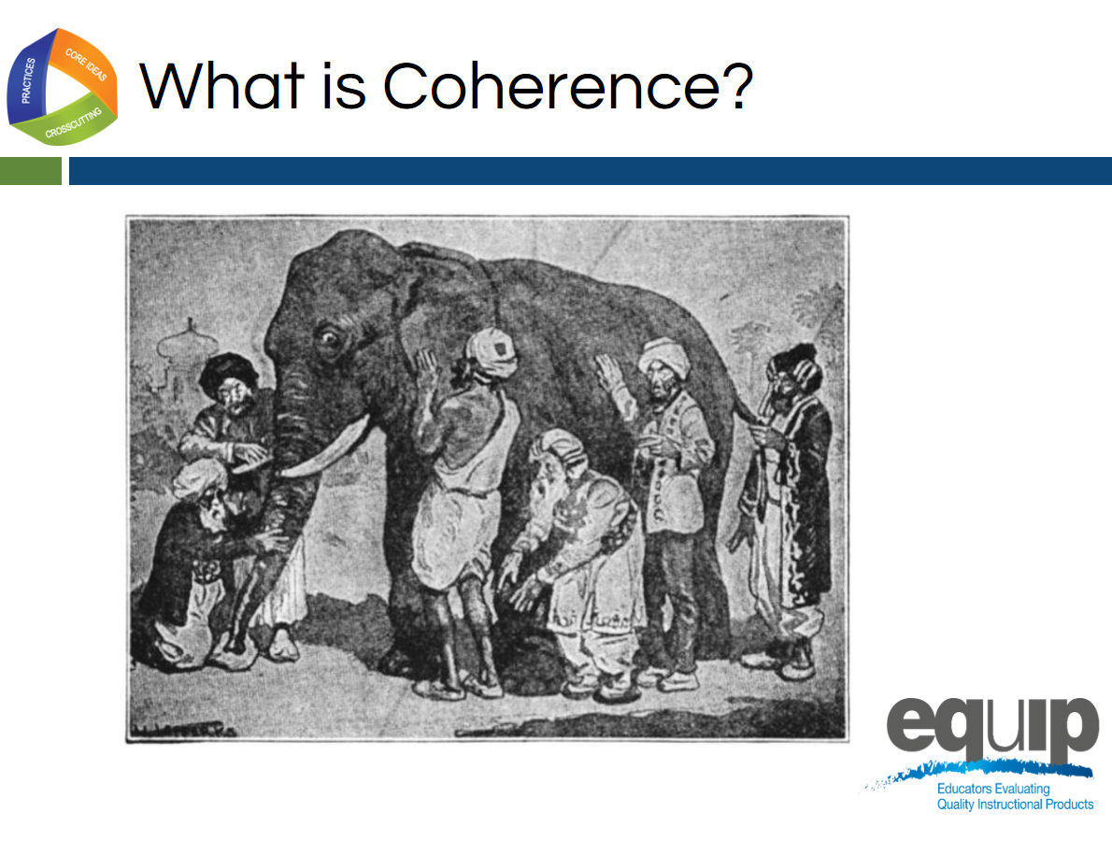
Slide 151
Talking Points
- Who knows the story of the blind men and the elephant? [Note to facilitator: Have someone share the story with the whole group. If no one volunteers, the facilitator should retell the story.]
- Although the men in this story certainly examined the parts of the elephant, their individual explanations did not depict a coherent representation of the elephant. Their various descriptions of the parts of an elephant did not fit together to create a picture of an entire elephant that made sense. Their individual descriptions, when examined as a whole, lacked coherence.
- So what is coherence? Take a few minutes to talk about what you think coherence might look like in a longer lesson, a series of lessons, or a unit in science. [Note to facilitator: Allow approximately five minutes before asking for volunteers to share. Allow several people to share. Facilitator should guide this discussion to ensure that s/he brings everything together to define coherence as intended in the EQuIP Rubric.]
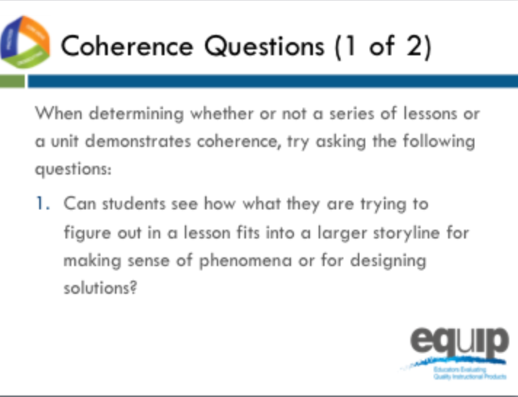
Slide 152
Talking Points
- As you examine lessons and units to determine whether they meet the rubric criteria for coherence, keep these two questions in mind:
  - Can students see how what they are trying to figure out in a lesson fits into a larger storyline for making sense of phenomena or for designing solutions to problems?
  - Is there a coherent story that, based on explicit evidence found in the lessons, builds across the unit to reach a bundle—a set of more than one—of performance expectations?
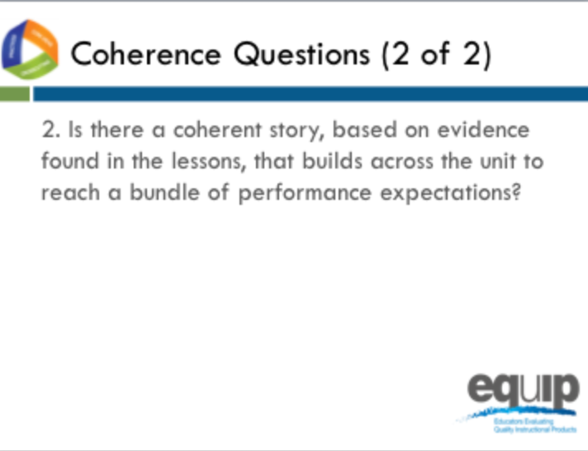
Slide 153
Talking Points
- So what exactly do we mean by a storyline or a coherent story?
- Think of your favorite episode of Law and Order or another TV mystery series you watch regularly. The episode begins with a question: “Who committed the crime?” From here the plot proceeds logically as evidence is collected, suspects are questioned, and a case is built. The show ends when everything comes together, the question we began with is answered, and the perpetrator of the crime is revealed.
- This exemplifies a coherent storyline.
- Now think back to a TV show or movie you’ve watched where you’ve reached the end only to discover that the answer to the question of who committed the crime comes straight out of left field. There was no way you could have figured out the ending because either it wasn’t logical or the crime ended up being committed by someone who wasn’t even present in the earlier portion of the show. You feel as if you’ve wasted your time because the storyline wasn’t coherent; one thing did not follow from another.
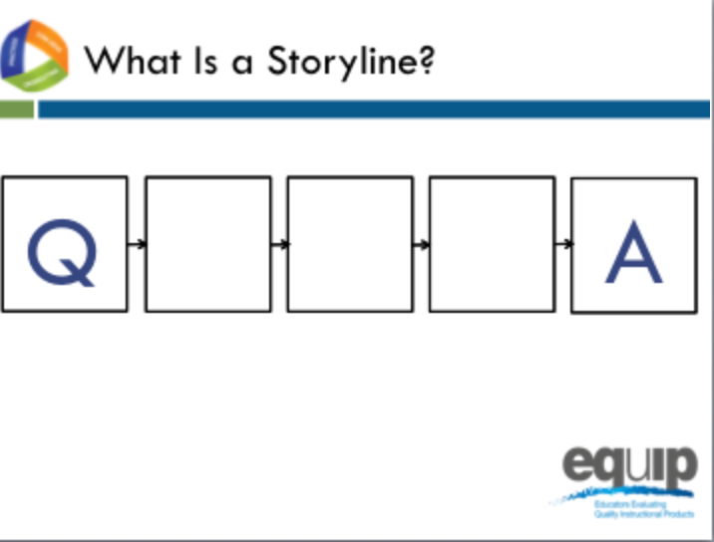
Slide 154
Facilitator Notes
Make sure each table group has an envelope with the Storyline Cards for this task.
Talking Points
- In the center of your table you’ll find an envelope. Inside are five slips of paper, each with a question on it.
- As a group, read through these questions and then put them in the order that you believe to be the most coherent storyline.
- As you work to make a coherent storyline from these cards, think about what this process would look like in a classroom where students are trying to make sense of phenomena and/or design solutions to problems.
- As you arrange the cards, ask yourself the following questions:
  - Can students see how what they are trying to figure out in a lesson fits into a larger storyline for making sense of phenomena and/or for designing solutions to problems?
  - Is there a coherent story that, based on explicit evidence found in the lessons, builds across the unit to reach a bundle of performance expectations?
- Can you arrange the questions so that students see how what they are trying to figure out in a lesson fits into a larger storyline for making sense of phenomena and/or for designing solutions?
- Can the questions be organized to build a series of lessons or a unit to reach a bundle of performance expectations? [Note to facilitator: Allow five minutes for the groups to work and then have two to three tables share.]

Lessons That Fit Together Coherently
Slide 155
Talking Points
- We have been evaluating the Intermediate version of the lesson sequence called Urban Heat. Based on your table discussion while you were organizing your cards into a coherent storyline, do you see ways this lesson sequence could be improved? What were your takeaways from this activity as it connects to our common lesson? [Note to facilitator: Have a few groups share responses.]
- The classification of our common lesson as intermediate indicates that there may be another version.
- We are going to continue our review with the final version of Urban Heat, a revision of the intermediate version. This classification of final is to indicate that it is the last revision thus far, as opposed to an indicator of quality.
- Before we resume with our rubric evaluation, let’s look at the role questions play in the organization of a unit with this graphic organizer and think about how it connects to our storyline cards table discussions.

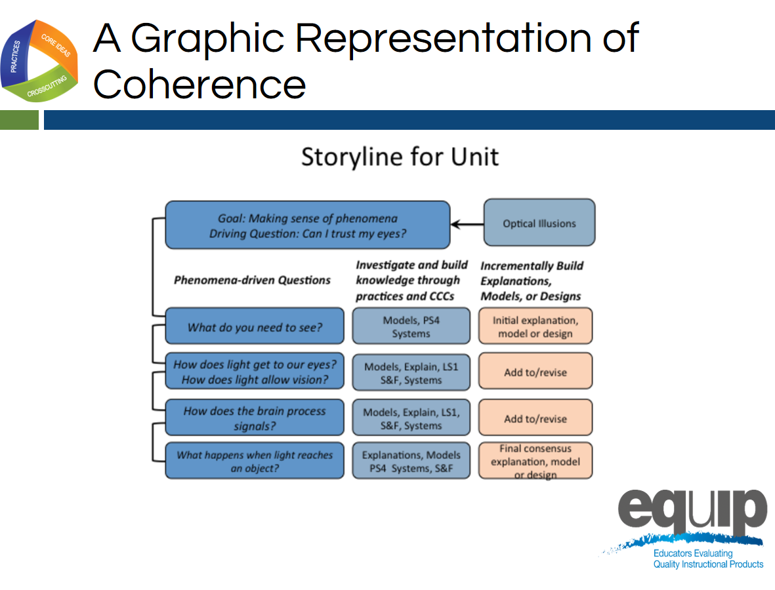
Slide 156
Talking Points
- Please refer to the handout entitled, “Graphic Example of Coherence,” which provides a larger version of this slide.
- Notice the “making sense question” at the top—the anchoring phenomenon.
- Now look at the order of the phenomena-driven questions—the questions at the beginning of each row.
- In this example, we can see coherence just by virtue of the fact that each subsequent phenomena-driven question relates directly back to our attempt to answer the making sense question or driving question.
- In other words, if we assume that each phenomena-driven question relates to one lesson in a series of lessons, all of which are designed to address the making sense question, then each lesson connects and builds onto the previous as students work to answer the making sense question.
- Here students engage in science practices to answer each of the phenomena-driven questions.
- And, since the phenomena-driven questions logically and sequentially build on one another, what the students figure out—the meaning they make—logically and sequentially builds as well. In other words, their learning is coherent because the students can see how what they are trying to figure out in one lesson fits into a larger storyline for making sense of phenomena.

Connections
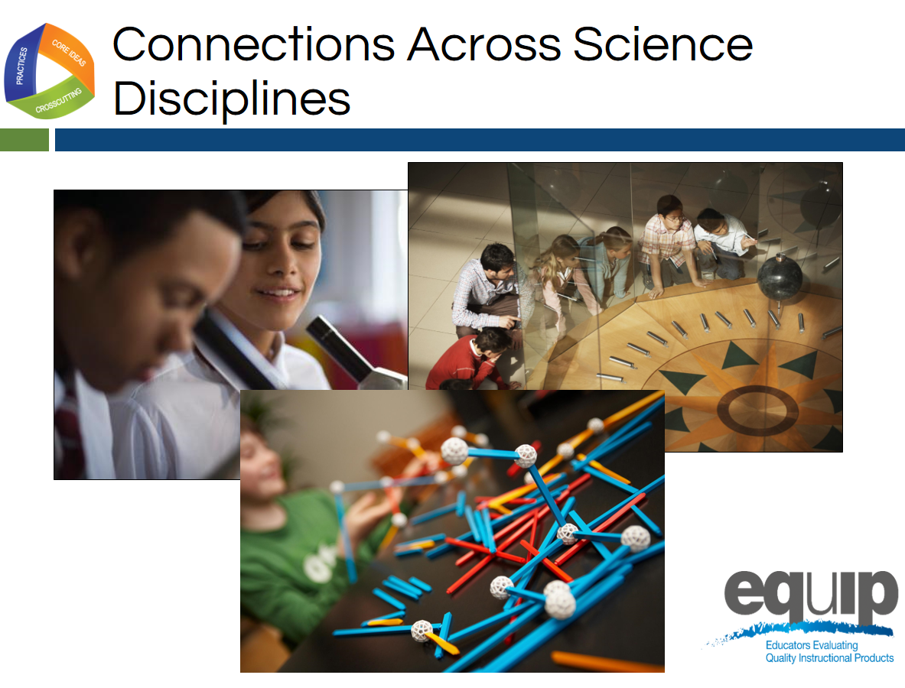
Slides 157
Talking Points
- Just as coherence occurs in a series of lessons, where appropriate, disciplinary core ideas from different science disciplines can be used together to explain phenomena.
- Likewise, where appropriate, crosscutting concepts can be used in the explanation of phenomena from a variety of science disciplines.
- Again, here we’re looking for connections that enable students to see the bigger picture or see how different science disciplines relate to form a larger storyline for making sense of the natural world or the human-designed world.
- As you look for this evidence, ask yourself the following questions:
  - Are students using what they have figured out in other disciplines of science to make sense of the phenomena and/or to design solutions to problems in current lessons and units?
  - Are students using crosscutting concepts to make sense of phenomena or design solutions across science domains?
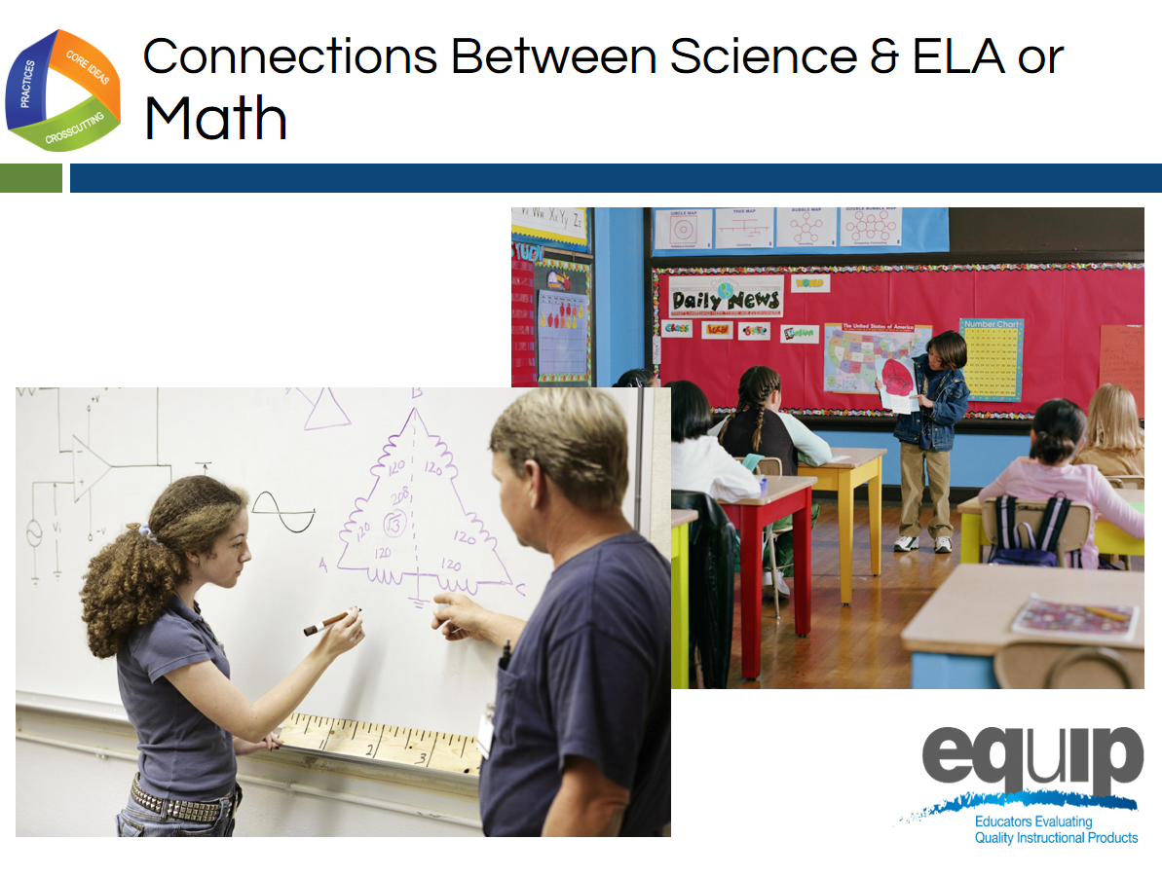
Slide 158
Talking Points
- Finally, connections can occur between science and ELA/literacy and science and mathematics.
- For example, students could create mathematical models to explain science phenomena, or write arguments to show how they reason from evidence to reach a logical conclusion in science.
- As before, we’re looking for connections that enable students to see the bigger picture or see how different areas of study relate to form a larger storyline for making sense of the natural world or the human-designed world.
- As you look for evidence of connections between science and mathematics and/or ELA/literacy, ask yourself the following questions:
  - Are students using what they have learned or are learning in ELA/literacy or mathematics as a tool to make sense of new phenomena or design solutions to problems? To express or convey the sense they make of phenomena or the solutions they design?
  - Are the students reflecting on the ELA/literacy and mathematics skills they are using and thus improving their skills in these areas?

Coherence and Connections Practice
Slide 159
Talking Points
- For this task, you will need:
  - The Common Lesson Urban Heat Final Version (we will now put aside the Intermediate version of Urban Heat and instead use the revised version for the rest of the training.
  - The EQuIP Rubric response sheet; and
  - A pen or pencil.
- As you work, keep in mind:
  - You’re working individually on the first two parts of the process, so don’t begin sharing and comparing until after you have completed these first two parts of the process.
  - Use the Arabic and Roman numerals associated with the rubric criteria to code the evidence you locate.
  - It’s exceedingly important to locate explicit evidence in the lessons first before you use reasoning to think about how this evidence connects to the rubric criteria.
  - The evaluations you then make as a group are based on the evidence you located and thought about as individuals.
  - All determinations are criteria-based.
  - As a group you are working to develop a common understanding of NGSS 3D Design and quality.

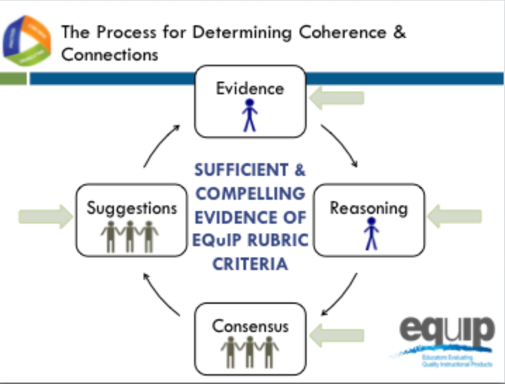
Slide 160
Talking Points
- In addition to the specific materials for this task, you will need the three debrief questions for this module, which you have on Handout 9, “Debriefing Questions for Module 7.”
- If you or your group finishes any part of this examination process early, please begin reflecting on or discussing these three debriefing questions.
- The process you will use to examine the common lesson for coherence and/or connections is the same as the process you used in an earlier module to examine the common lesson to determine whether or not it met the criteria for three-dimensional learning and explaining phenomena. You will have a specific amount of time for each part of the process.
  - First, look for the evidence in the lessons or unit individually. Use the Arabic and Roman numerals associated with the rubric criteria to code the evidence you locate. You have seven minutes for this part. [Note to facilitator: Set timer for seven minutes.]
  - Now, still individually, determine how the evidence fits together and connects to one or more criteria. You have four minutes for this part of the process. [Note to facilitator: Set timer for four minutes.]
  - Next, as a group, designate one person to record the group’s responses, and then share and discuss this evidence and reasoning and collaboratively make evaluations about whether or not the lesson or unit provides sufficient and compelling evidence of the criteria, and assign evidence of quality ratings for each of the criteria as well as for each category.
  - You have 15 minutes for this part of the process. [Note to facilitator: Set timer for 15 minutes.]
  - Finally, make suggestions for how the lesson or unit might be improved. You have four minutes for this part of the process. [Note to facilitator: Set timer for four minutes.]
  - [Note to facilitator: At the conclusion of the practice, ask several groups to share their evidence and reasoning. After several groups have shared, ask one or two to share a suggestion for improvement.]
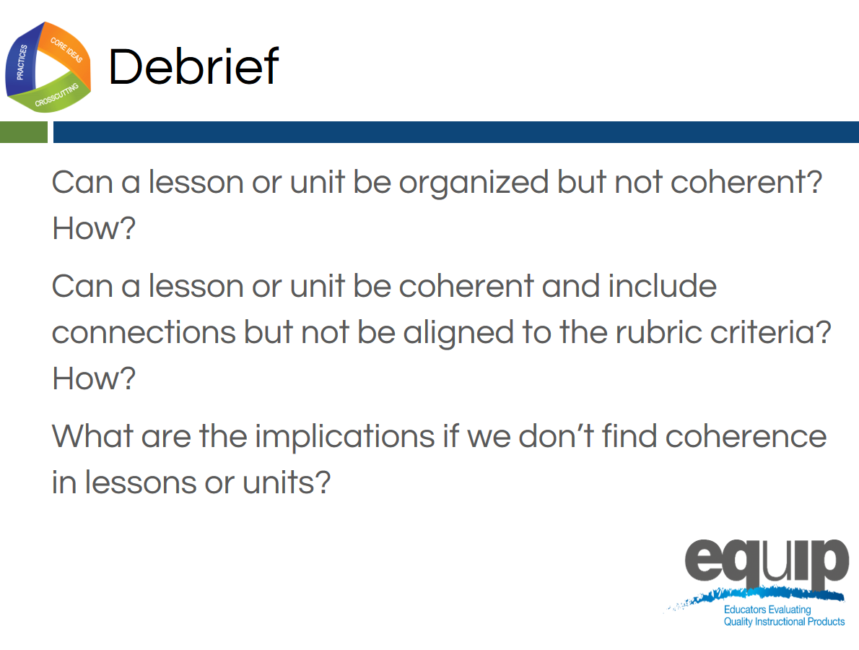
Slide 161
Talking Points
- So, now that you’ve examined a lesson for coherence and connections, what do you think?
  - Can a lesson or unit be organized but not coherent? How? [Note to facilitator: Allow participants to respond.]
  - Can a lesson or unit be coherent or include connections but not be aligned to the rubric criteria? How? [Note to facilitator: Allow participants to respond.]
  - What are the implications if we don’t find coherence in lessons or units? [Note to facilitator: Allow participants to respond.]
- [Note to facilitator: Ask each of the following questions separately and allow participants to respond.]
  - Was this easier or harder than determining three-dimensional learning?
  - Do you have any takeaways that might be useful for other groups to hear?
  - Are you beginning to feel more confident in using the rubric to examine science materials?

Concluding Slide for Module 7
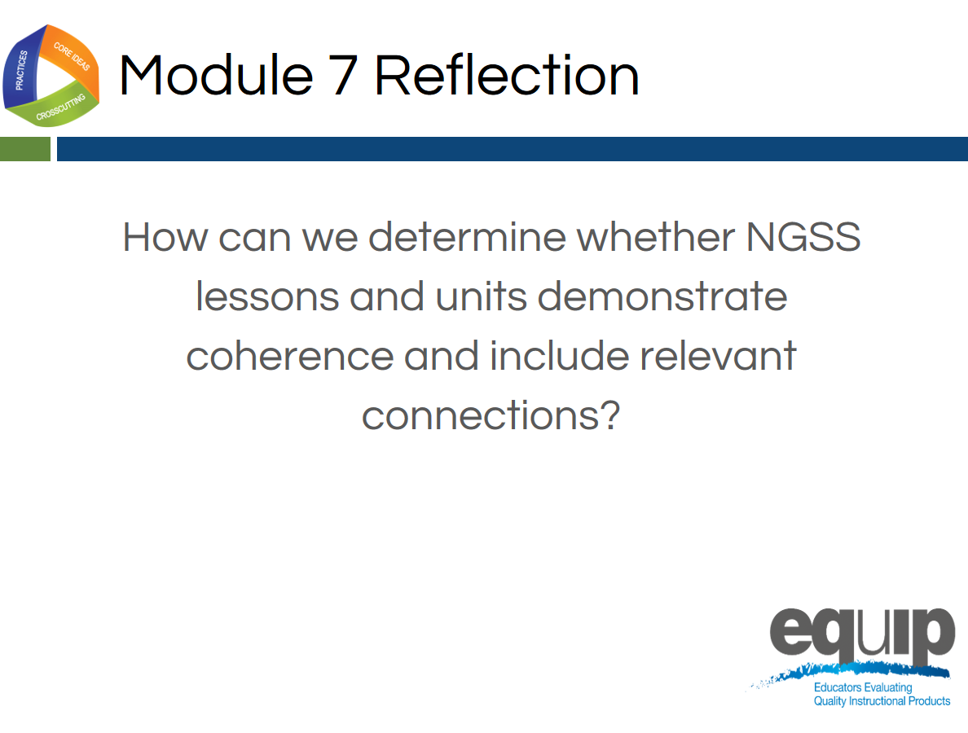
Slide 162
Talking Points
- Coherence and connections are criteria we use to evaluate whether or not a longer lesson or a unit aligns to the NGSS.
- While it may seem that we’re spending a lot of time working with Category I of the rubric, remember, if a lesson or unit is not closely aligned to the NGSS, it may not be appropriate to move on to the second and third categories. So, it’s important that we spend sufficient time here to build educator capacity, sharpen our professional judgment, and develop a common understanding of alignment and quality among reviewers.
- If you still have questions about what coherence and/or connections look like, please ask them now.
- Does anyone still have questions about using Category I of the rubric to determine NGSS 3D design, including determining coherence? [Note to facilitator: Address any questions that arise.]
- In the next module, we’ll be moving on to Category II and using the rubric criteria for Instructional Supports.

MODULE
EQuIP for Science v3.0
8

Category II: Instructional
Supports

Module 8: Category II: Instructional Supports
Module 8 builds on Modules 6 and 7 by having participants continue examining the Common Lesson, this time using the criteria in Category II: Instructional Supports. Category II: Instructional Supports focuses on examining lessons and units to determine whether they include the kinds of instructional practices and supports necessary to allow all students to access the NGSS successfully.
Materials Needed
- Module 8 PowerPoint slides or slides 163–172 of the full PowerPoint
- Common Lesson: Urban Heat “Final” Version*
- Handout 7: Module 4, “EQuIP Rubric, Version 3.0”* or a computer or tablet with the electronic version of the rubric (at least one person per table should record their group’s findings electronically)

*Introduced in a previous module.

Introduction to Module 8
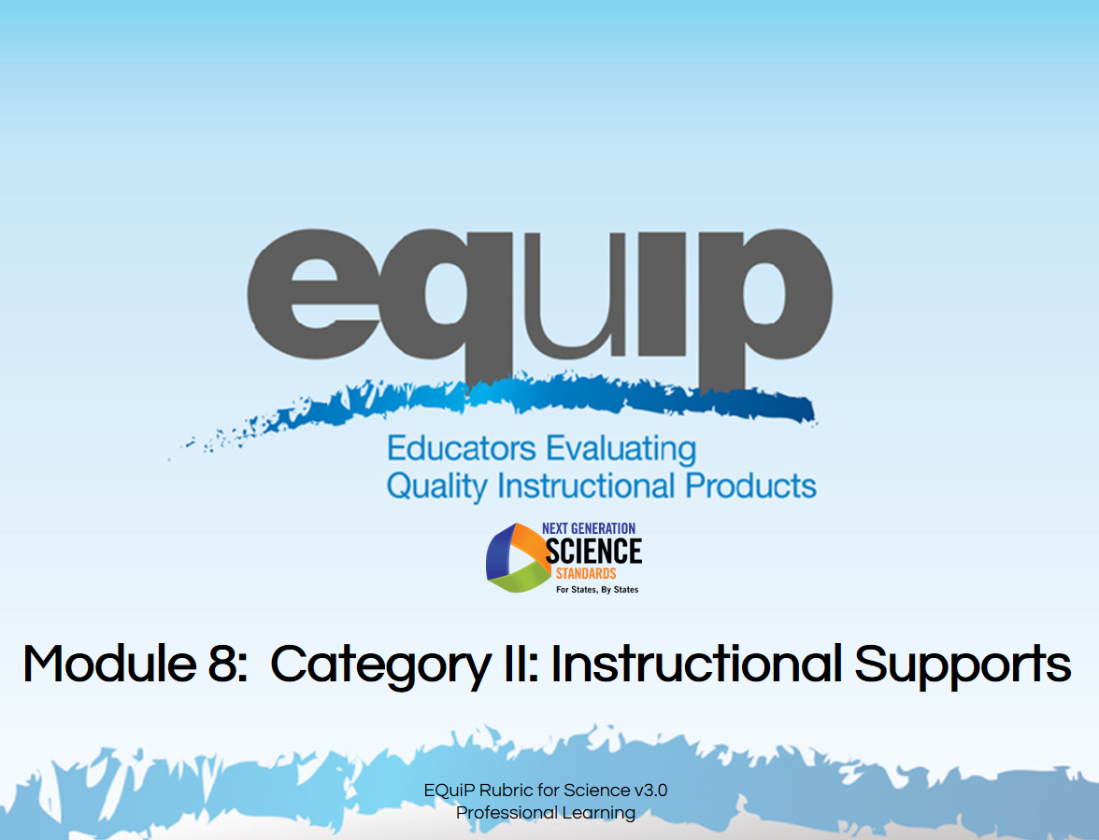
Slide 163
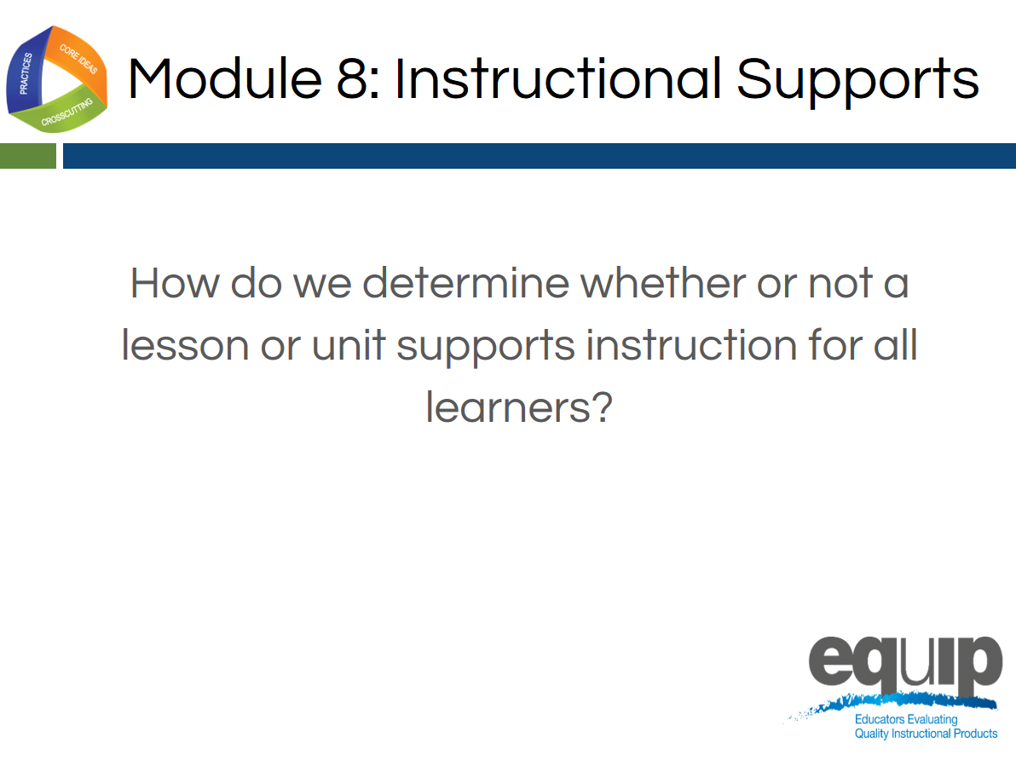
Slide 164
Talking Points
- In this module, we’ll be looking at Category II: Instructional Supports.
- By the conclusion of this module, you should be able to use the EQuIP Rubric to determine whether or not a lesson or unit supports instruction for all learners.
- Now, locate Category II on page 9 of your rubric.
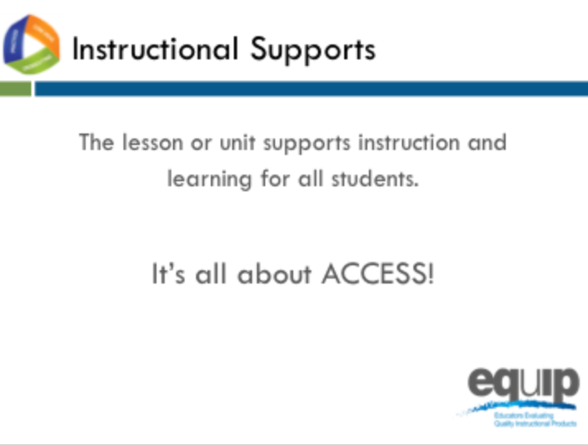
Slide 165
Talking Points
- Category II: Instructional Supports focuses on examining lessons and units to determine whether they include the kinds of instructional practices and supports necessary to allow all students to access the NGSS successfully.
- Take a few minutes to read through all of Category II quickly. [Note to facilitator: Allow three to five minutes.]
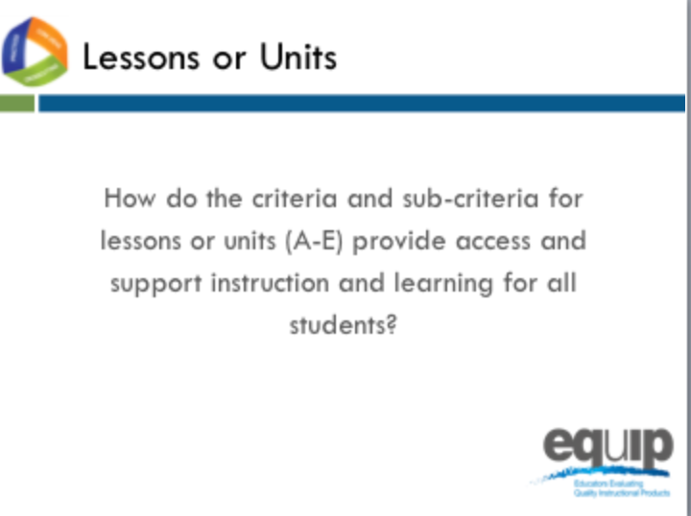
Slide 166
Talking Points
- Now that you’ve read through all of Category II, let’s look more closely at specific sections.
- First, read back through the first four criteria: A, B, C and, D, along with their sub-criteria, and circle key words. You have three minutes to do this. [Note to facilitator: Allow 3 minutes.]
- Noting what you’ve circled, what might evidence of criteria A through D look like in a lesson or unit? [Note to facilitator: Allow a few participants to share.]
- All of the EQuIP Rubric criteria are important, but in Category II, Criterion E, along with its sub-criteria, is particularly deep.
- So, take a few minutes at your tables just to discuss Criterion E and its sub-criteria. [Note to facilitator: Allow five minutes.]
- What are some of the points you discussed regarding Criterion E? And, based on what you see in Criterion E, what might evidence of Criterion E, along with its sub-criteria, look like in a lesson or unit? [Note to facilitator: Allow a few groups to share.]
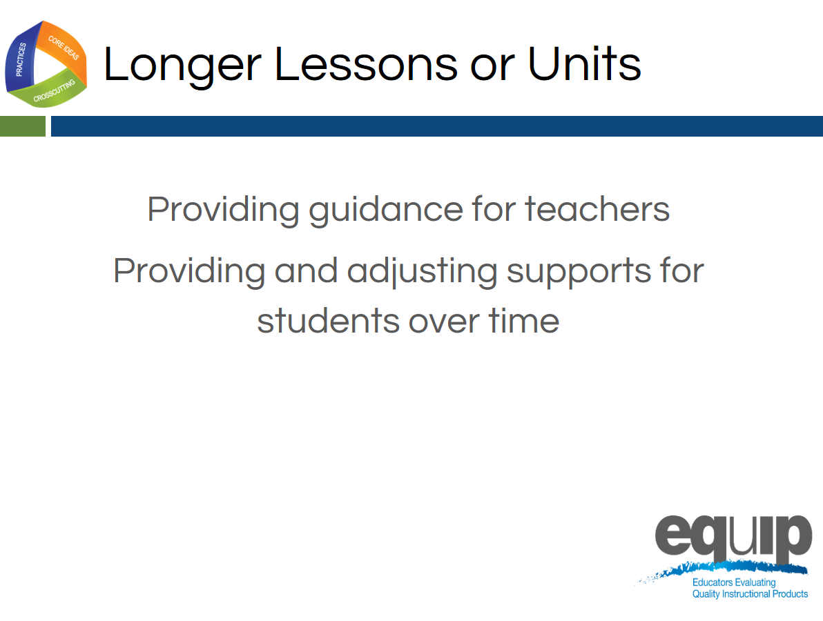
Slide 167
Talking Points
- In Category I the focus for a unit or longer lessons is on the coherence of the lessons—whether they were designed in a coherent way.
- In Category II, the first criterion for a unit or longer lessons focuses on whether there is built-in support for the teachers to ensure that students see the coherence and that this deepens their understanding. Consequently, some of the evidence you identified when looking for coherence in Category I may also provide evidence here.
- The second criterion for longer lessons and units focuses on providing and then gradually adjusting supports for students over time so that the students become increasingly responsible for making sense of phenomena and designing solutions to problems.

Instructional Supports Practice
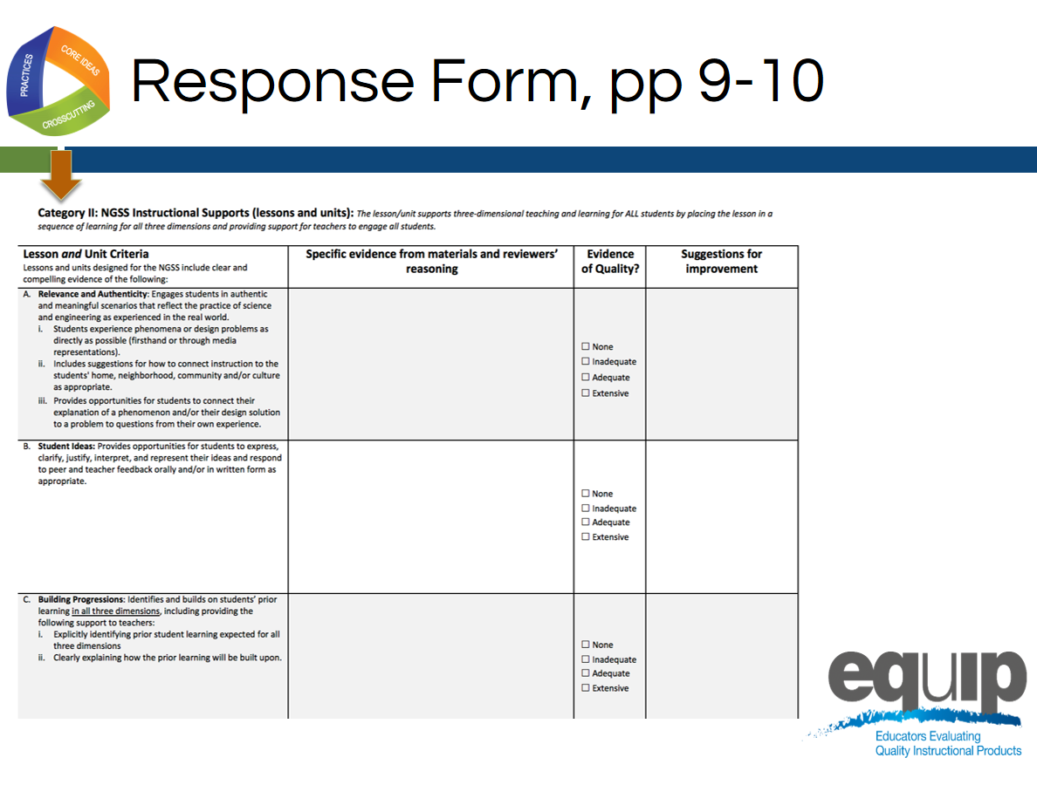
Slide 168
Talking Points
- The response form for Category II is located on pages 9 and 10 of your rubric document. Please note that this slide only shows page 9 of the response form, but you will need both page 9 and page 10.

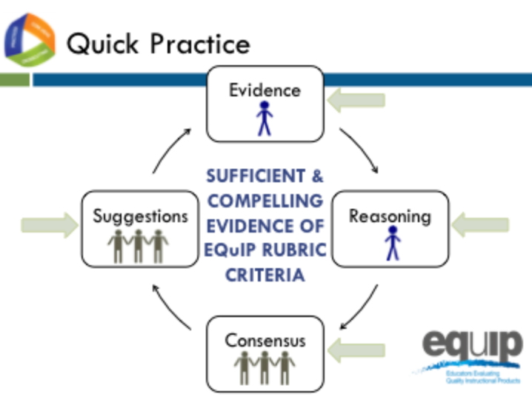
Slide 169
Talking Points
- For this quick practice you will need:
  - The response sheet for Category II;
  - The common lesson provided for this practice, Urban Heat Final Version; and
  - A pen or pencil to code the evidence you find with the Arabic or Roman numerals associated with the specific criteria and/or sub-criteria that the evidence supports.
- Please note that for this practice you will be examining the lesson for criteria A through E for a lesson.
- As you work through this practice, follow the same process you used earlier when examining a lesson or unit for three-dimensional learning, explaining phenomena, and coherence:
  - [Note to facilitator: Click for animation.] First, individually look for the evidence in the lessons or unit. Use the Arabic and Roman numerals associated with the rubric criteria to code the evidence you locate.
  - [Note to facilitator: Click for animation.] Next, still individually, determine how the evidence fits together and connects to one or more criteria.
  - [Note to facilitator: Click for animation.] Then, as a group, examine this evidence and reasoning and collaboratively make evaluations about whether or not the lesson or unit provides sufficient and compelling evidence of the criteria, and assign evidence of quality ratings for each of the criteria as well as for each category.
  - [Note to facilitator: Click for animation.] Finally, make suggestions for how the lesson or unit might be improved.
- You have 30 minutes for this task. Remember, you’re examining the lesson for criteria A through E for Category II.
- If your group finishes early, use the extra time to think about and discuss this question: “What are the implications if a lesson or unit does not meet the criteria for Category II?” [Note to facilitator: Set the timer for thirty minutes, but monitor the groups to determine if they need more or less time to complete the practice before moving on.]
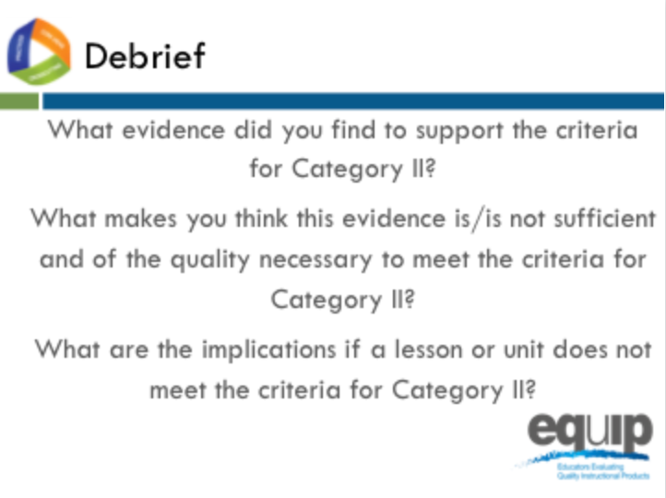
Slide 170
Talking Points
- So what determinations did you make at your tables? Does this lesson meet the criteria in Category II for criteria A through D?
- How? Why or why not? [Note to facilitator: Allow several tables to share.]
- What about for Criterion E? How or why not? [Note to facilitator: Allow a few tables to share.]
- What are the implications if a lesson or unit does not meet the criteria for Category II? [Note to facilitator: Allow a few tables to share.]

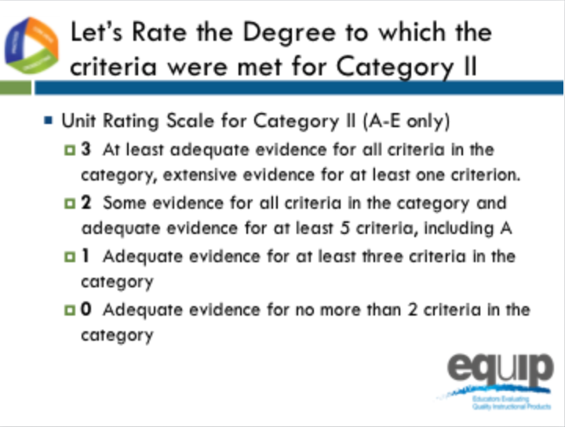
Slide 171
Talking Points
- Let’s rate the degree to which the criteria were met in Category II.
- Let’s only consider criteria A–E since we are examining a lesson, not a unit.
- At each table, let’s review the evidence of quality for categories A–E. Then, as a group, let’s determine a rating for Category II using the language on page 10 of the rubric.
- Notice that the possible ratings fall across a 0–3 scale.
- Facilitator, give groups about 5 minutes to discuss evidence of quality for each category A–C and determine a Category rating.
- By a show of fingers, would table facilitators indicate how many of the criteria you found at least adequate evidence of in the lesson? [Note to facilitator: Do a quick summary of the room and announce a consensus response.]
- Let's take a quick poll of the room, what rating did your group give to Category II? [Note to facilitator: Quickly survey the room by asking for a response from each group, and discuss a consensus answer.]

Concluding Slide for Module 8
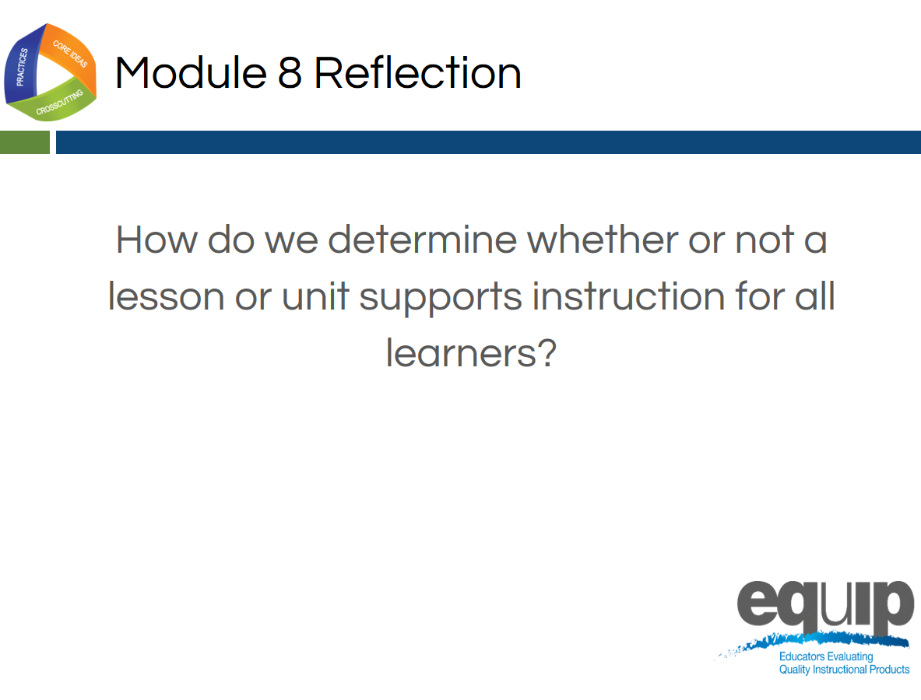
Slide 172
Talking Points
- Providing the kinds of instructional supports that allow all students to access the NGSS and engage in three-dimensional learning is very important.
- As a result of this module, you should feel comfortable using the rubric to determine whether or not a lesson or unit meets the criteria in Category II.
  - Are there any questions or additional comments before we move on? [Note to facilitator: Address question or comments if they arise.]

MODULE
EQuIP for Science v3.0
9

Category III:
Monitoring
Student Progress
Module 9: Category III: Monitoring Student Progress
Module 9 builds on Modules 6, 7, and 8 by having participants continue examining the Common Lesson, this time using the criteria in Category III: Monitoring NGSS Student Progress. As with all standards, teaching to the NGSS is not sufficient. It’s about students learning. In the case of the NGSS, this should be three-dimensional learning. Examining a lesson or unit against the criteria in Category III determines whether a lesson or unit includes the kinds of assessments that allow all students to demonstrate understanding and that allow all teachers to monitor the progress and performance of all students.
If the meeting participants are not going to continue on to Module 10 to examine additional lessons and units, consider pulling reflection questions and closing ideas from slides 197–199.
Materials Needed
- Module 9 PowerPoint slides or slides 173–189 of the full PowerPoint
- Handout 10: Module 9, Slide 180, “Formative Assessment Vignettes.”
- Common Lesson: Urban Heat “Final” Version*
- Handout 7: Module 4, “EQuIP Rubric, Version 3.0”* or a computer or tablet with the electronic version of the rubric (At least one person per table should record their group’s findings electronically.)

*Introduced in a previous module.

Introduction to Module 9
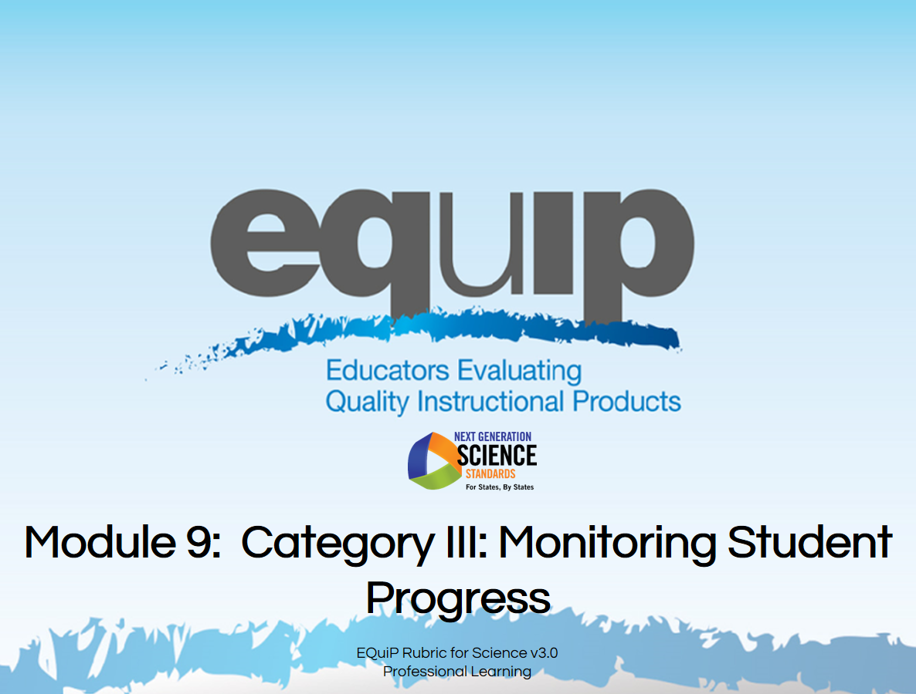
Slide 173
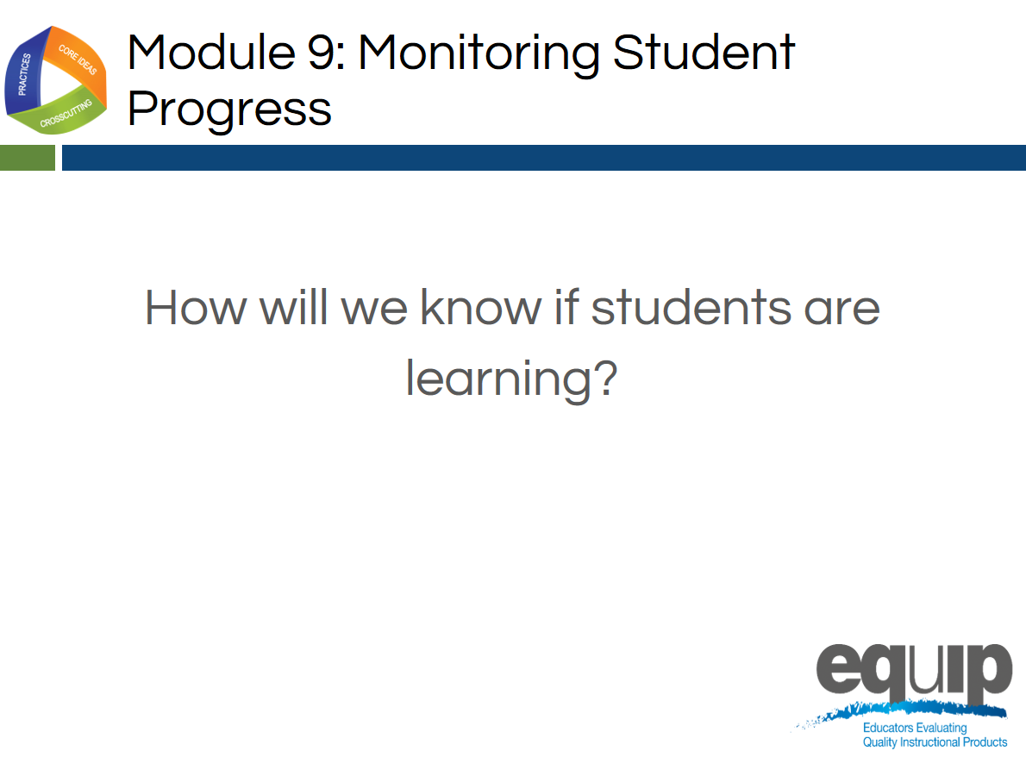
Slide 174
Talking Points
- In this module, we’ll be looking at Category III: Monitoring NGSS Student Progress.
- By the conclusion of this module, you should be able to use the EQuIP Rubric to determine whether a lesson or unit includes a variety of assessments that align to three-dimensional learning and provides multiple opportunities to elicit observable, unbiased evidence of student understanding through performance.
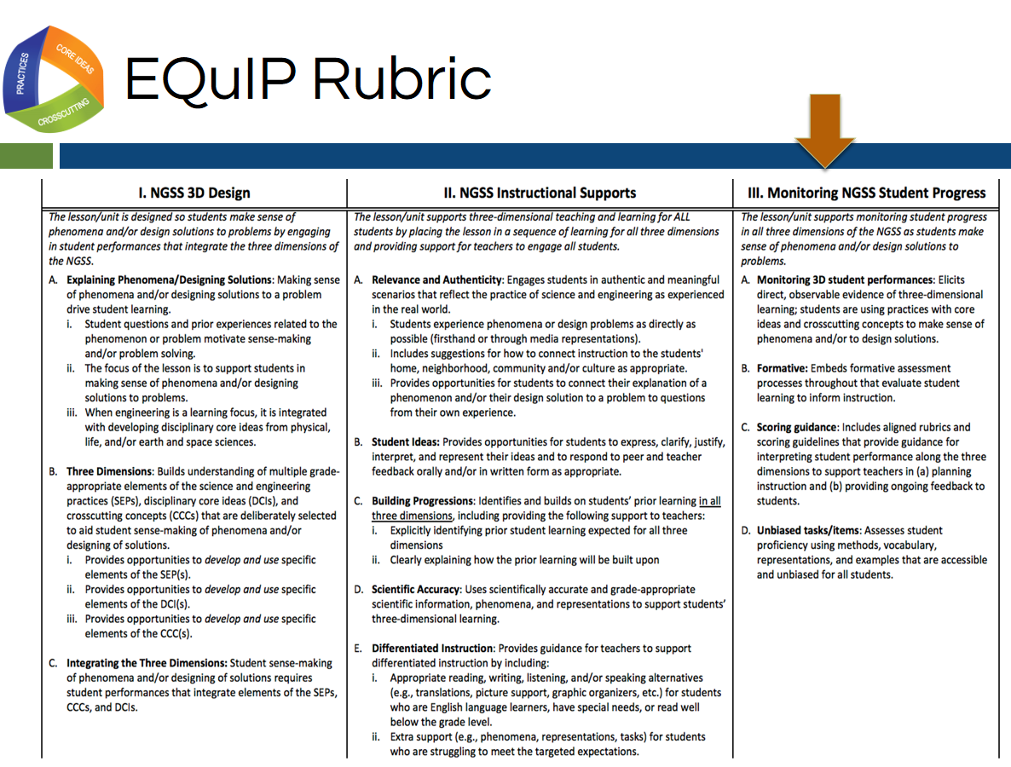
Slide 175
Talking Points
- Now, locate Category III on page twelve of your rubric document.
- Category III: Monitoring NGSS Student Progress focuses on examining lessons and units to determine whether they include the kinds of assessments necessary to assess student mastery of the NGSS accurately.
- Take a few minutes to read through Category III. [Note to facilitator: Allow three to five minutes.]
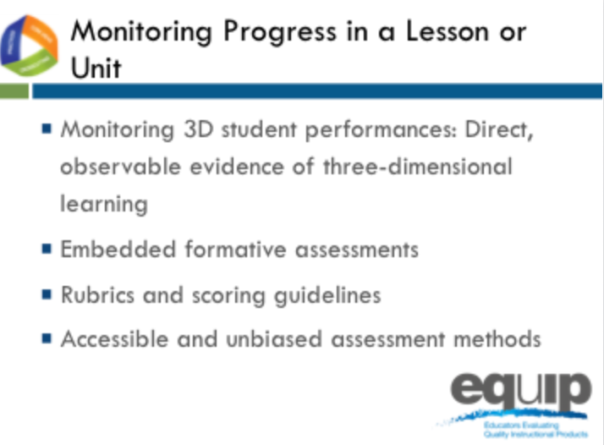
Slide 176
Talking Points
- The four criteria at the top of Category III focus on monitoring student NGSS progress in a lesson or unit.
- We’ve focused extensively on direct, observable evidence of three-dimensional learning; but before we can examine lessons or units to look for evidence of embedded formative assessments, we need to determine just what that looks like.

Formative Assessment
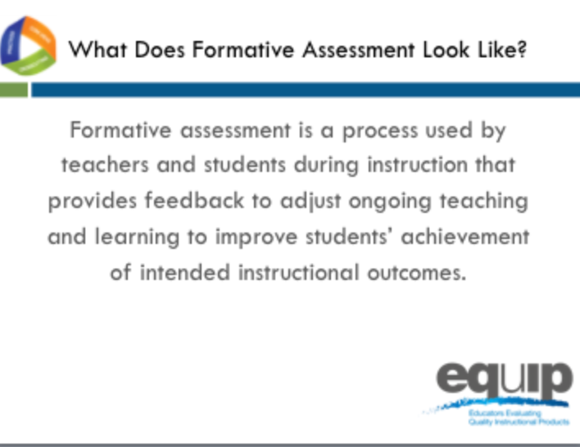
Slide 177
Talking Points
- According to a paper initiated by the Council of Chief State School Officers (CCSSO) in 2008 entitled, “Formative Assessment: Examples of Practice,” formative assessment is:
  - A process used by teachers and students during instruction that provides feedback to adjust ongoing teaching and learning to improve students’ achievement of intended instructional outcomes.
- Dylan Wiliam, who you may recall co-authored “Inside the Black Box,” the groundbreaking research report on the impact of formative assessment on student learning, says this about formative assessment in his 2011 book, “Embedded Formative Assessment”:
  - “An assessment functions formatively to the extent that evidence about student achievement is elicited, interpreted, and used by teachers, learners, or their peers to make decisions about the next steps in instruction that are likely to be better, or better founded, than the decisions they would have made in absence of that evidence.” (43)

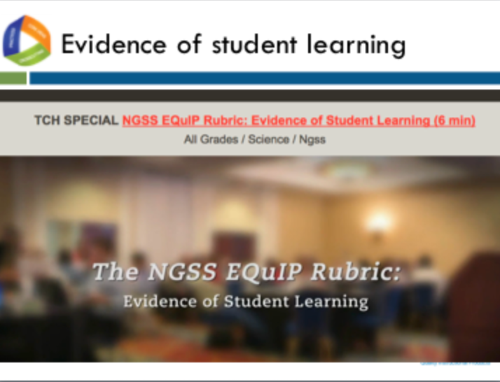
Slide 178

Facilitator Notes
This video can be found at http://www.nextgenscience.org/resources/ngss-equip-rubric-evidence-student-learning
Talking Points
- This video highlights category 3 of the EQuIP rubric: Monitoring student progress.
- Let’s watch this video to better understand how we may approach looking for direct observable evidence of 3D student learning in a lesson.
- Note to Facilitator: After the video Ask participants: “How can the features of the NGSS offer ways to make student thinking visible?” Have a brief discussion (1–2 minutes).
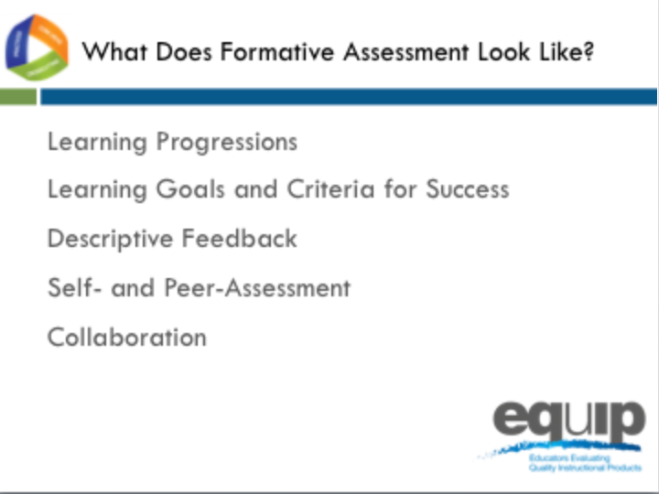
Slide 179
Talking Points
- According to the CCSSO paper, five attributes are associated with effective formative assessment:
  - [Note to facilitator: Click for animation.] Learning Progressions that clearly articulate the sub-goals of the ultimate learning goal [for a lesson or unit];
  - [Note to facilitator: Click for animation.] Learning Goals and Success Criteria that are clearly identified and communicated to students;
  - [Note to facilitator: Click for animation.] Descriptive Feedback provided to students that is evidence-based and linked to the intended instructional outcomes and criteria for success;
  - [Note to facilitator: Click for animation.] Self- and Peer-Assessment that provide students with opportunities to think meta-cognitively about their learning; and
  - [Note to facilitator: Click for animation.] Collaboration exemplified by a classroom culture in which teachers and students are partners in learning.
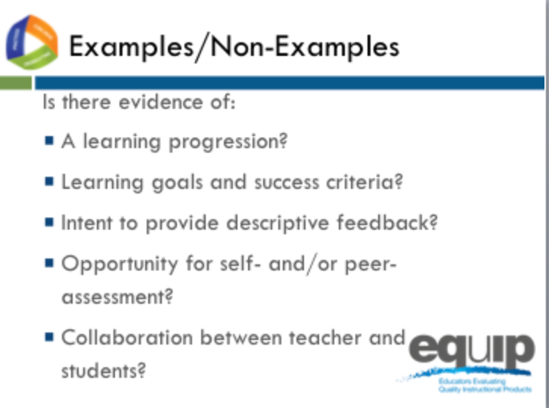
Slide 180
Facilitator Notes
Refer participants to Handout 10, Module 9, Slide 180, “Formative Assessment Vignettes.”
Talking Points
- You have a handout entitled, “Formative Assessment Vignettes,” which you need to take out.
- Read through the different vignettes to determine what evidence you see of the five attributes delineated by CCSSO or evidence you see that supports Wiliam’s definition of formative assessment. Please note that the examples presented in the vignettes are not necessarily three-dimensional.
- Once you’ve read through the vignettes individually, discuss your findings as a group to determine which vignettes are examples of formative assessment and which are non-examples. [Note to facilitator: These vignettes, as well as additional information about formative assessment, are available in the paper from the Council of State School Officers. Allow seven to ten minutes.]
- Now let’s take a look at these examples and non-examples.
- The first vignette is “Thumbs Up and Thumbs Down.” What do you think? Let’s see your thumbs up if you think this example provides evidence of formative assessment or thumbs down if you do not.
- What’s your reasoning? [Note to facilitator: Allow one or two people to share.]
- Here’s what the experts say about this first vignette: “This teacher is using a formative assessment approach to collect evidence to adjust instruction. This is, therefore, an instance of formative assessment.”
- Moving on to the second vignette, “Structured Pair Work,” again, let’s see your thumbs up if you think this example provides evidence of formative assessment or thumbs down if you do not.
- What’s your reasoning for this one? [Note to facilitator: Allow one or two people to share.]
- Here’s what the experts say about this second vignette: “This is an example of formative assessment where the posed questions and the peer conversations are used to elicit evidence of the students' understandings. In this context, the formative assessment process is embedded into the learning activity itself due to the teacher’s careful engineering of the activity. The students are able to self-reflect and get feedback from their peers. The teacher is able to listen to the conversations between students to note the current level of understanding for the class and for individual students. The teacher uses the information immediately to assist students in their learning by redirecting thinking, reinforcing ideas or providing cues.”
- Now for the third vignette, “Classroom Quizzes,” again, let’s see your thumbs up if you think this example provides evidence of formative assessment or thumbs down if you do not.
- What’s your reasoning for this one? [Note to facilitator: Allow one or two people to share.]
- Here’s what the experts say about this third vignette: “This is not an example of formative assessment because the teacher does not use the evidence from the quizzes to adjust instruction, nor does the teacher provide direction to students for them to think meta-cognitively about their own learning. The only information the students receive is a score for the number of correct answers. This is an example of ongoing summative assessment, not formative assessment.”
- Continuing on to the fourth vignette, “Shared Thinking,” again, let’s see your thumbs up if you think this example provides evidence of formative assessment or thumbs down if you do not.
- What’s your reasoning for this one? [Note to facilitator: Allow one or two people to share.]
- Here’s what the experts say about this fourth vignette: “In this example of formative assessment the teacher is provided with information about student learning, and the process used to gather that information also requires students to reflect on their own learning. This activity provides the teacher with information about how well the students understand the concept and how best to demonstrate that understanding. To fully participate in the activity, students must reflect on their own level of understanding as they analyze the work of others and provide reasons why they think there are gaps in understanding.”
- Finally, for vignette number five, “District-Developed Assessments,” let’s see your thumbs up if you think this example provides evidence of formative assessment or thumbs down if you do not.
- What’s your reasoning for this one? [Note to facilitator: Allow one or two people to share.]
- Here’s what the experts say about this fifth vignette: “In this example, we see neither teachers’ adjustment of their instruction nor students’ adjustment of their learning tactics. Thus, this probably well-intentioned distribution of the monthly exams’ results to parents would constitute a counter-example of formative assessment.”
- So, determining whether evidence of embedded formative assessment is present in a lesson or unit is not easy. Misconceptions regarding what is and what is not formative assessment are common. Hopefully these examples and non-examples from the CCSSO document, along with the expert commentary, help identify some of the more common misconceptions and clarify what we’re looking for in terms of evidence of embedded formative assessment.

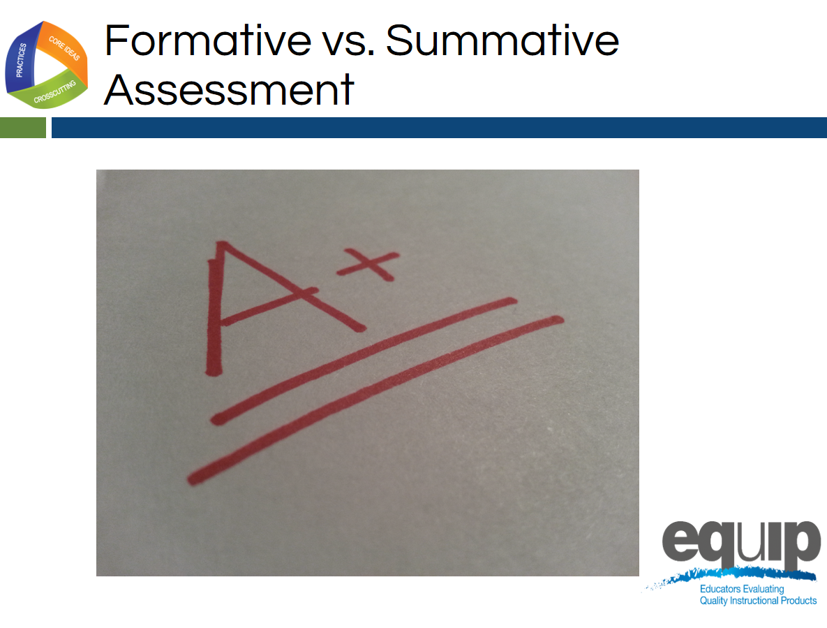
Slide 181

Talking Points
- Overall, whether an assessment is formative or summative depends on the purpose for which that assessment is being used.
- As Wiliam states, “An assessment functions formatively to the extent that evidence about student achievement is elicited, interpreted and used by teachers, learners or their peers to make decisions about the next steps in instruction.”
- Summative assessments, on the other hand, are those whose purpose is evaluation. Summative assessments provide grades or scores denoting overall mastery of the material.
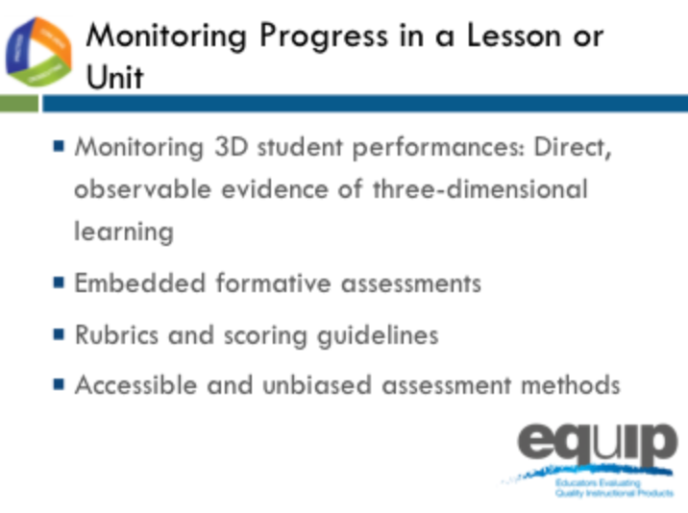
Slide 182
Talking Points
- As we prepare to look for evidence of the Category III criteria in an actual lesson, let’s quickly review criteria A through D for Category III.
- Keep in mind that you’ll be looking for direct, observable evidence of these criteria. This evidence must be explicitly stated in the lesson.
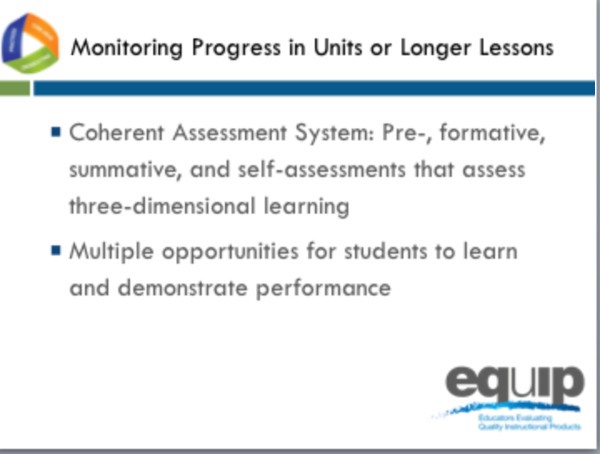
Slide 183

Talking Points
- The criteria at the bottom of Category III focus on monitoring student progress in a longer lessons or in a unit of instruction.
- Note that these criteria require multiple forms of assessment as well as multiple opportunities for students to demonstrate performance.
- Again, keep in mind that you’re always looking for direct, observable evidence of these criteria.
Monitoring Student Progress Practice
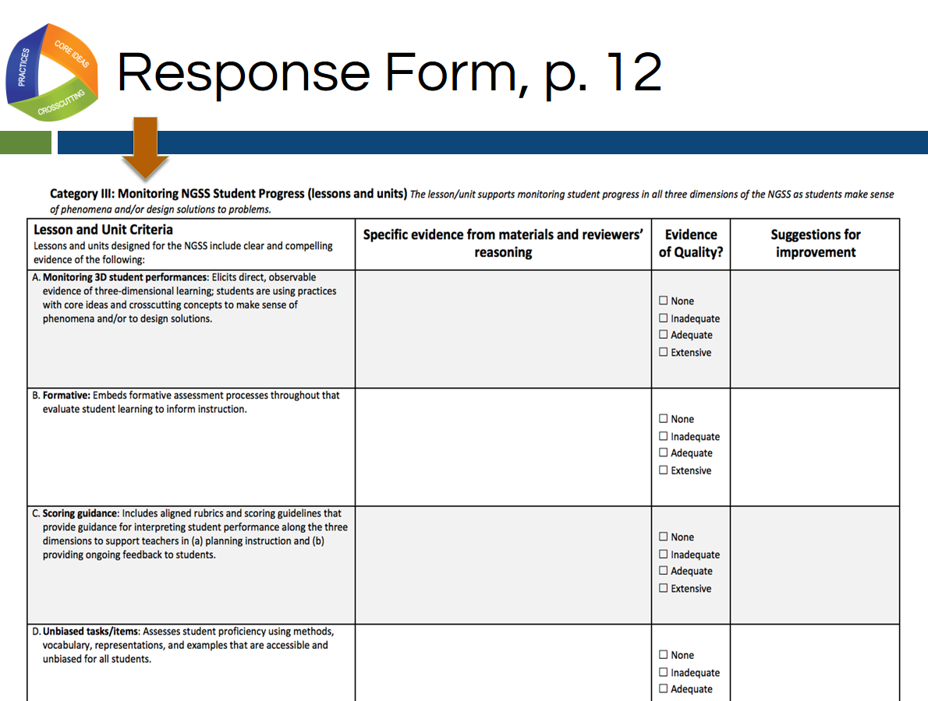
Slide 184
Talking Points
- For this quick practice you will need:
  - The response sheet for Category III, which is located on page twelve of your rubric document;
  - The Common Lesson Urban Heat final version; and
  - A pen, pencil, or a tablet or laptop with the electronic version of the rubric to record your findings.
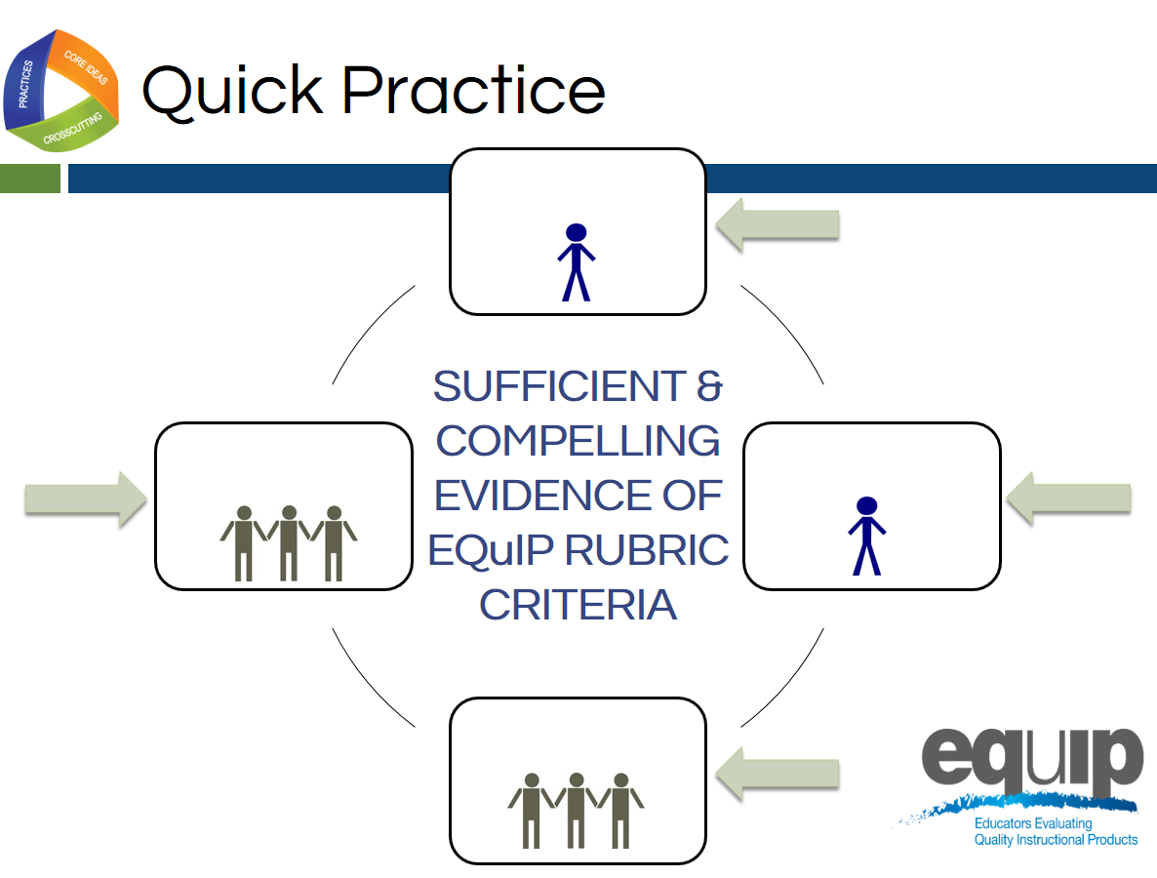
Slide 185

Talking Points
- As you work through this category, follow the same process you used earlier when examining a lesson or unit for Categories I and II:
  - First, work individually to look for the evidence in the Common Lesson.
  - Use the Arabic and Roman numerals associated with the rubric criteria to code the evidence you locate.
  - Next, still individually, determine how the evidence fits together and connects to one or more criteria.
  - Once you’ve made your individual determinations, work with your group to share and compare the evidence you’ve located in the Common Lesson.
  - Then, as a result of this evidence and reasoning, collaboratively evaluate whether or not the lesson or unit provides sufficient and compelling evidence of the criteria, and assign evidence of quality ratings for each of the criteria as well as for each category.
  - Finally, make suggestions for how the lesson or unit might be improved.
- You have 30 minutes for this task. [Note to facilitator: Set the timer, but monitor the groups to determine if they need more or less time to complete the practice before moving on.]

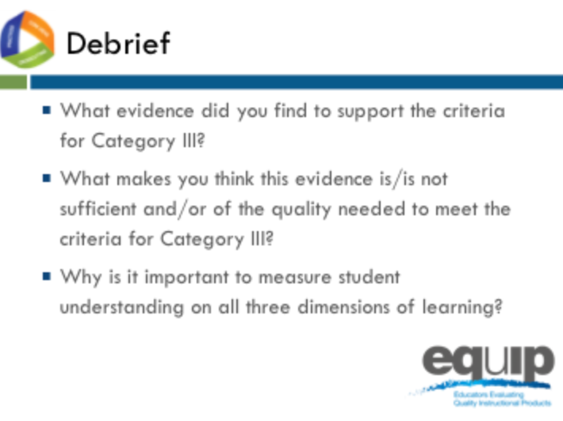
Slide 186
Talking Points
- So what determinations did you make at your tables? Does this lesson meet the criteria in Category III?
- How? Why or why not? [Note to facilitator: Allow several tables to share.]
- Why is it important to measure student understanding on all three dimensions of learning? [Note to facilitator: Allow several tables to share.]
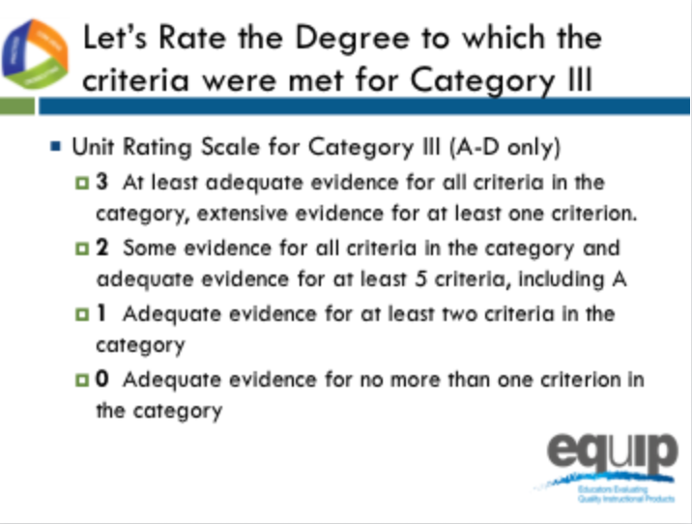
Slide 187
Talking Points
- Let’s rate the degree to which the criteria were met in Category III.
- Let’s only consider criteria A–D since we are examining a lesson, not a unit.
- At each table, let’s review the evidence of quality for categories A–D. Then, as a group, let’s determine a rating for Category III using the language on page 12 of the rubric.
- Notice that the possible ratings fall across a 0–3 scale.
- Facilitator, give groups about 5 minutes to discuss evidence of quality for each category A–C and determine a Category rating.
- By a show of fingers, would table facilitators indicate how many of the criteria you found at least adequate evidence of in the lesson? [Note to facilitator: Do a quick summary of the room and announce a consensus response.]
- Let's take a quick poll of the room, what rating did your group give to Category III? [Note to facilitator: Quickly survey the room by asking for a response from each group, and discuss a consensus answer.]
- Finally, would a few groups be willing to share specific evidence and reasoning for your evidence of quality rating? [Note to facilitator: Take a few group volunteers.]

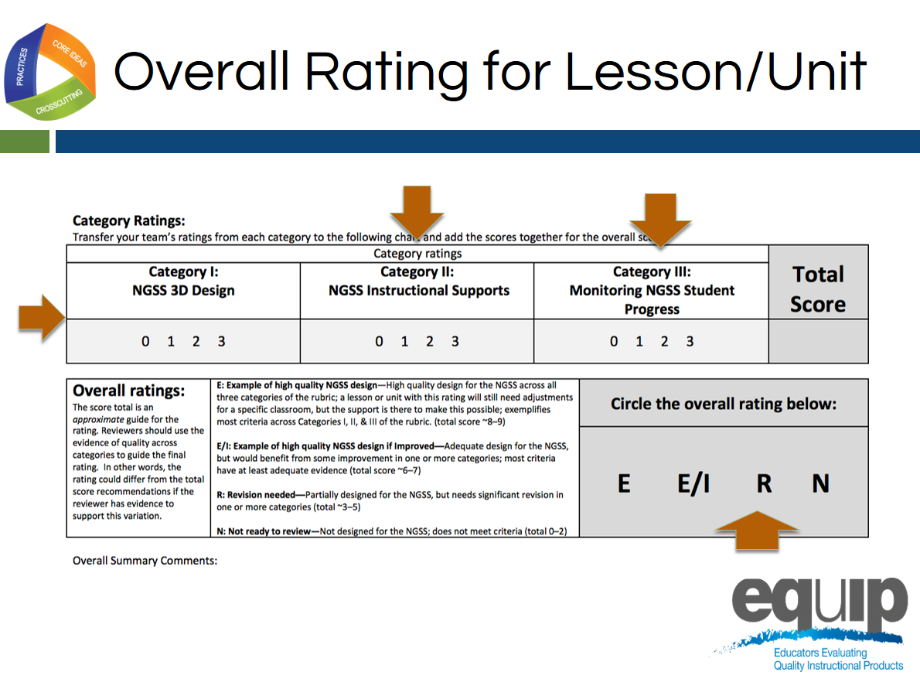
Slide 188

Facilitator Notes
If there is time available, have groups share their overall ratings and a comment after the 10-minute time allotted for this task.
Talking Points
- Let’s determine an overall rating and share summary comments.
- Let’s turn to page 14 of our rubric, pictured on this slide.
- At our tables, let’s review our ratings for categories I. [Note to facilitator: click animation II, click animation and III click animation one at a time.]
- As you look back at each category in the rubric and share the category rating, try to record at least one summary comment in the Overall Summary Comments for the category.
- Total your category ratings and reflect on the overall quality of the lesson and record your overall rating. [Note to facilitator: Click animation.]
- Notice that total scores of 8–9 are examples of high quality design.
- Scores of 6–7 are examples of high quality design if improved.
- Scores of 3–5 indicate that revision is needed since these lessons are only partially designed for the NGSS.
- Scores of less than 3 indicate that this lesson was not ready for review since it does not reflect NGSS Design.
- You will have ten minutes to complete this task.
Concluding Slide for Module 9
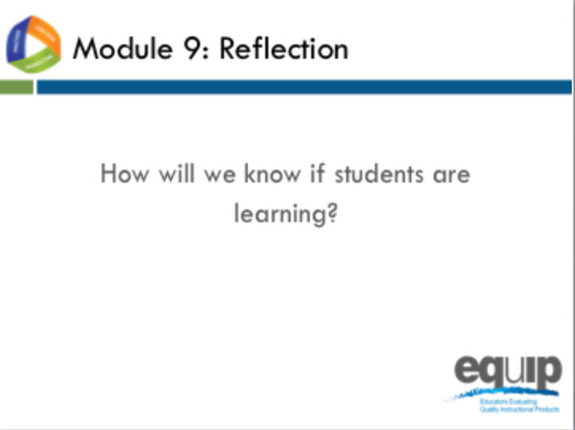
Slide 189
Talking Points
- As with all standards, teaching to the NGSS is not sufficient. It’s about students learning—in the case of the NGSS, three-dimensional learning. Examining a lesson or unit against the criteria in Category III determines whether that lesson or unit includes the kinds of assessments that allow all students to demonstrate understanding and for all teachers to monitor the progress and performance of all students.
- As a result of this module, you should feel comfortable using the rubric to determine whether or not a lesson or unit meets the criteria in Category III.
- Are there any questions or additional comments about the criteria in Category III? [Note to facilitator: Address question or comments if they arise.]
- You have now completed the first nine modules of this professional learning.
- You’ve applied the EQuIP Rubric criteria to examine a common lesson to determine whether this lesson contains evidence of sufficient quality to meet the criteria for:
  - NGSS 3D Design;
  - Instructional Supports; and
  - Monitoring NGSS Student Progress.
- Now that you’ve had practice with each category of the rubric separately, you’re ready for the culminating task where you will put what you’ve learned into practice to examine a lesson or unit that has been developed for your grade, grade band and/or specific science discipline.
- [Note to facilitator: Ask each of the following questions one at a time, allow participants to answer, and provide follow up as needed before proceeding to the culminating task.]
  - Do you feel ready to use the EQuIP Rubric to examine NGSS instructional materials?
  - What have been the strengths of the training?
  - Is there anything you need to review or revisit before the culminating task?

MODULE
EQuIP for Science v3.0
10

Culminating
Task
Module 10: Culminating Task
Module 10 provides participants an opportunity to examine a lesson or unit specific to their grade, grade band, and/or science discipline. Participants also have a chance to reflect on this task as well as the overall professional learning encompassed by the ten modules.
Materials Needed
- Module 10 PowerPoint slides or slides 190–199 of the full PowerPoint
- Locally-developed or identified lessons and units for participants to examine
- Handout 11: Module 10, “Culminating Task Debrief Questions”
- Additional copies of Handout 7: Module 4, “EQuIP Rubric, Version 3.0”* or a computer or tablet with the electronic version of the rubric (At least one person per table should record their group’s findings electronically.)

*Introduced in a previous module.
Introduction to Module 10
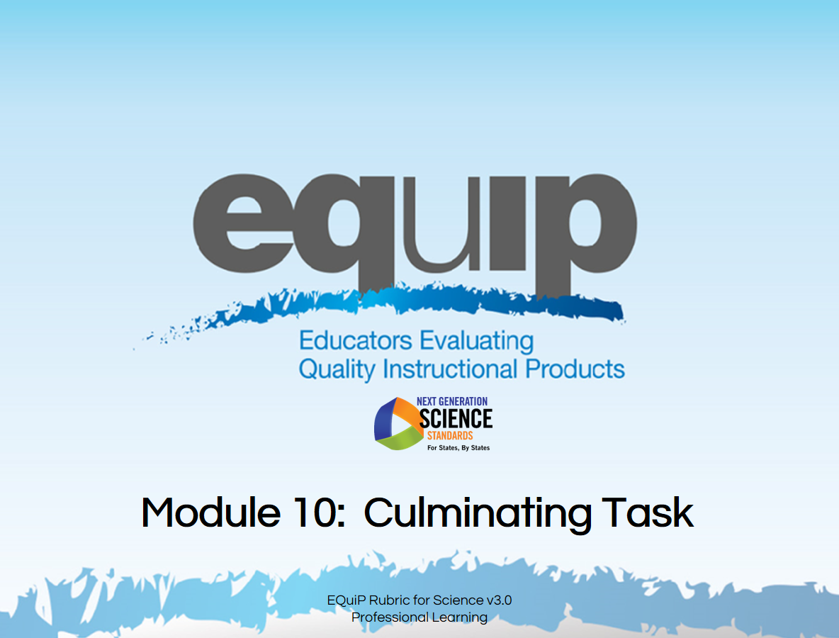
Slide 190
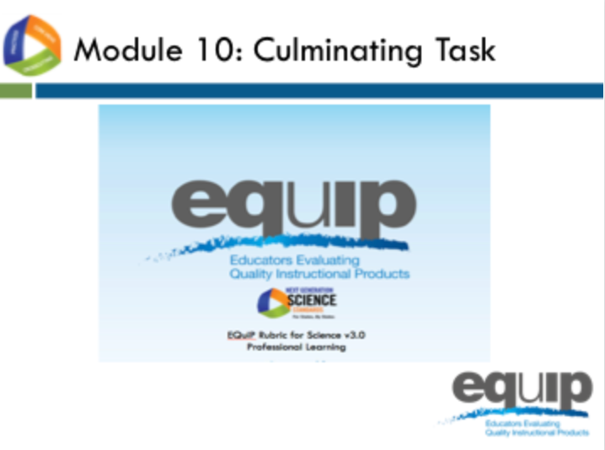
Slide 191
Talking Points
- We’re now ready for the culminating task where you will apply all of the learning from the previous nine modules of this professional learning to examine instructional materials directly related to a specific grade, grade band, or science discipline.
- This is an opportunity for you as reviewers to examine locally-developed or identified instructional materials.

The Task
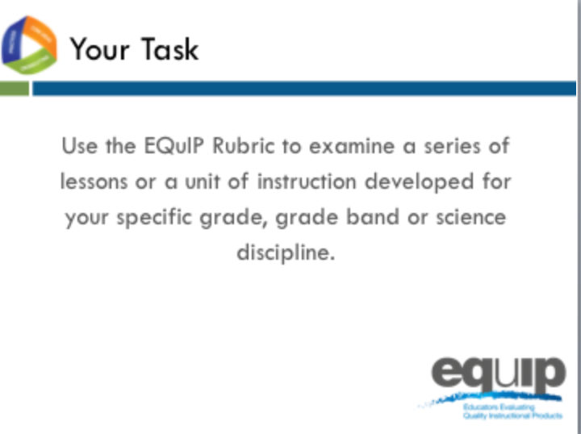
Slide 192
Talking Points
- For this task, each group has a different set of instructional materials to examine.
- In addition, you will need:
  - The EQuIP Rubric, specifically the response forms for Categories I, II, and III;
  - A computer loaded with an electronic version of the EQuIP Rubric to record group responses;
  - If available, a small projector to allow group members to view the group responses as they are recorded. A screen-sharing application could also be used.
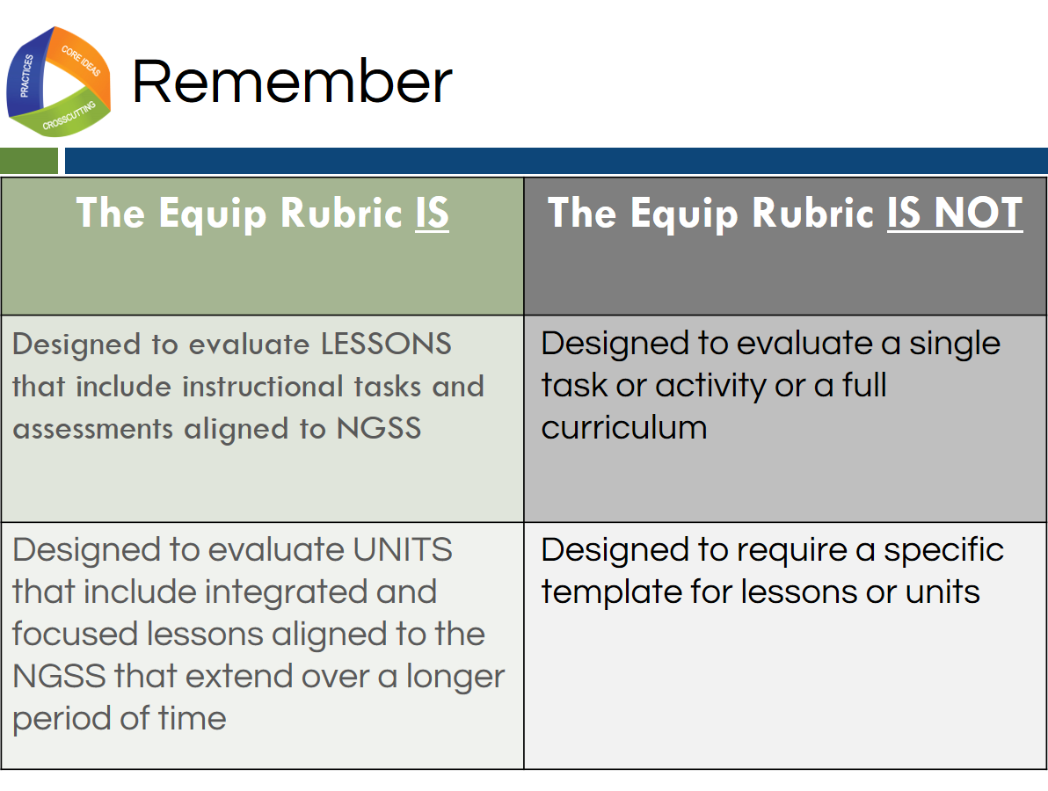
Slide 193
Talking Points
- Remember, as defined by the EQuIP Rubric:
!
  - A lesson is a coherent set of instructional activities and assessments aligned to the NGSS that may extend over a few to several class periods or days; and
  - A unit is a coherent set of lessons aligned to the NGSS that extend over a longer period of time.
- An integrated instructional sequence is rooted in an explanatory question aimed at making sense of a phenomenon and/or designing a solution to a problem.
- With these definitions in mind, it is important to note that the lessons the EQuIP Rubric is designed to evaluate may extend over a few to several class periods or days.
- Any single task, activity, or mini-lesson would not be suitable for use with the EQuIP Rubric as it would likely not include instructional supports and assessments, two of the categories of the rubric.
- Likewise, the EQuIP Rubric is not appropriate for reviewing a full curriculum; however, the rubric could be used to review specific lessons or units within the curriculum. A tool is available here http://www.nextgenscience.org/resources/peec-alignment-ngss-publishers-criteria to look at full curricula.
- Finally, the EQuIP Rubric does not require that lessons or units be put into a specific format in order to be evaluated against the rubric criteria.
!
- [Note to facilitator: If participants bring lessons or units that do not list the targeted performance expectations, take time to consider what performance expectations the lesson may be building toward.]
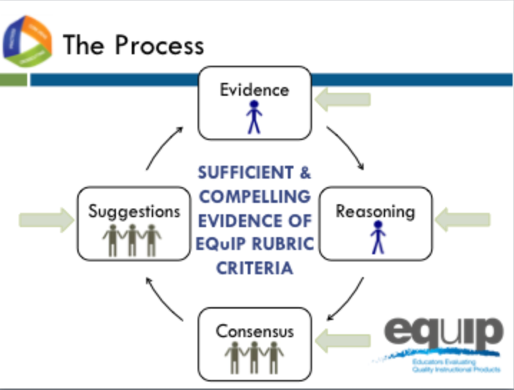
Slide 194
Talking Points
- Follow the same process you used during the previous practice sessions.
  - Individually, closely examine the materials through the lens of the criteria for the EQuIP Rubric and record this evidence on the response form. Use the Arabic and Roman numerals associated with the rubric criteria to code the evidence you locate.
  - Individually, use reasoning to connect the evidence you locate to the rubric criteria and record your reasoning on the response form.
  - As a group, share, discuss, and work collaboratively toward consensus as to whether there is sufficient clear and compelling evidence to say that the rubric criteria have been met, and assign evidence of quality ratings for each of the criteria as well as for each category.
  - As a group, provide suggestions for improvement on the response form.
  - Finally, transfer your team’s ratings from each category to the following chart and add the scores together for the overall score.
- Keep in mind that the comments you make on the response form will provide feedback, evaluation, and guidance for the developer(s) or user(s) of these instructional materials.
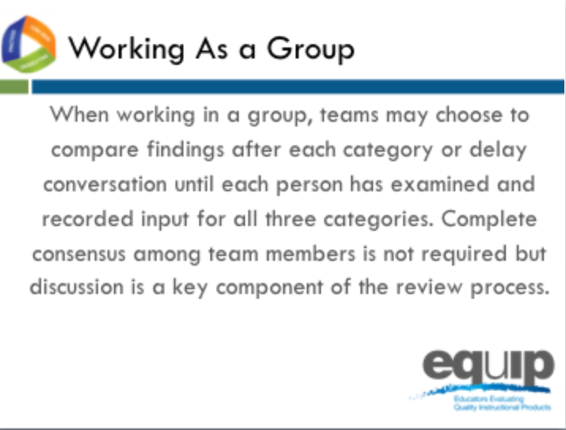
Slide 195
Talking Points
- For this culminating task you will be working through all three categories of the rubric with a lesson or unit specific to your group’s discipline and grade band.
- Prior to beginning, decide how your group would like to approach this task.
- You may elect to work through the process as a group one category at a time, or you may choose to work through all three categories individually before beginning your discussion as a group.
- Before you begin the group discussion, designate a recorder for your group.
- Your recorder should use an electronic version of the EQuIP Rubric response form to record your comments electronically.
- You also may find it helpful to designate other roles for members of your group. These roles might include:
  - One group member to monitor time,
  - One group member to facilitate the discussion, etc.
- [Note to facilitator: Pass out lessons and units if participants do not already have them.]
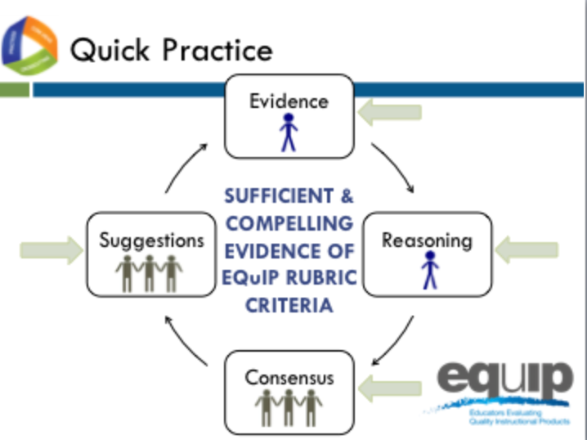
Slide 196
Talking Points
- Each group should now have a packet of instructional materials that includes copies of these materials for each member of your group.
- Here again is the examination process.
- Be thoughtful about your time. You have approximately two hours of relatively uninterrupted time to complete your examination. Pace yourself so you can make it through the entire rubric.
- Allow approximately one hour for Category I, 30 minutes for Category II, and 30 minutes for Category III.
- We’ll keep you posted periodically regarding how much time is remaining.
- Because you have a limited amount of time for this task, you may not be able to list all of the evidence that supports a criterion; rather, you may need to cite examples.
- If your examination does not take the full time allotted, you may begin responding to the debriefing questions for the training, which are located on Handout 11.
- Please remember that the comments you record on the response sheet will provide feedback, evaluation, and guidance for the developer(s) or user(s) of these instructional materials.
- [Notes to facilitator: 1) Leave this slide up and set a separate timer or alarm. Provide frequent time updates to allow groups to monitor progress. Allow more or less time as needed to complete the task before moving on to the reflection. 2) If, as you monitor the progress of the groups, you notice common issues or places where multiple groups are having difficulty, briefly interrupt the process and address all the groups simultaneously to clarify or get groups back on track.]

Reflecting on the Culminating Task
Slide 197
Facilitator Notes
Refer participants to Handout 11, Module 10, “Culminating Task Debrief Questions.”
Talking Points
- So how did it go?
- Take a few minutes to reflect on your experience using the EQuIP Rubric for the culminating task.
- At your tables you should have a list of questions to discuss as you debrief on this culminating task. You have ten minutes to discuss these questions before we share our reflections. [Note to facilitator: Allow ten minutes.]
- Let’s share some of your thoughts. [Note to facilitator: Ask each set of questions separately, allow several tables to share, and then move on to the next set of questions.]
  - On a scale of one to four, to what extent did your group share a common language and understanding of EQuIP criteria as you reviewed this lesson? Why this rating?
  - Are there any criteria or evidence about which you disagreed? If so, did you disagree about what you considered evidence of a criterion, about whether the evidence was sufficient to meet a criterion, or about both?
  - What differences arose among your group members when checking criteria? How did you resolve those differences? What do you think caused those differences? Were there differences that remained unresolved? What were some of those unresolved differences?
  - Where in the review process did you experience the most difficulty or the greatest disagreements? What suggestions do you have regarding resolving differences among reviewers?
  - How did having collaborative discussions move individual group members or the group as a whole toward a decision?
Reflecting on this Professional Learning
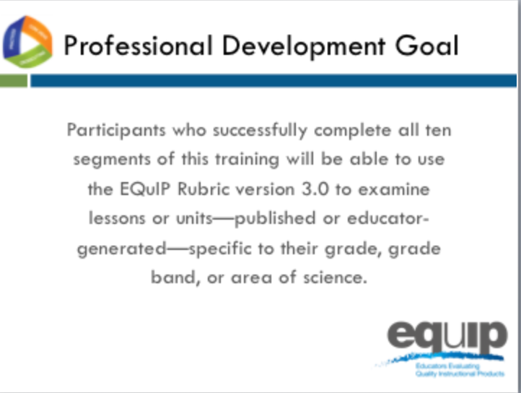
Slide 198
Talking Points
- Overall, what has been your experience with this professional learning?
- [Note to facilitator: Ask each of the questions below, one at a time, and allow groups/individuals to respond.]
  - What will be your next steps as a group?
  - How will you use this professional learning in your role/job/position?
    - What are your plans for using the EQuIP Rubric and the review process to examine instructional materials?
    - How will you use the EQuIP Rubric to inform the development of new instructional materials?
    - Will you be redelivering this professional learning to other science educators? If so, when and to whom?
    - How else might you use this professional learning?

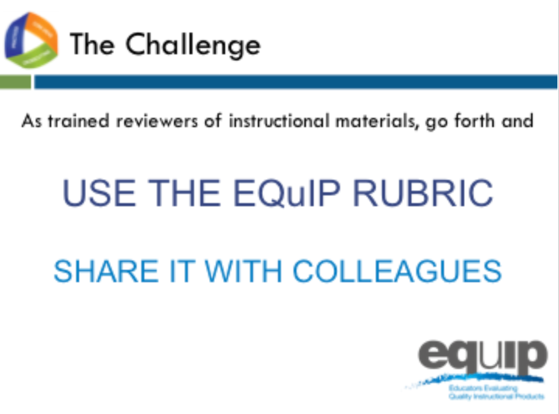
Slide 199
Talking Points
- As we conclude this training, we’d like to challenge each of you newly trained reviewers of instructional materials to:
  - [Note to facilitator: Click for animation.] Use the Equip Rubric to examine instructional materials for use with the NGSS; and
  - [Note to facilitator: Click for animation.] Share your knowledge and expertise in using the EQuIP Rubric to examine instructional materials with your colleagues.
- For more information about NGSS resources, visit http://www.nextgenscience.org/equip.
- This concludes the EQuIP version 3.0 Rubric training.

