How to Read the Next Generation Science Standards (NGSS)
The Next Generation Science Standards (NGSS) are distinct from prior science standards in three essential ways.
- Performance. Prior standards documents listed what students should “know” or “understand.” These ideas needed to be translated into performances that could be assessed to determine whether or not students met the standard. Different interpretations sometimes resulted in assessments that were not aligned with curriculum and instruction. The NGSS has avoided this difficulty by developing performance expectations that state what students should be able to do in order to demonstrate that they have met the standard, thus providing the same clear and specific targets for curriculum, instruction, and assessment.
- Foundations. Each performance expectation incorporates all three dimensions from the Framework— a science or engineering practice, a core disciplinary idea, and a crosscutting concept.
- Coherence. Each set of performance expectations lists connections to other ideas within the disciplines of science and engineering, and with Common Core State Standards in Mathematics and English Language Arts.
This chapter describes how these three unique characteristics are embodied in the format of the standards, beginning with the “system architecture.”

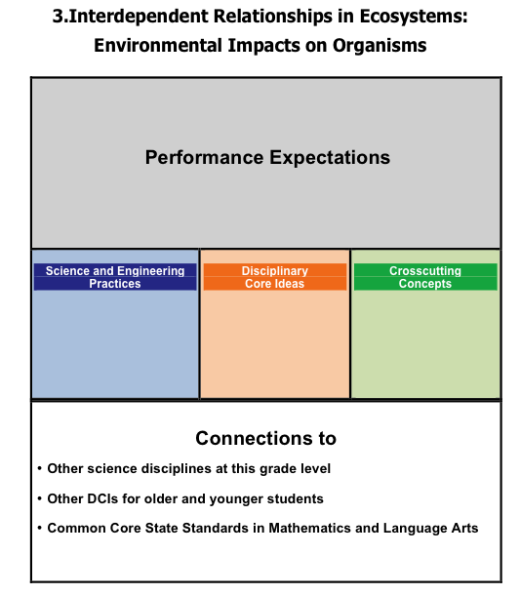
System Architecture
As shown in the illustration at right, each set of performance expectations has a title. Below the title is a box containing the performance expectations. Below that are three foundation boxes, which list (from left to right) the specific science and engineering practices, core disciplinary ideas, and crosscutting concepts that were combined to produce the performance expectations (PEs) above. The bottom section lists connections to PEs in other science disciplines at the same grade level, to PEs of the same core idea for younger and older students, and to related Common State Standards in mathematics and language arts. These sections are described in further detail below.

Performance Expectations
Performance expectations are the assessable statements of what students should know and be able to do. Some states consider these performance expectations alone to be “the standards,” while other states also include the content of the three foundation boxes and connections to be included in “the standard.” The writing team is neutral on that issue. The essential point is that all students should be held accountable for demonstrating their achievement of all PEs, which are written to allow for multiple means of assessment.
The last sentence in the above paragraph—that all students should be held accountable for demonstrating their achievement of all performance expectations—deserves special attention because it is a fundamental departure from prior standards documents, especially at the high school level where it has become customary for students to take courses in some but not all science disciplines. The NGSS takes the position that a scientifically literate person understands and is able to apply core ideas in each of the major science disciplines, and that they gain experience in the practices of science and engineering and crosscutting concepts. In order for this to be feasible the writing team has limited the core ideas included in the performance expectations to just those listed in the Framework.
The NGSS writers initially attempted to include all of the disciplinary core ideas (DCIs) verbatim from the Framework in the performance expectations, but found that the resulting statements were bulky and reduced readers’ comprehension of the standards. Instead, the performance expectations were written to communicate a “big idea” that combined content from the three foundation boxes. In the final phase of development we further limited the number of performance expectations with input from our state teams, to ensure that this set of PEs is achievable at some reasonable level of proficiency by the vast majority of students.
Some states have standards that include concepts that are not found in the NGSS. However, in most cases not all students in those states are expected to take courses in all three areas of science and engineering. The NGSS are for all students, and all students are expected to achieve proficiency with respect to all of the performance expectations in the NGSS.
A second essential point is that the NGSS performance expectations should not limit the curriculum. Students interested in pursuing science further (through Advanced Placement or other advanced courses) should have the opportunity to do so. The NGSS performance expectations provide a foundation for rigorous advanced courses in science or engineering that some students may choose to take.
A third point is that the performance expectations are not a set of instructional or assessment tasks. They are statements of what students should be able to do after instruction. Decisions on how best to help students meet these PEs are left to states, districts, and teachers.
In the example below, notice how the performance expectation combines the skills and ideas that students need to learn, while it suggests ways of assessing whether or not second graders have the capabilities and understandings specified in the three foundation boxes.
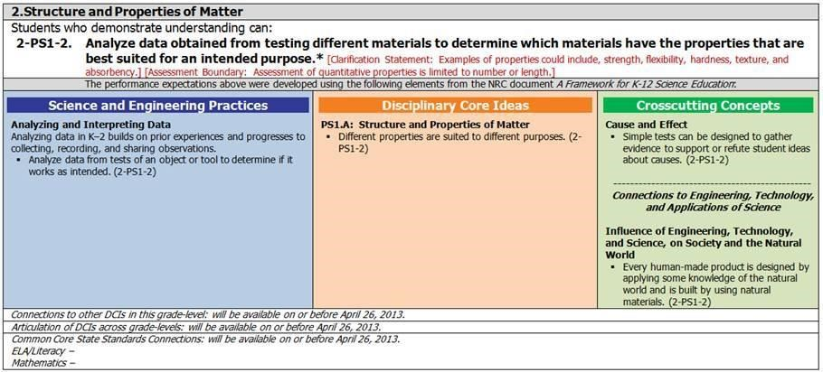
As shown in the example, most of the performance expectations are followed by one or two additional statements in smaller type. These include clarification statements, which supply examples or additional clarification to the performance expectations; and assessment boundary statements, which specify the limits to large scale assessment.
Notice that one of the DCIs was “moved from K-2.” That means the writing team decided that a DCI that the Framework specified for end of second grade could be more easily assessed if combined with the other ideas specified for third grade. This was only done in a limited number of cases.
Also, notice that the code for this performance expectation (2-PS1-2) is indicated in each of the three foundation boxes to illustrate the specific practices, disciplinary core ideas, and crosscutting concepts on which it is built. Since all of the standards have several PEs, the codes make it easy to see how the information in the foundation boxes is used to construct each performance expectation.
The codes for the performance expectations were derived from the Framework. As with the titles, the first digit indicates a grade K-5, or specifies MS (middle school) or HS (high school). The next alpha-numeric code specifies the discipline, core idea and sub-idea. All of these codes are shown in the table below, derived from the Framework. Finally, the number at the end of each code indicates the order in which that statement appeared as a DCI in the Framework.

Physical Science | Life Science | Earth and Space Science
PS1 Matter and Its Interactions PS1A Structure and Properties of matter  PS1B Chemical Reactions  PS1C Nuclear Processes  PS2 Motion and Stability: Forces and  Interactions  PS2A Forces and Motion PS2B  Types of Interactions  PS2C Stability and Instability in  Physical Systems  PS3 Energy  PS3A Definitions of Energy PS3B Conservation of Energy and Energy Transfer  PS3C Relationship Between Energy and Forces  PS3D Energy and Chemical  Processes in Everyday Life  PS4 Waves and Their Applications in Technologies for Information Transfer  PS4A Wave Properties  PS4B Electromagnetic Radiation PS4C Information Technologies and  Instrumentation | LS1 From Molecules to Organisms: Structures and Processes  LS1A Structure and Function LS1B Growth and Development of Organisms  LS1C Organization for Matter and Energy Flow in Organisms  LS1D Information Processing  LS2 Ecosystems: Interactions, Energy, and Dynamics  LS2A Interdependent Relationships in Ecosystems  LS2B Cycles of Matter and Energy  Transfer in Ecosystems  LS2C Ecosystem Dynamics,  Functioning, and Resilience  LS2D Social Interactions and Group Behavior  LS3 Heredity: Inheritance and Variation of  Traits  LS3A Inheritance of Traits  LS3B Variation of Traits  LS4 Biological Evolution: Unity and  Diversity  LS4A Evidence of Common Ancestry  LS4B Natural Selection  LS4C Adaptation  LS4D Biodiversity and Humans | ESS1 Earth’s Place in the Universe  ESS1A The Universe and Its Stars  ESS1B Earth and the Solar System  ESS1C The History of Planet Earth  ESS2 Earth’s Systems  ESS2A Earth Materials and Systems  ESS2B Plate Tectonics and  Large-Scale System Interactions  ESS2C The Roles of Water in  Earth’s Surface Processes  ESS2D Weather and Climate  ESS2E Biogeology  ESS3 Earth and Human Activity  ESS3A Natural Resources  ESS3B Natural Hazards  ESS3C Human Impacts on Earth Systems  ESS3D Global Climate Change

Foundation Boxes
While the performance expectations can stand alone, a more coherent and complete view of what students should be able to do comes when the performance expectations are viewed in tandem with the contents of the foundation boxes that lie just below the performance expectations. These three boxes include the practices, core disciplinary ideas, and crosscutting concepts, derived from the Framework, that were used to construct this set of performance expectations.
Disciplinary Core Ideas (DCIs). The orange box in the middle includes statements that are taken from the Framework about the most essential ideas in the major science disciplines that all students should understand during 13 years of school. Including these detailed statements was very helpful to the NGSS writing team as they analyzed and “unpacked” the disciplinary core ideas and sub-ideas to reach a level that is helpful in describing what each student should understand about each sub-idea at the end of grades 2, 5, 8, and 12. Although they appear in paragraph form in the Framework, here they are bulleted to be certain that each statement is distinct.
Science and Engineering Practices. The blue box on the left includes just the science and engineering practices used to construct the performance expectations in the box above. These statements are derived from and grouped by the eight categories detailed in the Framework to further explain the science and engineering practices important to emphasize in each grade band. Most sets of performance expectations emphasize only a few of the practice categories; however, all practices are emphasized within a grade band. Teachers should be encouraged to utilize several practices in any instruction, and need not be limited by the performance expectation, which is only intended to guide assessment.
Crosscutting Concepts. The green box on the right includes statements derived from the Framework’s list of crosscutting concepts, which apply to one or more of the performance expectations in the box above. Most sets of PEs limit the number of crosscutting concepts so as focus on those that are readily apparent when considering the DCIs. However all are emphasized within a grade band. Again, the list is not exhaustive nor is it intended to limit instruction. Aspects of the Nature of Science relevant to the standard are also listed in this box, as are the interdependence of science and engineering, and the influence of engineering, technology, and science on society and the natural world. Although these are not crosscutting concepts in the same sense as the others, they are best taught and assessed in the context of specific science ideas, so they are also listed in this box.

Connection Boxes
Three Connection Boxes, below the Foundation Boxes, are designed to support a coherent vision of the standards by showing how the performance expectations in each standard connect to other PEs in science, as well as to common core state standards. The three boxes include:
Connections to other DCIs in this grade level. This box contains the names of science topics in other disciplines that have related disciplinary core ideas at the same grade level. For example, both Physical Science and Life Science performance expectations contain core ideas related to Photosynthesis, and could be taught in relation to one another.
Articulation of DCIs across grade levels. This box contains the names of other science topics that either
1) provide a foundation for student understanding of the core ideas in this set of performance expectations (usually at prior grade levels) or 2) build on the foundation provided by the core ideas in this set of PEs (usually at subsequent grade levels).
Connections to the Common Core State Standards. This box contains the coding and names of pre- requisite or co-requisite Common Core State Standards in English Language Arts & and Literacy and Mathematics that align to the performance expectations. For example, performance expectations that require student use of exponential notation will align to the corresponding CCSS mathematics standards. An effort has been made to ensure that the mathematical skills that students need for science were taught in a previous year where possible.

Color Coding
Online versions of the standards display color coding of the words within each performance expectation that represent the three dimensions: blue for Science and Engineering Practices, orange for Disciplinary Core Ideas, and green for Crosscutting Concepts. Clarification Statements and Assessment Boundaries are in red. Because some of the words used in the performance expectation represented both a crosscutting concept and the disciplinary core idea it was not possible to color- code both simultaneously.
Printed and PDF versions of the standards do not have color coding of the three dimensions. In these cases the connections between individual performance expectations and the statements in the foundation boxes will be shown by including the relevant codes after each statement in the foundation boxes.
Title. The organization of the NGSS is based on the core ideas in the major fields of natural science from A Framework for K-12 Science Education (NRC 2012), plus one set of PEs for engineering. For the elementary level, from Kindergarten to grade five, sets of performance expectations are assigned to specific grades. A numeral at the start of a title indicates the grade level; so the title in the example above is a third grade standard. Titles for middle school (grades 6-8) standards begin with “MS” and those for high school standards (grades 9-12) begin with “HS.”
The titles also reveal the organization of the standards, which is based on the core ideas in the disciplines from the Framework. The Framework lists 11 core ideas, four in life science, four in physical science, and three in Earth and Space Science. The core ideas are divided into a total of 39 sub-ideas, and each sub-idea is elaborated in a list of what students should understand about that sub-idea at the end of grades 2, 5, 8, and 12. We have called these grade-specific statements Disciplinary Core Ideas (DCIs).
At the beginning of the process, the writers examined all of the DCIs in the Framework to eliminate redundant statements, find natural connections among DCIs, and develop PEs that were appropriate for the different grade levels. The result was a topical clustering of DCIs that usually, but did not always correspond to the core ideas identified in the Framework. This structure provided the original basis of the standards and has continued through the process. Below is a list of all clusters of PEs. The list does not indicate any particular order within each grade level or band, so the following list should not be considered a scope and sequence document for the purpose of curriculum planning and development.

