MODULE
NGSS EQuIP
6

Category I:
Determining
Alignment to
the NGSS
Module 6: Category I: Determining Alignment to the NGSS
Module 6 dives deeper into three-dimensional learning by having participants examine a short activity (coming soon) and determine whether the three dimensions are present and if they work together to support students in making sense of phenomena and/or designing solutions to problems. After this first task, participants begin examining a common lesson (coming soon) using just the first criteria in Category I: Alignment to the NGSS. [Note to facilitator: If you plan to use this module before Handout 7 and the common lesson are available, you will need to identify your own materials for these. Additionally, slides 66–68 will need to be changed to include specific examples from the identified materials.]
Materials Needed
- Module 6 PowerPoint slides or slides 58–77 of the full PowerPoint
- Handout 7: Module 6, Slide 65, “Example of Three-Dimensionality” (COMING SOON)
- Common Lesson (COMING SOON — ideally this lesson will be shared with participants before the professional learning so they can review it)
- Blue, orange, and green highlighters.
- Handout 5: Module 4, Slide 42, “EQuIP Agreements” (1 page)*
- Handout 6: Module 4, Slide 43, “EQuIP Rubric, Version 2” (4 pages)* or a computer or tablet with the electronic version of the rubric (at least one person per table should record their group’s findings electronically)
- Optional: Because participants will want to consider the elements of the three dimensions, it may be necessary to have copies of the standards as well as Appendix F and Appendix G . Alternatively, participants can find the standards and appendices at www.nextgenscience.org if internet access is available.

*Introduced in a previous module.
Introduction to Module 6
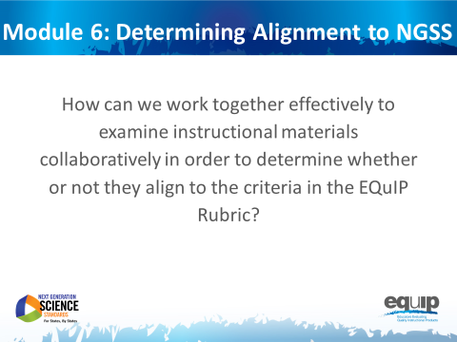
Slide 58
Talking Points
- In this module, we’re going to apply everything we’ve learned to this point and actually work together to examine a common lesson using the EQuIP Rubric.
- As we use the EQuIP Rubric in this module to examine instructional materials, you will:
  - Apply the common definitions we discussed in the last module.
  - Locate evidence of specific rubric criteria and use reasoning to explain how or why this evidence meets or does not meet rubric criteria.
  - Evaluate whether the evidence you’ve located is sufficient to demonstrate alignment to the NGSS.
  - Provide guidance regarding how a lesson or unit might be revised in order to meet rubric criteria.

Category I: Alignment to the NGSS
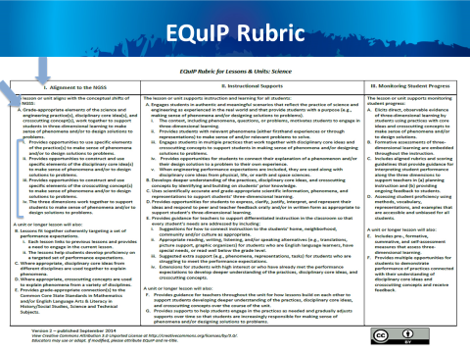
Slide 59

Talking Points
- Please get out your EQuIP Rubric and turn to page 4 of the rubric document where you’ll see all three categories of the rubric.
- For the lesson we are going to examine in this module, we will only be looking at the first major criterion in Category I and its component parts. [Note to facilitator: Click for animation.]
- This is Criterion A, which you’ll find under “The lesson or unit aligns with the conceptual shifts of the NGSS.” [Note to facilitator: Click for animation.]
- We will be looking at Criterion A along with the four sub-criteria under Criterion A. [Note to facilitator: Click for animation.]
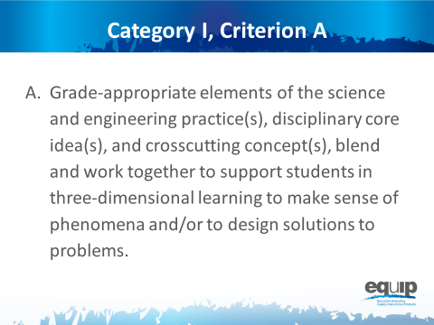
Slide 60
Talking Points
- Criterion A states, “Grade-appropriate elements of the science and engineering practice(s), disciplinary core idea(s), and crosscutting concept(s), blend and work together to support students in three-dimensional learning to make sense of phenomena and/or design solutions.”
- Here the term “elements” is used to represent the relevant, bulleted practices, disciplinary core ideas, and crosscutting concepts that are articulated in the foundations boxes of the standards, as well as in the NGSS appendices on each dimension. Looking at the elements of the disciplinary core ideas ensures that each dimension is grade or grade-band appropriate.
!
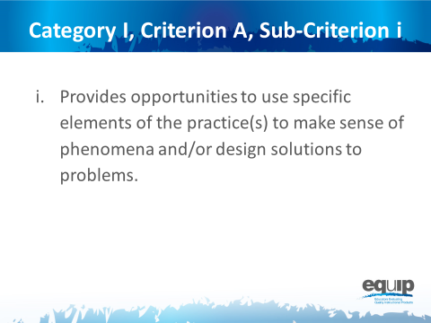
Slide 61
Talking Points
- We’ll also be looking at the sub-criteria under this overall criterion.
- Category I, Criterion A, Sub-Criterion i:
  - Provides opportunities to develop and use specific elements of the practice(s) to make sense of phenomena and/or design solutions to problems.
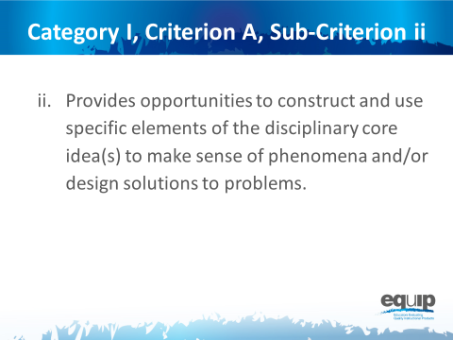
Slide 62
Talking Points
- Category I, Criterion A, Sub-Criterion ii:
- Provides opportunities to develop and use specific elements of the disciplinary core idea(s) to make sense of phenomena and/or design solutions to problems.
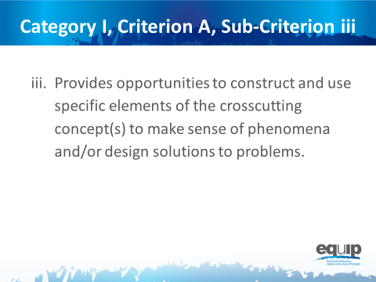
Slide 63
Talking Points
- Category I, Criterion A, Sub-Criterion iii:
- Provides opportunities to develop and use specific elements of the crosscutting concept(s) to make sense of phenomena and/or design solutions to problems.
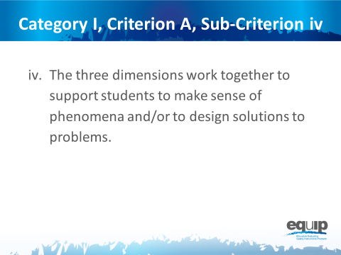
Slide 64
Talking Points
- And Category I, Criterion A, Sub-Criterion iv:
- The three dimensions work together to support students to make sense of phenomena and/or to design solutions to problems.
- Has everyone located Category I, Criterion A on the EQuIP Rubric?
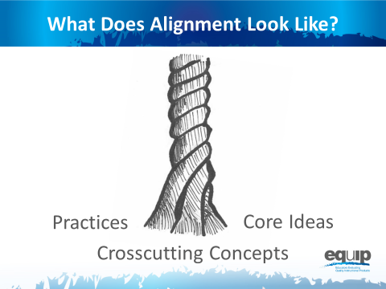
Note to facilitator: Refer participants to Handout 7, Module 6, Slide 65, “Example of Alignment.” (COMING SOON)
Slide 65
Talking Points
- Before we begin to examine a lesson, let’s take another look at what three-dimensional learning might look like.
- You’ll recall that we’re looking for explicit evidence of practices [Note to facilitator: Click for animation.], disciplinary core ideas [Note to facilitator: Click for animation.], and crosscutting concepts [Note to facilitator: Click for animation.], and then for how these work together in three-dimensional learning to help students make sense of phenomena and/or to design solutions to problems.
- Take a look at Handout 7, “Example of Alignment” (COMING SOON).
- Now, look at the area(s) highlighted in blue, orange, and green. This highlighting represents examples of identified evidence of practices, disciplinary core ideas, and crosscutting concepts respectively.
- Which elements of the three dimensions do you see in this lesson? Explain why the highlighted areas are evidence of practices, disciplinary core ideas, and crosscutting concepts. The process you use here to “explain why” represents reasoning as we discussed it in an earlier module.
- [Note to facilitator: Participants may not be familiar with referring to the elements of the three dimensions, so it may be useful to show them how to locate elements in the foundation boxes of a performance expectation and to refer them to where they can be found in Appendix F and Appendix G of the NGSS.]
- Take a minute to discuss what you see in terms of Criterion A and the first three sub-criteria in this example. [Note to facilitator: Allow three to five minutes and then ask the table to share.]

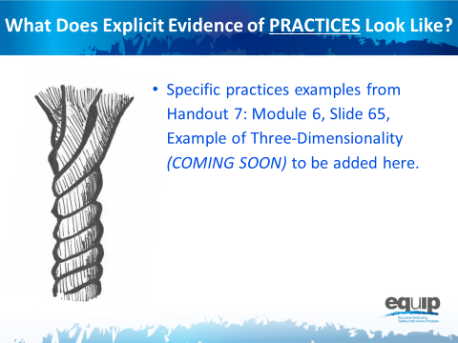
Slide 66
Talking Points
- Now, let’s look at this example together.
- The blue areas are examples of explicit evidence of science and engineering practices.
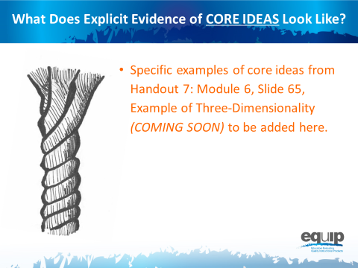
Slide 67
Talking Points
- The orange areas are examples of explicit evidence of disciplinary core ideas.
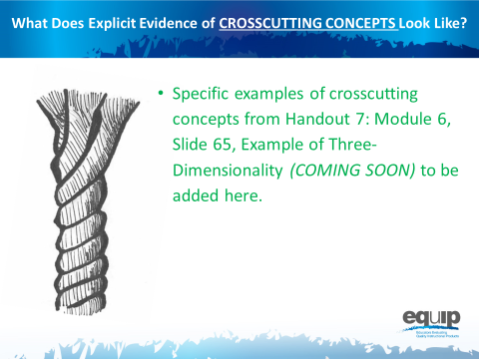
Slide 68
Talking Points
- And the green is an example of explicit evidence of a crosscutting concept.
- What makes these highlighted areas examples of explicit evidence? [Note to facilitator: Allow a few participants to respond.]
- Remember, for the purposes of the EQuIP Rubric, evidence is what is stated or described explicitly in a lesson or unit. If it is evidence, you can see it, point directly to it in the lesson or unit, highlight it, cite it, or quote it directly from what is written.
Slide 69
Talking Points
- Now, with your table group, take three to five minutes to discuss how the practices, core ideas, and crosscutting concepts work together here. [Note to facilitator: Allow three to five minutes and then ask tables to share.]
- [Note to facilitator: Specific examples from Handout 7: Module 6, Slide 65, “Example of Three-Dimensionality” (COMING SOON) of how the three dimensions work together to be added here.]
- So, do you think the practices, disciplinary core ideas, and crosscutting concepts work together in this example to help students make sense of phenomena and/or design solutions to problems? Is there sufficient evidence of three-dimensional learning to meet this first criterion?
- Talk about this at your table and decide why you do or do not think this lesson meets the first criterion. [Note to facilitator: Allow three to five minutes and then ask a few tables to share.]
- As you’ve noted, this lesson does meet the first criterion. This is just one example, and not every lesson or unit that meets the criterion will look the same. It’s important to look at the specific evidence in each lesson or unit, determine how that evidence connects to the criterion, and then collaboratively evaluate whether or not the evidence is sufficient to show alignment to the NGSS.
- Our goal throughout this training is to develop a common understanding of alignment and quality among those persons or groups reviewing lessons and units.
- We’re going to practice this with a common lesson now.

Learning Task: Working Through the Process
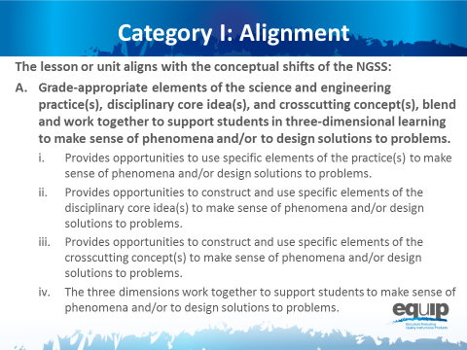
Slide 70
Talking Points
- For this task you will need:
  - An electronic or a hard copy of the EQuIP Rubric;
  - Common Lesson (COMING SOON); and
  - Blue, orange, and green highlighters.
- [Note to facilitator: Specific entities utilizing this training may elect to examine their own or other different materials. If this is the case, however, the trainers/facilitators should take time to examine the common lesson included with this training thoroughly to ensure that the training with these different materials is consistent with what is intended.]
- For this task, you will only be working with the first section of Category I of the EQuIP Rubric that is pictured on this slide. It’s the same criteria we just looked at with the example.
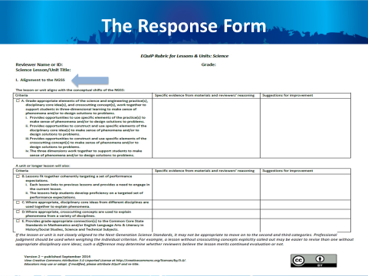
Slide 71
Talking Points
- Now, you need to locate this section on the response form, which is on page 5 of the rubric document — Category I: Alignment to the NGSS. The response form will have the criteria on the left hand side, with blank cells for evidence, reasoning, and suggestions for improvement to the right of the criteria. Please locate that section now.
- This task is designed to acquaint you with the process for using the rubric to examine lessons and units. This examination involves the seven processes and agreements discussed in the previous module, so you may want to pull out that handout and look over it again.
- Before we get started let’s listen to Tricia Shelton discuss how much evidence is sufficient in this video. Joe Krajcik also discusses one example of thinking about how much evidence is sufficient – how student and teacher materials should work together – in this video.
- As you examine this common lesson for evidence of these criteria, keep these questions in mind:
  - For the first sub-criterion, determine whether there is sufficient and compelling evidence that the lesson “provides opportunities to use specific elements of the practice(s) to make sense of phenomena and/or design solutions.”
  - For the second sub-criterion, determine whether there is sufficient and compelling evidence that the lesson “provides opportunities to construct and use specific elements of the disciplinary core idea(s) to make sense of phenomena and/or design solutions.”
  - For the third sub-criterion, determine whether there is sufficient and compelling evidence that the lesson “provides opportunities to construct and use specific elements of the crosscutting concepts to make sense of phenomena and/or design solutions.”
- As you peruse the lesson to make these determinations, you will be locating and marking the actual evidence in the lesson that supports the rubric criteria.
- Because you have a limited amount of time for this task, you may not be able to list all of the evidence that supports a criterion; rather, you may need to cite examples.
- As you work through this common lesson, it is essential that you follow the instructions exactly in order to experience the process as it should be followed in later modules.
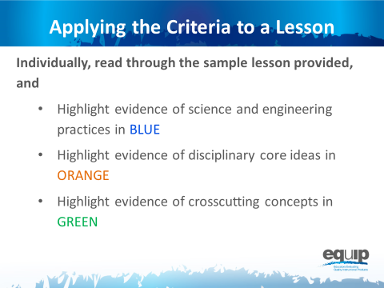
Slide 72
Talking Points
- First, examine the common lesson or unit for evidence of science and engineering practices, core ideas, and crosscutting concepts. Don’t forget to refer back to the elements of the dimensions found in the foundation boxes and the appendices.
- This is completed individually without any discussion between or among group members. Even if you complete this part before other tables are finished, do not discuss your findings before being instructed to do so.
- As you locate evidence, use the Arabic and Roman numerals associated with the rubric criteria to code the evidence you locate.
- Remember, evidence is what you can see explicitly in the lesson or unit.
- You can use the second column of the response form to summarize your evidence.
- You have ten minutes to do this. [Note to facilitator: Set a timer for ten minutes, on the screen for all to see if possible. When the timer sounds, ask if participants need more time before moving on.]
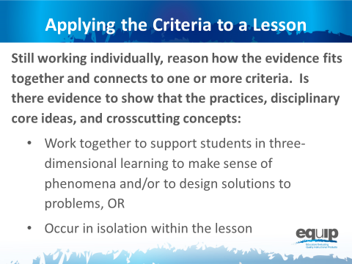
Slide 73

Talking Points
- Now, still working individually without talking or collaborating with others at your table, use reasoning to think about how the evidence fits together and how it relates to the rubric criteria.
- Reasoning is the bridge connecting the evidence to the rubric criteria and to how the practices, core ideas, and crosscutting concepts work together.
- Do the students have an opportunity to engage in three-dimensional learning to help them make sense of phenomena and/or design solutions, OR Do the three dimensions occur in isolation?
- Again, you can use the second column of the response form for this.
- You have five to seven minutes to do this. [Note to facilitator: Set the timer but ask if participants need more time before moving on.]
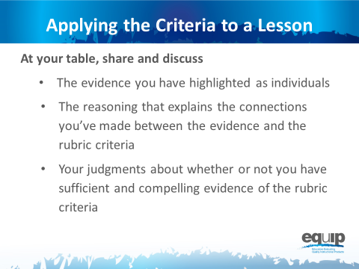
Note to facilitator: At this point ask that the note takers record their group’s findings electronically on the response form. In addition, if available, provide each group with a small projector so that the information being inputted can be seen by all group members. A screen sharing application also could be used.

Slide 74
Talking Points
- Now you finally get to share and compare.
- Before you begin the group discussion, designate a recorder for your group.
- You also may find it helpful to designate other roles for members of your group. These roles might include
  - One group member to monitor time,
  - One group member to facilitate the discussion, etc.
- Making sure everyone contributes his/her findings, share and discuss:
  - [Note to facilitator: Click for animation.] The evidence you highlighted;
  - [Note to facilitator: Click for animation.] The reasoning that explains the connections you made between the evidence and the rubric criteria; and then
  - [Note to facilitator: Click for animation.] Collaboratively evaluate whether this lesson or unit includes sufficient and compelling evidence of three-dimensional learning and whether or not the lesson aligns to the NGSS.
- Attempt to reach consensus as a table group and be prepared to share your evaluation and support them with evidence and reasoning.
- You have 30 minutes for this discussion. [Note to facilitator: Set the timer for 30 minutes but monitor the table groups and provide more or less time as needed to complete this. When the table groups are ready, have two or three share their determinations and then allow for questions and comments related to the determinations before moving on.]
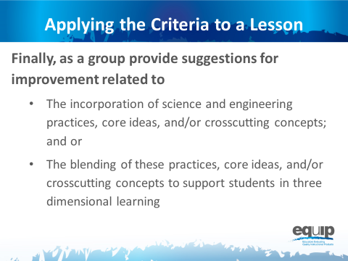
Slide 75
Talking Points
- This part of the task involves providing guidance or suggestions for how the lesson developer can improve the lesson.
- This guidance should be at the element level. Again, when using the EQuIP Rubric, the term “element” refers to the relevant, bulleted practices, disciplinary core ideas, and crosscutting concepts that are articulated in the foundations boxes of the standards, as well as in the NGSS appendices on each dimension.
- Remember to state these suggestions as positive actions for the developer to take rather than as negative statements of what’s missing, etc.
- You have five minutes for this. [Note to facilitator: Set the timer for five minutes. When it sounds, ask for two or three suggestions for improvement before moving to the next slide.]

Debriefing the Task
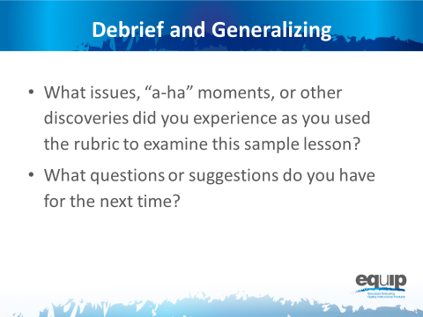
Slide 76
Talking Points
- So, how did it go? What did you experience using the rubric for the first time to determine alignment to the NGSS?
- Do you have any issues related to using the rubric to determine alignment to the NGSS that need to be addressed? Any “aha” moments? Other discoveries that might be important for others to hear? What questions do you have? Do you have any suggestions for improving the process? [Note to facilitator: Have people share as time allows.]
- Why is it important to first use the rubric individually to examine a lesson or unit?
- Why is it important to discuss your individual findings collaboratively as a group in order to make decisions about whether or not a lesson or unit aligns to the NGSS?
- [Note to facilitator: Refer participants to Handout 5, Module 4, Slide 42, “EQuIP Agreements.”] Look back over the agreements we discussed earlier. Why are these so important? [Note to facilitator: Allow two to three people to respond.]
!
- It is essential to understand that the EQuIP quality review process is a collegial process that centers on the use of the criteria-based rubric for science.
!
- While an individual certainly might use the rubric to examine a lesson or unit, the effective evaluation of lessons and units is the product of examination and discussion by a group of people using the rubric collaboratively.
- While using the EQuIP Rubric to examine instructional materials should lead to consensus regarding the overall lessons or units, group members may not always agree about every individual piece of evidence within a lesson or unit.
- The process we just followed to examine the common lesson is the same process we’ll use in examining other lessons and units regardless of whether we’re looking for alignment, coherence, access for all learners, or assessment practices.
- First we look for the evidence in the lesson or unit. Next we determine how the evidence fits together and connects to one or more criteria. From this evidence and reasoning we then make evaluations collaboratively about the lesson or unit. And then, finally, we make suggestions for how the lesson or unit might be improved.

Concluding Slide for Module 6
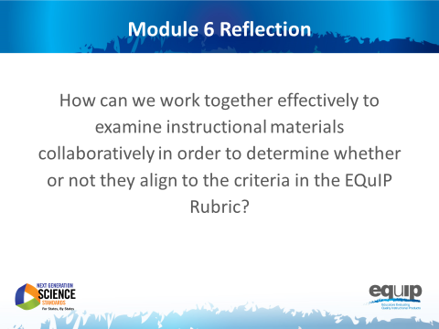
Slide 77
Talking Points
- With your table group, reflect on the process you just used to examine the common lesson.
- Determine where your group is on a scale of one to four, with four indicating that you feel confident that you all understand the process and can now use it to determine whether other instructional materials provide sufficient, explicit evidence to meet EQuIP Rubric criteria. [Note to facilitator: Allow five minutes, and then ask representatives to hold up one to four fingers for their table. Survey the room and address any tables holding up one or two fingers by asking, “What do you still need to move to a three?”]
- In the next module, we’ll take a look at the other criteria in Category I related to alignment to the NGSS.

