MODULE
EQuIP for Science v3.0
1

A Quick
Overview of the Framework for K–12 Science Education
Module 1: A Quick Overview of the Framework for K–12 Science Education
This module provides a brief background on the Framework for K–12 Science Education and should not be considered a thorough review of the Framework. Participants should have an understanding of the Framework and the NGSS before engaging in this professional learning. While this module does provide a brief background on these topics, ideally participants will not need to spend much time on it since they should already be comfortable with the Framework and the NGSS. If this module is skipped or given to participants prior to the meeting, the first introductory slides may need to be pulled and added to a later module.
Materials Needed
- Module 1 PowerPoint slides or slides 53–69 of the full PowerPoint
- Handout 1: Module 1, “The Framework”
- Handout 2: Using Phenomena in NGSS-Designed Lessons and Units
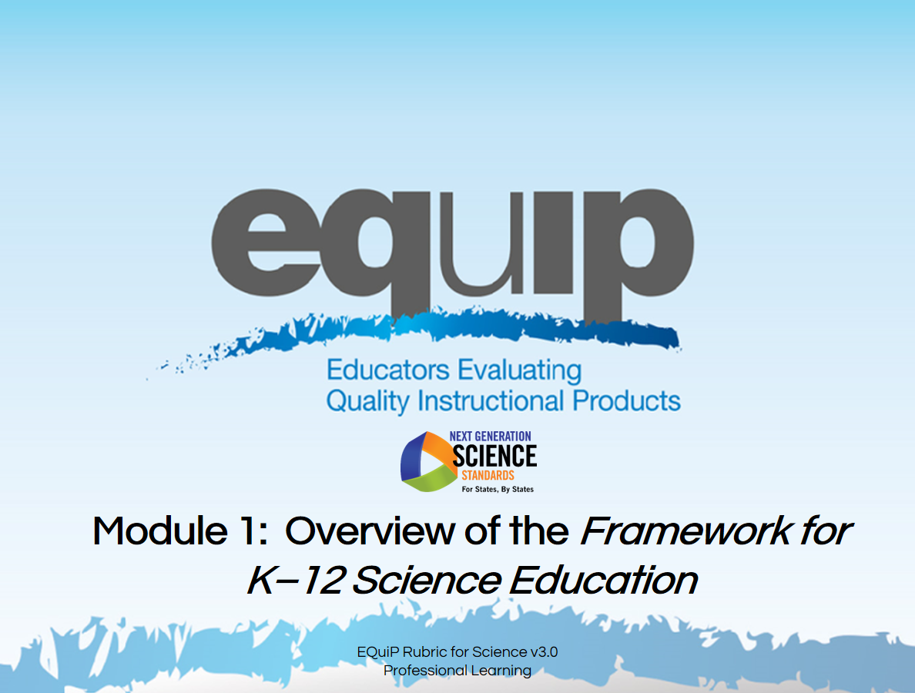
Slide 53
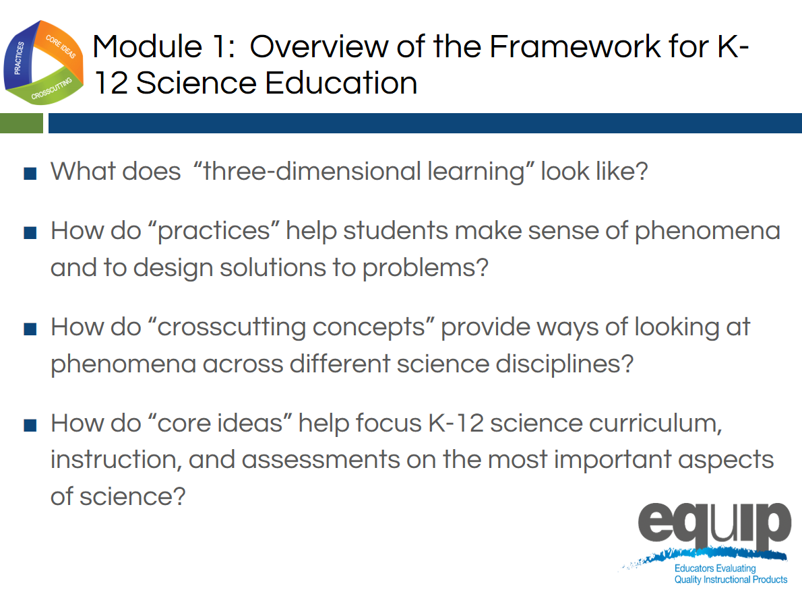
Slide 54
Facilitator Notes
Much of Modules 1 and 2 may constitute a review for many participants and be fairly new information for others. Facilitators may speed up or slow down the delivery of these two modules as determined by the needs of the participants.
Talking Points
- This module includes questions about the Framework that participants should be able to answer by the end of this module:
  - What does “three-dimensional learning” look like?
  - How do “practices” help teachers and students make sense of phenomena or design solutions to problems?
  - How do “crosscutting concepts” provide ways of looking at phenomena across different science disciplines?
  - How do “core ideas” help focus K–12 science curriculum, instruction, and assessments on the most important aspects of science?

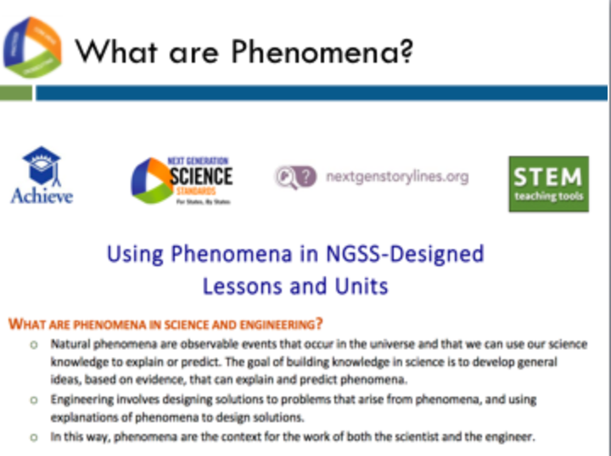
Slide 55
Talking Points
- Both the NGSS and the Framework focus on the innovation of 3-dimensional learning.
- 3D learning supports students in figuring out phenomena or developing solutions to problems.
- As we proceed through this training, we will be emphasizing this focus in the NGSS many times. Let’s define phenomena using Handout 2, which is a resource developed by Achieve and partners called Using Phenomena in NGSS-Designed Lessons and Units.
- This resource defines natural phenomena as observable events that occur in the universe and that we can use our science knowledge to explain and predict. The goal of building knowledge in science is to develop general ideas, based on evidence, that can explain and predict phenomena.
- Engineering involves designing solutions to problems that arise from phenomena, and using explanations of phenomena to design solutions.

Slide 56

Talking Points
- The NGSS and the Framework are about science for all students.
- In today’s world, science, engineering, and technology are not a luxury to be experienced by only some students.
- A strong science education equips students with skills necessary for all careers. Science develops students’ abilities to think critically and to innovate. All students need strong foundational knowledge in science to tackle difficult and/or long-term issues that face both our generation and future generations.
- Science, engineering, and technology:
  - Serve as cultural achievements and a common good across societies;
  - Permeate modern life and as such are essential at the individual level;
  - Are critical to participation in public policy and good decision-making; and
  - Are essential for ensuring that future generations will live in a society that is economically viable, sustainable, and free.

Three-Dimensional Learning
Facilitator Notes
Participants will need Handout 1, Module 1, “The Framework,” for the remaining portion of Module 1.
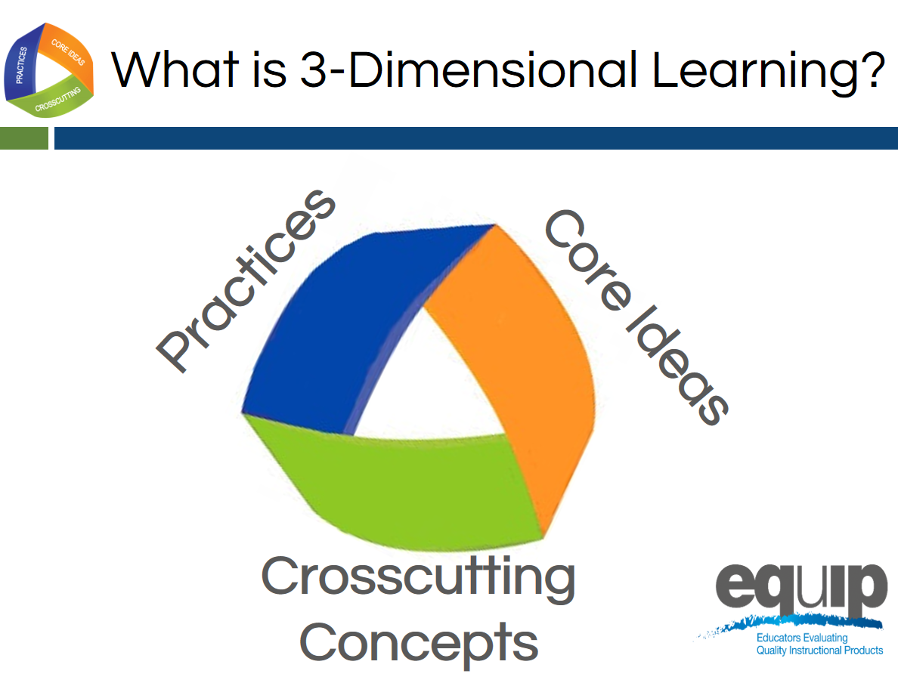
Slide 57
Talking Points
- Perhaps the most important shift in the NGSS is three-dimensional learning. This shift is defined here in Module 1; however, it is addressed in more detail in the third module of the professional learning.
- The three dimensions are practices, crosscutting concepts, and disciplinary core ideas.
- When you hear the term “three-dimensional learning,” what does it mean to you? Take two or three minutes to talk about this at your tables. Be prepared to share. [Note to facilitator: Allow two to three minutes, and then ask a few tables to share.]
- Three-dimensional learning is when these three dimensions work together to support students in making sense of phenomena or designing solutions to problems.
- Before looking at how the dimensions work together, we’ll look at the three separately to ensure our common understanding of each.

Practices
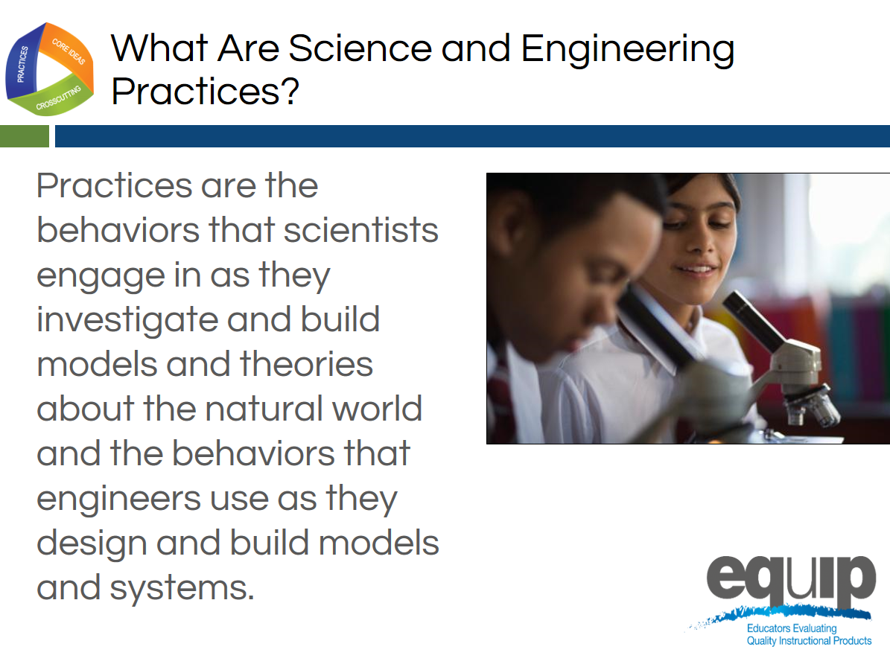
Slide 58
Talking Points
- Practices are the behaviors that scientists engage in as they investigate and build models and theories about the natural world, as well as the behaviors that engineers use as they design and build models and systems.
- The term practices is used instead of “skills” to emphasize that engaging in scientific investigation requires not only skill but also knowledge that is specific to each practice.
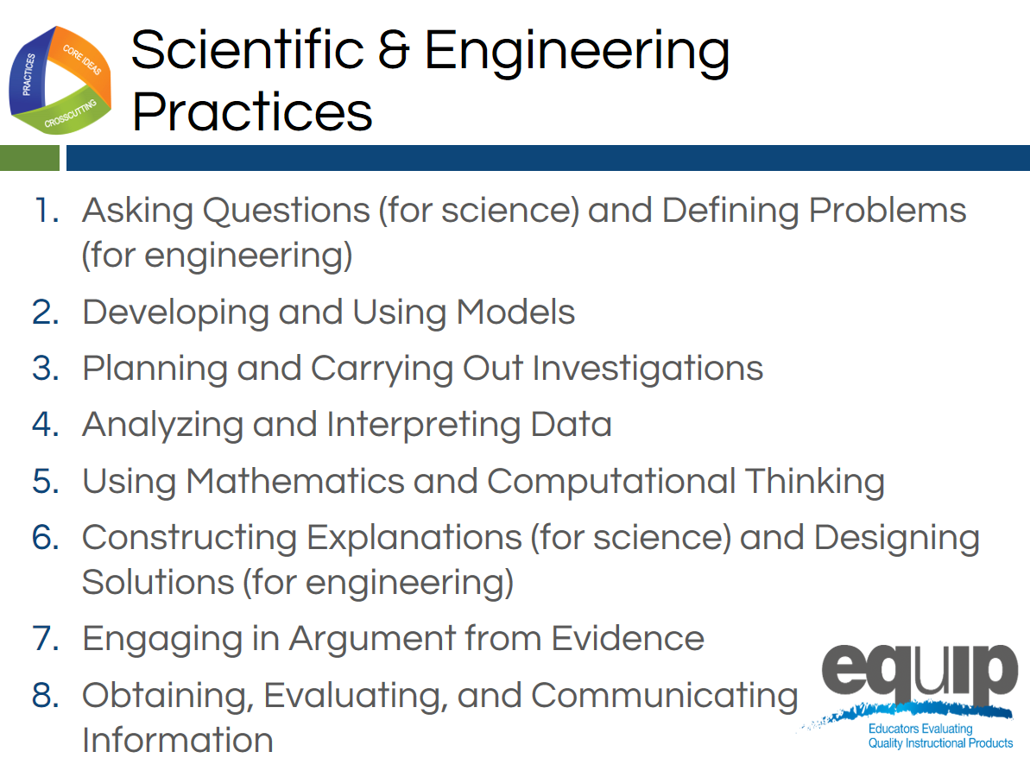
Slide 59
Talking Points
- The Framework identifies scientific and engineering practices that occur throughout the different disciplines of science. Descriptions of these practices and how they should become more complex over time can be found in the Framework and the NGSS.
- These practices are:
  - Asking questions (for science) and defining problems (for engineering);
  - Developing and using models;
  - Planning and carrying out investigations;
  - Analyzing and interpreting data;
  - Using mathematics and computational thinking;
  - Constructing explanations (for science) and designing solutions (for engineering);
  - Engaging in argument from evidence; and
  - Obtaining, evaluating, and communicating information.
- Let’s watch Joe Krajcik in this video explain how practices work together.
- Now, take five minutes at your table to discuss how you’ve observed these practices in science lessons and units. [Note to facilitator: After five minutes, have a few tables share.]
Crosscutting Concepts
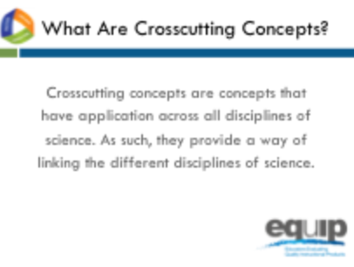
Slide 60
Talking Points
- Crosscutting concepts have applications across all disciplines of science. As such, they are a way of linking the different disciplines of science by providing ways of looking at and making sense of phenomena and/or of designing solutions to problems.
!
- The Framework emphasizes that these concepts need to be made explicit for students because they provide an organizational schema for interrelating knowledge from various science fields into a coherent and scientifically-based view of the world.
Slide 61
Talking Points
- Think, for example, about weather, a phenomenon in nature.
- Could you describe this phenomenon through the lens of:
  - Patterns? How/why or why not? [Note to facilitator: Allow one or two participants to respond.]
  - Cause and effect? How/why or why not? [Note to facilitator: Allow one or two participants to respond.]
  - Scale, proportion, and quantity? How/why or why not? [Note to facilitator: Allow one or two participants to respond.]
  - Systems and system models? How/why or why not? [Note to facilitator: Allow one or two participants to respond.]
  - Energy and matter? How/why or why not? [Note to facilitator: Allow one or two participants to respond.]
  - Structure and function? How/why or why not? [Note to facilitator: Allow one or two participants to respond.]
  - Stability and change? How/why or why not? [Note to facilitator: Allow one or two participants to respond.]
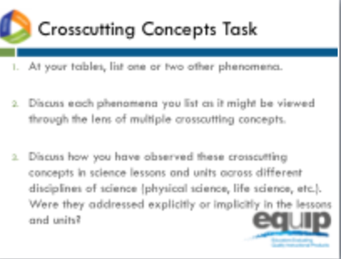
Slide 62

Talking Points
- Refer back to Handout 1 where you’ll see that the Framework lists the following crosscutting concepts:
  - Patterns;
  - Cause and effect;
  - Scale, proportion, and quantity;
  - Systems and system models;
  - Energy and matter;
  - Structure and function; and
  - Stability and change.
- Now, take 10 minutes at your table to:
  - List one or two other phenomena.
  - Discuss each phenomenon you list as it might be viewed through the lens of multiple crosscutting concepts.
- Finally, discuss how you have observed these crosscutting concepts in science lessons and units across different disciplines of science (physical sciences, life sciences, etc.). Were they addressed explicitly or implicitly in the lessons and units? [Note to facilitator: After 10 minutes, have a few tables share.]

Disciplinary Core Ideas
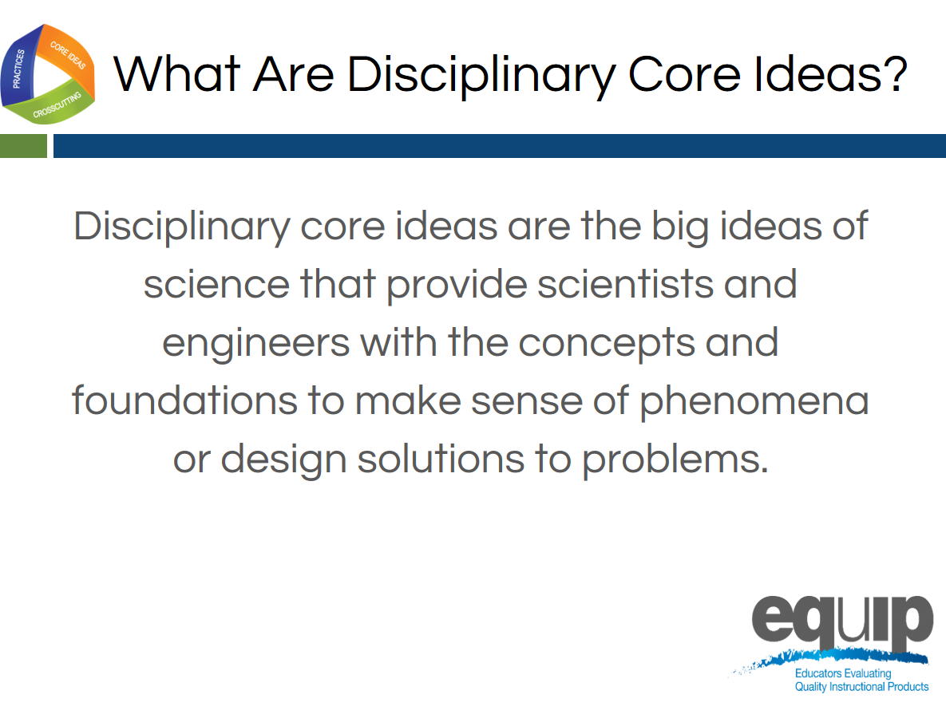
Slide 63
Talking Points
- Disciplinary core ideas are the big ideas—the most important aspects—of science that provide scientists, engineers, and students with the concepts and the foundations to make sense of phenomena and/or to design solutions to problems.
- They can be used to focus K–12 science curriculum, instruction, and assessments on the most important aspects of science.
- According to the Framework, to be considered core, the ideas must meet at least two of the following criteria and ideally all four:
  - Have broad importance across multiple sciences or engineering disciplines or be a key organizing concept of a single discipline.
  - Provide a key tool for understanding or investigating more complex ideas and solving problems.
  - Relate to the interests and life experiences of students or be connected to societal or personal concerns that require scientific or technological knowledge.
  - Be teachable and learnable over multiple grades at increasing levels of depth and sophistication.
- Disciplinary core ideas are grouped into four disciplines:
  - The physical sciences;
  - The life sciences;
  - The Earth and space sciences; and
  - Engineering, technology, and applications of science.
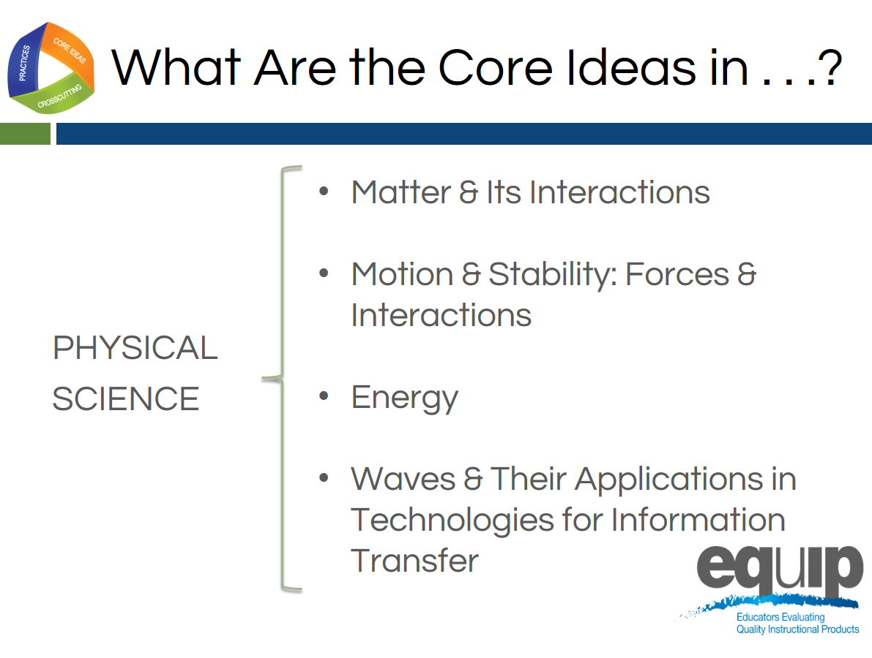
Slide 64
Talking Points
- The physical sciences include four core ideas:
  - Matter and its interactions;
  - Motion and stability: forces and interactions;
  - Energy; and
  - Waves and their applications in technologies for information transfer.
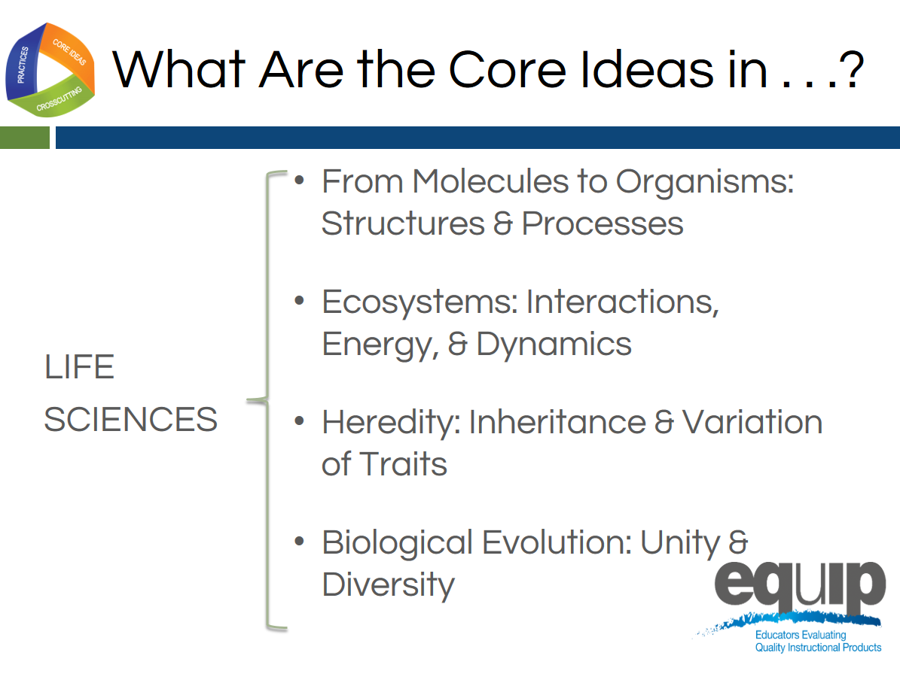
Slide 65
Talking Points
- The life sciences include four core ideas as well:
  - From molecules to organisms: structures and processes;
  - Ecosystems: interactions, energy, and dynamics;
  - Heredity: inheritance and variation of traits; and
  - Biological evolution: unity and diversity.
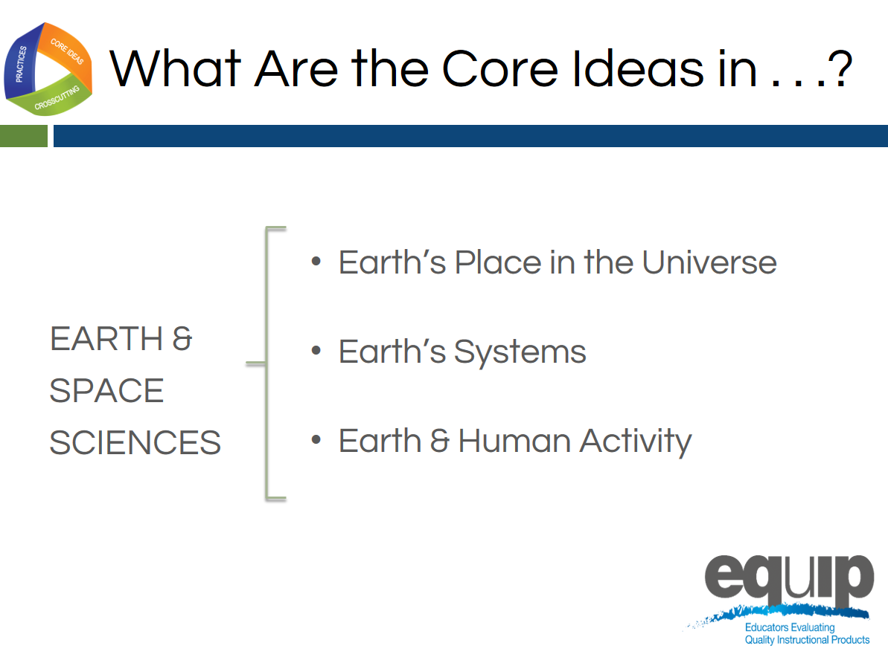
Slide 66
Talking Points
- The Earth and space sciences include three core ideas:
  - Earth’s place in the universe;
  - Earth’s systems; and
  - Earth and human activity.
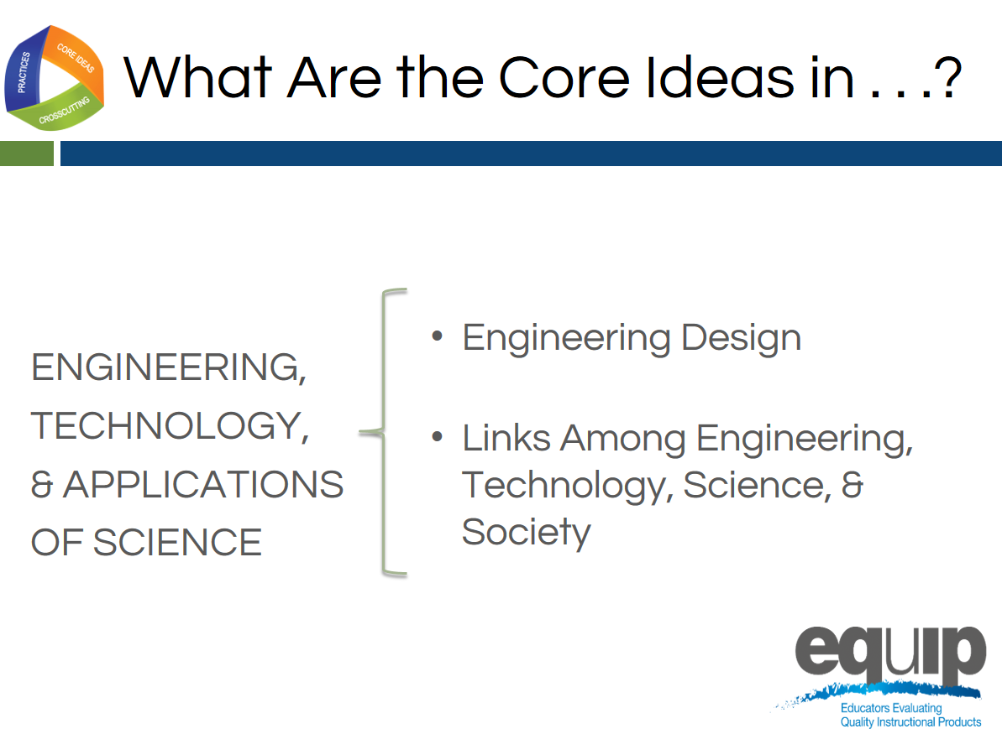
Slide 67

Talking Points
- Engineering, technology, and the applications of science include two core ideas:
  - Engineering design; and
  - Links among engineering, technology, science, and society.
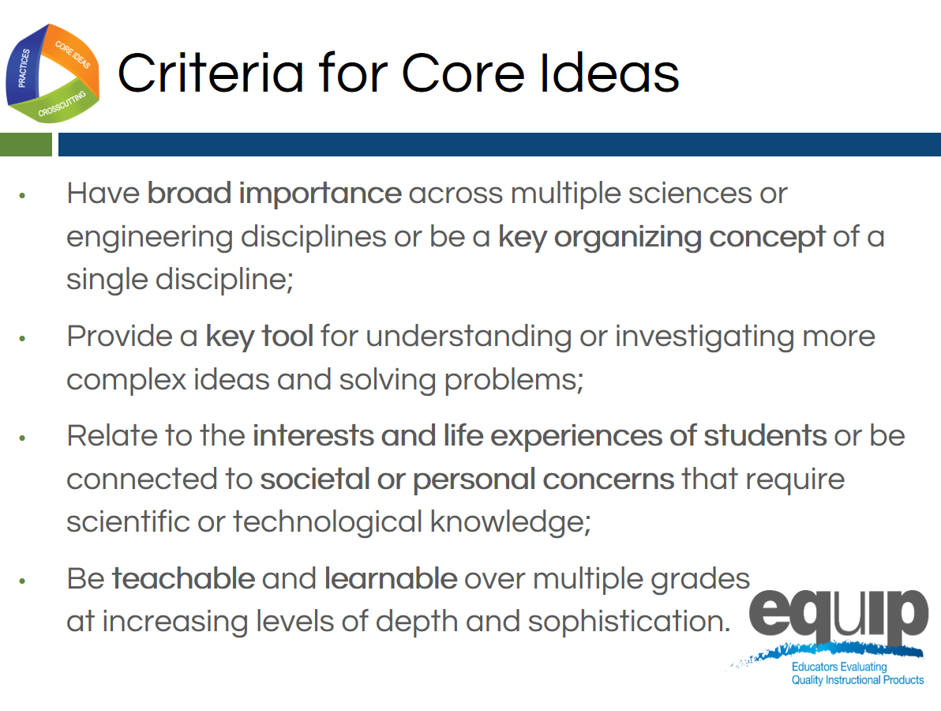
Slide 68
Facilitator Notes
Remind participants that the core ideas for the different science disciplines are listed on the handout for this module. They may wish to refer to this handout for this task.
Talking Points
- Now take 10 minutes at your table to discuss how the core ideas in one discipline of science meet two or more of the criteria for a core idea:
  - Have broad importance across multiple sciences or engineering disciplines or be a key organizing concept of a single discipline.
  - Provide a key tool for understanding or investigating more complex ideas and solving problems.
  - Relate to the interests and life experiences of students or be connected to societal or personal concerns that require scientific or technological knowledge.
  - Be teachable and learnable over multiple grades at increasing levels of depth and sophistication.
[Note to facilitator: After 10 minutes, have a few tables share.]

Concluding Slide for Module 1
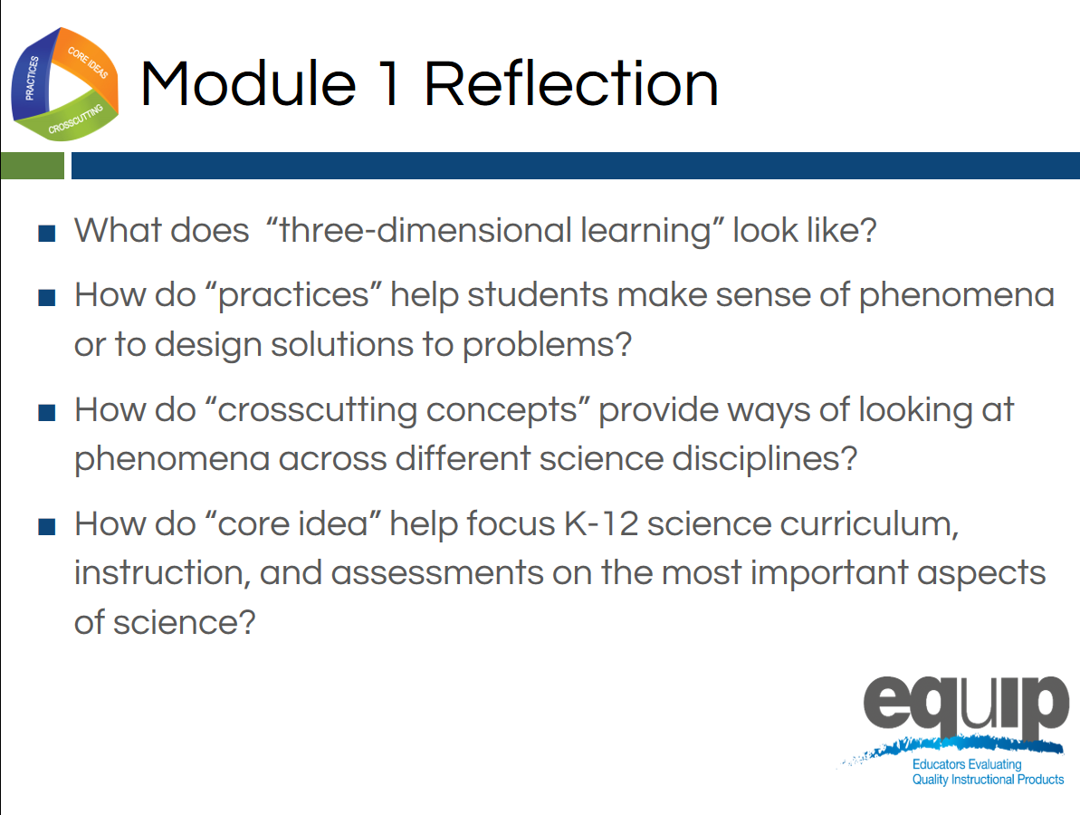
Slide 69
Talking Points
- In order to use the EQuIP Rubric to examine and evaluate NGSS lessons and units, it’s imperative that we have a common understanding of the practices, crosscutting concepts, and disciplinary core ideas as they relate to the Framework.
- Look back at the questions we began with in this module. Where are you now in terms of being able to respond to these questions with confidence?
- Take five minutes to jot down your reflections and your takeaways from this first module:
  - Where are you now in terms of being able to respond to these four questions with confidence?
  - Has your thinking changed as a result of this module?
  - What did you hear that was new?
  - What’s still rolling around in your head that you need to know more about?
[Note to facilitator: After five minutes, ask a few people to share their reflections.]
- As we conclude this first module, keep in mind that practices, crosscutting concepts, and disciplinary core ideas do not function in isolation.
- The key shift in the NGSS is three-dimensional learning. That is, lessons and units where practices, crosscutting concepts, and disciplinary core ideas work together to help students make sense of phenomena or to design solutions to problems.
- We’ll talk more about three-dimensional learning and phenomena in a subsequent module.
- If you would like more information about the Framework, visit the NGSS website: www.nextgenscience.org/.
- Keep in mind that you may wish to refer to the handout from Module 1 when you begin to use the rubric itself.

