MODULE
EQuIP for Science v3.0
6

Category I:
Determining
Alignment
to the NGSS
Module 6: Category I: Determining Alignment to the NGSS
Module 6 dives deeper into three-dimensional learning by having participants examine a short video to help us understand how to determine whether the three dimensions are present and if they work together to support students in making sense of phenomena or designing solutions to problems. After this first task, participants begin examining a common lesson using criteria in Category I: NGSS 3D Design.
Materials Needed
- Module 6 PowerPoint slides or slides 114–144 of the full PowerPoint
- Common Lesson: Urban Heat Intermediate Version (Ideally this lesson will be shared with participants before the professional learning so they can review it)
- Blue, orange, and green highlighters.
- Handout 2: Using Phenomena in NGSS Lessons and Units*
- Handout 6: Module 4, “EQuIP Agreements and Table Facilitator Guidelines”*
- Handout 7: Module 4, “EQuIP Rubric, Version 3.0”* or a computer or tablet with the electronic version of the rubric (at least one person per table should record their group’s findings electronically)
Optional: Because participants will want to consider the elements of the three dimensions, it may be necessary to have copies of the standards as well as Appendix F and Appendix G . Alternatively, participants can find the standards and appendices at www.nextgenscience.org if Internet access is available.

*Introduced in a previous module.
Introduction to Module 6
Slide 114
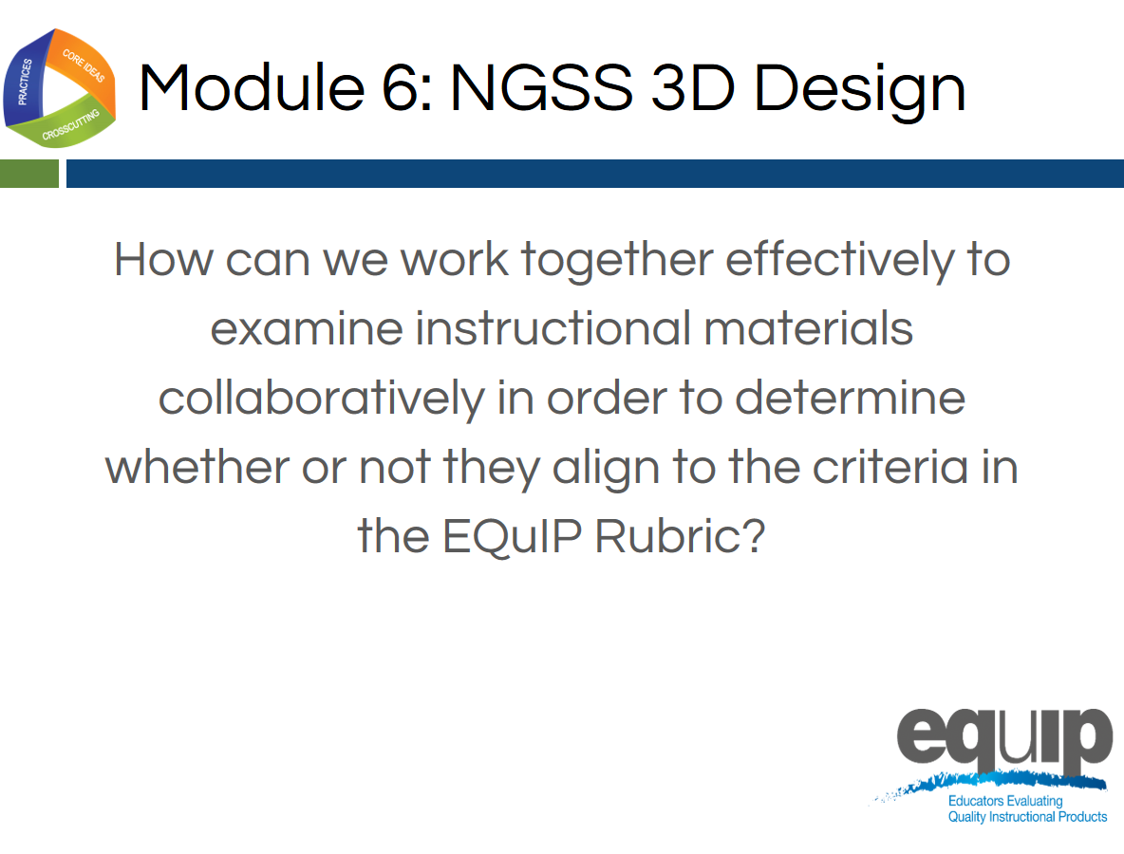
Slide 115
Talking Points
- In this module, we’re going to apply everything we’ve learned to this point and actually work together to examine a common lesson using the EQuIP Rubric.
- As we use the EQuIP Rubric in this module to examine instructional materials, you will:
  - Apply the common definitions we discussed in the last module.
  - Locate evidence of specific rubric criteria and use reasoning to explain how or why this evidence meets or does not meet rubric criteria.
  - Evaluate whether the evidence you’ve located is sufficient to demonstrate NGSS 3D Design.
  - Provide guidance regarding how a lesson or unit might be revised in order to meet rubric criteria.

Category I: NGSS 3D Design
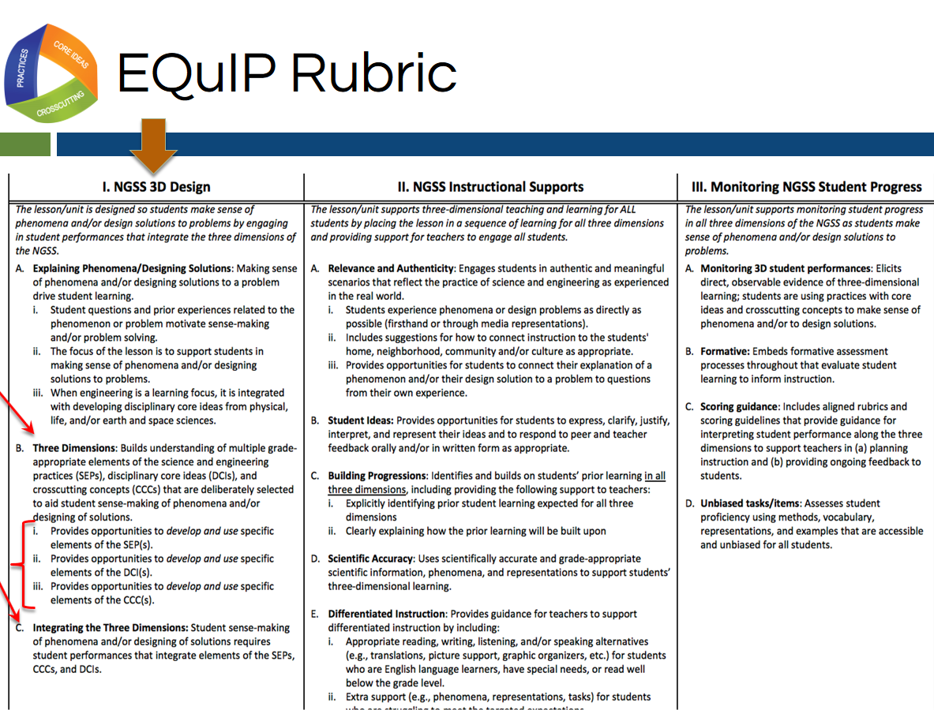
Slide 116
Talking Points
- Please get out your EQuIP Rubric and turn to page 2 of the rubric document where you’ll see all three categories of the rubric.
- For the lesson we are going to examine in this module, we will only be looking at the first major criteria in Category I and their component parts. [Note to facilitator: Click for animation.]
- We are going to start with Criterion B. Three Dimensions and C. Integrating the Three Dimensions, which was the focus of module 3 (as well as our immersion activity).
- [Note to facilitator: Click for animation once for B and a second time for C.]
- We will be looking at Criteria B and C along with the three sub-criteria under Criterion B. [Note to facilitator: Click for animation.]
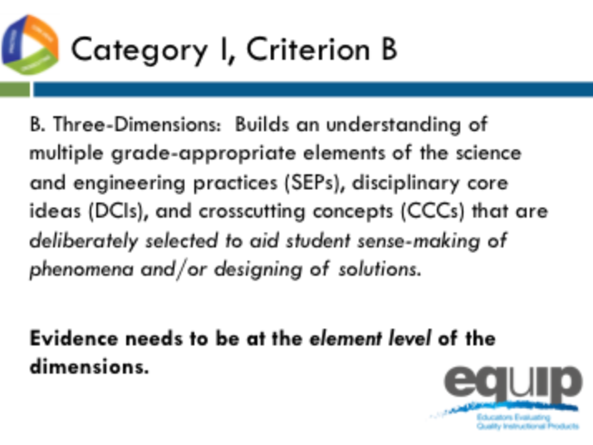
Slide 117
Talking Points
- Criterion B states about the three dimensions that they, “Build an understanding of multiple grade-appropriate elements of the science and engineering practices (SEPs), disciplinary core ideas (DCIs), and crosscutting concepts (CCCs) that are deliberately selected to aid student sense-making of phenomena and/or designing of solutions.”
!
- Here the term “elements” is used to represent the relevant, bulleted practices, disciplinary core ideas, and crosscutting concepts that are articulated in the foundations boxes of the standards, as well as in the NGSS appendices on each dimension. Looking at the elements ensures that each dimension is grade or grade-band appropriate.
- It is important to note that evidence recorded in the rubric needs to be at the element level of each dimension: practices, core ideas, and crosscutting concepts.
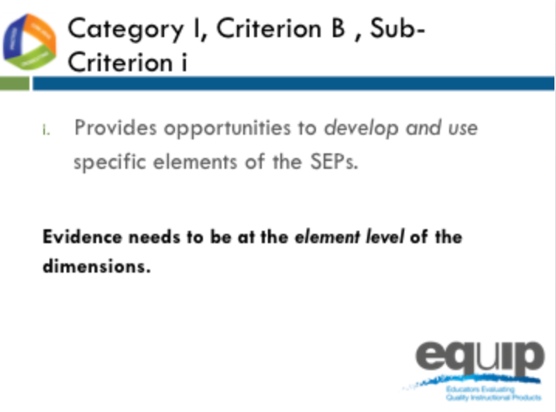
Slide 118
Talking Points
- We’ll also be looking at the sub-criteria under this overall criterion.
- Category I, Criterion B, Sub-Criterion i:
  - Provides opportunities to develop and use specific elements of the SEPs.

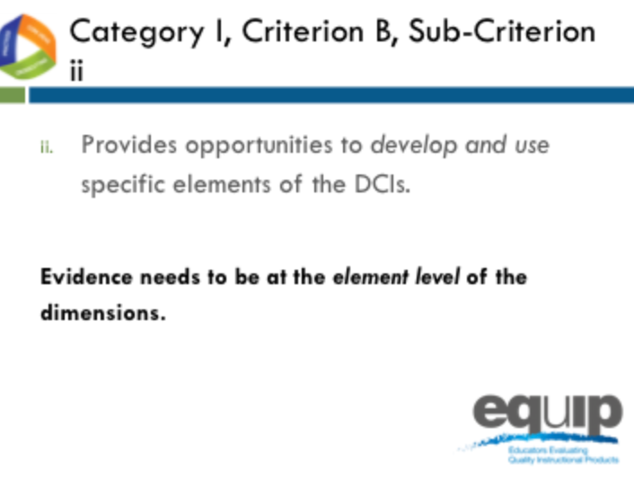
Slide 119

Talking Points
- Category I, Criterion B, Sub-Criterion ii:
- Provides opportunities to develop and use specific elements of the DCIs.
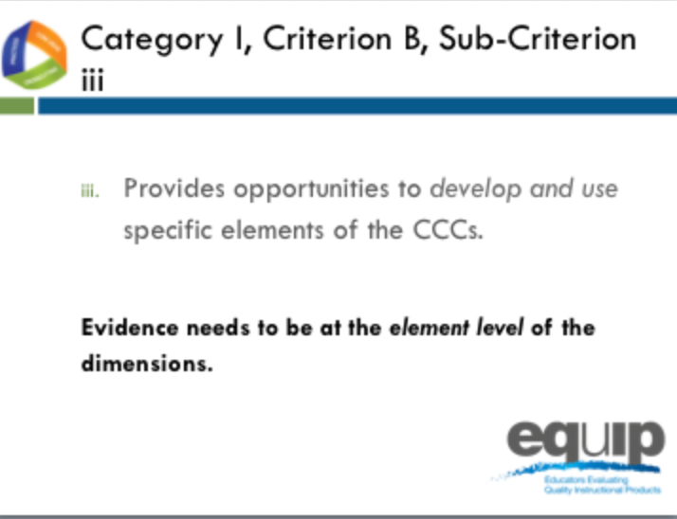
Slide 120
Talking Points
- Category I, Criterion B, Sub-Criterion iii:
- Provides opportunities to develop and use specific elements of the CCCs.
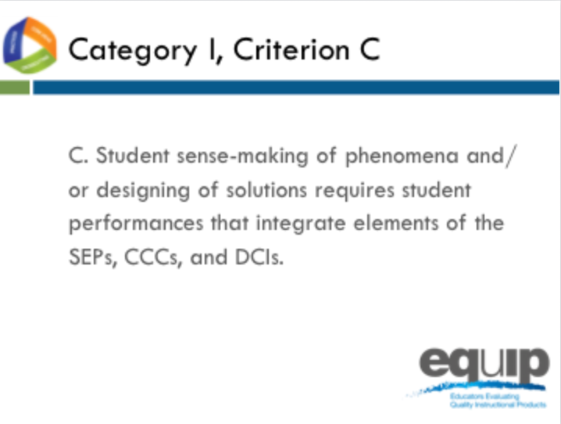
Slide 121
Talking Points
- And Category I, Criterion C:
Student sense-making of phenomena or designing of solutions requires student performances that integrate elements of the SEPs, CCCs and DCIs.
- Has everyone located Category I, Criteria B and C on the EQuIP Rubric?

Slide 122
Facilitator Notes
- The video can be found at the following link: http://www.nextgenscience.org/resources/ngss-equip-rubric-3-dimensional-learning
Talking Points
- This video highlights Category 1, Criterion B and C of the EQuIP rubric, three-dimensional learning.
- Let’s view this video together to help us determine whether the three dimensions are present and if they work together to support students in making sense of phenomena or designing solutions to problems.
- Note to facilitator: After the video Ask participants: “What kinds of changes do you think three-dimensional classrooms will require for teachers?” Have a brief discussion (1–2 minutes).
- [Note to facilitator: After discussion about the first question, ask “What are some major look-fors in a lesson to determine if it is three-dimensional? Have a brief discussion (1–2 minutes).
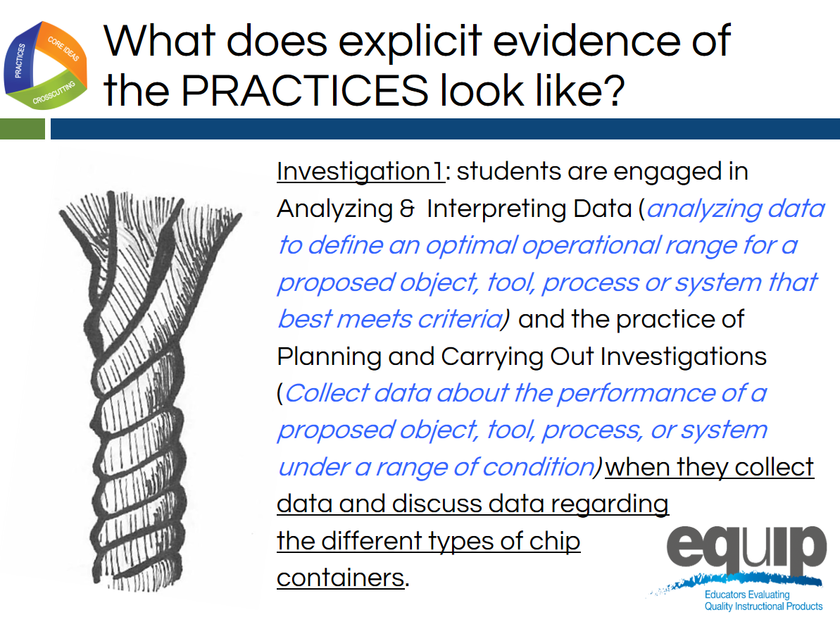
Slide 123
Talking Points
- Now, let’s look at some examples of how we can record evidence of these “look-fors” in a lesson in column 2 of the EQuIP response form together.
- This feedback should include evidence from the lesson, evidence from the NGSS for this dimension at the element level, and your reasoning of WHY or HOW this evidence connects to the rubric criteria.
- Let’s remember that the criterion for Category 1B sub criterion I is “Provides opportunities to develop and use specific elements of the SEPs.”
- When we look at this slide, we see that the reviewer cites specific details about where the evidence of the SEPs was found in the lesson by indicating “Investigation 1” and “when they collect data and discuss data regarding the different types of chip containers”, which are both underlined on this slide.
- In addition, the reviewer cites evidence of the SEPs by indicating the name of the practices (analyzing and interpreting data and planning and carrying out investigations) as well as the elements of the practices that this lesson addresses. For analyzing and interpreting data, the element identified is analyzing data to define an optimal operational range for a proposed object, tool, process or system that best meets criteria) and the element of the practice of planning and carrying out investigations is collect data about the performance of a proposed object, tool, process, or system under a range of condition).
- It is important when providing feedback that both lesson evidence and element level NGSS evidence from the appendices be connected in column 2 when giving feedback about this sub-criterion.
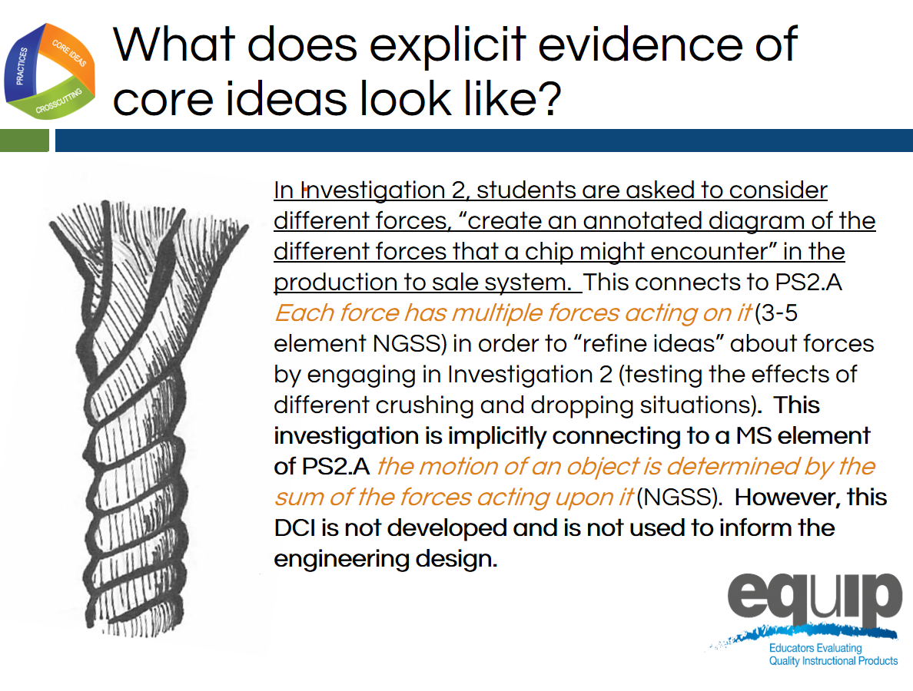
Slide 124
Talking Points
- Category 1B sub criterion ii is “Provides opportunities to develop and use specific elements of the DCIs.”
- When we look at this slide, we see that the reviewer cites specific details about where the evidence of the SEPs was found in the lesson by indicating “In Investigation 2, students are asked to consider different forces, “create an annotated diagram of the different forces that a chip might encounter in the production to sale system,” which is underlined on this slide.
- The reviewer makes a claim that this serves as evidence for PS2.A Each force has multiple forces acting on it. This is an element of the disciplinary core idea PS2.A at the 3–5 grade band and only implicitly connects to the middle school elements of this core idea.
- Because the evidence is explicit for a grade band below the lesson target AND this science is not used to inform the engineering design (which is critical when a lesson contains an engineering task), this evidence would not be adequate to say that students had opportunities to develop and use specific elements of the disciplinary core ideas.

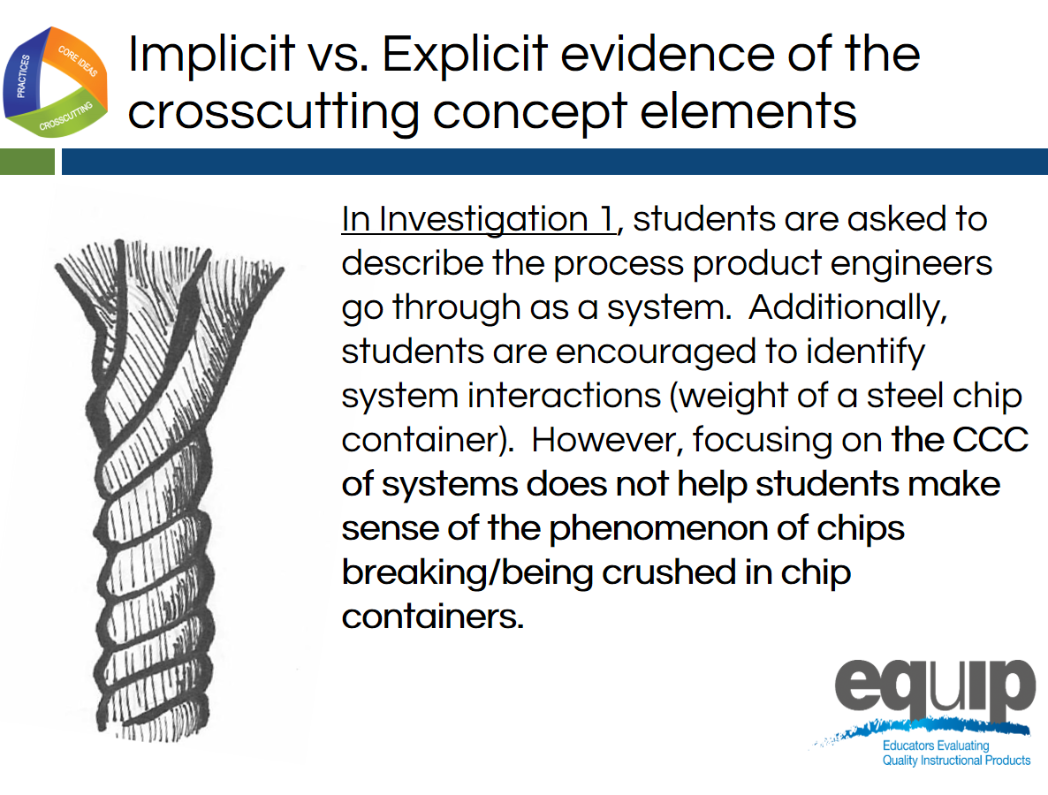
Slide 125
Talking Points
- This slide describes implicit evidence of the crosscutting concept.
- In this case, the evidence is implicit since on the CCC of systems does not help students make sense of the phenomenon of chips breaking/being crushed in chip containers.
- What is the difference between implicit and explicit evidence?
- Remember, for the purposes of the EQuIP Rubric, evidence is what is stated or described explicitly in a lesson or unit. If it is evidence, you can see it, point directly to it in the lesson or unit, highlight it, cite it, or quote it directly from what is written.
- For lesson evidence to be explicit for Category 1, Criterion B, students need to have the opportunity to use the element of the dimension to make sense of the phenomenon or to develop a solution to a problem.
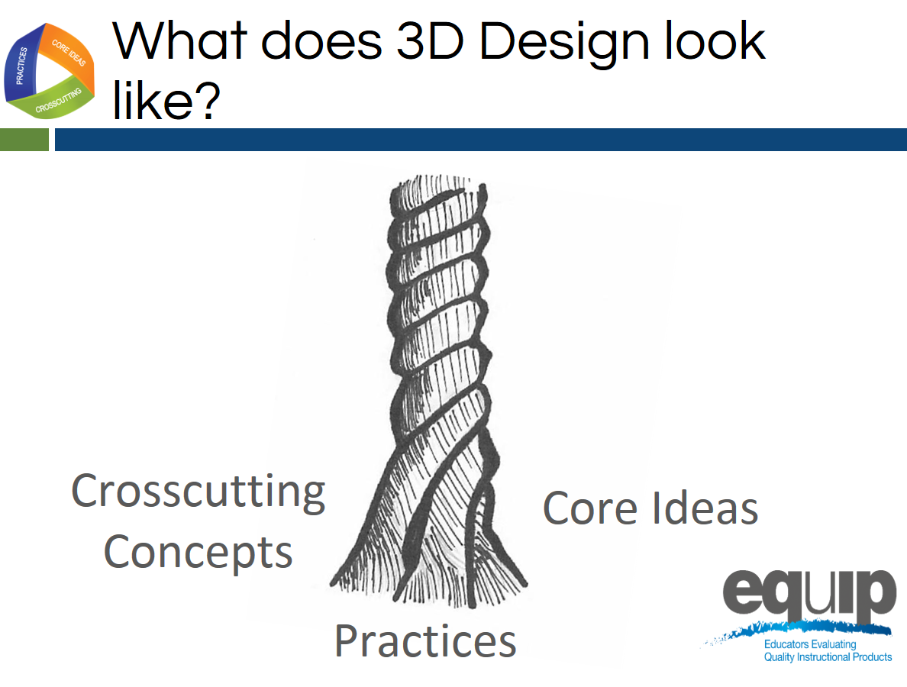
Slide 126
Talking Points
- After we look for evidence of each of the three dimensions separately so we can provide very specific feedback and guidance to the lesson or unit developer, we look for evidence of integration of the three dimensions for Criterion 1C.
- When looking for evidence of this criterion, we can ask ourselves: Do the students have an opportunity to engage in three-dimensional learning to help them make sense of phenomena or design solutions, OR Do the three dimensions occur in isolation?
- Our goal throughout this training is to develop a common understanding of alignment and quality among those persons or groups reviewing lessons and units.
- We’re going to practice this with a common lesson now.
Learning Task: Working Through the Process
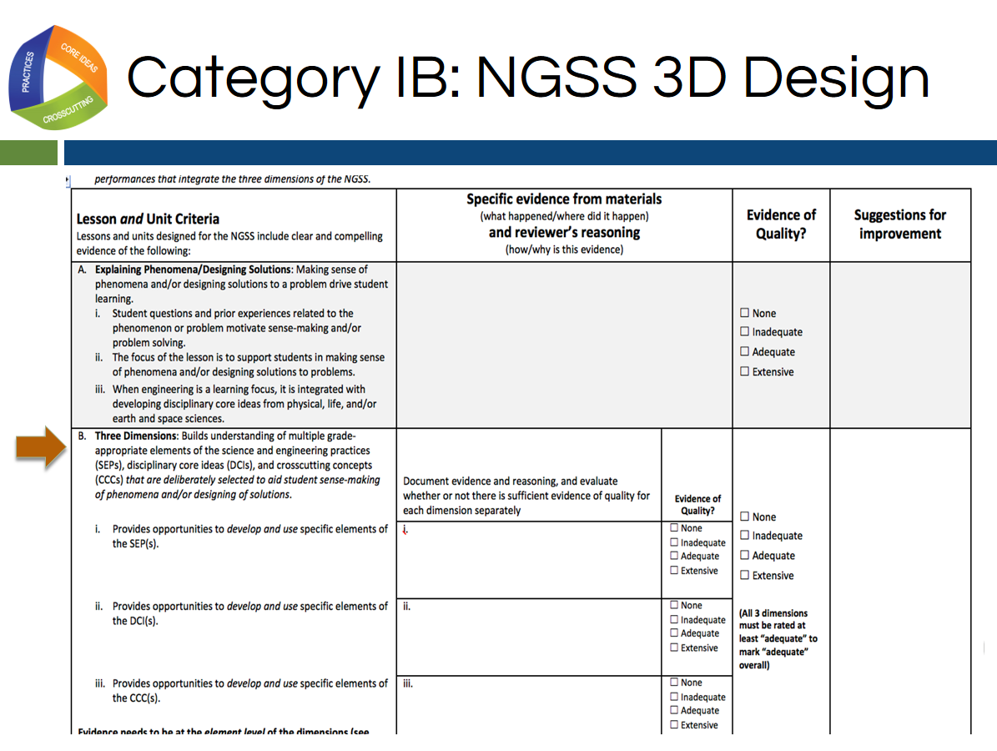
Slide 127
Talking Points
- For this task you will need:
  - An electronic or a hard copy of the EQuIP Rubric version 3.0;
  - Common Lesson Urban Heat [Note to facilitator: Intermediate version]; and
  - Blue, orange, and green highlighters.
- [Note to facilitator: Specific entities using this training may elect to examine their own or other different materials. If this is the case, however, the trainers/facilitators should take time to examine the common lesson included with this training thoroughly to ensure that the training with these different materials is consistent with what is intended.]
- For this task, you will only be working with the second section of Category I of the EQuIP Rubric, starting with Criterion B that is pictured on this slide. It’s the same criterion we just looked at with the example.
- This task is designed to acquaint you with the process for using the rubric to examine lessons and units. This examination involves the seven processes and agreements discussed in the previous module, so you may want to pull out that handout and look over it again.
- Before we get started let’s listen to Tricia Shelton discuss how much evidence is sufficient in this video. Joe Krajcik also discusses one example of thinking about how much evidence is sufficient – how student and teacher materials should work together – in this video.
- As you peruse the lesson to make these determinations, you will be locating and marking the actual evidence in the lesson that supports the rubric criteria.
- Because you have a limited amount of time for this task, you may not be able to list all of the evidence that supports a criterion; rather, you may need to cite examples.
- As you work through this common lesson, it is essential that you follow the instructions exactly in order to experience the process as it should be followed in later modules.
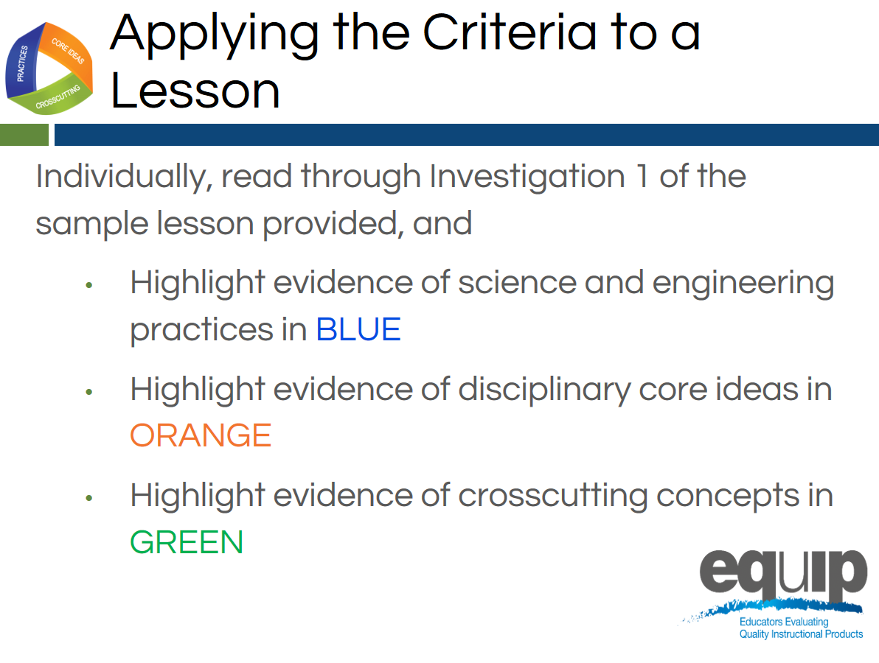
Slide 128
Talking Points
- First, examine the common lesson Urban Heat Intermediate version for evidence of science and engineering practices, core ideas, and crosscutting concepts. Don’t forget to refer back to the elements of the dimensions found in the foundation boxes and the appendices.
- Initially, we will only examine Investigation 1, highlighting evidence of the three dimensions according to the key on the screen: evidence of the science and engineering practices in blue, evidence of the disciplinary core ideas in orange, and evidence of the crosscutting concepts in green.
- We will stop and briefly discuss this evidence before continuing the evaluation of the common lesson.
- This is completed individually without any discussion between or among group members. Even if you complete this part before other tables are finished, do not discuss your findings before being instructed to do so.
- As you locate evidence, use the Arabic and Roman numerals associated with the rubric criteria to code the evidence you locate.
- Remember, evidence is what you can see explicitly in the lesson or unit.
- You can use the second column of the response form to summarize your evidence.
- You have 15 minutes to do this. [Note to facilitator: Set a timer for 15 minutes, on the screen for all to see if possible. When the timer sounds, ask if participants need more time before moving on.]
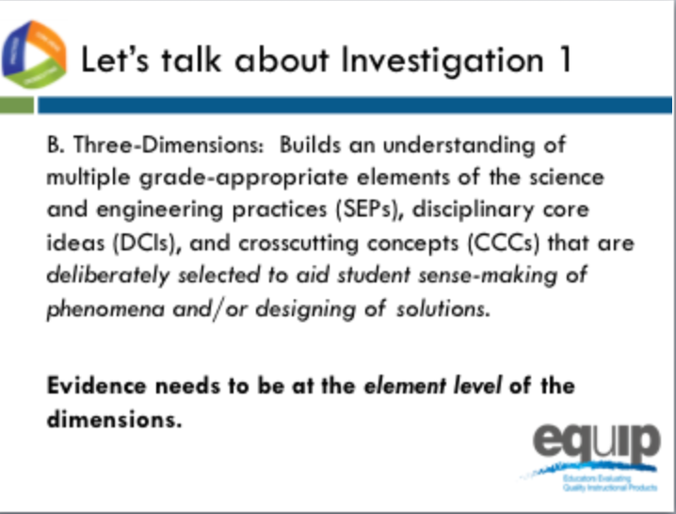
Slide 129
Facilitator Notes
Below are some examples of feedback (evidence and reasoning) from column 2 of the rubric for the Urban Heat intermediate version. This may be helpful in supporting a discussion about evidence and reasoning for Investigation 1. The purpose of this discussion is to help participants have confidence when continuing their evaluation of the common lesson.
Here is a link to a sample rubric created for this intermediate version that may be helpful for module 6 only since in module 7, we switch to the final version of the lesson
Science and Engineering Practices
- On page 1 students are “defining what the independent and dependent variable will be for the experiment” providing an opportunity for students to, “identify independent and dependent variables” which is part of an element of Planning and Carrying out Investigations (NGSS Appendix F). However, this is the only element of this practice, providing limited evidence of this practice
- On page 2, students are asked to communicate their understanding of “temperature variance on different surfaces” through an explanation in the “assessment” section. However, there is not enough guidance to be sure this meets the elements of Constructing Explanations and Designing Solutions
Disciplinary Core Ideas
- In investigation 1, students are developing and using elements of PS4.B. Specifically, they are seeing that when light shines on an object, it is reflected, absorbed, or transmitted though the object, depending on the object’s material and the frequency (color) of the light.
- In investigation 1, students are developing and using elements of PS3.A. Specifically, “temperature is a measure of the average kinetic energy of particles of matter. The relationship between the temperature and the total energy of a system depends on the types, states, and amounts of matter present.”
Crosscutting Concepts
- On page 1 students are engaged by posing the question “why it is so much cooler on the grass at a park than on the pavement?” setting up the investigation of a cause and effect relationship involving surface temperature and urban development.

Talking Points
- Let’s share some evidence from Investigation 1 that may meet the sub-criteria for IB.
- Let's start with evidence of the science and engineering practices. Were students given an opportunity to develop and use specific elements of the science and engineering practices in Investigation 1? [Note to facilitator: Accept some responses from participants and emphasize some points from the facilitator notes.]
- Were students given an opportunity to develop and use specific elements of the disciplinary core ideas in Investigation 1? [Note to facilitator: Accept some responses from participants and emphasize some points from the facilitator notes.]
- Were students given an opportunity to develop and use specific elements of the crosscutting concepts in Investigation 1? [Note to facilitator: Accept some responses from participants and emphasize some points from the facilitator notes.]
- Does anyone have any questions about finding evidence in a lesson and connecting it to both the criteria for IB and the elements of the dimensions?
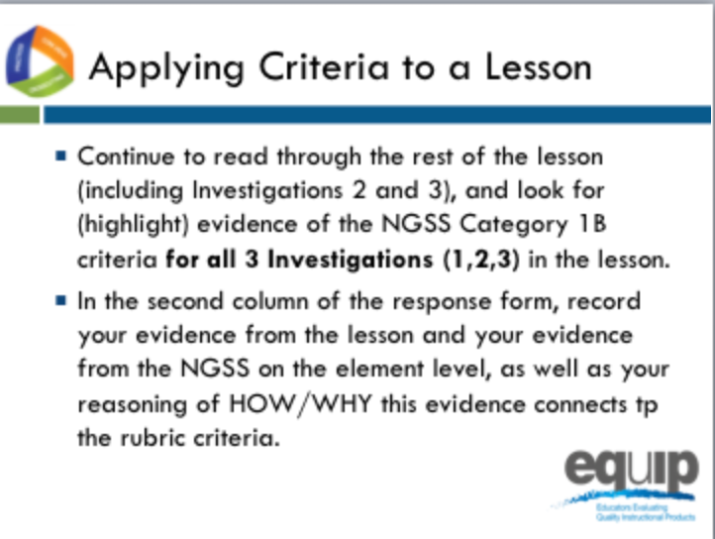
Slide 130
Talking Points
- Now, let's continue to read and highlight the rest of the common lesson for evidence of science and engineering practices, core ideas, and crosscutting concepts. Don’t forget to refer back to the elements of the dimensions found in the foundation boxes and the appendices.
- This is completed individually without any discussion between or among group members. Even if you complete this part before other tables are finished, do not discuss your findings before being instructed to do so.
- As you locate evidence, use the Arabic and Roman numerals associated with the rubric criteria to code the evidence you locate from the lesson, and the evidence from the NGSS at the element level using the appendices.
- Remember, evidence is what you can see explicitly in the lesson or unit.
- You can use the second column of the response form to summarize your evidence and your reasoning of HOW/WHY this evidence connects to the rubric criteria and sub-criteria for Category 1B.
- Reasoning is the bridge connecting the evidence to the rubric criteria and to how the practices, core ideas, and crosscutting concepts work together
- You have fifteen minutes to do this. [Note to facilitator: Set a timer for fifteen minutes, on the screen for all to see if possible. When the timer sounds, ask if participants need more time before moving on.]
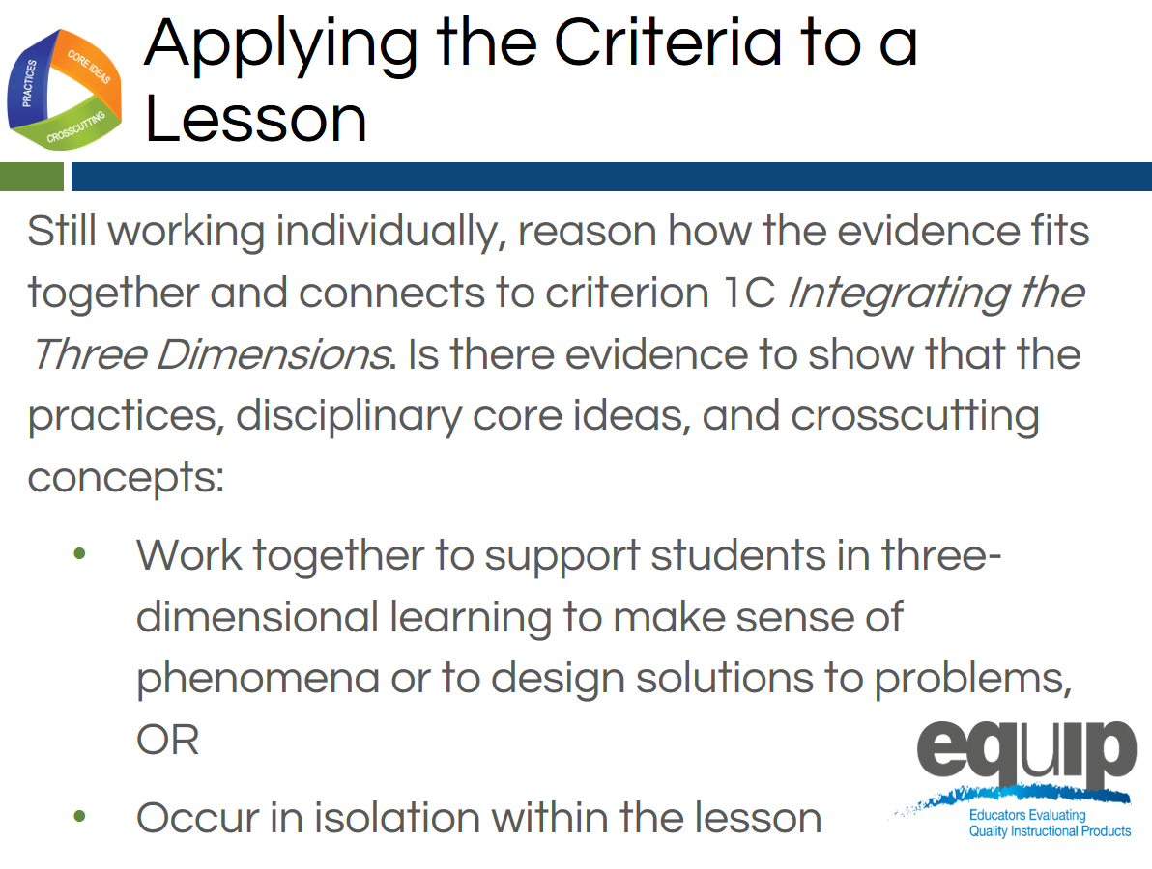
Slide 131
Talking Points
- Still working as individuals, let's consider Category 1, Criterion C: Integrating the Three Dimensions.
- Remember, the three dimensions need to work together to support student sense-making of phenomena or designing solutions to problems.
- For the dimensions to work together, student performances that integrate the elements of the SEPs, DCIs and CCCs are required.
- As you consider evidence for this criterion, ask yourself “Do the students have an opportunity to engage in three-dimensional learning to help them make sense of phenomena or design solutions, OR Do the three dimensions occur in isolation?”
- Again, you can use the second column of the response form for this.
- You have five to seven minutes to do this. [Note to facilitator: Set the timer but ask if participants need more time before moving on.]
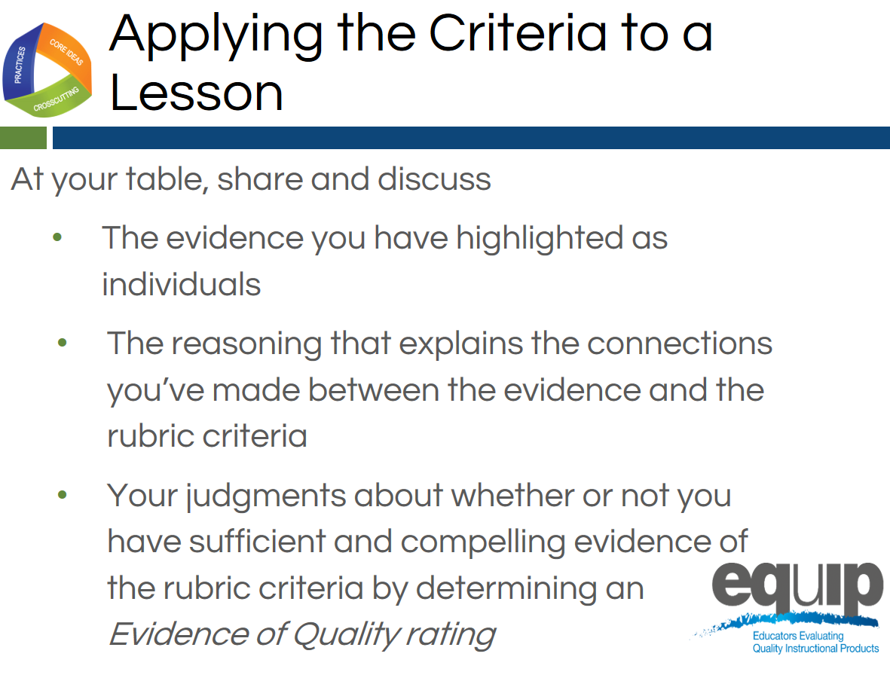
Slide 132

Facilitator Notes
At this point ask that the note takers record their group’s findings electronically on the response form. In addition, if available, provide each group with a small projector so that the information being inputted can be seen by all group members. A screen sharing application also could be used.
Talking Points
- Now you finally get to share and compare.
- Before you begin the group discussion, designate a table facilitator and recorder for your group and take a minute to review the Table Facilitator expectations on the back of Handout 6.
- Making sure everyone contributes his/her findings, share and discuss:
  - [Note to facilitator: Click for animation.] The evidence you highlighted;
  - [Note to facilitator: Click for animation.] The reasoning that explains the connections you made between the evidence and the rubric criteria; and then
  - [Note to facilitator: Click for animation.] Collaboratively evaluate whether this lesson or unit includes sufficient and compelling evidence of three-dimensional learning and whether or you see evidence of NGSS 3D Design according to Criteria IB and IC.
- Attempt to reach consensus as a table group and determine an evidence of quality rating for Category IB and Category 1C. Be prepared to share your evaluation and support them with evidence and reasoning.
- You have 30 minutes for this discussion. [Note to facilitator: Set the timer for 30 minutes but monitor the table groups and provide more or less time as needed to complete this. When the table groups are ready, have two or three share their determinations and then allow for questions and comments related to the determinations before moving on.]
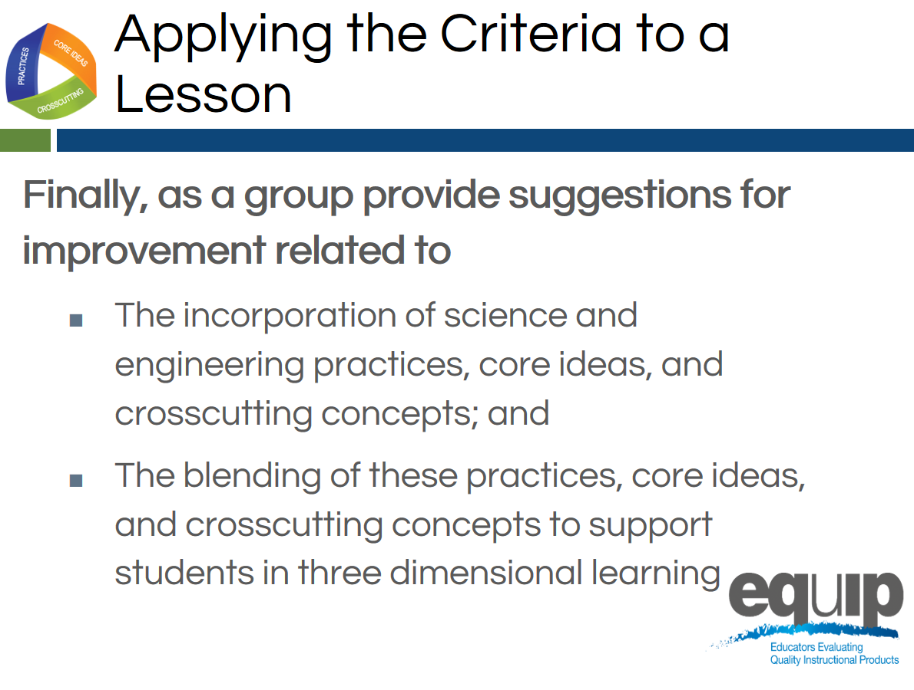
Slide 133
Talking Points
- This part of the task involves providing guidance or suggestions for how the lesson developer can improve the lesson.
- This guidance should be at the element level. Again, when using the EQuIP Rubric, the term “element” refers to the relevant, bulleted practices, disciplinary core ideas, and crosscutting concepts that are articulated in the foundations boxes of the standards, as well as in the NGSS appendices on each dimension.
- Remember to state these suggestions as positive actions for the developer to take rather than as negative statements of what’s missing, etc.
- You have five minutes for this. [Note to facilitator: Set the timer for five minutes. When it sounds, ask for two or three suggestions for improvement before moving to the next slide.]
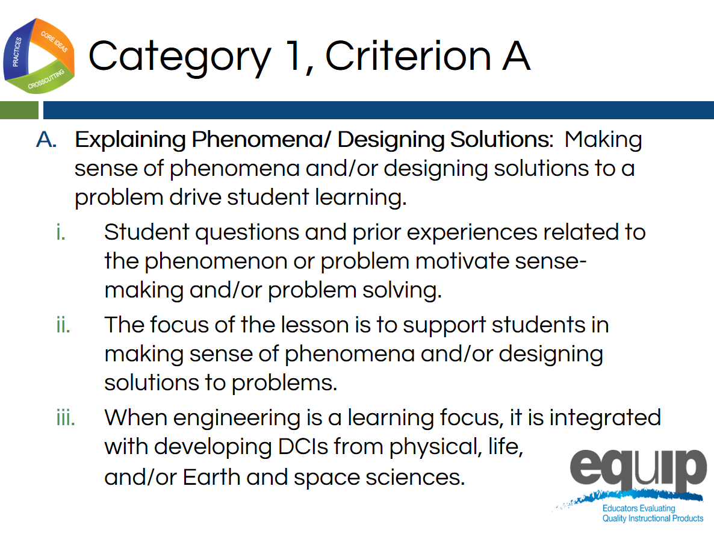
Slide 134
Talking Points
- Now that we have first individually and then collectively determined if there was evidence of three-dimensional learning, let’s consider Criterion A of Category 1: Explaining Phenomena and Designing Solutions.
- This criterion focuses on how making sense of phenomena or designing solutions to problems drives the three-dimensional learning evaluated thus far in the training.
- Before we return to the evaluation of our common lesson, let’s establish some common language and understandings about phenomena and how they are important to NGSS design.
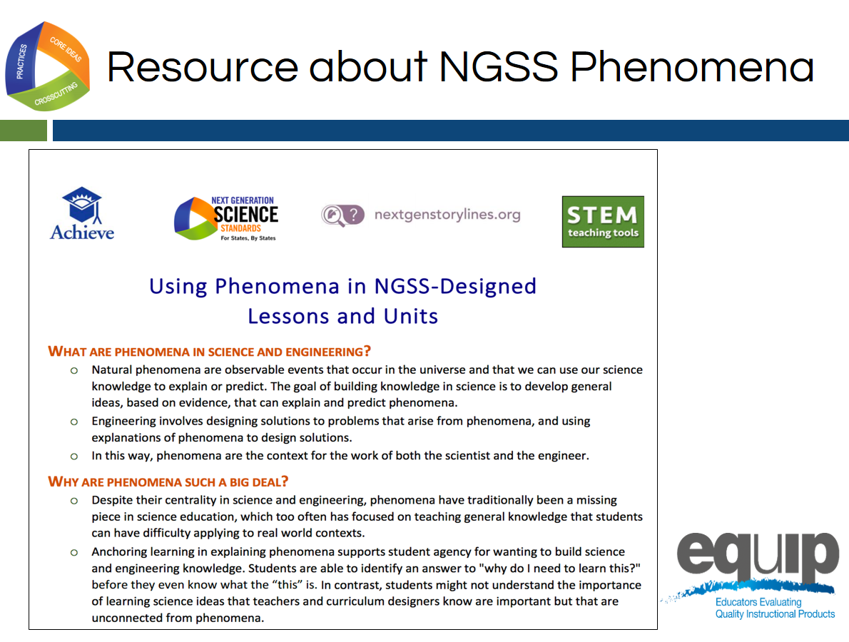
Slide 135
Talking Points
- Phenomena are an essential piece if NGSS 3D Design.
- Please find Handout 2: Using Phenomena in NGSS-Designed Lessons and Units.
- Please take a few minutes to read this resource developed by Achieve and some of its partners.
- You have five minutes for this task. [Note to facilitator: Set the timer for five minutes. If this handout was already reviewed in Module 1, this step can be changed to a review.}.
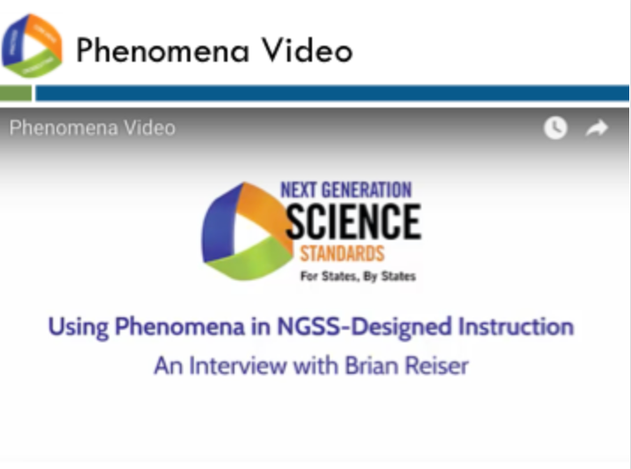
Slide 136
Talking Points
- Now that we have a better understanding of phenomena and how they can be used in NGSS-Designed instruction, let’s view this brief video from Dr. Brian Reiser that introduces phenomena and their connection to NGSS 3D learning. [Note to facilitator: The video is at http://nextgenscience.org/resources/phenomena]
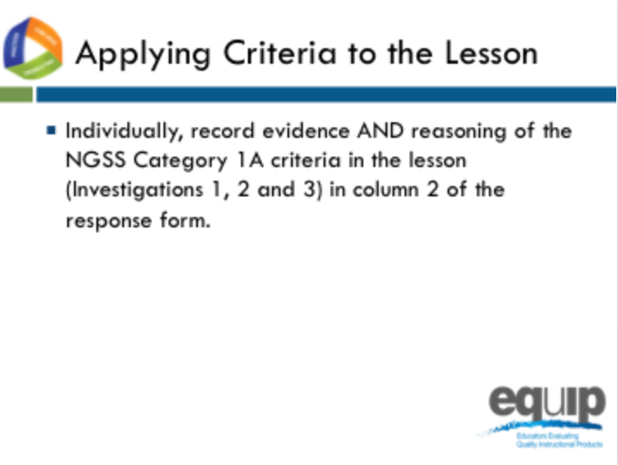
Slide 137
Talking Points
- Now that we have an established a foundational understanding of phenomena in NGSS Design, let’s go back to our common lesson Urban Heat, the intermediate version.
- Please re-read the whole lesson, Investigations 1, 2 and 3 to find evidence of Category 1A.
- This is completed individually without any discussion between or among group members. Even if you complete this part before other tables are finished, do not discuss your findings before being instructed to do so.
- As you locate evidence, use the Arabic and Roman numerals associated with the rubric criteria 1A to code the evidence you locate from the lesson.
- Remember, evidence is what you can see explicitly in the lesson or unit.
- You can use the second column of the response form to summarize your evidence and your reasoning of HOW/WHY this evidence connects to the rubric criteria and sub-criteria for Category 1A.
- Reasoning is the bridge connecting the evidence to the rubric criteria and to how the practices, core ideas, and crosscutting concepts work together.
- You have ten minutes to do this. [Note to facilitator: Set a timer for ten minutes, on the screen for all to see if possible. When the timer sounds, ask if participants need more time before moving on.]

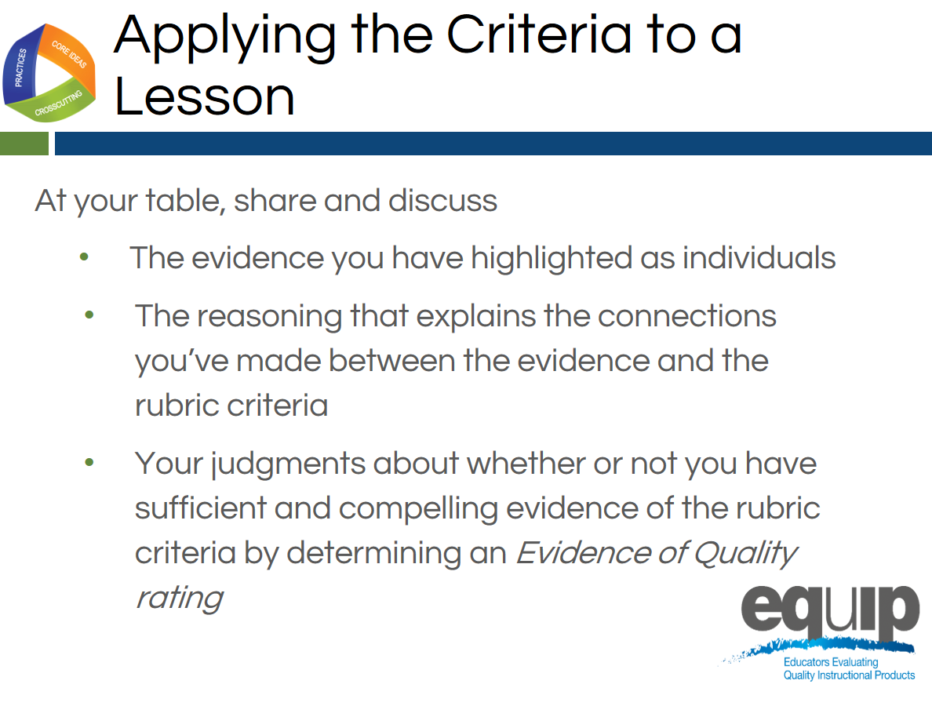
Slide 138
Talking Points
- Now it’s time to share and compare.
- Before table facilitators begin the group discussion, designate a recorder for your group and remember the Table Facilitator expectations on the back of Handout 6.
- Making sure everyone contributes his/her findings, share and discuss:
  - [Note to facilitator: Click for animation.] The evidence you highlighted;
  - [Note to facilitator: Click for animation.] The reasoning that explains the connections you made between the evidence and the rubric criteria; and then
  - [Note to facilitator: Click for animation.] Collaboratively evaluate whether this lesson or unit includes sufficient and compelling evidence of three-dimensional learning and whether or you see evidence of NGSS 3D Design according to Criteria IA.
- Attempt to reach consensus as a table group and determine an evidence of quality rating for Category IA. Be prepared to share your evaluation and support them with evidence and reasoning.
- You have 10 minutes for this discussion. [Note to facilitator: Set the timer for10 minutes but monitor the table groups and provide more or less time as needed to complete this. When the table groups are ready, have two or three share their determinations and then allow for questions and comments related to the determinations before moving on.]

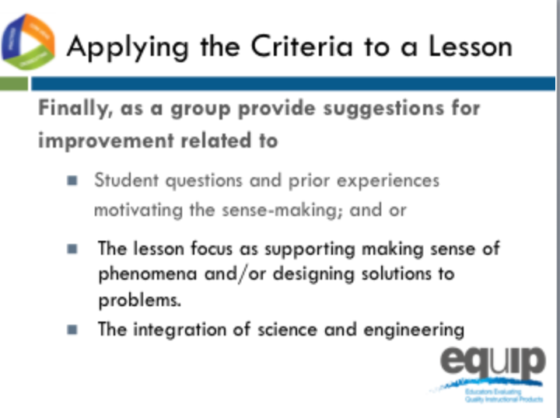
Slides 139–140
Talking Points
- This part of the task involves providing guidance or suggestions for how the lesson developer can improve the lesson.
- This guidance should be at the element level. Again, when using the EQuIP Rubric, the term “element” refers to the relevant, bulleted practices, disciplinary core ideas, and crosscutting concepts that are articulated in the foundations boxes of the standards, as well as in the NGSS appendices on each dimension.
- Remember to state these suggestions as positive actions for the developer to take rather than as negative statements of what’s missing, etc.
- You have five minutes for this. [Note to facilitator: Set the timer for five minutes. When it sounds, discuss the feedback in column 2 for Category IA and ask for two or three suggestions for improvement before moving to the next slide.]
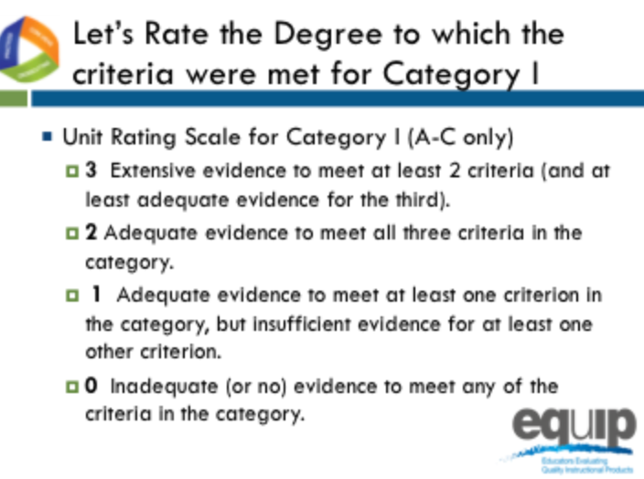
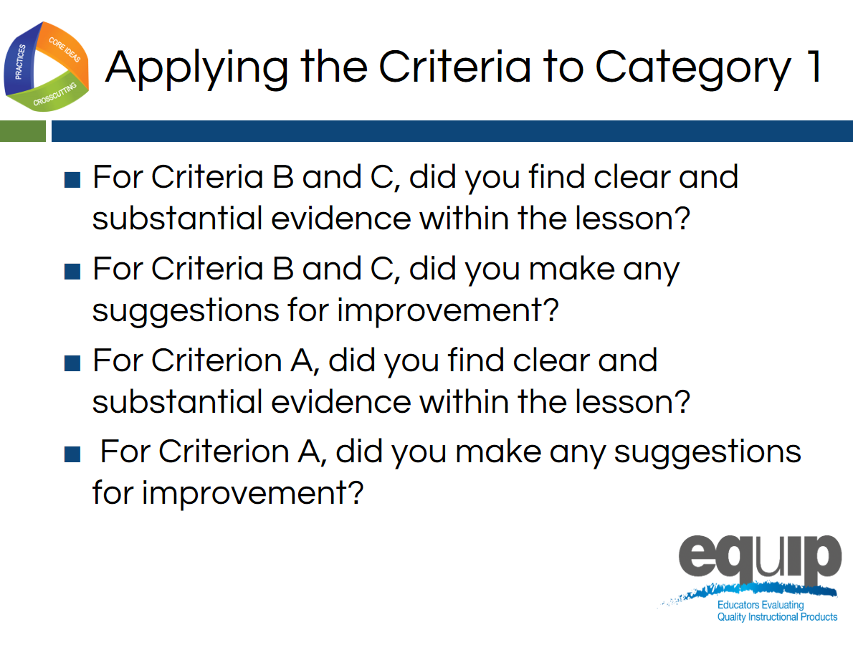
Slides 141–142
Talking Points
- Let’s rate the degree to which the criteria were met in Category I.
- Let’s only consider criteria A–C since we are examining a lesson, not a unit.
- At each table, let’s review the evidence of quality for categories A, B, and C. Then, as a group, let’s determine a rating for Category I using the language on page 7 of the rubric.
- Notice that the possible ratings fall across a 0–3 scale.
- Facilitator, give groups about 5 minutes to discuss evidence of quality for each category A–C and determine a Category rating.
- By a show of fingers, would table facilitators indicate your rating for Category I? [Note to facilitator: Do a quick summary of the room and announce a consensus response.]

Debriefing the Task
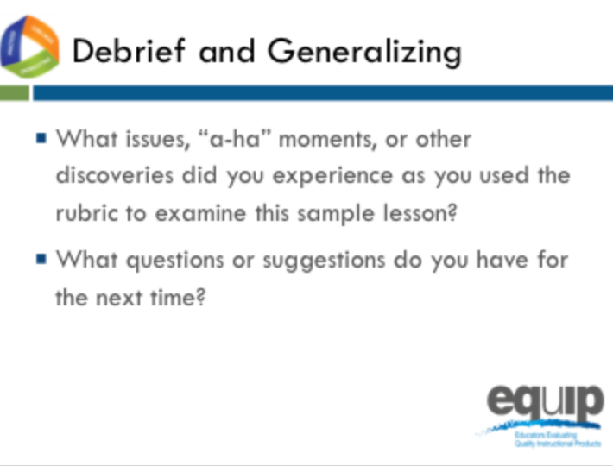
Slide 143
Talking Points
- So, how did it go? What did you experience using the rubric for the first time to determine alignment to the NGSS?
- Do you have any issues related to using the rubric to determine NGSS 3D Design that need to be addressed? Any “aha” moments? Other discoveries that might be important for others to hear? What questions do you have? Do you have any suggestions for improving the process? [Note to facilitator: Have people share as time allows.]
- Why is it important to first use the rubric individually to examine a lesson or unit?
- Why is it important to discuss your individual findings collaboratively as a group in order to make decisions about whether or not a lesson or unit aligns to the NGSS?
- [Note to facilitator: Refer participants to Handout 6, Module 4, “EQuIP Agreements.”] Look back over the agreements we discussed earlier. Why are these so important? [Note to facilitator: Allow two to three people to respond.]
!
- It is essential to understand that the EQuIP quality review process is a collegial process that centers on the use of the criteria-based rubric for science.
!
- While an individual certainly might use the rubric to examine a lesson or unit, the effective evaluation of lessons and units is the product of examination and discussion by a group of people using the rubric collaboratively.
- While using the EQuIP Rubric to examine instructional materials should lead to consensus regarding the overall lessons or units, group members may not always agree about every individual piece of evidence within a lesson or unit.
- The process we just followed to examine the common lesson is the same process we’ll use in examining other lessons and units regardless of whether we’re looking for 3D Design, coherence, access for all learners, or assessment practices.
- First we look for the evidence in the lesson or unit. Next we determine how the evidence fits together and connects to one or more criteria. From this evidence and reasoning we then make evaluations collaboratively about the lesson or unit. And then, finally, we make suggestions for how the lesson or unit might be improved.

Concluding Slide for Module 6

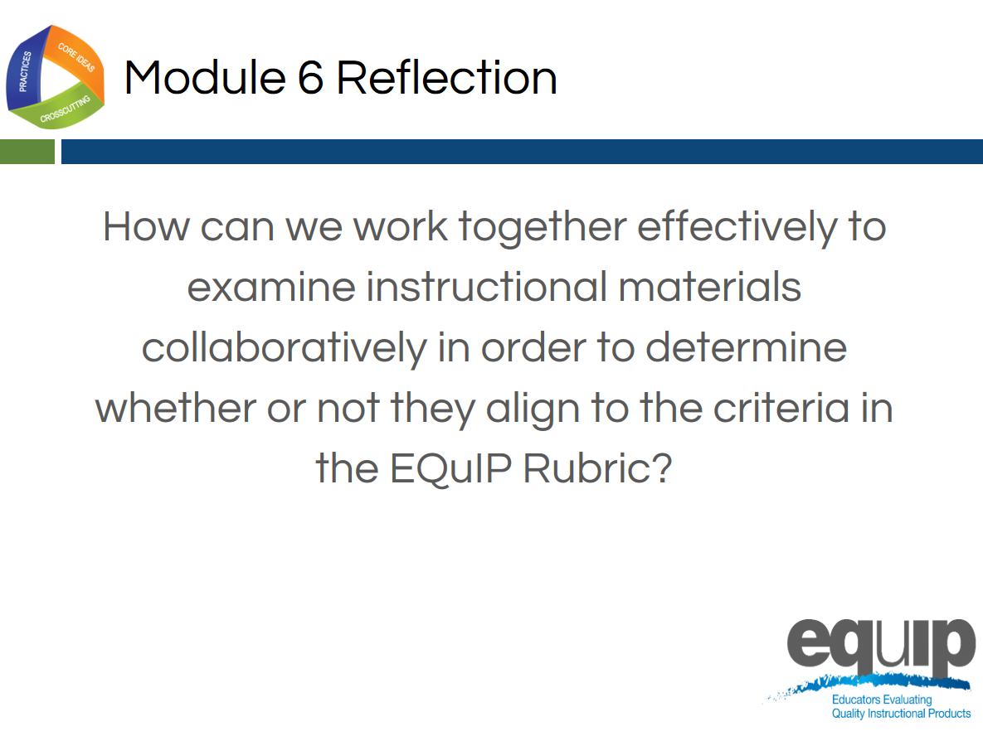
Slide 144
Talking Points
- With your table group, reflect on the process you just used to examine the common lesson.
- Determine where your group is on a scale of one to four, with four indicating that you feel confident that you all understand the process and can now use it to determine whether other instructional materials provide sufficient, explicit evidence to meet EQuIP Rubric criteria. [Note to facilitator: Allow five minutes, and then ask representatives to hold up one to four fingers for their table. Survey the room and address any tables holding up one or two fingers by asking, “What do you still need to move to a three?”]
- In the next module, we’ll take a look at the other criteria in Category I related to NGSS 3D Design.

