Where Did the Water Go?: Watershed Study – Middle School Sample Classroom Task
Introduction
In this task, students will demonstrate their understanding of the water cycle by considering the inputs and outputs of water as it moves through a watershed in New York state. The students start with a simple model dominated by one input and one output. Students begin by calculating the volume of water entering a small watershed as precipitation over the course of one year and the amount of water that exited from that watershed via the outflow stream over the same amount of time. Through their calculations, students find that that some of the water has gone “missing”, and reconsider their model throughout the task to account for the missing water by including outputs not initially included in the starting model, such as loss of water to evapotranspiration.

This task is adapted from Earth Science Puzzles: Making meaning from data, by Kim Kastens and Margie Turrin, 2010, NSTA Press, pages 123-143.
Standards Bundle
(Standards completely highlighted in bold are fully addressed by the task; where all parts of the standard are not addressed by the task, bolding represents the parts addressed.)

CCSS-M
MP.1 Make sense of problems and persevere in solving them.
MP.2 Reason abstractly and quantitatively.
MP.4 Model with mathematics.
6.RP.3.C Find a percent of a quantity as a rate per 100 (e.g., 30% of a quantity means 30/100 times the quantity); solve problems involving finding the whole, given a part and the percent.
6.EE.B.9 Use variables to represent two quantities in a real-world problem that change in relationship to one another; write an equation to express one quantity, thought of as the dependent variable., in terms of the other quantity, thought of as the independent variable. Analyze the relationship between the dependent and independent variables using graphs and tables, and relate these to the equation.
6.G.A.1 Find the area of right triangles, other triangles, special quadrilaterals and polygons by composing into rectangles or decomposing into triangles and other shapes; apply these techniques in the context of solving real-world and mathematical problems.
7.G.B.6 Solve real-world and mathematical problems involving area, volume and surface area of two- and three-dimensional objects composed of triangles, quadrilaterals, polygons, cubes, and right prisms.
8.G.9 Know the formulas for the volumes of cones, cylinders and spheres and use them to solve real-world and mathematical problems.
8.SP.A.1 Construct and interpret scatterplots for bivariate measurement data to investigate patterns of association between two quantities. Describe patterns such as clustering, outliers, positive or negative association, linear association, and nonlinear association.
8.SP.A.2 Know that straight lines are widely used to model relationships between two quantitative variables. For scatterplots that suggest a linear association, informally fit a straight line, and informally assess the model fit by judging the closeness of the data points to the line.

NGSS
MS-ESS2-4 Develop a model to describe the cycling of water through Earth's systems driven by energy from the sun and the force of gravity.

CCSS-ELA/Literacy
W.8.1 Write arguments to support claims with clear reasons and relevant evidence.
W.8.1.a Introduce claim(s), acknowledge and distinguish the claim(s) from alternate or opposing claims, and organize the reasons and evidence logically.
W.8.1.b Support claim(s) with logical reasoning and relevant evidence, using accurate, credible sources and demonstrating an understanding of the topic or text.
W.8.1.c, Use words, phrases, and clauses to create cohesion and clarify the relationships among claim(s), counterclaims, reasons, and evidence
WHST.6-8.1 Write arguments focused on discipline-specific content.
WHST.6-8.1.a Introduce claim(s) about a topic or issue, acknowledge and distinguish the claim(s) from alternate or opposing claims, and organize the reasons and evidence logically.
WHST.6-8.1.b Support claim(s) with logical reasoning and relevant, accurate data and evidence that demonstrate an understanding of the topic or text, using credible sources.
WHST.6-8.1.cUse words, phrases, and clauses to create cohesion and clarify the relationships among claim(s), counterclaims, reasons, and evidence.

Information for Classroom Use
Connections to Instruction
This task is intended for students at the 8th grade level in math and would best fit within an instructional unit on the water cycle and/or on rivers (particularly in a place in the unit where students have already had some instruction on the components and processes of the water cycle). The task involves material covered in 6th and 7th grade math standards, but also addresses some material covered in the 8th grade standards, such as the more advanced plotting standards. Task Components A, B and C could be simplified for students in lower levels of the grade range by not having students calculate relief and slope and not having them create the scatterplot, but teachers should be aware that with such changes the task may no longer fully address the NGSS performance expectation of MS-ESS2-4. In a blended math/science course or in a setting where there is collaboration between teachers of different classes, the students could mathematically model the area and create the plots within a math-focused component of the class and then follow with the water cycle model development and other related parts of the task as part of the science unit.

Because the interpretation of the data is essential for the development and explanation of the water cycle model, Task Components A through G are best used as checks for understanding (i.e., formative assessment), while the final watershed model of Task H used a mechanism for students to apply the previously developed understandings in context.

Although students are asked to compose explanations in this task, overall the writing focus most closely aligns with the ELA/Literacy standards on writing argument. Writing argument is not introduced until the 6th grade in the ELA/Literacy standards; and while students are asked to acknowledge “alternate or opposing claims,” in 7th grade, counterclaims and the relationship between claims and counterclaims is not introduced until 8th grade. Consequently, this task aligns best with the 8th grade ELA/Literacy standards.

Approximate Duration for the Task
The entire task could take between 4-10 class periods (45-50 minutes each) spread out over the course of an instructional unit, with the divisions listed below:
Task Component A: 1 class period
Task Components B and C: 1-2 class periods
Task Component D: up to 1 class period, or used as homework
Task Component E: up to 1 class period, or used as homework
Task Component F: 1-2 class periods, depending on whether the explanation is used as homework
Task Component G: 1-2 class periods, depending on whether the evaluation is used as homework
Task Component H: up to 1 class period, or 1-2 class periods if used in conjunction with the explanation in Task Component D.

Note that this timeline only refers to the approximate time a student may spend engaging in the task components, and does not reflect any instructional time that may be interwoven with this task.

Assumptions
Students need to know or be familiar with the following:
- What a watershed is and where the watershed fits within the model of the water cycle.
- How to read a topographic map and how to use a map scale and compass rose.
- A basic knowledge of topography and topographic contours and know how symbols are used on topographic maps.
- The “rule of Vs”: Topographic contour lines crossing a stream valley form a sharp pointed V shape, with the stream channel passing through the point of the V. The V points in the upstream direction.
- A model of the water cycle as a system of flows or pathways by which water moves through the Earth system.

Materials Needed
It might be helpful for students who live outside of the northeastern United States to see photographs of the terrain, environment, and climatic conditions of southeastern New York state. The site used in the task is located at coordinates (LAT: 41.394816, LONG: -74.0062516), which can be used on terrain imaging programs (e.g. GoogleEarthTM). Alternatively, this task can be easily altered to include more local watersheds.

Supplementary Resources
See http://techalive.mtu.edu/meec/module01/whatiswatershed.htm for a good animation to illustrate the concept of a watershed and the parts of the water cycle.

Accommodations for Instruction and Classroom Tasks
To accurately measure three dimensional learning of the NGSS along with CCSS for mathematics, modifications and/or accommodations should be provided during instruction and assessment for students with disabilities, English language learners, and students who are speakers of social or regional varieties of English that are generally referred to as “non-Standard” English.

Classroom Task
Context
Cascade Brook is an important watershed in its local environment, providing water supplies to neighboring communities. For several years, the downstream neighboring community, which is dependent on this watershed for water, has been carefully monitoring and recording rainfall within the watershed. Recently, local research scientists installed a stream station on Cascade Brook in order to measure how much of the water that enters the watershed as rainfall is actually flowing downstream to the neighboring community. Now that there is a stream station installed, the community can determine whether the rainfall numbers they have been collecting match the streamflow numbers at the gauging station. There is a concern that water supplies might run short if too little of the rainfall water is flowing through the gauging station. Let's find out where the water is going.

Task Components

A. Use the provided topographic map (Attachment 1) to visualize the watershed. Describe the geometry of the watershed in terms of (1) the amount of relief in the watershed, (2) the steepness of the slope over which the stream is flowing, and (3) the direction of streamflow. Use the scale provided to estimate the actual measurements. Show your work and include units in your answer.

B. Estimate the two-dimensional mapped area (in square meters) of the watershed that feeds into the stream monitoring station. Consider various models you have experience with; for example, you may want to consider modeling the area as a combination of smaller shapes (circles, squares, rectangles and/or triangles) and adding those segments in order to find the total area. Each square in the grid on the map represents 100 m by 100 m. Consider each square that is more than 50% inside the watershed. Show your work and include units in your answer.

C. Using the area you found in Task Component B, write an equation that would allow you to calculate the volume of water in cubic meters falling within this area. Once you have your equation, calculate the volume of water that fell into the watershed during a year in which the region received a total of 129 cm of precipitation. Show your work and include units in your answer.

D. Using the volume of water falling on the watershed that you calculated in Task Component C, make a prediction for how much of that water will flow out of the watershed in the stream during the same year, as measured by the stream monitoring station. Consider a way to represent the Cascade Brook watershed on paper. Draw and label your model with arrows to show the ways that the water enters and leaves the watershed (inputs and outputs), and where the water goes while it is in the watershed (including storage in the watershed). Be sure to consider any changes or differences in the state and behavior of the water from season to season. Label your diagram to show what state of matter the water is in as it moves into, through, and out of the Cascade Brook watershed. Use labels or arrows to indicate what is driving the movement of the water and any water transformations: energy from gravity and/or energy from the sun. You may use a single model, or a series of models to show the differences across seasons over time. Use this model as evidence to support your prediction for the volume of water that will leave the watershed in the stream.

E. Calculate the total annual volume of water that flowed through Cascade Brook at the stream monitoring station over the entire year using the data table provided (Attachment 2 and 3). Compare this number with the annual volume of water entering the watershed as precipitation that you calculated in Task Component D, and express the difference as a percentage. Based on what you learned from the comparisons, make revisions to your model of the Cascade Brook watershed as you think of other pathways for water to move through the different parts of the watershed. Be sure to use arrows and labels to show any additional water movement, states, and processes that may be part of your revised model.

F. Using the equation you made in Task Component C and the average precipitation values for southeast New York in the given data table (Attachment 3), calculate the volume of water that would be entering the watershed from precipitation for each month of the year. Compare that number with the total amount of water leaving the watershed every month as streamflow by calculating a percentage for the amount of water from precipitation leaving the watershed in the stream. Complete the data table in Attachment 3, and use the data to create the following graphs:
(a) a line graph showing the water volume per month, with one set of points showing the “Volume of Water Passing Through Stream Monitoring Stations per Month” and a different set of points showing the “Volume of Water Entering the Watershed from Precipitation per Month” (Attachment 4)
(b) a line graph showing the “Percent of Water from Precipitation Leaving as Water in the Stream” (Attachment 5)
Use these graphs and your watershed model to construct an explanation for why you think the percentage of water from precipitation leaving the watershed in the stream is so different from month to month. Take into account the climate of New York, including seasonal changes, and the environment around the stream. In your explanation, consider
- the state (e.g., liquid vs. gas) the water is in as it enters, travels through, is stored in, and exits the watershed;
- what drives the movement of water; and
- how the inputs and outputs of the watershed might change from month-to-month.

G. Use the data in Attachment 3 to create the following plots:
(a) a bar graph or line graph showing the mean temperature per month. (Attachment 6)
(b) a bar graph or line graph showing the average total precipitation per month. (Attachment 7)
(c) a scatterplot comparing the average total monthly precipitation versus the monthly mean temperature (Attachment 8). Draw a trendline (a line of best fit) that represents the relationship between precipitation and temperature.
Use these graphs and the scatterplot as evidence to evaluate the claim that “there are differences in the percentage of precipitation leaving the watershed in the stream from month to month because the climate is hot and very dry in the summer months”. Make revisions to the explanation you constructed in Task Component F if you feel that your explanation has changed in light of the new evidence provided by the temperature and precipitation plots.

H. Redraw your water cycle sketch for the Cascade Brook watershed taking into account the calculations and plots you have made. Label your model with arrows to show the ways that the water enters and leaves the watershed (inputs and outputs) and where the water goes while it is in the watershed. Label your diagram to show what state (e.g., liquid) the water is in as it moves into, through, and out of the Cascade Brook watershed and to indicate what is driving the movement of the water: gravity and/or energy from the sun. Include and describe all inputs, outputs, and processes that might occur at any time during the year.

Use the revised model to evaluate the claim that “all of the water that enters the watershed as precipitation is pulled downhill by gravity and flows out of the watershed as streamflow”. In your evaluation, create and explain your own evidence-based claim for how and why water moves through the watershed, including what state (e.g., liquid) the water is and what is driving the movement (gravity and/or energy from the sun). Use the provided water cycle diagram to inform your ideas (Attachment 9).
Alignment and Connections of Task Components to the Standards Bundle
Task Components A, B, and C ask students to quantitatively describe the watershed and to calculate the volume of precipitation over the year using area estimates of the watershed. These components partially address the CCSS-M content standards of 6.G.A.1, 7.G.B.6, and 8.G.9, and the CCSS-M practices MP.1, MP.2, and MP.4. By creating an equation for calculating the volume of water entering the watershed, students partially address the CCSS-M content standards of 6.EE.B.9, 7.G.B.6, and 8.G.9. By using the topographic map and modeled geometry of the watershed to estimate the precipitation input to the watershed over a year, students address parts (individual bullets from Appendix G) of the NGSS crosscutting concept of Systems and Systems Models. By describing aspects of the watershed mathematically (e.g., using slope), by quantitatively estimating the area of the watershed, and by calculating the volume of water entering the watershed within a year, students can demonstrate their understanding of parts of the NGSS practice of Using Mathematics and Computational Thinking, which enhances student understanding of parts of the NGSS core idea of ESS2.C Roles of Water in Earth’s Surface Processes as it relates to MS-ESS2-4. In this task component, making and supporting a prediction also aligns with making and supporting a claim in the ELA/Literacy standards W.8.1, W.8.1.a, W.8.1.b, WHST.8.1, WHST.8.1.a, and WHST.8.1.b.

Task Component D asks students to develop their own model for the cycling of water through the watershed and to use that model to support a prediction they make for how much water will flow through a stream monitoring station located in the watershed. This task component addresses the NGSS performance expectation of MS-ESS2-4. By developing and using their own model to explain their prediction, students partially address parts of the NGSS practice of Developing and Using Models as it relates to MS-ESS2-4 and parts of the crosscutting concept of Systems and Systems Models. By labeling the state of and movement of water in the model and labeling where gravity and solar energy play a role in that water movement, the students can demonstrate their understanding of the NGSS core idea of ESS2.C Roles of Water in Earth’s Surface Processes and parts of the crosscutting concept of Energy and Matter, as they relate to MS-ESS2-4. In this task component, making and supporting a prediction also aligns with making and supporting a claim in the ELA/Literacy standards W.8.1, W.8.1.a, W.8.1.b, WHST.8.1, WHST.8.1.a, and WHST.8.1.b.

Task Component E asks students to calculate the total volume of water leaving the watershed as streamflow and compare that number to (a) the volume of water entering as precipitation and to (b) their predicted amount of water leaving as streamflow. This allows students to demonstrate their understanding of CCSS-M practices MP.1, MP.2, and MP.4. By considering factors that might account for the difference in the predicted versus actual numbers and by revising their model in light of new data, students are partially addressing parts of the NGSS core idea of ESS2.C Roles of Water in Earth’s Surface Processes as it relates to MS-ESS2-4 through parts of the NGSS practices of Developing and Using Models and Using Mathematics and Computational Thinking as it applies to parts of the crosscutting concepts of Systems and Systems Models and Energy and Matter as it relates toMS-ESS2-4. When students compare data and their predictions and use reasoning to consider factors that might account for the differences that occur, they can address parts of ELA/Literacy standards W.8.1 and WHST.8.1, specifically on the related performance indicators W.8.1.c and WHST.8.1.c, clarifying the relationships among claim(s), reasons, and evidence.

Task Components F and G ask students to use monthly streamflow, temperature, and precipitation data to determine the percentage of precipitation leaving the watershed as streamflow; to create graphs and scatterplots of the data; and to interpret the data in the context of the seasonal effects on the water cycle, which addresses 6.RP.3.C. By constructing a scatterplot, by determining a trendline (a line of best fit) of the data, and by interpreting the data, the students can address the CCSS-M content standards of 8.SP.A.1 and 8.SP.A.2, and the CCSS-M practices MP.1 and MP.2, with the science context enhancing assessment of the math standards. By using the equation for calculating the volume of water entering the watershed developed in Task Component C, students can further check their understanding on the CCSS-M content standard of 6.EE.B.9. By using the data to construct and reevaluate an explanation that accounts for variations in the volume of streamflow from month to month and to assess the inputs, outputs, and energy drivers of their watershed model, students are partially addressing the NGSS the core idea of Roles of Water in Earth’s Surface Processes (ESS2.C, via MS-ESS2-4); the crosscutting concepts of Systems and Systems Models and Energy and Matter (MS-ESS2-4); and the practices of Constructing Explanations, Developing and Using Models, and Analyzing and Interpreting Data. By using the graphs and scatterplot to evaluate the claim in Task Component G, students are additionally partially addressing the NGSS practice of Engaging in Argument from Evidence. This task component partially addresses the NGSS performance expectation of MS-ESS2-4, and the mathematical interpretation of the plots enhances understanding of the associated NGSS the core idea and practices. By explaining their reasoning in Task Component F and evaluating a claim in Task component G, students can demonstrate their understanding of ELA/Literacy standards W.8.1, W.8.1.a, W.8.1.b, WHST.8.1, WHST.8.1.a, and WHST.8.1.b.

Task Component H asks students to redraw their water cycle diagram in light of the data calculations and plots made in Task Components E, F, and G. By using data and plots for evaluating system inputs and outputs, by revising their water cycle model, and by using the model to evaluate a claim and produce a counter-claim, students are partially addressing the NGSS the core idea of Roles of Water in Earth’s Surface Processes (ESS2.C, via MS-ESS2-4), the crosscutting concept of Energy and Matter (MS-ESS2-4), the NGSS practices of Developing and Using Models (MS-ESS2-4) and Engaging in Argument from Evidence, and the CCSS-M practices MP.1 and MP.2.In addition, by asking students to evaluate a claim, as well as to create and explain an evidence-based counter claim, this task component partially addresses ELA/Literacy standards W.8.1, W.8.1.a, W.8.1.b, W.8.1.c, WHST.8.1, WHST.8.1.a, WHST.8.1.b, and WHST.8.1.c.

Together, Task Components D, E, F, G, and H addresses the NGSS performance expectation of MS-ESS2-4. The task components address the core idea of ESS2.C: Roles of Water in Earth’s Surface Processes and the crosscutting concept of Energy and Matter through the practice Developing and Using Models by asking for the production of a visual model of the watershed that identifies the direction of water movement into, within, and out of the watershed with arrows and that includes labels for the state that the water is in as it moves and for what is driving water movement (gravity or energy from the sun). By creating and labeling this model and by using it to evaluate and discuss the movement of water through the watershed and the types and nature of the outputs, students completing the task components are integrating the disciplinary core idea with the crosscutting concept and the practice.
Evidence Statements
Task Component A
- Students calculate
- A topographic relief value by using elevation numbers from contour lines.
- A value for the gradient of the stream by using elevation numbers from contour lines on the map and distance numbers from the map scale.
- Students identify the stream as flowing from northwest to southeast.

Task Component B
- Students mathematically model the watershed as a composite of two-dimensional shapes that completely cover the mapped area (minus any boxes that are less than 50% within the watershed) without significant overlap.
- Students use the formulas for the area of each shape to calculate a combined area estimate for the watershed.

Task Component C
- Students use volume equations as the basis for constructing the equation for calculating the volume of water entering (input) the watershed from precipitation, and include the amount of precipitation as the “height” variable.
- Students use their produced equation to calculate the volume of precipitation in cubic meters for 129cm of precipitation.

Task Component D
- Students create a visual model of the watershed, including:
  - Labeling with arrows accurately depict the direction of water movement into, within, and out of the watershed. Labeled components of the model should include
    - the inputs of water into the watershed – including the entry of water from the atmosphere as precipitation
    - the flow of water within the watershed over land in the downhill direction to the stream,
    - the flow of water in the stream in the downhill direction within the watershed, and
    - any output(s) of water from the watershed, including loss of water from the stream as streamflow.
  - Labeling the state the water is in as it enters, moves through, and leaves the watershed. Labeled components of the model should include the state of the water as vapor in the atmosphere, liquid water (rain) or frozen water (snow/ice) as precipitation, and liquid water as water in the ground, in the surface of the land, and/or in the stream.
  - Labeling the source(s) of energy (gravity or energy from the sun) that is driving water movement into, within, and out of the watershed.
  - A description of the relationships between components of the model (including gravity or energy from the sun), including that gravity is the driver as water condenses and falls to the land as precipitation, and gravity is the driver when water flows across the land, into the rivers, and out of the watershed via the river.
- Students may also label other components of the model, including:
  - Arrows showing the storage of water by movement of water into or out of a pile(s) of ice/snow or into or out of the ground as groundwater, and additional outputs, e.g., the movement of water from the land or water surface to the atmosphere, and the loss of water from the ground through the plants to the atmosphere.
  - Energy from the sun driving the change in water state as it moves from storage as snow/ice to liquid ground water, run-off, or stream water; energy from the sun driving the change in water state form liquid to vapor as it moves from the land surface to the air during evaporation and transpiration; and gravity if showing the movement of groundwater.
- Students form a prediction for the amount of water leaving the watershed, and describe their reasoning for why the amount of water leaving the watershed is either equal to or less than the amount of water entering the watershed as precipitation.
- Students support their prediction using the model, either citing the output of all water as streamflow or citing more than one output, with the additional output(s) accounting for the predicted “loss” of streamflow.

Task Component E
- Students total the monthly values to calculate the annual volume of water leaving the watershed as streamflow
- Students calculate the percentage of precipitation leaving the watershed as streamflow. Due to differences in student calculations, actual percentage answers may vary (but should be less than 100% but greater than zero).
- Students revise their watershed model, and include notation that indicates that there is more than one output. Students accurately label direction of water flow, states of water at additional points, and describe any processes associated with additional output, such as evaporation.

Task Component F
- Students use the average monthly precipitation values and their previously developed equation to calculate the volume of water entering from precipitation per month.
- Students calculate the percentage of precipitation leaving the watershed per month as streamflow.
- Students construct line graphs that represent the monthly data.
- Students construct an explanation that connects the difference in the percentage of water from precipitation leaving the watershed as stream flow with seasonal changes in the state of water, and in the types of inputs and outputs. Examples of lines of reasoning may include:
  - More energy from the sun is captured in the summer causing higher temperatures; therefore more water is lost to the atmosphere as vapor through evaporation rather than as stream flow in the summer months.
  - More plant growth occurs in the spring and summer, therefore more water is lost to the atmosphere as vapor through transpiration rather than as stream flow in the spring and summer months.
  - Precipitation in the winter is solid ice/snow, which is stored in the winter months rather than lost as stream flow.
  - Stored ice/snow melts as the temperatures (energy from the sun) rise increasing the amount of stream flow during the spring months.
- In their explanation, students cite the graphs, as well as other scientific information as evidence.
- In their explanation, students cite one specific potential cause for month-to-month variation in the percentage of water from precipitation leaving the watershed as stream flow.

Task Component G
- Students construct line or bar graphs and a scatterplot that represent the monthly data.
- Students identify and draw a trendline of the scatterplot, which shows an increasing linear relationship (with increasing slope) between temperature and precipitation.
- Students evaluate the given claim, identifying that it is not consistent with the data, and use the graphs and the trendline of the scatterplot as evidence to refute the claim. Students describe the evidence that although the climate is hot in the summer, it is not dry.
- Students revise their explanation for the month-to-month variation, citing which new evidence is used in the revised explanations. Student should not cite dry summer weather as a reason for a drop in the percentage of precipitation leaving the watershed as streamflow in the summer months Instead, students could cite other possible factors, such as increased evaporation in light of high temperatures or increased transpiration because of summertime plant growth,.

Task Component H
- Students revise their visual model of the watershed, including:
  - Identifying precipitation as an input and including two outputs, one of which is streamflow
  - Labelling with arrows the direction of water movement into, within, and out of the watershed
  - Labelling the state of matter the water is in as it enters, moves through or is stored in, and leaves the watershed.
  - Labelling the cause (gravity or energy from the sun) that is driving water movement into, within, and out of the watershed.
- Students’ evaluation of the claim cites the outputs identified in the model as evidence
- Students synthesize the evidence to argue that the given claim incorrectly cites that all water entering the watershed leaves as streamflow. Outputs should include streamflow as well as evaporation and/or transpiration.
- Students construct an evidence-based counter-claim that includes the idea that while some of the water entering the watershed as precipitation moves through the watershed as liquid driven by gravity and leaves the watershed as streamflow, there are alternative outputs of water in the system.
- As evidence for their counter-claim, students cite the data analyzed and/or aspects of the updated model, including the state of water and what is driving water movement.
- Students describe reasoning that some of the water entering the watershed as precipitation leaves the watershed through evaporation and/or transpiration, indicating the state of the water as liquid vapor lost to the atmosphere.

Attachment 1- Topographic Map of Cascade Brook Watershed;
(Watershed divide connects the high points surrounding the watershed; contour interval is 20 ft)
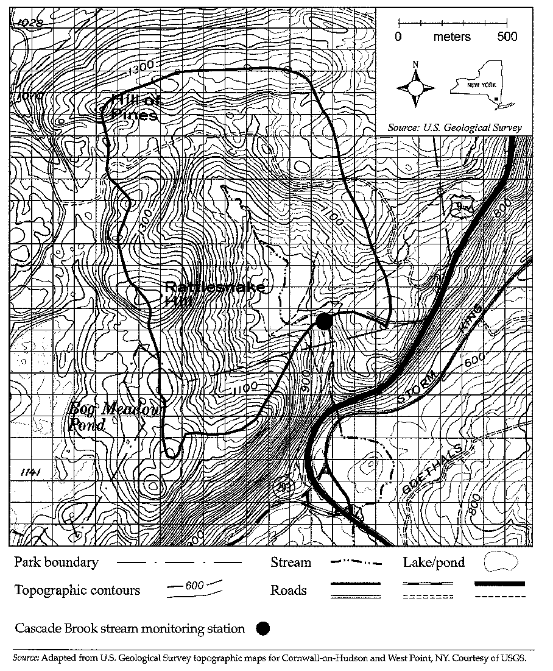
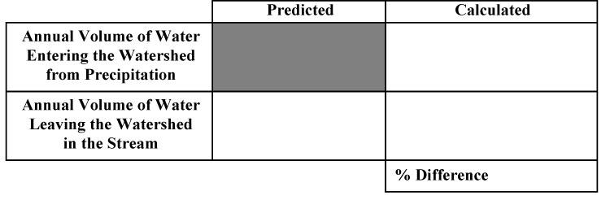
Attachment 2- Chart for Comparing Total Annual Water Volumes.
Attachment 3- Climate Data for Southeast New York State.
Month | Monthly Mean Temp. (degrees F) | Volume of Water Passing Through Stream Monitoring Station per Month (cubic meters) | Average Total Precipitation per Month (cm) | Volume of Water Entering the Watershed from Precipitation per Month (cubic meters) | Percent of Water from Precipitation Leaving as Water in the Stream
Jan | 28 | 99,094 | 9.30
Feb | 31 | 70,992 | 8.13
Mar | 39 | 81,842 | 9.88
Apr | 51 | 115,930 | 10.49
May | 61 | 146,614 | 10.44
Jun | 70 | 84,127 | 11.58
Jul | 75 | 262 | 11.66
Aug | 73 | 0 | 11.71
Sept | 65 | 0 | 11.35
Oct | 54 | 76,429 | 12.67
Nov | 44 | 163,473 | 11.00
Dec | 33 | 130,619 | 10.67
Data on the chart are from:
- source material (Earth Science Puzzles: Making meaning from data)
- http://www.usclimatedata.com/climate.php?location=USNY1567
- http://www.weather.com/weather/wxclimatology/monthly/10996
Attachment 4. Water Volume per Month Line Graph
Note: Teachers may choose to have their students design their own graph rather than be given the graph below.

Attachment 5. Graph for the Percent Water from Precipitation Leaving the Watershed as Streamflow per Month
Note: Teachers may choose to have their students design their own graphs rather than be given the graph below.

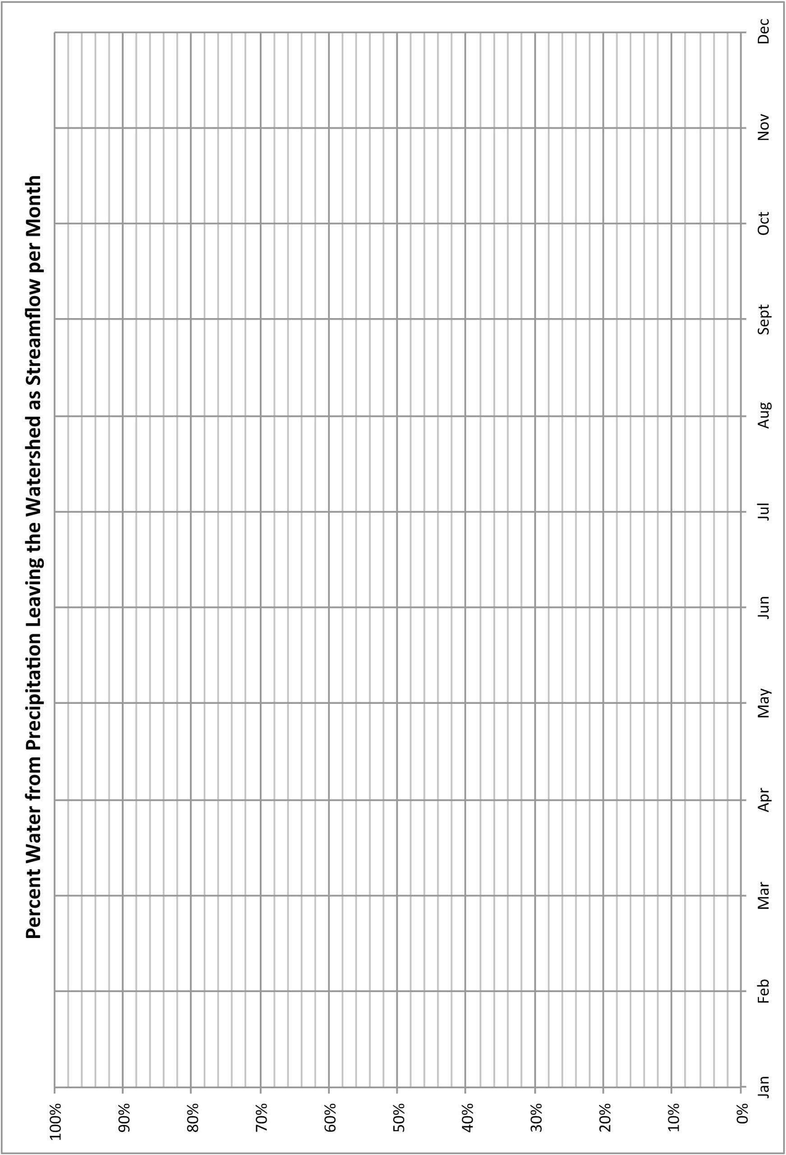

Attachment 6. Graph Showing the Mean Temperature per Month
Note: Teachers may choose to have their students design their own graphs rather than be given the graph below.

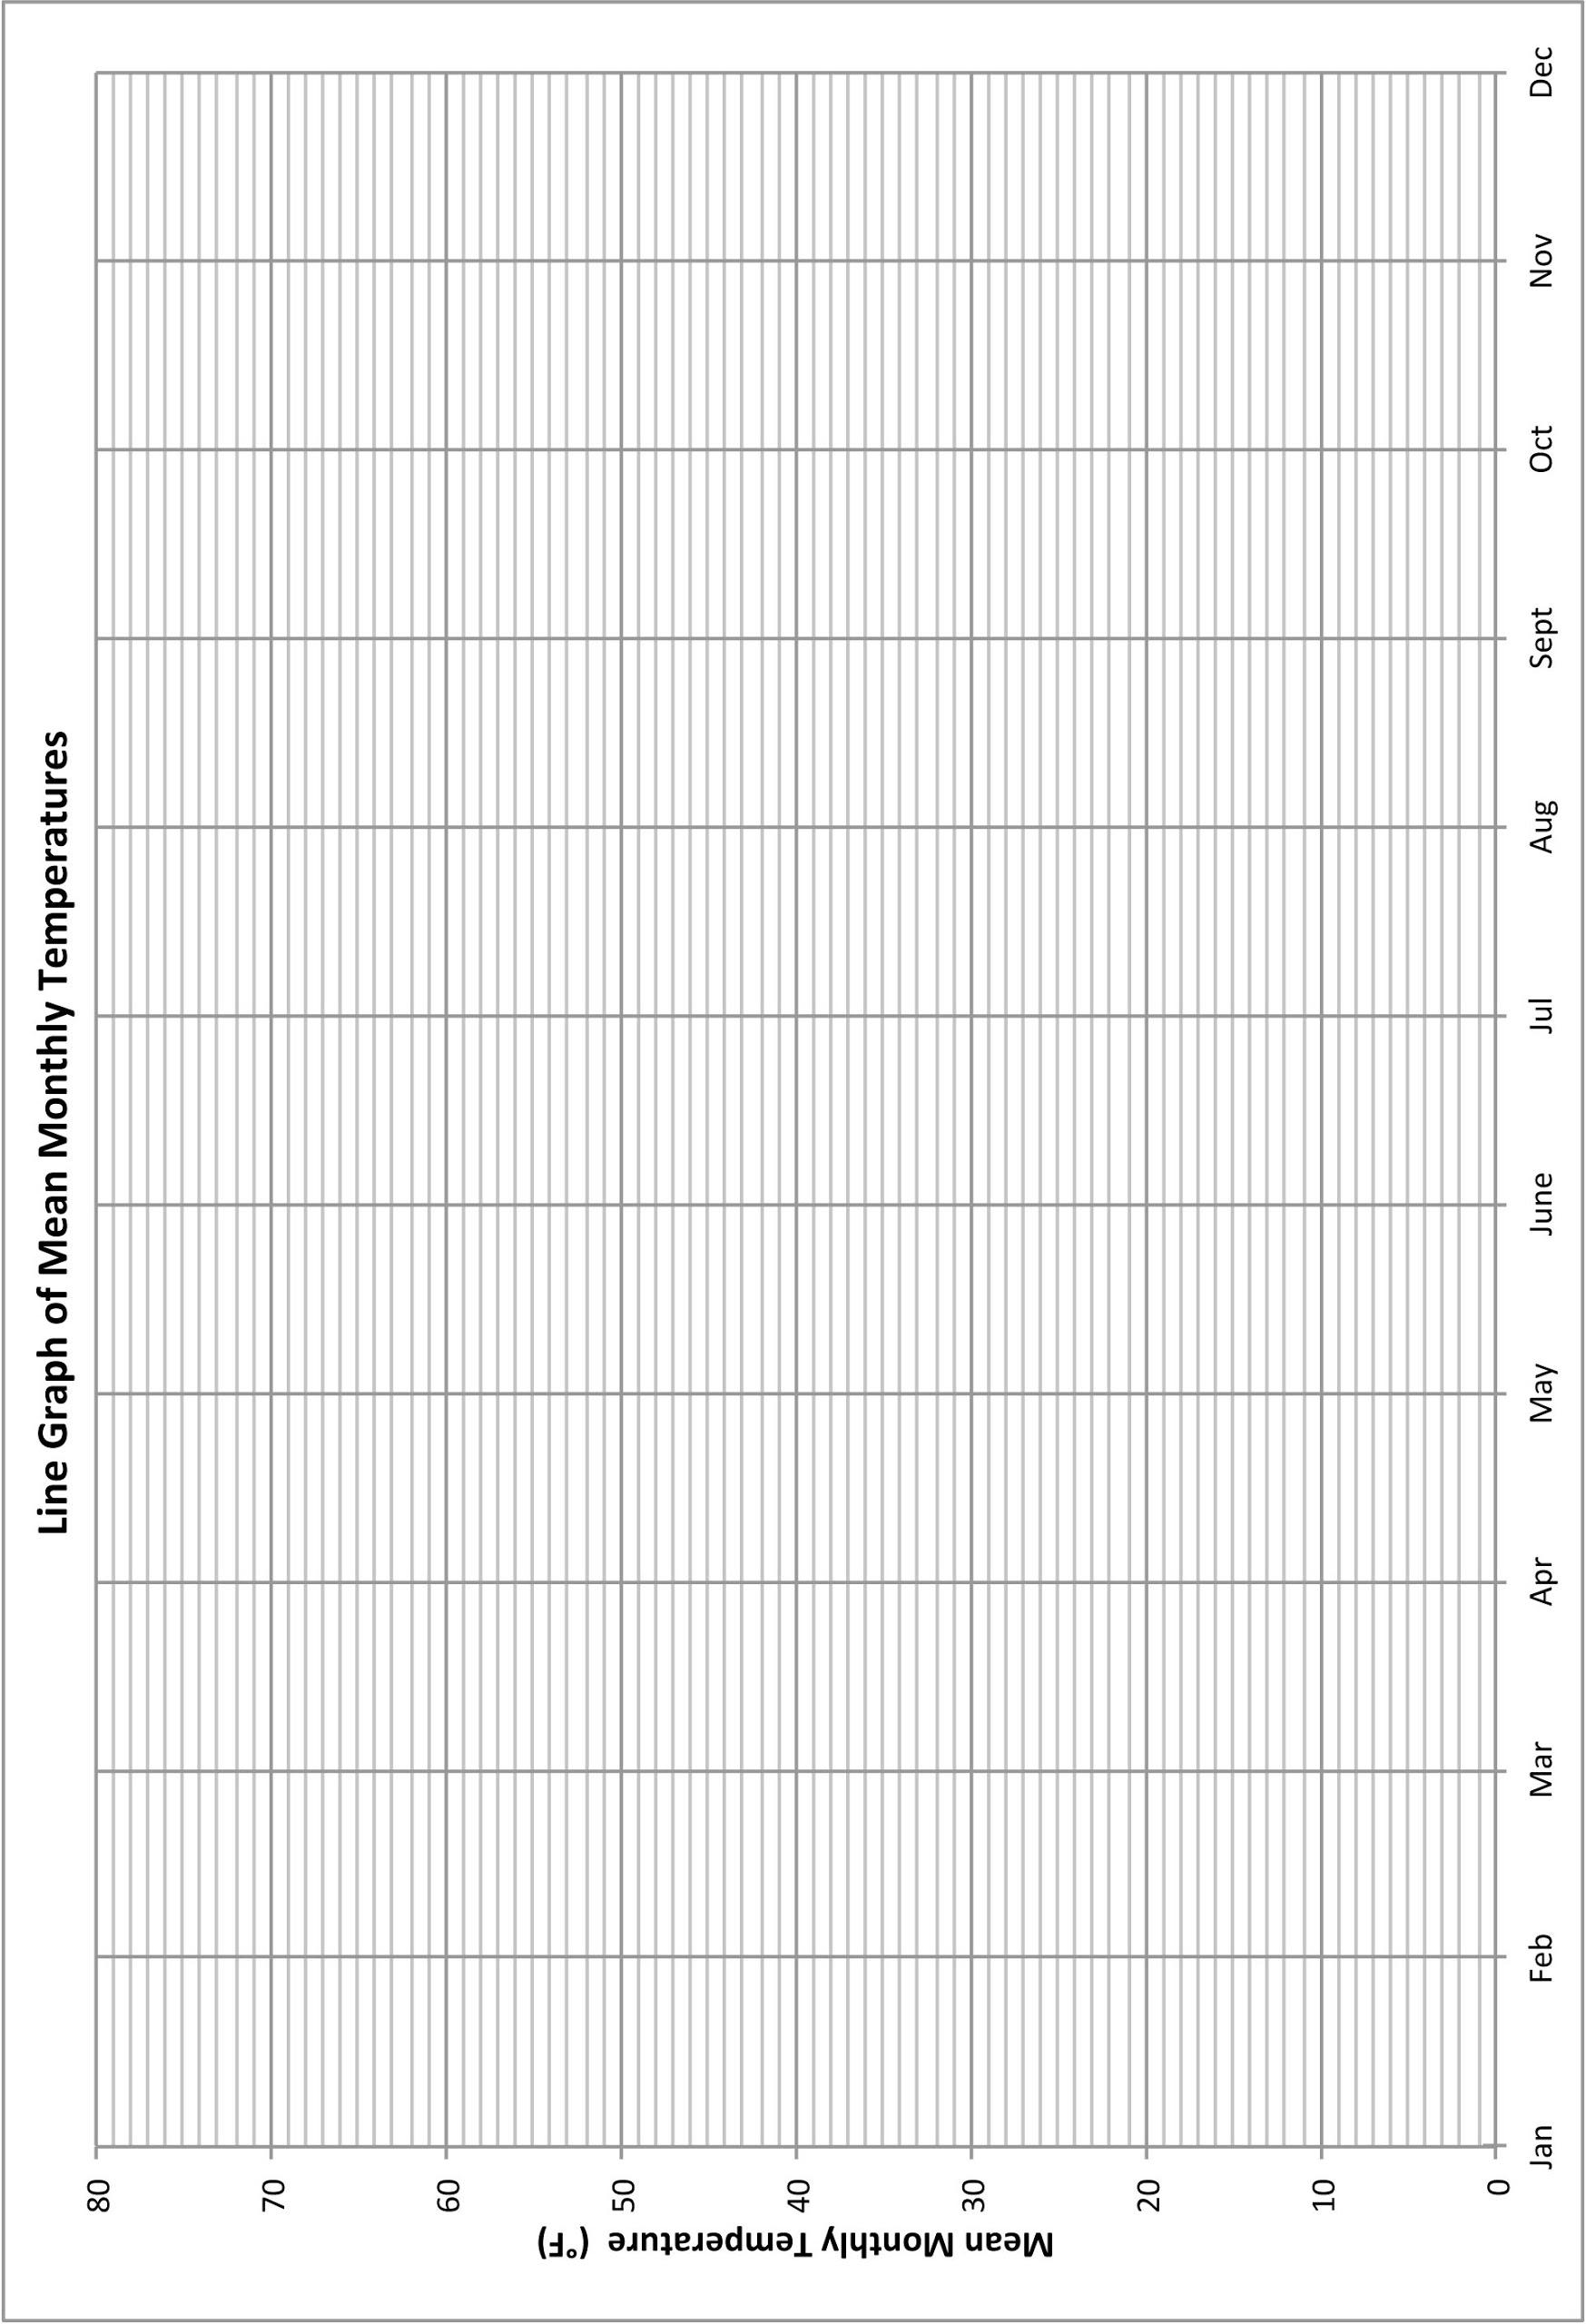

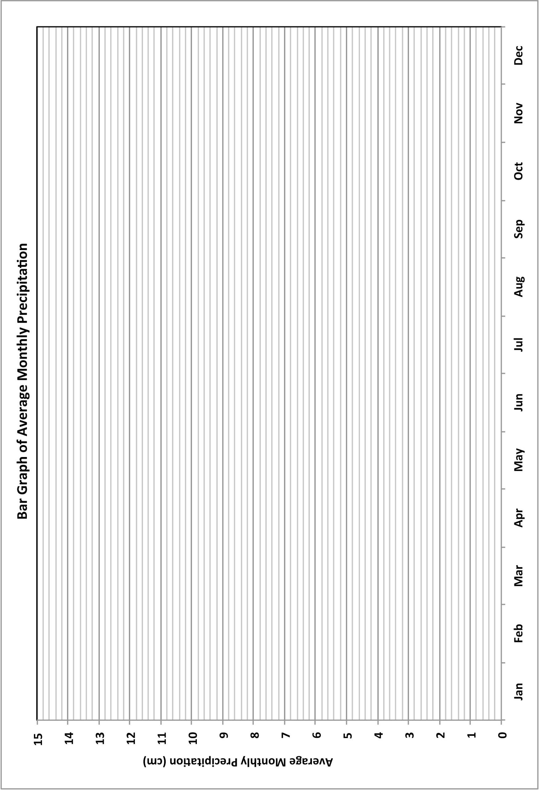
Attachment 7. Average Total Precipitation per Month Graph
Note: Teachers may choose to have their students design their own graphs rather than be given the graph below.

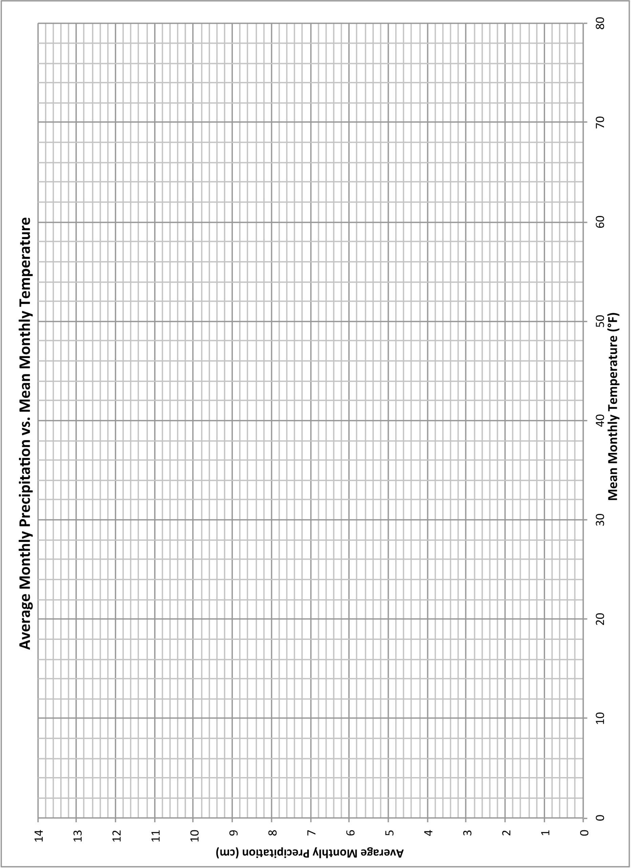
Attachment 8. Total Monthly Precipitation vs. Monthly Mean Temperature Scatterplot
Note: Teachers may choose to have their students design their own plots rather than be given the plot below.

Attachment 9. Model of the Water Cycle
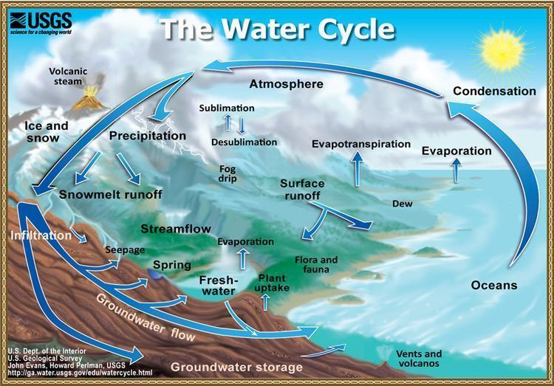

Image Source: http://ga.water.usgs.gov/edu/graphics/watercyclesummary.jpg
Last accessed: February 8, 2014

Sample Answer Graphs and Scatterplots:
