Using the EQuIP Rubric To Examine Next Generation Science Lessons & Units

NGSS EQuIP Professional Learning Facilitator’s Guide

About This Professional Learning
Completing this professional learning will provide science educators with the processes and procedures necessary to use the EQuIP Rubric to review science lessons and units, to provide effective feedback and suggestions for improvement to developers of these instructional materials, to identify model or exemplar lessons and units, and to inform the development of new instructional materials.
As noted by Joe Krajcik, professor of science education and director of the CREATE for STEM Institute at Michigan State University, “Many developers and publishers of science materials claim that their materials align with the NGSS and feature the NGSS performance expectations. And while some publishers will make legitimate attempts at modifying their materials to do an appropriate alignment, you will need to have the appropriate tool to judge which materials better represent the intent of the NGSS and which materials just really don’t match up” (http://nstacommunities.org/blog/2014/04/25/equip/). The EQuIP Rubric serves as this tool not only for published materials, but also for educator-developed lessons and units.
This professional learning consists of 10 modules that may be used separately or with two or more modules grouped together. These modules are designed sequentially to build participants’ proficiency in using the EQuIP Rubric.
All modules include one or more specific learning outcomes.
Most modules will take 15 minutes to an hour to complete; however, Modules 6 and 10 will take longer. Timing is important, so Craig Gabler, regional science coordinator and co-director of LASER Alliance, explains more about thoughtful timing of the training in this video.
After completing the first nine modules, participants will apply their learning and complete a culminating task in Module 10.
The Modules
- Overview of the Framework for K–12 Science Education
- Overview of Performance Expectations
- Three-Dimensional Learning
- Overview of the EQuIP Rubric
- Providing Feedback, Evaluation, and Guidance
- Category I: Alignment to the NGSS
- Determining Coherence and Connections
- Category II: Instructional Supports
- Category III: Monitoring Student Progress
- Culminating Task
Version 1 – January 2015
The Facilitator’s Guide
This guide includes each slide from the professional learning PowerPoint, talking points for each slide, and instructions for all tasks (the learning tasks and the culminating task).
A number of symbols are used throughout the Facilitator’s Guide to signal specific features of the training:
The clock signals a timed task.
!
The exclamation mark signals a very important point that needs to be emphasized.

The video camera signals a video clip.

Materials and Other Considerations
- Participants should have an understanding of the Framework for K–12 Science Education and the Next Generation Science Standards (NGSS). Modules 1 and 2 do provide a brief background on these topics, but ideally participants will not need to spend much time on these modules since they should already be comfortable with the Framework and the NGSS.
- Participants will need hard copies of the following handouts (the page counts below assume that each handout is printed 2-sided):
  - Handout 1: Module 1, Slide 7, “The Framework” (2 pages)
  - Handout 2: Module 2, Slide 25, “Format of Performance Expectation” (1 page, preferably color copies)
  - Handout 3: Module 2, Slide 27, “How to Read the NGSS” (3 pages, preferably color copies)
  - Handout 4: Module 3, Slide 35, “Sample Performance Expectation” (1 page, preferably color copies)
  - Handout 5: Module 4, Slide 42, “EQuIP Agreements” (1 page)
  - Handout 6: Module 4, Slide 43, “EQuIP Rubric, Version 2” (4 pages, if participants use hard copies instead of using the electronic rubric in Module 10, extra copies will be needed)
  - Handout 7: Module 6, Slide 65, “Example of Three-Dimensionality” (COMING SOON)
  - Handout 8: Module 7, Slide 85, “Graphic Example of Coherence” (1 page, preferably color copies)
  - Handout 9: Module 7, Slide 89, “Debriefing Questions for Module 7” (1 page)
  - Handout 10: Module 9, Slide 104, “Formative Assessment Vignettes” (1 page)
  - Handout 11: Module 10, Slide 118, “Culminating Task Debriefing Questions” (1 page)
  - Common Lesson (COMING SOON, ideally this lesson will be shared with participants before the professional learning so they can review it)
- Participants may want to have laptops in order to be able to type into the rubric. This will allow them to capture more of their ideas and group discussions (the rubric can be found at www.nextgenscience.org/resources).
- Participants may want to have blue, green, and orange highlighters to highlight the three dimensions when examining a lesson or unit.
- Participants will need to be able to look up standards and appendices.
- The facilitator will need to prepare the Storyline Cards for the task in Module 7, Slide 84. These cards are located on the Facilitator’s Resource — Storyline Cards, which is included with the handouts.
- Ideally, participants will be in teams of four to six members. This size gives everyone an opportunity to be part of the team discussion.
- If the resources are available to provide each group with a projector, the group can then see what the recorder is writing, allowing the group to more fully engage in the process and ensuring that recorded feedback, evaluation, and guidance represent the group’s consensus. Screen-sharing applications also can be used for this.
- For Module 10, materials to be evaluated by teams will need to be coordinated. The professional learning facilitator will need to make instructional materials available for groups of participants to examine or ensure that participants will be bringing the appropriate number and types of materials. Ideally, participants will have the opportunity to evaluate lessons and units for their respective grade bands and disciplines. Additionally, the ideal materials will state the NGSS performance expectations to which they are aligned and, if possible, the foundation boxes and any additional practices, core ideas and crosscutting concepts that are included; however, this is not required. Finally, the facilitator should be thoughtful about grouping participants for the culminating task.
- Craig Gabler explains more about thoughtful grouping in this video.

Acknowledgements
In a process coordinated by Achieve, the following team wrote, adapted and contributed to this professional learning facilitator’s guide:
Jennifer Arnswald Educational Consultant, Kent ISD, Michigan
Kristoffer R. Carroll K–12 Regional Science Trainer, Southern Nevada Regional Professional Development Program
Mary Colson Earth Science Teacher, Horizon Middle School, Minnesota
Zoe Evans Assistant Principal, Central Middle School, Georgia
Mike Fumagalli Science Teacher and Assistant Dean, Leyden High School, Illinois
Craig Gabler Regional Science Coordinator and LASER Alliance Co-Director
Joe Krajcik Professor of Science Education and Director of the CREATE for STEM Institute at Michigan State University
Sally Pardue Associate Professor of Mechanical Engineering at Tennessee Technological University and Director of the Oakley STEM Center
Tricia Shelton Science Teacher, Boone County Schools, Kentucky
Cynde Snider Consultant, Cynde Snider Consulting, LLC
Reviews and feedback provided by the National Science Teachers Association (NSTA), members of the Council for State Science Supervisors, and science education experts in Delaware, Minnesota, and Rhode Island.

Contents
About This Professional Learning 2
The Modules 2
The Facilitator’s Guide 3
Materials and Other Considerations 3
Acknowledgments 4
Module 1: Quick Overview of the Framework for K–12 Science Education 7
General Information (Slides 1–3) 9
Introduction to Module 1 (Slides 4–6) 11
Three-Dimensional Learning (Slide 7) 13
Practices (Slides 8–9) 13
Crosscutting Concepts (Slides 10–12) 15
Disciplinary Core Ideas (Slides 13–18) 17
Concluding Slide for Module 1 (Slide 19) 20
Module 2: Quick Overview of Performance Expectations 22
Introduction to Module Two (Slide 20) 24
Defining and Explaining Performance Expectations (Slides 21–23) 24
How to Read a Performance Expectation (Slides 24–26) 27
Concluding Slide for Module 2 (Slide 27) 29
Module 3: Three-Dimensional Learning 31
Introduction to Module 3 (Slide 28) 33
What is Three-Dimensional Learning (Slide 29) 33
Why is Three-Dimensional Learning Essential to the NGSS (Slide 30) 34
Analogies: Three-Dimensional Learning is Like. . . (Slide 31–34) 35
Visualizing Three-Dimensional Learning (Slides 35–36) 37
Concluding Slide for Module 3 (Slide 37) 40
Module 4: Overview of EQuIP Rubric 41
Introduction to Module 4 (Slide 38) 43
History of the EQuIP Rubric (Slide 39) 43
Purposes and Objectives of the EQuIP Rubric (Slides 40–42) 44
The Three-Category Structure of the Rubric (Slide 43–47) 47
Concluding Slide for Module 4 (Slide 48) 50
Module 5: Providing Feedback, Evaluation and Guidance 52
Introduction to Module 5 (Slide 49–50) 54
Defining Terms (Slides 51–55) 56
Concluding Slides for Module 5 (Slides 56–57) 60
Module 6: Category I: Determining Alignment to NGSS 62
Introduction to Module 6 (Slide 58) 64
Category I: Alignment to the NGSS (Slides 59–69) 64
Learning Task: Working through the Process (Slides 70–75) 71
Debriefing the Task (Slide 76) 75
Concluding Slide for Module 6 (Slide 77) 76
Module 7: Determining Coherence and Connections 78
Introduction to Module 7 (Slides 78–80) 80
What is Coherence? (Slides 81–84) 81
Lessons That Fit Together Coherently (Slide 85) 84
Connections (Slides 86–87) 85
Coherence and Connections Practice (Slides 88–90) 87
Concluding Slide for Module 7 (Slide 91) 89
Module 8: Category II: Instructional Supports 90
Introduction to Module 8 (Slides 92–95) 92
Instructional Supports Practice (Slides 96–98) 94
Concluding Slide for Module 8 (Slide 99) 96
Module 9: Category III: Monitoring Student Progress 98
Introduction to Module 9 (Slides 100–102) 100
Formative Assessment (Slides 103–108) 101
Monitoring Student Progress Practice (Slides 109–111) 106
Concluding Slide for Module 9 (Slide 112) 108
Module 10: Culminating Task 109
Introduction to Module 10 (Slide 112) 111
The Task (Slides 114–117) 111
Reflecting on the Culminating Task (Slide 119) 115
Reflecting on this Professional Learning (Slide 120–121) 116

MODULE
NGSS EQuIP
1
A Quick
Overview of the Framework for K–12 Science Education
Module 1: A Quick Overview of the Framework for K–12 Science Education
This module provides a brief background on the Framework for K-12 Science Education and should not be considered a thorough review of the Framework. Participants should have an understanding of the Framework and the NGSS before engaging in this professional learning. While this module does provide a brief background on these topics, ideally participants will not need to spend much time on it since they should already be comfortable with the Framework and the NGSS. If this module is skipped or given to participants prior to the meeting, the first introductory slides may need to be pulled and added to a later module.
Materials Needed
- Module 1 PowerPoint slides or slides 1–19 of the full PowerPoint
- Handout 1: Module 1, Slide 7, “The Framework”
General Information
Slide 1
Talking Points
- This professional learning is designed to provide participants with the knowledge and conceptual understanding necessary to examine teaching and learning materials related to the NGSS.
- Training is divided into 10 modules: nine instructional modules followed by a culminating task in Module 10 where participants apply what they’ve learned through the first nine modules.
- The first three modules provide a brief overview of the Framework, the NGSS performance expectations, and a major shift in the NGSS — three-dimensional learning.

Slide 2
Talking Points
- The implementation of the NGSS requires instructional materials that align with the shifts and increased rigor of these new standards.
- While we might be inclined to assume that there will be an initial shortage of materials for the NGSS, in fact we may find ourselves inundated with materials claiming to be NGSS-aligned.
- As noted by Joe Krajcik, professor of science education and director of the CREATE for STEM Institute at Michigan State University, “Many developers and publishers of science materials claim that their materials align with the NGSS and feature the NGSS performance expectations. And while some publishers will make legitimate attempts at modifying their materials to do an appropriate alignment, you will need to have the appropriate tool to judge which materials better represent the intent of the NGSS and which materials just really don’t match up” (http:// nstacommunities.org/blog/2014/04/25/equip/).
- Case in point, Bill Schmidt of Michigan State University reviewed roughly 700 mathematics textbooks used by 60% of U.S. public school children and found that many claiming Common Core alignment were “page by page, paragraph by paragraph” the same as older versions, resulting in textbooks that reflect the standards minimally, if at all. In some of the texts, less than a quarter of the content matched the standards of the grade in question. As Schmidt notes, “It’s hard to imagine how this could support instruction” (http://www.hewlett.org/blog/posts/curriculum-core).
!
- As this research indicates, too often new labels may be placed on old materials without any substantive changes having been made to those materials.
- To ensure the quality of the teaching and learning materials used with the NGSS, we need a common basis for examining and evaluating these materials.
- The EQuIP Rubric provides this common basis and allows educators to select the best and most appropriate instructional materials — published or educator-generated — for effective teaching and learning.
- The development of the EQuIP Rubric for NGSS was managed by Achieve in partnership with the NSTA. It was written and reviewed by groups of educators in several states, English Language Arts (ELA)/literacy and math EQuIP developers, standards writers, and other science and engineering education experts.
- The EQuIP Rubric for Science also has been tested with teacher focus groups.
- We want science educators to be critical evaluators and/or developers of quality science materials. Consequently, we want to train as many science educators as feasible to use the EQuIP Rubric effectively.
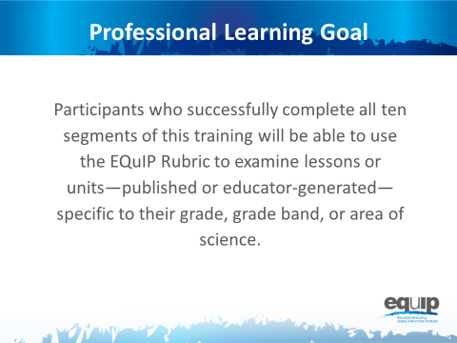
Slide 3
Talking Points
- For purposes of the training, all participants should work together with a single common lesson or unit. However, the knowledge, skills, and understandings acquired are transferable to materials in all disciplines of science.
- Throughout this training, when we refer to the different disciplines of science, we mean physical sciences; life sciences; earth and space sciences; and engineering, technology, and applications of science.
- Finally, the training provides participants with a process for reviewing materials and engaging in meaningful discussions about materials with their peers. These are rich discussions that require reviewers to use evidence and reasoning.

Introduction to Module 1
Slide 4
Talking Points
- The NGSS are not just new; they represent major shifts in how we expect students to demonstrate their understanding of science.
- Before we begin, take a couple of minutes to list what you think are the biggest shifts in the NGSS. [Note to facilitator: Allow two or three minutes and then ask a few people to share.]
- Put your list aside for now, but revisit it throughout this training to confirm or adjust your thinking.
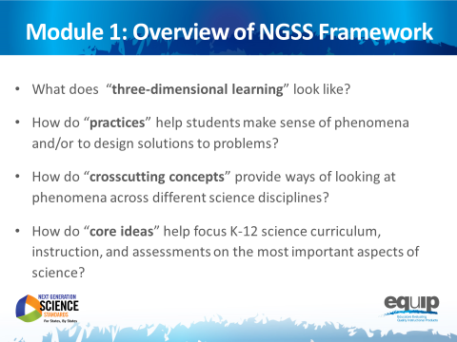
Note to facilitator: Much of Modules 1 and 2 may constitute a review for many participants and be fairly new information for others. Facilitators may speed up or slow down the delivery of these two modules as determined by the needs of the participants.
Slide 5

Talking Points
- This module includes questions about the Framework that participants should be able to answer by the end of this module:
  - What does “three-dimensional learning” look like?
  - How do “practices” help teachers and students make sense of phenomena or design solutions to problems?
  - How do “crosscutting concepts” provide ways of looking at phenomena across different science disciplines?
  - How do “core ideas” help focus K–12 science curriculum, instruction and assessments on the most important aspects of science?
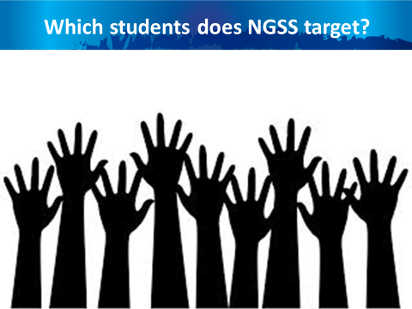
Slide 6
Talking Points
- The NGSS and the Framework are about science for all students.
- In today’s world, science, engineering, and technology are not a luxury to be experienced by only some students.
- A strong science education equips students with skills necessary for all careers. Science develops students’ abilities to think critically and to innovate. All students need strong foundational knowledge in science to tackle difficult and/or long-term issues that face both our generation and future generations.
- Science, engineering, and technology:
  - Serve as cultural achievements and a common good across societies;
  - Permeate modern life and as such are essential at the individual level;
  - Are critical to participation in public policy and good decisionmaking; and
  - Are essential for ensuring that future generations will live in a society that is economically viable, sustainable, and free.

Three-Dimensional Learning
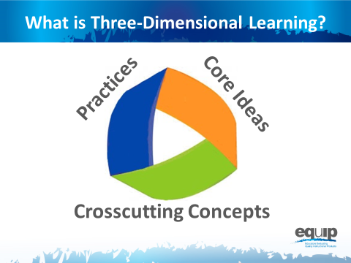
Note to facilitator: Participants will need Handout 1, Module 1, Slide 7, “The Framework,” for the remaining portion of Module 1.
Slide 7
Talking Points
- Perhaps the most important shift in the NGSS is three-dimensional learning. This shift is defined here in Module 1; however, it is addressed in more detail in the third module of the professional learning.
- The three dimensions are practices, crosscutting concepts, and disciplinary core ideas.
- When you hear the term “three-dimensional learning,” what does it mean to you? Take two or three minutes to talk about this at your tables. Be prepared to share. [Note to facilitator: Allow two to three minutes, and then ask a few tables to share.]
- Three-dimensional learning is when these three dimensions work together to support students in making sense of phenomena and/or to design solutions to problems.
- Before looking at how the dimensions work together, we’ll look at the three separately to ensure our common understanding of each.

Practices
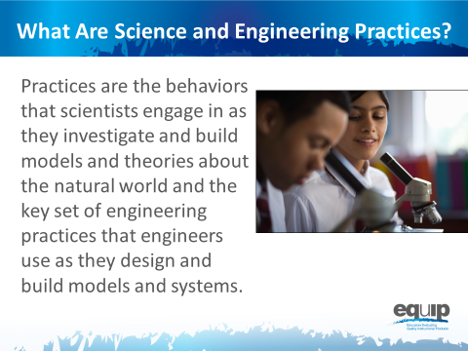
Slide 8
Talking Points
- Practices are the behaviors that scientists engage in as they investigate and build models and theories about the natural world, as well as the key set of engineering practices that engineers use as they design and build models and systems.
- The term practices is used instead of “skills” to emphasize that engaging in scientific investigation requires not only skill but also knowledge that is specific to each practice.
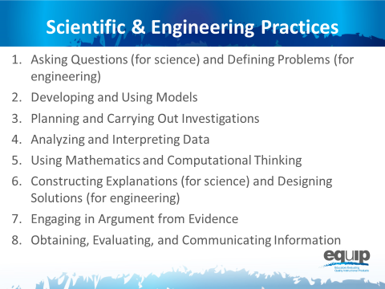
Slide 9
Talking Points
- The Framework identifies scientific and engineering practices that occur throughout the different disciplines of science. Descriptions of these practices and how they should become more complex over time can be found in the Framework and the NGSS.
- These practices are:
  - Asking questions (for science) and defining problems (for engineering);
  - Developing and using models;
  - Planning and carrying out investigations;
  - Analyzing and interpreting data;
  - Using mathematics and computational thinking;
  - Constructing explanations (for science) and designing solutions (for engineering);
  - Engaging in argument from evidence; and
  - Obtaining, evaluating, and communicating information.
- Let’s watch Joe Krajcik in this video explain how practices work together.
- Now, take five minutes at your table to discuss how you’ve observed these practices in science lessons and units. [Note to facilitator: After five minutes, have a few tables share.]

Crosscutting Concepts
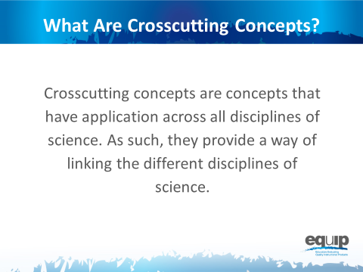
Slide 10
Talking Points
- Crosscutting concepts have applications across all disciplines of science. As such, they are a way of linking the different disciplines of science by providing ways of looking at and making sense of phenomena and/or of designing solutions to problems.
!
- The Framework emphasizes that these concepts need to be made explicit for students because they provide an organizational schema for interrelating knowledge from various science fields into a coherent and scientifically based view of the world.
Slide 11
Talking Points
- Think, for example, about weather, a phenomenon in nature.
- Could you describe this phenomenon through the lens of:
  - Patterns? How/why or why not? [Note to facilitator: Allow one or two participants to respond.]
  - Cause and effect? How/why or why not? [Note to facilitator: Allow one or two participants to respond.]
  - Scale, proportion, and quantity? How/why or why not? [Note to facilitator: Allow one or two participants to respond.]
  - Systems and system models? How/why or why not? [Note to facilitator: Allow one or two participants to respond.]
  - Energy and matter? How/why or why not? [Note to facilitator: Allow one or two participants to respond.]
  - Structure and function? How/why or why not? [Note to facilitator: Allow one or two participants to respond.]
  - Stability and change? How/why or why not? [Note to facilitator: Allow one or two participants to respond.]
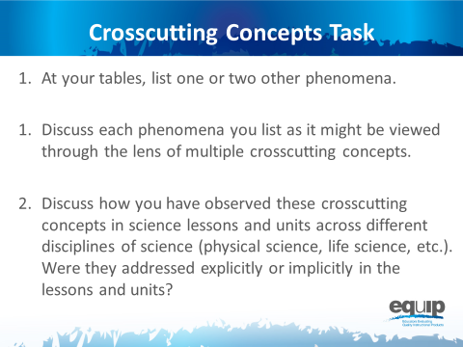
Slide 12
Talking Points
- Refer back to Handout 1 where you’ll see that the Framework lists the following crosscutting concepts:
  - Patterns;
  - Cause and effect;
  - Scale, proportion, and quantity;
  - Systems and system models;
  - Energy and matter;
  - Structure and function; and
  - Stability and change.
- Now, take 10 minutes at your table to:
  - List one or two other phenomena.
  - Discuss each phenomenon you list as it might be viewed through the lens of multiple crosscutting concepts.
- Finally, discuss how you have observed these crosscutting concepts in science lessons and units across different disciplines of science (physical science, life science, etc.). Were they addressed explicitly or implicitly in the lessons and units? [Note to facilitator: After 10 minutes, have a few tables share.]

Disciplinary Core Ideas
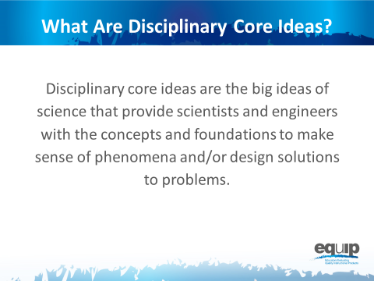
Slide 13
Talking Points
- Disciplinary core ideas are the big ideas — the most important aspects — of science that provide scientists, engineers, and students with the concepts and the foundations to make sense of phenomena and/or to design solutions to problems.
- They can be used to focus K–12 science curriculum, instruction, and assessments on the most important aspects of science.
- According to the Framework, to be considered core the ideas must meet at least two of the following criteria and ideally all four:
  - Have broad importance across multiple sciences or engineering disciplines or be a key organizing concept of a single discipline.
  - Provide a key tool for understanding or investigating more complex ideas and solving problems.
  - Relate to the interests and life experiences of students or be connected to societal or personal concerns that require scientific or technological knowledge.
  - Be teachable and learnable over multiple grades at increasing levels of depth and sophistication.
- Disciplinary core ideas are grouped into four disciplines:
  - The physical sciences;
  - The life sciences;
  - The earth and space sciences; and
  - Engineering, technology, and applications of science.
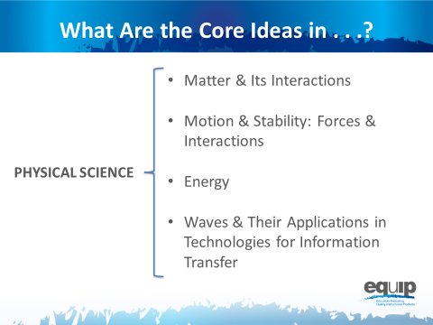
Slide 14
Talking Points
- The physical sciences include four core ideas:
  - Matter and its interactions;
  - Motion and stability: forces and interactions;
  - Energy; and
  - Waves and their applications in technologies for information transfer.
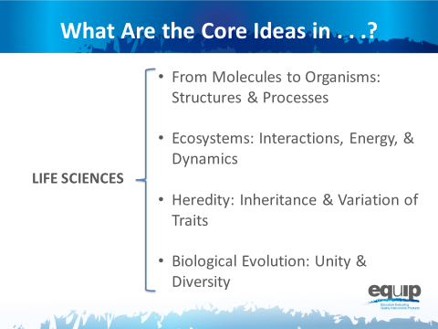
Slide 15
Talking Points
- The life sciences include four core ideas as well:
  - From molecules to organisms: structures and processes;
  - Ecosystems: interactions, energy, and dynamics;
  - Heredity: inheritance and variation of traits; and
  - Biological evolution: unity and diversity.
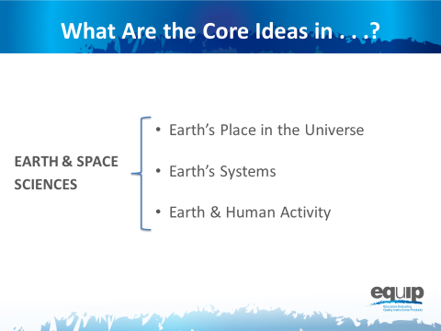
Slide 16
Talking Points
- The earth sciences include three core ideas:
  - Earth’s place in the universe;
  - Earth’s systems; and
  - Earth and human activity.
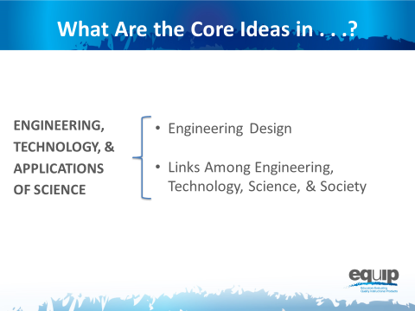
Slide 17
Talking Points
- Engineering, technology, and the applications of science include two core ideas:
  - Engineering design; and
  - Links among engineering, technology, science, and society.
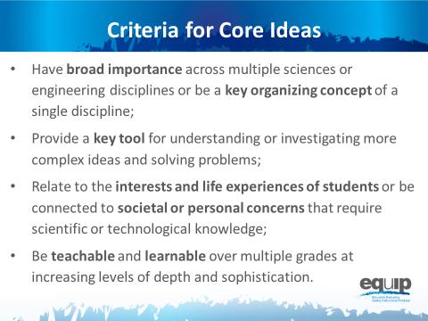
Note to facilitator: Remind participants that the core ideas for the different science disciplines are listed on the handout for this module. They may wish to refer to this handout for this task.
Slide 18
Talking Points
- Now take 10 minutes at your table to discuss how the core ideas in one discipline of science meet two or more of the criteria for a core idea:
  - Have broad importance across multiple sciences or engineering disciplines or be a key organizing concept of a single discipline.
  - Provide a key tool for understanding or investigating more complex ideas and solving problems.
  - Relate to the interests and life experiences of students or be connected to societal or personal concerns that require scientific or technological knowledge.
  - Be teachable and learnable over multiple grades at increasing levels of depth and sophistication.
[Note to facilitator: After 10 minutes, have a few tables share.]

Concluding Slide for Module 1
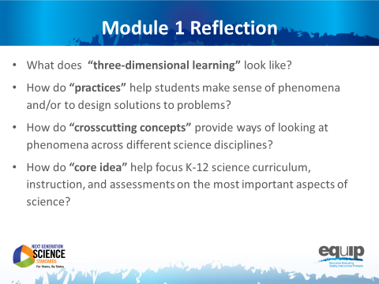
Slide 19

Talking Points
- In order to use the EQuIP Rubric to examine and evaluate NGSS lessons and units, it’s imperative that we have a common understanding of the practices, crosscutting concepts and disciplinary core ideas as they relate to the Framework.
- Look back at the questions we began with in this module. Where are you now in terms of being able to respond to these questions with confidence?
- Take five minutes to jot down your reflections and your takeaways from this first module:
  - Where are you now in terms of being able to respond to these four questions with confidence?
  - Has your thinking changed as a result of this module?
  - What did you hear that was new?
  - What’s still rolling around in your head that you need to know more about?
[Note to facilitator: After five minutes, ask a few people to share their reflections.]
- As we conclude this first module, keep in mind that practices, crosscutting concepts, and disciplinary core ideas do not function in isolation.
- The key shift in the NGSS is three-dimensional learning. That is, lessons and units where practices, crosscutting concepts, and disciplinary core ideas work together to help students make sense of phenomena and/or to design solutions to problems.
- We’ll talk more about three-dimensional learning in a subsequent module.
- If you would like more information about the Framework, visit the NGSS website: www.nextgenscience.org/.
- Keep in mind that you may wish to refer to the handout from Module 1 when you begin to use the rubric itself.

MODULE
NGSS EQuIP
2
A
Quick Overview of Performance Expectations
Module 2: A Quick Overview of Performance Expectations
This module provides a brief background on the performance expectations of the NGSS but should not be considered a thorough review of the NGSS. Participants should have an understanding of the Framework for K–12 Science Education and the NGSS before engaging in this professional learning. While this module does provide a brief background, ideally participants will not need to spend much time on it since they should already have an understanding of the Framework and the NGSS. If Module 2 is skipped or given to participants prior to the meeting, it may still be appropriate to emphasize some of the ideas in this module, such as the talking points identified with exclamation marks, throughout the professional learning.
Materials Needed
- Module 2 PowerPoint slides or slides 20–27 of the full PowerPoint
- Handout 2: Module 2, Slide 25, “Format of Performance Expectations” (1 page, preferably color copies)
- Handout 3: Module 2, Slide 27, “How to Read the NGSS” (3 pages, preferably color copies)
Introduction to Module 2
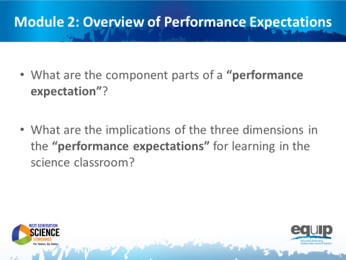
Slide 20
Talking Points
- By the conclusion of this module, all participants should be able to respond confidently to the following questions:
  - What are the component parts of a performance expectation?
  - What are the implications of the three dimensions in the performance expectations for learning in the science classroom?
- Having a thorough conceptual understanding of performance expectations and their implications for teaching and learning NGSS is exceedingly important when using the EQuIP Rubric to examine and evaluate NGSS learning materials and resources.

Defining and Explaining Performance Expectations
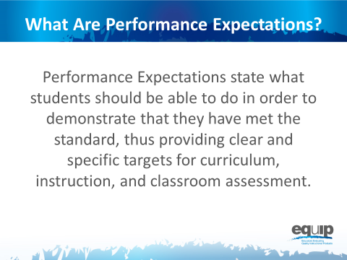
Slide 21

Talking Points
- Essentially, a performance expectation states what students should be able to do in order to demonstrate understanding of the three dimensions.
- Performance expectations, however, go beyond the knowledge, skills, and understandings generally seen in previous standards documents.
- NGSS performance expectations require students to demonstrate conceptual understanding by applying the knowledge and understanding inherent in a standard.
- In addition, performance expectations require students to transfer knowledge and understanding to new or somewhat different situations.
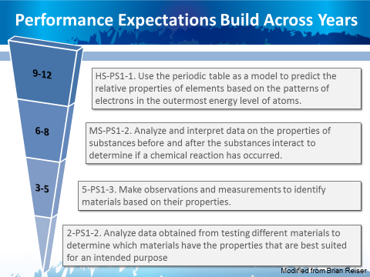
Slide 22
Talking Points
!
- Performance expectations are not learning tasks or instructional strategies. They are statements of what students should be able to do after instruction.
- Multiple lessons and/or multiple units of instruction experienced over time may be required for students to acquire the conceptual understanding needed to demonstrate mastery of standards via the performance expectations.
- In addition, as represented in this slide, student learning and the performance expectations that demonstrate this learning will build as students move through the grades.
Slide 23
Talking Points
- The Framework takes the position that a scientifically literate person understands and is able to apply all of the core ideas in each of the major science disciplines in the Framework, so all students should be held accountable for demonstrating their achievement of all performance expectations.
- This is especially important in high school where traditionally students may have taken courses in some but not all science disciplines.
- Consequently, the disciplinary core ideas included in the performance expectations are limited to only those core ideas listed in the Framework.
- Performance expectations allow for an emphasis on coherence within lessons and units and across the years and grade levels — it’s all about learning progressions. When students demonstrate achievement via performance expectations, we can no longer say, “Students didn’t get it last year, so they can’t possibly get it this year.”
!
- Overall, it’s about what the students are doing and not what the teachers have done.
- The performance expectations should not, however, limit the curriculum. Students interested in pursuing science further via more advanced coursework or through additional concepts of interest and relevance to the student and/or the community should have the opportunity to do so.

How to Read a Performance Expectation
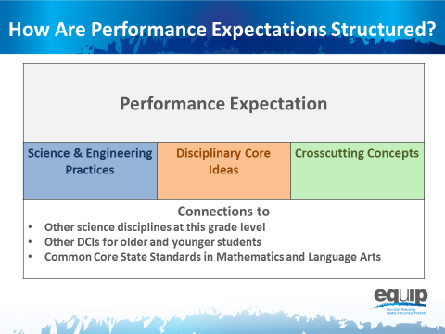
Slide 24
Talking Points
- We’re going to look now at the foundation boxes of the performance expectation, but it’s important to keep in mind that these foundation boxes are not the assessed piece of the performance expectation. The three-dimensional performance expectation overall is what is to be assessed.
- Irrespective of grade level or discipline of science, every performance expectation has the following three parts:
  - The statement of the actual performance expected;
  - The foundations for this performance or, in other words, the practices, disciplinary core ideas and crosscutting concepts that constitute this performance (again, it’s important to note that students are not assessed on the foundation boxes or on a single dimension individually); and
  - The connections to other science disciplines, to other grades or grade bands, and to CCSS in ELA/literacy and mathematics, which contribute to coherence and will be addressed in a later module.
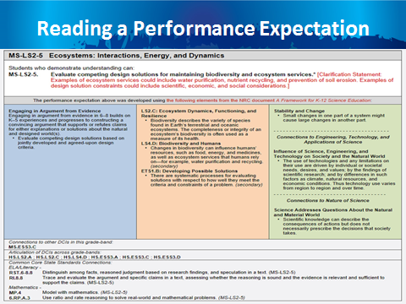
Note to facilitator: In order to complete specific learning tasks, participants will need Handout 2, Module 2, Slide 25, “Format of Performance Expectations,” which is displayed on this slide.
Slide 25

Talking Points
- Now take a look at an actual performance expectation.
!
- Performance expectations may be viewed either by topic or by core idea. The specific example on this slide is grouped by core idea.
- As noted in the top row [Note to facilitator: click for animation.], this performance expectation is MS-LS2-5 — Middle School, Life Science Core Idea 2 (Ecosystems: Interactions, Energy and Dynamics), Performance Expectation 5. This notation is the same regardless of whether the performance expectations are viewed by topic or core idea.
- The actual performance expectation appears in the second row following “Students who demonstrate understanding can...” [Note to facilitator: click for animation.]
- The performance expectation is sometimes followed by a clarification statement and/or assessment boundary, which appear in red [Note to facilitator: click for animation.]. Here the clarification statement elaborates on what is meant by properties that could be predicted from patterns, and the assessment boundary provides specific information regarding what this performance expectation does not include for large-scale assessment. It should be noted that while assessment boundaries do limit assessment, they do not necessarily limit instruction.
- While the performance expectations can stand alone, a more coherent and complete view the standards can be seen when the performance expectations are viewed in tandem with the contents of the foundation boxes that lie just below the performance expectations.
- These blue, orange, and green foundation boxes delineate the three dimensions. That is, the practices [Note to facilitator: click for animation.], disciplinary core ideas [Note to facilitator: click for animation.] and crosscutting concepts [Note to facilitator: click for animation.] derived from the Framework that were used to construct this set of performance expectations.
- Finally, [Note to facilitator: click for animation.] connections are made to other disciplinary core ideas within this grade band, across grade bands, and to the CCSS in ELA and mathematics.
- Now, individually circle the words or phrases in the performance expectation that directly relate to the specific practice(s), core idea(s), and crosscutting concept(s) listed in the blue, orange and green boxes.
- Next, draw arrows to connect your circled words and phrases directly to the specific practice, core idea and crosscutting concept in the colored boxes.
- When finished, share and compare at your table. What general statement about performance expectations can you make as a result of the connections you just made? [Note to facilitator: Allow approximately five minutes for this task, and then have one or two tables to share. Elicit responses that show how the performance expectation is three-dimensional.]

Note to facilitator: Please give credit for the photo on this slide to http://blogs.wsj.com/photojournal/2009/07/10/pictures-of-the-day-216/.
Slide 26
Talking Points
- Remember, instruction, over time, builds the structures — the practices, disciplinary core ideas and crosscutting concepts — that students need to meet the performance expectations.
- It also is important to note that while the practices, disciplinary core ideas and crosscutting concepts specified in the performance expectations describe how students are asked to demonstrate understanding at the end of instruction, this does not limit what practices can or should be used in instruction. For example, if a performance expectation calls for students to construct an explanation, this merely indicates the assessment expectation for students. In the classroom, a teacher also will have students engage in additional practices such as asking questions and analyzing data.
!

Concluding Slide for Module 2
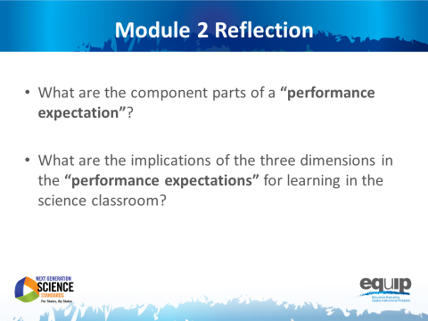
Note to facilitator: Refer participants to Handout 3, Module 2, Slide 27, “How to Read the NGSS,” where they will find more information on this topic.
Slide 27

Talking Points
- At your tables, quickly think about how you would respond to the two questions for Module 2 to ensure your understanding before going on to Module 3.
- Identify and be prepared to ask any questions you still have about performance expectations. [Note to facilitator: Allow approximately five minutes, and then address any remaining questions.]
- For more information about the performance expectations, refer to the handout for Module 2, Slide 27, “How to Read the NGSS.”

MODULE
NGSS EQuIP
3

Three-
Dimensional
Learning
Module 3: Three-Dimensional Learning
This module addresses what three-dimensional learning is, what it looks like in a classroom, and why it is essential for students to engage in three-dimensional learning to help them build toward proficiency of performance expectations. This is an important module, as understanding how to determine whether or not a lesson or unit provides an opportunity for students to engage in three-dimensional learning is crucial to using the EQuIP Rubric to examine lessons and units and their alignment to the NGSS. Three-dimensional learning will be emphasized again in Module 6 and will be discussed in all the remaining modules.
Materials Needed
- Module 3 PowerPoint slides or slides 28–37 of the full PowerPoint
- Handout 4: Module 3, Slide 35, “Sample Performance Expectation” (1 page, preferably color copies)
Introduction to Module 3
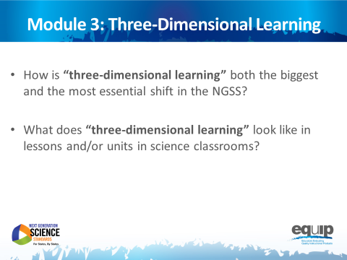
Slide 28
Talking Points
- The third module of this EQuIP training includes two essential questions that all participants should be able to answer by the conclusion of the module:
  - How is three-dimensional learning both the biggest and the most essential shift in the NGSS?
  - What does three-dimensional learning look like in lessons and/or units in science classrooms?
- Understanding how to determine whether or not a lesson or unit embodies three-dimensional learning is crucial to using the EQuIP Rubric to examine lessons’ and units’ alignment to the NGSS, as well as to the development of aligned lessons and units.

What is Three-Dimensional Learning?
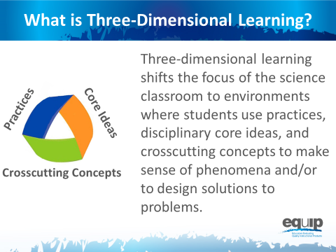
Slide 29

Talking Points
- As discussed in Module 1, three-dimensional learning happens when the three dimensions — practices, core ideas, and crosscutting concepts — work together.
!
- Three-dimensional learning shifts the focus of the science classroom to environments where students use practices, disciplinary core ideas, and crosscutting concepts together to make sense of phenomena and/or to design solutions to problems.

Why is Three-Dimensional Learning Essential to the NGSS?
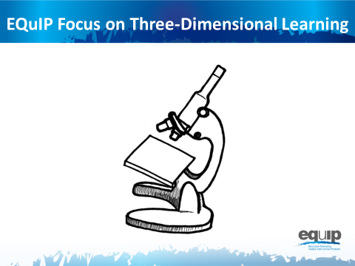
Slide 30
Talking Points
- Just as we use tools to examine objects carefully and in detail, we will use the EQuIP Rubric to examine NGSS materials — lessons and units — carefully and in detail to determine whether or not they align with one or more of the conceptual shifts of the NGSS.
- As noted by Joe Krajcik, “If the lessons or units you are judging don’t meet this criteria, there is no need to go on with an evaluation to discern if the materials align with NGSS or not. As such, you really need to understand the concept of three-dimensional learning. It represents an entirely new way of thinking about and enacting science teaching. It’s not as simple as using the practices and crosscutting concepts to help students understand the disciplinary core ideas. Rather, the three work together to help students make sense of phenomena or design solutions. Making sense of phenomena and designing solutions drives the teaching and learning process.” (http://nstacommunities.org/blog/2014/04/25/equip/).
- Consequently, before actually using the EQuIP rubric to examine lessons and units, we need to have a deep understanding of three-dimensional learning.

Analogies: Three-Dimensional Learning is Like...
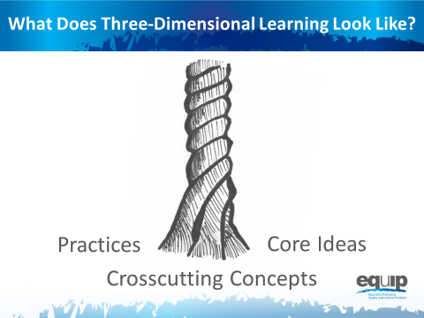
Slide 31
Talking Points
- Think of the three components of three-dimensional learning as three intertwining stands of a rope. While the rope can be separated into its three different strands, the strength of the rope is determined by the strands working together; separating the strands weakens the rope so that it is no longer effective for our intended use.
- Likewise, while in the past we may have separated out the knowledge and skills students need in the study of science, in actuality, knowing and doing cannot be separated if our goal is the kind of usable, conceptual understanding students need to think, act, and learn like scientists.
- Three-dimensional learning — practices, core ideas, and crosscutting concepts working together — is therefore a non-negotiable for NGSS lessons and units.
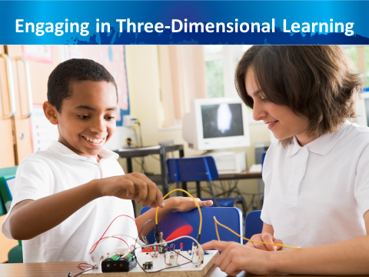
Slide 32

Talking Points
- Scientific ideas are best learned when students engage in practices.
- Three-dimensional learning allows students to use core ideas, through the lens of crosscutting concepts, while engaging in practices to solve problems, make decisions, explain real-world phenomena, and integrate new ideas.
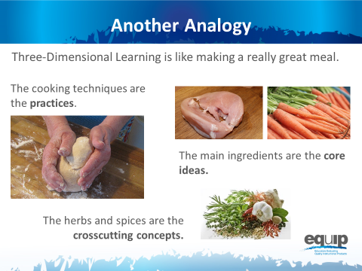
Slide 33
Talking Points
- Let’s continue thinking about three-dimensional learning metaphorically for a minute.
- As stated by Joe Krajcik, “To use the EQuIP rubric, you first need a solid understanding of the disciplinary core ideas, science and engineering practices, and crosscutting concepts, each of which is described in detail in the Framework and NGSS Appendices. Understanding each of these dimensions is essential, but real transformation comes with understanding how these dimensions blend and work together; this is the critical and perhaps most important shift in the NGSS. The EQuIP rubric refers to this blending of DCIs, practices and CCCS as three-dimensional learning” (http://nstacommunities.org/blog/2014/04/25/equip/).
- Borrowing an idea from Ted Willard at NSTA, Joe often compares three-dimensional learning to making a really good meal.
- As Joe says so well, “Think of knowing how to do various techniques in the kitchen like kneading bread, cutting tomatoes, beating an egg, frying or roasting, and so forth as the practices. You could know how to do all of these things and still not be able to prepare a really good meal.

“Now think of picking out really good ingredients for the meal. You want to pick out a high-quality piece of fish or poultry or excellent pasta for the meal. These are your core ideas. A disciplinary core idea is essential to explaining a number of phenomena. Your main ingredient is essential to the meal. But just as the [disciplinary core idea] works with practices to make sense of phenomena and design solutions, you need to know how to cook that main ingredient. But something is still missing. The meal tastes bland. What is missing? To make a really good meal, we need to use spices and herbs to enhance the flavor of the main ingredients.”

Crosscutting concepts are like these spices and herbs — they enhance learning by providing a familiar lens to use to examine and understand phenomena. Because the same spices and herbs are used in many different dishes, we recognize them even when we have them in a new or unfamiliar dish. Consequently, we can use our familiarity with a spice or herb to examine a new meal and understand what was used to make it. Likewise, crosscutting concepts can be found in all scientific disciplines, and we can use our familiarity with crosscutting concepts in one discipline of science to examine phenomena and enhance understanding and learning in other disciplines of science.

“To make a really wonderful meal, good main ingredients are necessary, but you need to know how to use various techniques to prepare them, and you must have the spices and herbs to enhance the flavors. All three work and blend together to make a great meal. Similarly, to foster three-dimensional learning where all learners can make sense of phenomena and design solutions, all three dimensions need to work and blend together” (http://nstacommunities.org/blog/2014/04/25/equip/).
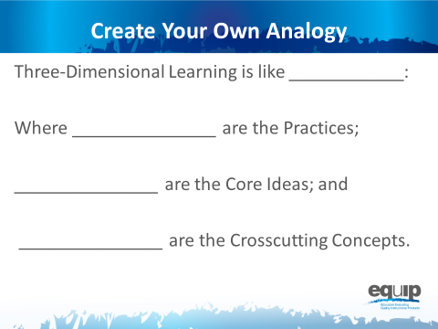
Slide 34
Talking Points
- Now, take a few minutes and create your own analogy for three-dimensional learning. [Note to facilitator: Allow 10–15 minutes for participants to create an individual analogy and share out at their tables, and then ask for a few to share their analogies with the whole group.]

Visualizing Three-Dimensional Learning
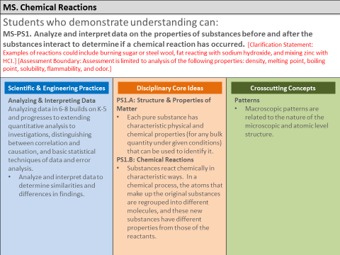
Note to facilitator: For slides 35 and 36, refer participants to Handout 4, Module 3, Slide 35, “Sample Performance Expectation,” which is displayed on this slide.

Slide 35
Talking Points
- Thinking back to Module 2, three-dimensional learning will support students in demonstrating the understanding demanded by the performance expectations.
- So, let’s analyze a performance expectation to see how the three dimensions provide its essential structure.
- First, let’s look at the actual expectation [Note to facilitator: Click for animation.]: “Students who demonstrate understanding can… Analyze and interpret data on the properties of substances before and after the substances interact to determine if a chemical reaction has occurred.” MS-PS1-2
- Being able to do this requires students to incorporate practices, disciplinary core ideas, and crosscutting concepts.
- [Note to facilitator: Click for animation.] So, in order to meet this performance expectation, students are required to incorporate the specific science and engineering practices of “analyzing and interpreting data to determine similarities and differences in findings.” As noted previously, however, during instruction, other practices will also be used.
- In addition, students must incorporate disciplinary core ideas. [Note to facilitator: Click for animation.] This performance expectation specifies two component ideas of the disciplinary core idea HS-PS1: Matter and its Interactions. What are these two component ideas? [Note to facilitator: Solicit responses from participants. Refer them to the handout if necessary.]
- Finally, to meet this performance expectation, students will need to incorporate the crosscutting concept of patterns. [Note to facilitator: Click for animation.]
- You can see, then, that for all performance expectations, the whole is truly greater than the sum of its parts.
Slide 36
Talking Points
- Now, let’s take a look at what this looks like in an actual classroom. As you watch this short video clip (COMING SOON), note how and where you see students engaged in three-dimensional learning. Remember, it’s not enough to have practices, disciplinary core ideas, and/or crosscutting concepts. These must work together to help students make sense of phenomena and/or design solutions to problems. [Note to facilitator: Show video of classroom that illustrates three-dimensional learning. Following the video clip, ask participants to share what they noted in the video and explain how the three dimensions work together.]
- Finally, let’s move to your own experiences.
- Where have you seen students engaged in three-dimensional learning in science lessons and units? What did that look like? How did the practices, disciplinary core ideas, and crosscutting concepts work together so that students could make sense of phenomena and/or design solutions to problems?
- Take about three minutes to think of lessons or units you’ve seen or experienced where practices, disciplinary core ideas, and crosscutting concepts have worked together for effective learning to occur. Again, this does not mean that students passively receive content, and then apply it, or that there is an implicit crosscutting concept that does not support student learning. Rather, all three dimensions work together. [Note to facilitator: After about three minutes, ask participants to take an additional five to seven minutes to share and compare at their tables, and then ask two or three table groups to provide examples of three-dimensional learning from their experiences.]

Concluding Slide for Module 3
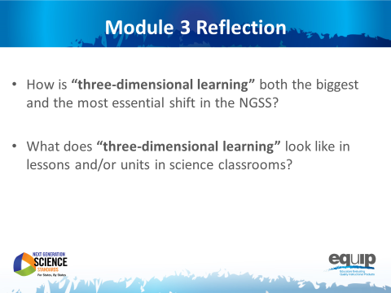
Slide 37
Talking Points
- At your tables, quickly review two essential questions from Module 3 to ensure your understanding before going on to Module 4.
- Identify and be prepared to ask any clarifying questions you still have. [Note to facilitator: Allow approximately five minutes, and then address any remaining questions. If it is apparent that participants are still having trouble clearly understanding three-dimensional learning, do not move on until they have reached this understanding.]

MODULE
NGSS EQuIP
4
Overview of
the EQuIP Rubric
Module 4: Overview of the EQuIP Rubric
Module 4 provides an overview of the EQuIP Rubric including a background on its development, the purposes of the rubric, and basic information about its structure and contents. This module also includes information on the quality review process — a collegial process that centers on the use of the criteria-based rubric for examining science lessons and units — including the agreements required for participating in the review.
Materials Needed
- Module 4 PowerPoint slides or slides 38–48 of the full PowerPoint
- Handout 5: Module 4, Slide 42, “EQuIP Agreements” (1 page)
- Handout 6: Module 4, Slide 43, “EQuIP Rubric, Version 2” (4 pages)

Introduction to Module 4
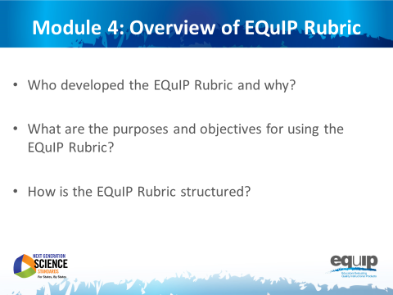
Slide 38
Talking Points
- In Module 4, we will begin looking at the EQuIP Rubric so that all participants will be able to answer the following questions confidently:
  - Who developed the EQuIP Rubric and why?
  - What are the purposes and objectives for using the EQuIP Rubric?
  - How is the EQuIP Rubric structured?

History of the EQuIP Rubric
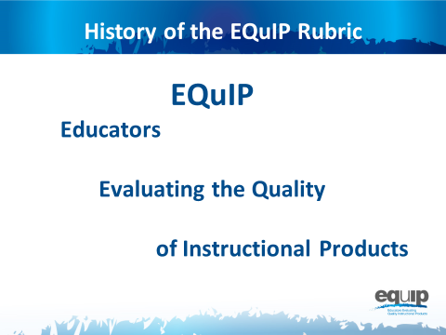
Slide 39
Talking Points
- EQuIP stands for Educators Evaluating the Quality of Instructional Products.
- The original criterion-based rubrics and review processes were developed to evaluate the quality of lessons and units for the CCSS for ELA/literacy and mathematics.
- The original ELA/literacy and mathematics rubrics were known as the Tri-State Rubrics because they were developed through a collaborative effort by Massachusetts, New York, and Rhode Island.
- This initial collaboration was facilitated by Achieve. There was so much interest in the rubric that Achieve facilitated a convening of states that wanted to learn more about the rubrics and use them to identify high-quality, aligned materials. The original states using the rubric were deemed the EQuIP Collaborative and the rubrics became known as the EQuIP Rubrics. Many more states have learned about and used the EQuIP Rubrics for ELA/literacy and mathematics since the original collaborative.
- EQuIP for NGSS builds on the work of EQuIP for CCSS and has been developed to be similar to the EQuIP Rubrics for CCSS while, at the same time, addressing the specific needs of the science standards.
- The development of the EQuIP Rubric for NGSS was managed by Achieve in partnership with NSTA. It was written and reviewed by science education experts in several states, CCSS EQuIP developers, standards writers, and other science and engineering education experts.
- The EQuIP Rubric for NGSS also has been tested with teacher focus groups.

Purposes and Objectives of the EQuIP Rubric
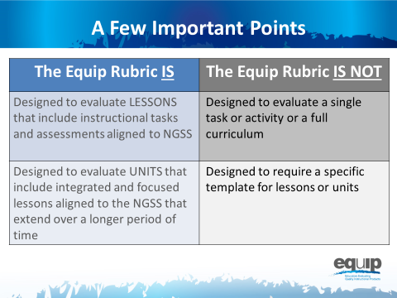
Slide 40
Talking Points
- As defined by the EQuIP Rubric:
!
  - A lesson is a coherent set of instructional activities and assessments aligned to the NGSS that may extend over a few to several class periods or days; and
  - A unit is a coherent set of lessons aligned to the NGSS that extend over a longer period of time.
- An integrated instructional sequence is rooted in an explanatory question aimed at making sense of a phenomena and/or designing a solution to a problem.
- With these definitions in mind, it is important to note that the lessons the EQuIP Rubric is designed to evaluate may extend over a few class periods or days.
- Any single task, activity, or mini-lesson would not be suitable for use with the EQuIP Rubric as it would likely not include instructional supports and assessments, two of the categories of the rubric.
- Likewise, the EQuIP Rubric is not appropriate for reviewing a full curriculum; however, the rubric could be used to review specific lessons or units within the curriculum. A tool is currently being developed to look at full curricula.
!
- Finally, the EQuIP Rubric does not require that lessons or units be put into a specific format in order to be evaluated against the rubric criteria.
Slide 41
Talking Points
!
- The EQuIP quality review process is a collegial process that centers on the use of the criterion-based rubric for examining science lessons and units.
- While an individual certainly might use the rubric to examine a lesson or unit, the effective evaluation of lessons and units is the product of examination and discussion by a group of people using the rubric collaboratively.
- The specific, stated purposes of the EQuIP rubric are to:
  - Review existing lessons and units to determine what revisions are needed;
  - Provide constructive criterion-based feedback and suggestions for improvement to developers;
  - Identify exemplars/models for teachers’ use within and across states; and
  - Inform the development of new lessons and units.
- Other implicit goals of the rubric include:
  - Assisting teachers and district staff in the selection of high-quality instructional materials that are aligned to the NGSS; and
  - Serving as a professional learning tool for analyzing lessons and units and deepening understanding of the NGSS.
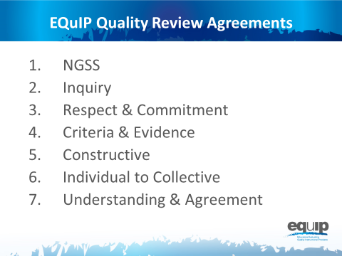
Note to facilitator: Refer participants to Handout 5, Module 4, Slide 42, “EQuIP Agreements.”
Slide 42
Talking Points
- All persons using the EQuIP Rubric to examine NGSS lessons and units must commit to the following agreements:
  - NGSS Understanding: Before beginning a review, all members of a review team have an understanding of the NGSS and the Framework.
  - Inquiry: Review processes emphasize inquiry rather than advocacy and are organized in steps around a set of guiding questions.
  - Respect and Commitment: Each member of a review team is respected as a valued colleague and contributor who makes a commitment to the EQuIP process.
  - Criteria and Evidence: All observations, evaluations, discussions, and recommendations are criterion- and evidence-based.
  - Constructive Feedback: Lessons and units to be reviewed are seen as “works in progress.” Reviewers are respectful of contributors’ work and make constructive observations and suggestions based on evidence from the work.
  - Individual to Collective Reviews: Each member of a review team independently records his/her observations prior to discussion. Discussions focus on understanding all reviewers’ interpretations of the criteria and the evidence they have found.
  - Understanding and Agreement: The goal of the process is to compare and eventually calibrate evaluations to move toward agreement about quality with respect to the NGSS.
- A rule of thumb for maintaining a respectful, collegial discussion might be to behave as if someone at your table has written or collaborated on a lesson or unit you are examining. Sometimes this may even be the case.
The Three-Category Structure of the Rubric
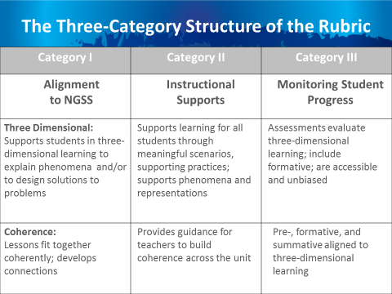
Note to facilitator: Refer participants to Handout 6, Module 4, Slide 43, “EQuIP Rubric.”
Slide 43
Talking Points
- Get out your copy of the EQuIP Rubric.
- Before we begin talking about the structure of the EQuIP Rubric, turn to page four of the rubric — the back of the second page — and take a few minutes to circle important terms that jump out at you as you read through the document. [Note to facilitator: Allow three to five minutes for participants to circle terms then ask several to share. Keep this sharing non-evaluative and avoid responding to participants with words such as “good” or “great,” which tend to signify right or wrong answers.]
- Now let’s dive deeper into the rubric.
- All educators will examine instructional materials against the criteria in each category.
- As you can see, each category is structured with criteria for a lesson or unit at the top and additional criteria for a unit or longer lesson at the bottom.
- Within each category, specific criteria and sub-criteria are delineated, with uppercase Arabic letters (A, B, C, etc.) representing the main criteria and lowercase Roman numerals (i, ii, iii, etc.) representing the sub-criteria.
- Working collaboratively, educators are able to use common standards for quality and to generate evidence-based commentary on the quality and alignment of materials.
- A rating scale will eventually be added to each category as well as to the entire rubric. However, during this early stage of NGSS implementation the focus should be on creating materials or transitioning materials to be more aligned with the NGSS as opposed to assigning materials a rating.
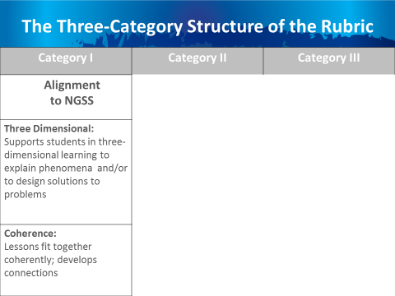
Slide 44
Talking Points
  - The first category is Alignment to NGSS. This includes supporting students in three-dimensional learning to explain phenomena or design solutions and ensuring lessons fit together coherently and develop connections.
- We will use the EQuIP Rubric to examine NGSS materials — lessons and units — carefully and in detail to determine whether or not they align with the conceptual shifts of the NGSS, including Category I, criteria A, which states that “grade-appropriate elements of the science and engineering practice(s), disciplinary core idea(s), and crosscutting concept(s) work together to support students in three-dimensional learning to make sense of phenomena and/or to design solutions to problems.”
- Examining a lesson or unit against the criteria in Category I: Alignment to NGSS, may reveal evidence related to Category II: Instructional Supports and/or Category III: Monitoring Student Progress; however, the EQuIP process involves examining a lesson or unit against the criteria for Category I before moving on to Category II and finally to Category III.
- If, as a result of examining a lesson or unit in relation to the criteria for Category I, we determine this alignment does exist, we will then examine that lesson or unit further in relation to the criteria for Categories II and III.
- If, however, we determine this alignment does not exist, we may elect to discontinue any examination of the lesson or unit; or, if we determine that a lesson or unit has the potential to align with specific, targeted revisions, we may continue with our examination and provide guidance for the lesson or unit designer or user in regard to the changes that need to be made to bring the lesson or unit into alignment.
- Tricia Shelton, science teacher at Boone County Schools in Kentucky, explains this further in this short video.
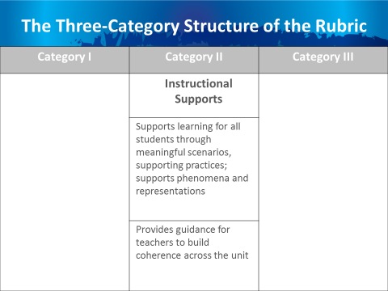
Slide 45
Talking Points
  - Now let’s look more closely at Category II: Instructional Supports. Category II focuses on supporting learning for all students through meaningful scenarios and supporting practices, as well as supporting phenomena and representations. Criteria and sub-criteria focus on engaging students in three-dimensional learning that is relevant, authentic and connected to students’ experiences.
  - In addition, this category includes criteria related to providing guidance to help teachers build coherence and to provide and adjust supports for students in order to make students increasingly responsible for their learning.
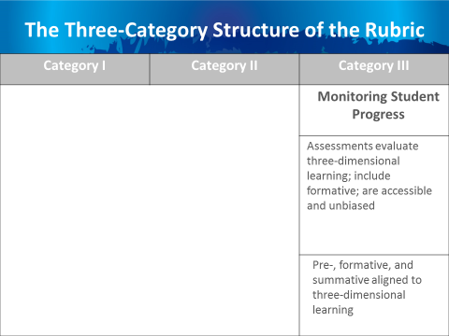
Slide 46
Talking Points
  - The third category, Monitoring Student Progress, ensures that assessments elicit observable evidence of three-dimensional learning, include formative assessments, and are accessible and unbiased.
  - It also ensures that all assessments — pre-, formative and summative — are aligned to three-dimensional learning.
Slide 47
Talking Points
- By working collaboratively, educators can use common definitions of quality to generate evidence-based commentary on the quality and alignment of materials.
- We’ve just begun looking at the EQuIP Rubric by examining how it’s structured. Each of these three categories of the EQuIP Rubric will be discussed in greater detail in subsequent modules.

Concluding Slide for Module 4
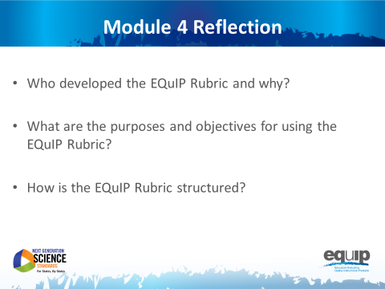
Slide 48
Talking Points
- Take a minute or two to look over the EQuIP Rubric again, noting the words you circled at the start of this module.
- Would you still circle the same words? Are there words you wouldn’t circle? Are there more words you would circle? Why or why not?
- How has what you’ve learned in this module informed your understanding of the EQuIP Rubric? What questions do you still have? [Note to facilitator: After three to four minutes, allow participants to share their thoughts and ask any remaining questions.]
- In the next module, we’ll take a look at what we mean when we talk about such things as evidence and reasoning in relation to using the EQuIP Rubric.

MODULE
NGSS EQuIP
5
Providing
Feedback, Evaluation, and Guidance
Module 5: Providing Feedback, Evaluation, and Guidance
Module 5 provides common language that is essential for using the rubric. The terms evidence, reasoning, feedback, evaluation, and guidance are often used in the rubric and in the remaining modules; therefore, it is important for all participants to have a common understanding of these terms before moving on.
Materials Needed
- Module 5 PowerPoint slides or slides 49–57 of the full PowerPoint
- Handout 6: Module 4, Slide 43, “EQuIP Rubric, Version 2” (4 pages)*

*Introduced in a previous module.
Introduction to Module 5
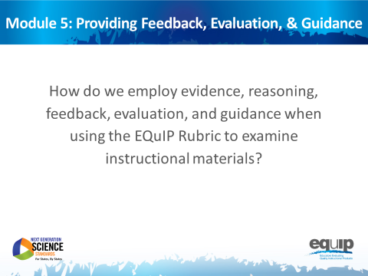
Slide 49
Talking Points
- Before we actually use the rubric to examine a lesson or unit, it’s important to take time to agree on what we mean by some of the language we’re using.
- While it’s easy to assume that everyone means the same thing when, for example, we talk about evidence, in reality people often have different ideas about what constitutes evidence and what does not.
- So, for the purpose of using the EQuIP Rubric to examine lessons and units, we need to develop a common understanding of specific terminology.
- Once we have a common understanding of the terms we’ll be using frequently, we can then begin to use the rubric to examine lessons and units.
- Before we begin, take three to five minutes at your tables to talk about what you think each of these terms means:
  - Evidence
  - Reasoning
  - Feedback
  - Evaluation
  - Guidance
[Note to facilitator: Allow three to five minutes before going on.]
- We’re not going to share your ideas here, but as we talk about how we will use these terms with the EQuIP Rubric, compare and contrast your initial perceptions with the ways we’re actually going to use these terms with the rubric to examine lessons and units.
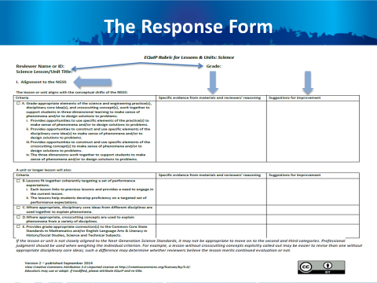
Slide 50
Talking Points
- Before we talk about the terms, let’s take a quick look at the response form section of the rubric. This begins on the page five of the rubric document.
- When using the response form, you will first record your name as the reviewer, the title of the lesson or unit, and the grade level for which the lesson or unit is intended at the top of the form. [Note to facilitator: Click for animation.]
- The first column of the response form lists the category and the criteria to which you are responding. [Note to facilitator: Click for animation.] The example on this slide shows Category I. Subsequent pages of the response form have Categories II and III.
- As you examine instructional materials, the second column of the response form is used to record evidence and reasoning. [Note to facilitator: Click for animation.]
- Finally, the last column of the form is used to record suggestions for improvement. [Note to facilitator: Click for animation.]
- Now let’s take a look at what these terms mean when we’re using the EQuIP Rubric.
- Again, as we look at how we will use these terms with the EQuIP Rubric, think about your initial perception of the meanings of these words and how these initial perceptions are similar to and/or different from how we’re going to use the terms with the rubric.

Defining Terms
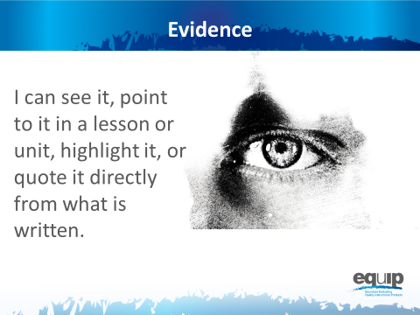
Slide 51
Talking Points
- Now we’re ready to determine a common understanding of what we mean when we talk about evidence.
- What should we be recording when we’re looking for evidence?
!
- Evidence is what is stated or described explicitly in a lesson or unit. If it is evidence, you can see it, point directly to it in the lesson or unit, highlight it, cite it, or quote it directly from what is written.
- When using the EQuIP Rubric, it is essential look for evidence of the different criteria in the lesson or unit itself before we start putting that evidence together to evaluate the lesson or unit.
- On a cautionary note, it is very common to want to “fill in the blanks” in a lesson or unit and add what we think the developer intended or what we would do if teaching the lesson and call it evidence; but to be very clear, we can only examine what we can see. If it’s not there, we cannot add it in and call it evidence. Think, for example, of asking a student to evaluate an argument. Students should only evaluate the argument as it exists and not “fill in the blanks” about what they think the person who made the argument intended. It is tempting for students to want to apply their own experiences and understanding to fill in the blanks, but the application of their expertise is better suited for making suggestions about how to improve the argument. Likewise, you cannot make assumptions about a lesson or unit developer’s intentions. Evidence must be explicitly stated in the materials you are examining. Later in the process, you will use professional judgment to decide whether the evidence is sufficient to say the criteria have been met and to make criterion-based suggestions for improvement. But for the purpose of finding evidence, it is essential to consider only what is explicit in the lesson or unit.
!
!
- In addition, it’s also common to skip right over the evidence and move directly to making judgments about whether or not a lesson or unit meets the rubric criteria or to offering suggestions on how to improve the lesson. We need to be careful to avoid this pitfall.
- Before we go on, let’s listen to Joe Krajcik address the importance of identifying evidence before determining whether a criterion has been met in this video.
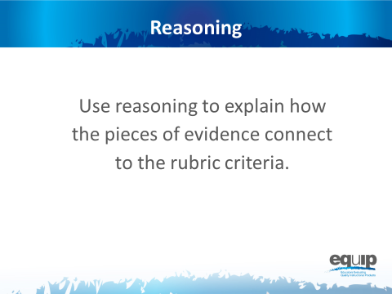
Slide 52
Talking Points
- Once we’ve located evidence of the criteria we’re looking for in a lesson or unit, we then use reasoning to explain how that evidence connects to the criteria in the rubric.
- Again, at this point we’re not yet evaluating whether the evidence is sufficient to say that the lesson or unit aligns to the NGSS in terms of three-dimensional learning or other criteria. We’re just stating that “x is an example of modeling”; “modeling is a science and engineering practice”; “so, therefore, this lesson/unit includes a science and engineering practice.”
- It’s important to reason through these connections because it’s not at all uncommon for different people to see the same exact thing in a lesson or unit without making the exact same connections to the rubric criteria.
- We use reasoning to put the different pieces of evidence we find in the lesson or unit together and then to connect that evidence to the rubric criteria so that we can, ultimately, work collaboratively to evaluate the lesson or unit.
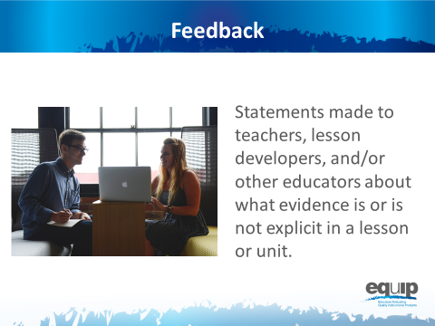
Slide 53

Talking Points
- In essence, feedback refers to statements made to teachers, lesson and unit developers, or other educators about what evidence is or is not explicit in a lesson or unit. Feedback is always criterion-based.
- Feedback may also include reasoning that explains how the evidence we see connects to one or more criteria in the rubric itself. For example, we might say something like, “Having the students develop a representation that presents a causal account to show that plants have similar life cycles is an example of modeling, and since modeling is one of the science and engineering practices, this lesson does include practices.” We may have similar evidence and reasoning for core ideas and crosscutting concepts.
- It also is critical to address whether the three dimensions are working together. For example, we might say something like, “Though each of the dimensions is present, they are each in isolation. I see no evidence that they are working together for three-dimensional learning.” In both of these examples we’re just stating what is or what is not explicit in the lesson or unit but not yet concluding whether or not the evidence is sufficient or of the quality necessary to state whether or not the lesson aligns with the NGSS.
- While it’s not uncommon to lump feedback, evaluation, and guidance together when making comments about a lesson or unit, it is important to be cognizant of how they are different from one another. We’ll talk more about evaluation and guidance in this module.
- For now, if we want to provide good feedback, we need to locate evidence determine how that evidence connects to the criteria on the rubric, and share this with the developer of the lesson.
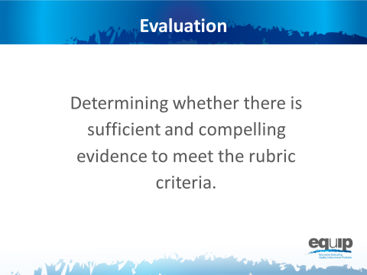
Slide 54
Talking Points
- Only after a group of people has individually examined a lesson or unit, identified the evidence of specific criteria in that lesson or unit, and used reasoning to establish the connections between the evidence and the criteria, can these individuals share their findings with the group. Then they can collaboratively determine whether they have sufficient and compelling evidence to say that the lesson or unit meets the rubric criteria and to check the boxes next to these different criteria on the response form.
- These evaluations can range from such things as whether something is an appropriate or sufficient example of a practice, a core idea, or a crosscutting concept; to whether the practices, core ideas, and crosscutting concepts in a lesson or unit work together appropriately to support students in three-dimensional learning; to whether the three dimensions actually function effectively to help students make sense of phenomena and/or design solutions to problems.
- Note that evaluation differs from reasoning as we defined it previously. Reasoning just makes the connection between the explicit evidence and what that evidence represents—for example, practices, disciplinary core ideas and/or crosscutting concepts. In this step, we evaluate whether the evidence is sufficient and compelling enough to say, for example, that the practices, disciplinary core ideas and crosscutting concepts work together to support students in three-dimensional learning to make sense of phenomena and/or design solutions to problems — in other words, sufficient and compelling enough to meet the stated rubric criteria.
!
Slide 55
Talking Points
- Finally, guidance refers to those suggestions for improvement that we provide to the developer of the lessons or units we are examining. These suggestions for improvement go in the third column of the response form. Feedback — statements about what is or is not in the lesson or unit — often provides the basis for suggestions for improvement.
- These suggestions should be stated positively as actions to be taken rather than statements about what is wrong with the lesson or unit.

Concluding Slides for Module 5
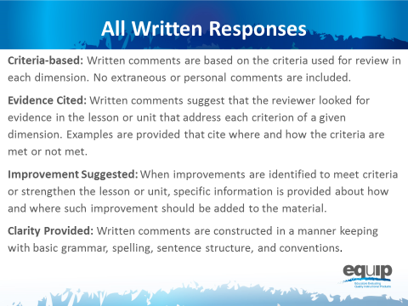
Slide 56
Talking Points
- Regardless of whether the comments provided on the response sheet are feedback, evaluation, or guidance, all comments should adhere to the following guidelines:
  - Be Criteria-Based: Written comments are based on the criteria used for review in each dimension. No extraneous or personal comments are included.
  - Cite Evidence: Written comments suggest that the reviewer looked for evidence in the lesson or unit that address each criterion of a given dimension. Examples are provided that cite where and how the criteria are met or not met.
  - Suggest Improvement: When improvements are identified to meet criteria or strengthen the lesson or unit, specific information is provided about how and where such improvement should be added to the material.
  - Provide Clarity: Written comments are constructed in a manner keeping with basic grammar, spelling, and sentence structure conventions.
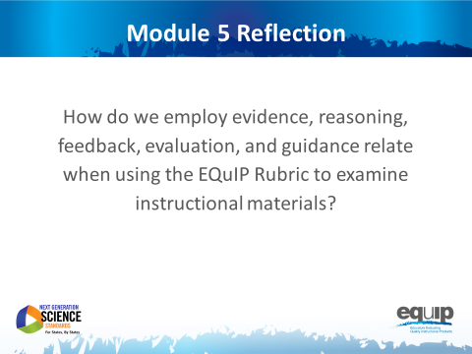
Slide 57
Talking Points
- In the next module, we’ll actually apply these definitions and examine a short lesson.
- Now, look back on the definitions you came up with at your tables at the beginning of this module. Has your understanding of these terms changed? What are the most important differences between what you thought at the beginning of this module and what you now know about how we’ll be using these terms with the EQuIP Rubric? [Note to facilitator: Have participants share as time allows.]

MODULE
NGSS EQuIP
6

Category I:
Determining
Alignment to
the NGSS
Module 6: Category I: Determining Alignment to the NGSS
Module 6 dives deeper into three-dimensional learning by having participants examine a short activity (coming soon) and determine whether the three dimensions are present and if they work together to support students in making sense of phenomena and/or designing solutions to problems. After this first task, participants begin examining a common lesson (coming soon) using just the first criteria in Category I: Alignment to the NGSS. [Note to facilitator: If you plan to use this module before Handout 7 and the common lesson are available, you will need to identify your own materials for these. Additionally, slides 66–68 will need to be changed to include specific examples from the identified materials.]
Materials Needed
- Module 6 PowerPoint slides or slides 58–77 of the full PowerPoint
- Handout 7: Module 6, Slide 65, “Example of Three-Dimensionality” (COMING SOON)
- Common Lesson (COMING SOON — ideally this lesson will be shared with participants before the professional learning so they can review it)
- Blue, orange, and green highlighters.
- Handout 5: Module 4, Slide 42, “EQuIP Agreements” (1 page)*
- Handout 6: Module 4, Slide 43, “EQuIP Rubric, Version 2” (4 pages)* or a computer or tablet with the electronic version of the rubric (at least one person per table should record their group’s findings electronically)
- Optional: Because participants will want to consider the elements of the three dimensions, it may be necessary to have copies of the standards as well as Appendix F and Appendix G . Alternatively, participants can find the standards and appendices at www.nextgenscience.org if internet access is available.

*Introduced in a previous module.
Introduction to Module 6
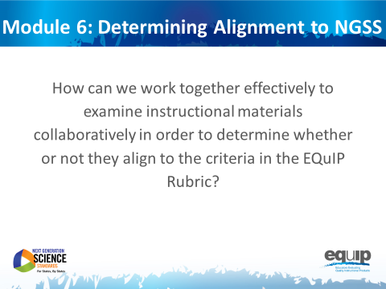
Slide 58
Talking Points
- In this module, we’re going to apply everything we’ve learned to this point and actually work together to examine a common lesson using the EQuIP Rubric.
- As we use the EQuIP Rubric in this module to examine instructional materials, you will:
  - Apply the common definitions we discussed in the last module.
  - Locate evidence of specific rubric criteria and use reasoning to explain how or why this evidence meets or does not meet rubric criteria.
  - Evaluate whether the evidence you’ve located is sufficient to demonstrate alignment to the NGSS.
  - Provide guidance regarding how a lesson or unit might be revised in order to meet rubric criteria.

Category I: Alignment to the NGSS
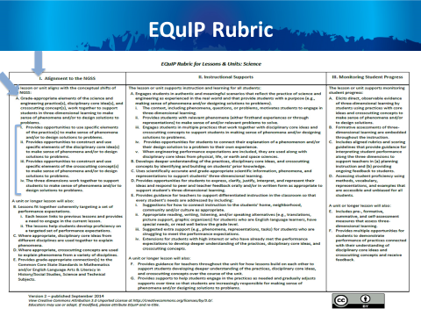
Slide 59

Talking Points
- Please get out your EQuIP Rubric and turn to page 4 of the rubric document where you’ll see all three categories of the rubric.
- For the lesson we are going to examine in this module, we will only be looking at the first major criterion in Category I and its component parts. [Note to facilitator: Click for animation.]
- This is Criterion A, which you’ll find under “The lesson or unit aligns with the conceptual shifts of the NGSS.” [Note to facilitator: Click for animation.]
- We will be looking at Criterion A along with the four sub-criteria under Criterion A. [Note to facilitator: Click for animation.]
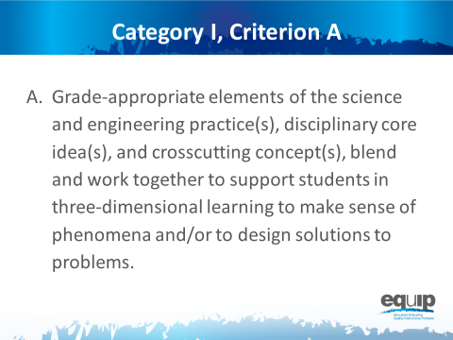
Slide 60
Talking Points
- Criterion A states, “Grade-appropriate elements of the science and engineering practice(s), disciplinary core idea(s), and crosscutting concept(s), blend and work together to support students in three-dimensional learning to make sense of phenomena and/or design solutions.”
- Here the term “elements” is used to represent the relevant, bulleted practices, disciplinary core ideas, and crosscutting concepts that are articulated in the foundations boxes of the standards, as well as in the NGSS appendices on each dimension. Looking at the elements of the disciplinary core ideas ensures that each dimension is grade or grade-band appropriate.
!
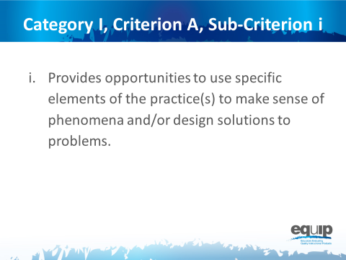
Slide 61
Talking Points
- We’ll also be looking at the sub-criteria under this overall criterion.
- Category I, Criterion A, Sub-Criterion i:
  - Provides opportunities to develop and use specific elements of the practice(s) to make sense of phenomena and/or design solutions to problems.
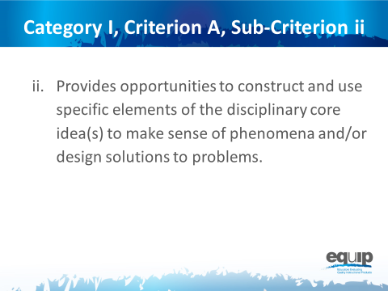
Slide 62
Talking Points
- Category I, Criterion A, Sub-Criterion ii:
- Provides opportunities to develop and use specific elements of the disciplinary core idea(s) to make sense of phenomena and/or design solutions to problems.
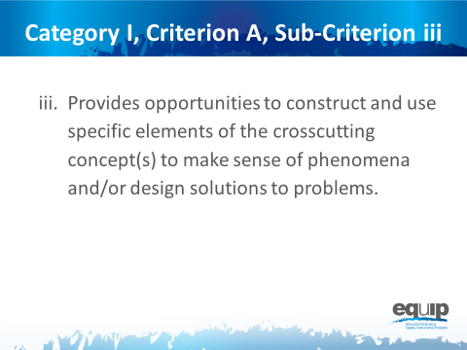
Slide 63
Talking Points
- Category I, Criterion A, Sub-Criterion iii:
- Provides opportunities to develop and use specific elements of the crosscutting concept(s) to make sense of phenomena and/or design solutions to problems.
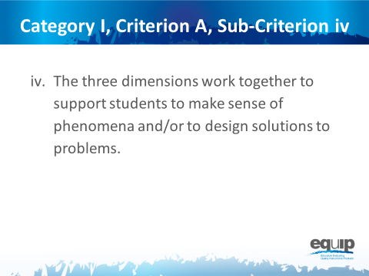
Slide 64
Talking Points
- And Category I, Criterion A, Sub-Criterion iv:
- The three dimensions work together to support students to make sense of phenomena and/or to design solutions to problems.
- Has everyone located Category I, Criterion A on the EQuIP Rubric?
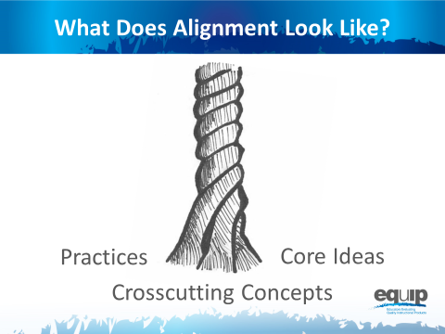
Note to facilitator: Refer participants to Handout 7, Module 6, Slide 65, “Example of Alignment.” (COMING SOON)
Slide 65
Talking Points
- Before we begin to examine a lesson, let’s take another look at what three-dimensional learning might look like.
- You’ll recall that we’re looking for explicit evidence of practices [Note to facilitator: Click for animation.], disciplinary core ideas [Note to facilitator: Click for animation.], and crosscutting concepts [Note to facilitator: Click for animation.], and then for how these work together in three-dimensional learning to help students make sense of phenomena and/or to design solutions to problems.
- Take a look at Handout 7, “Example of Alignment” (COMING SOON).
- Now, look at the area(s) highlighted in blue, orange, and green. This highlighting represents examples of identified evidence of practices, disciplinary core ideas, and crosscutting concepts respectively.
- Which elements of the three dimensions do you see in this lesson? Explain why the highlighted areas are evidence of practices, disciplinary core ideas, and crosscutting concepts. The process you use here to “explain why” represents reasoning as we discussed it in an earlier module.
- [Note to facilitator: Participants may not be familiar with referring to the elements of the three dimensions, so it may be useful to show them how to locate elements in the foundation boxes of a performance expectation and to refer them to where they can be found in Appendix F and Appendix G of the NGSS.]
- Take a minute to discuss what you see in terms of Criterion A and the first three sub-criteria in this example. [Note to facilitator: Allow three to five minutes and then ask the table to share.]

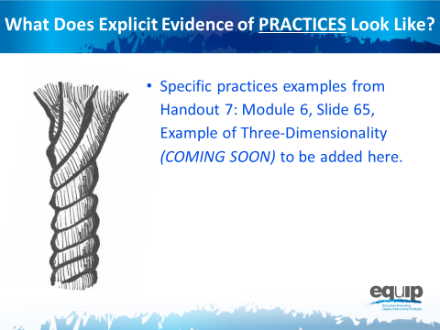
Slide 66
Talking Points
- Now, let’s look at this example together.
- The blue areas are examples of explicit evidence of science and engineering practices.
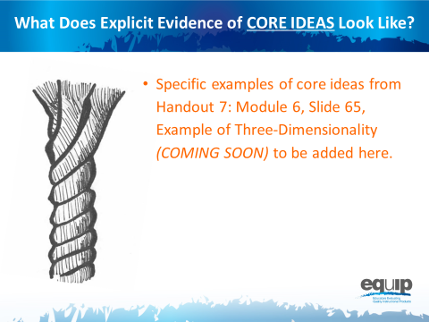
Slide 67
Talking Points
- The orange areas are examples of explicit evidence of disciplinary core ideas.
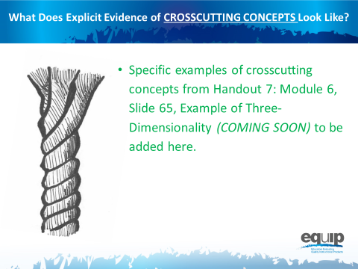
Slide 68
Talking Points
- And the green is an example of explicit evidence of a crosscutting concept.
- What makes these highlighted areas examples of explicit evidence? [Note to facilitator: Allow a few participants to respond.]
- Remember, for the purposes of the EQuIP Rubric, evidence is what is stated or described explicitly in a lesson or unit. If it is evidence, you can see it, point directly to it in the lesson or unit, highlight it, cite it, or quote it directly from what is written.
Slide 69
Talking Points
- Now, with your table group, take three to five minutes to discuss how the practices, core ideas, and crosscutting concepts work together here. [Note to facilitator: Allow three to five minutes and then ask tables to share.]
- [Note to facilitator: Specific examples from Handout 7: Module 6, Slide 65, “Example of Three-Dimensionality” (COMING SOON) of how the three dimensions work together to be added here.]
- So, do you think the practices, disciplinary core ideas, and crosscutting concepts work together in this example to help students make sense of phenomena and/or design solutions to problems? Is there sufficient evidence of three-dimensional learning to meet this first criterion?
- Talk about this at your table and decide why you do or do not think this lesson meets the first criterion. [Note to facilitator: Allow three to five minutes and then ask a few tables to share.]
- As you’ve noted, this lesson does meet the first criterion. This is just one example, and not every lesson or unit that meets the criterion will look the same. It’s important to look at the specific evidence in each lesson or unit, determine how that evidence connects to the criterion, and then collaboratively evaluate whether or not the evidence is sufficient to show alignment to the NGSS.
- Our goal throughout this training is to develop a common understanding of alignment and quality among those persons or groups reviewing lessons and units.
- We’re going to practice this with a common lesson now.

Learning Task: Working Through the Process
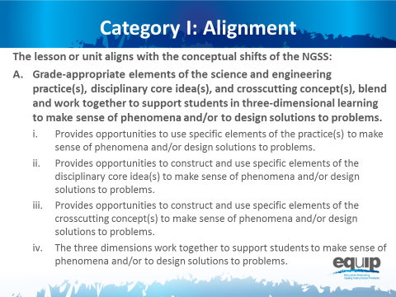
Slide 70
Talking Points
- For this task you will need:
  - An electronic or a hard copy of the EQuIP Rubric;
  - Common Lesson (COMING SOON); and
  - Blue, orange, and green highlighters.
- [Note to facilitator: Specific entities utilizing this training may elect to examine their own or other different materials. If this is the case, however, the trainers/facilitators should take time to examine the common lesson included with this training thoroughly to ensure that the training with these different materials is consistent with what is intended.]
- For this task, you will only be working with the first section of Category I of the EQuIP Rubric that is pictured on this slide. It’s the same criteria we just looked at with the example.
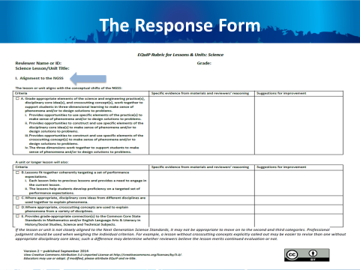
Slide 71
Talking Points
- Now, you need to locate this section on the response form, which is on page 5 of the rubric document — Category I: Alignment to the NGSS. The response form will have the criteria on the left hand side, with blank cells for evidence, reasoning, and suggestions for improvement to the right of the criteria. Please locate that section now.
- This task is designed to acquaint you with the process for using the rubric to examine lessons and units. This examination involves the seven processes and agreements discussed in the previous module, so you may want to pull out that handout and look over it again.
- Before we get started let’s listen to Tricia Shelton discuss how much evidence is sufficient in this video. Joe Krajcik also discusses one example of thinking about how much evidence is sufficient – how student and teacher materials should work together – in this video.
- As you examine this common lesson for evidence of these criteria, keep these questions in mind:
  - For the first sub-criterion, determine whether there is sufficient and compelling evidence that the lesson “provides opportunities to use specific elements of the practice(s) to make sense of phenomena and/or design solutions.”
  - For the second sub-criterion, determine whether there is sufficient and compelling evidence that the lesson “provides opportunities to construct and use specific elements of the disciplinary core idea(s) to make sense of phenomena and/or design solutions.”
  - For the third sub-criterion, determine whether there is sufficient and compelling evidence that the lesson “provides opportunities to construct and use specific elements of the crosscutting concepts to make sense of phenomena and/or design solutions.”
- As you peruse the lesson to make these determinations, you will be locating and marking the actual evidence in the lesson that supports the rubric criteria.
- Because you have a limited amount of time for this task, you may not be able to list all of the evidence that supports a criterion; rather, you may need to cite examples.
- As you work through this common lesson, it is essential that you follow the instructions exactly in order to experience the process as it should be followed in later modules.
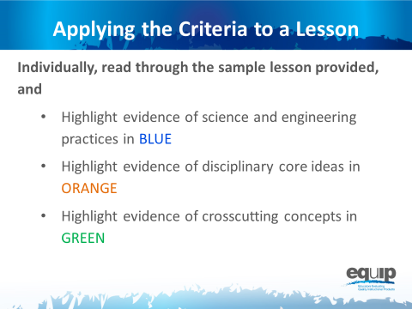
Slide 72
Talking Points
- First, examine the common lesson or unit for evidence of science and engineering practices, core ideas, and crosscutting concepts. Don’t forget to refer back to the elements of the dimensions found in the foundation boxes and the appendices.
- This is completed individually without any discussion between or among group members. Even if you complete this part before other tables are finished, do not discuss your findings before being instructed to do so.
- As you locate evidence, use the Arabic and Roman numerals associated with the rubric criteria to code the evidence you locate.
- Remember, evidence is what you can see explicitly in the lesson or unit.
- You can use the second column of the response form to summarize your evidence.
- You have ten minutes to do this. [Note to facilitator: Set a timer for ten minutes, on the screen for all to see if possible. When the timer sounds, ask if participants need more time before moving on.]
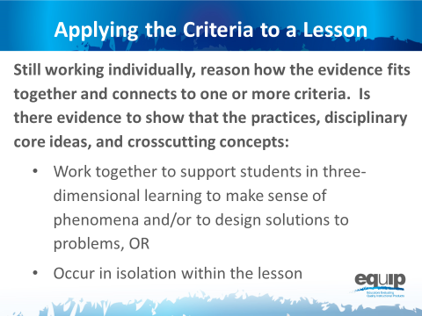
Slide 73

Talking Points
- Now, still working individually without talking or collaborating with others at your table, use reasoning to think about how the evidence fits together and how it relates to the rubric criteria.
- Reasoning is the bridge connecting the evidence to the rubric criteria and to how the practices, core ideas, and crosscutting concepts work together.
- Do the students have an opportunity to engage in three-dimensional learning to help them make sense of phenomena and/or design solutions, OR Do the three dimensions occur in isolation?
- Again, you can use the second column of the response form for this.
- You have five to seven minutes to do this. [Note to facilitator: Set the timer but ask if participants need more time before moving on.]
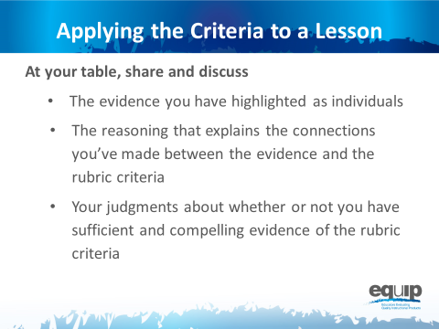
Note to facilitator: At this point ask that the note takers record their group’s findings electronically on the response form. In addition, if available, provide each group with a small projector so that the information being inputted can be seen by all group members. A screen sharing application also could be used.

Slide 74
Talking Points
- Now you finally get to share and compare.
- Before you begin the group discussion, designate a recorder for your group.
- You also may find it helpful to designate other roles for members of your group. These roles might include
  - One group member to monitor time,
  - One group member to facilitate the discussion, etc.
- Making sure everyone contributes his/her findings, share and discuss:
  - [Note to facilitator: Click for animation.] The evidence you highlighted;
  - [Note to facilitator: Click for animation.] The reasoning that explains the connections you made between the evidence and the rubric criteria; and then
  - [Note to facilitator: Click for animation.] Collaboratively evaluate whether this lesson or unit includes sufficient and compelling evidence of three-dimensional learning and whether or not the lesson aligns to the NGSS.
- Attempt to reach consensus as a table group and be prepared to share your evaluation and support them with evidence and reasoning.
- You have 30 minutes for this discussion. [Note to facilitator: Set the timer for 30 minutes but monitor the table groups and provide more or less time as needed to complete this. When the table groups are ready, have two or three share their determinations and then allow for questions and comments related to the determinations before moving on.]
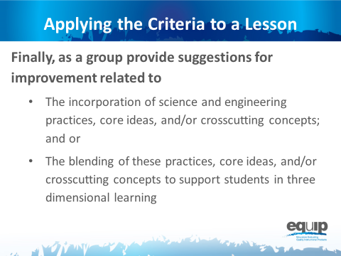
Slide 75
Talking Points
- This part of the task involves providing guidance or suggestions for how the lesson developer can improve the lesson.
- This guidance should be at the element level. Again, when using the EQuIP Rubric, the term “element” refers to the relevant, bulleted practices, disciplinary core ideas, and crosscutting concepts that are articulated in the foundations boxes of the standards, as well as in the NGSS appendices on each dimension.
- Remember to state these suggestions as positive actions for the developer to take rather than as negative statements of what’s missing, etc.
- You have five minutes for this. [Note to facilitator: Set the timer for five minutes. When it sounds, ask for two or three suggestions for improvement before moving to the next slide.]

Debriefing the Task
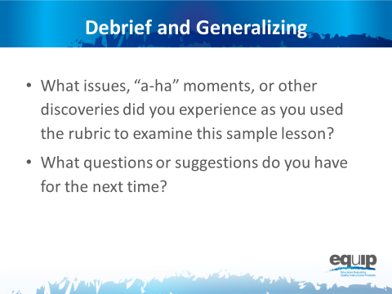
Slide 76
Talking Points
- So, how did it go? What did you experience using the rubric for the first time to determine alignment to the NGSS?
- Do you have any issues related to using the rubric to determine alignment to the NGSS that need to be addressed? Any “aha” moments? Other discoveries that might be important for others to hear? What questions do you have? Do you have any suggestions for improving the process? [Note to facilitator: Have people share as time allows.]
- Why is it important to first use the rubric individually to examine a lesson or unit?
- Why is it important to discuss your individual findings collaboratively as a group in order to make decisions about whether or not a lesson or unit aligns to the NGSS?
- [Note to facilitator: Refer participants to Handout 5, Module 4, Slide 42, “EQuIP Agreements.”] Look back over the agreements we discussed earlier. Why are these so important? [Note to facilitator: Allow two to three people to respond.]
!
- It is essential to understand that the EQuIP quality review process is a collegial process that centers on the use of the criteria-based rubric for science.
!
- While an individual certainly might use the rubric to examine a lesson or unit, the effective evaluation of lessons and units is the product of examination and discussion by a group of people using the rubric collaboratively.
- While using the EQuIP Rubric to examine instructional materials should lead to consensus regarding the overall lessons or units, group members may not always agree about every individual piece of evidence within a lesson or unit.
- The process we just followed to examine the common lesson is the same process we’ll use in examining other lessons and units regardless of whether we’re looking for alignment, coherence, access for all learners, or assessment practices.
- First we look for the evidence in the lesson or unit. Next we determine how the evidence fits together and connects to one or more criteria. From this evidence and reasoning we then make evaluations collaboratively about the lesson or unit. And then, finally, we make suggestions for how the lesson or unit might be improved.

Concluding Slide for Module 6
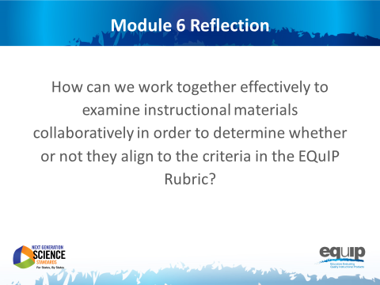
Slide 77
Talking Points
- With your table group, reflect on the process you just used to examine the common lesson.
- Determine where your group is on a scale of one to four, with four indicating that you feel confident that you all understand the process and can now use it to determine whether other instructional materials provide sufficient, explicit evidence to meet EQuIP Rubric criteria. [Note to facilitator: Allow five minutes, and then ask representatives to hold up one to four fingers for their table. Survey the room and address any tables holding up one or two fingers by asking, “What do you still need to move to a three?”]
- In the next module, we’ll take a look at the other criteria in Category I related to alignment to the NGSS.

MODULE
NGSS EQuIP
7

Determining
Coherence
and Connections
Module 7: Determining Coherence and Connections
Module 7 builds on Module 6 by having participants discuss the remaining criteria in Category I: Alignment to the NGSS, which deal with coherence and connections. Participants will engage in an activity to think about coherence—specifically, the coherence of a set of questions in a series of lessons. Then they will continue examining the Common Lesson using the remaining criteria in Category I.
Materials Needed
- Module 7 PowerPoint slides or slides 58–91 of the full PowerPoint
- Handout 8: Module 7, Slide 85, “Graphic Example of Coherence” (1 page, preferably color copies)
- Handout 9: Module 7, Slide 89, “Debriefing Questions for Module 7” (1 page)
- Facilitator’s Resource — Storyline Cards. [Note to facilitator: Prior to beginning this module, prepare the envelopes for the coherence Storyline Cards task, slide 84.]
- Handout 6: Module 4, Slide 43, “EQuIP Rubric, Version 2” (4 pages)* or a computer or tablet with the electronic version of the rubric (at least one person per table should record their group’s findings electronically)

*Introduced in a previous module.

Introduction to Module 7
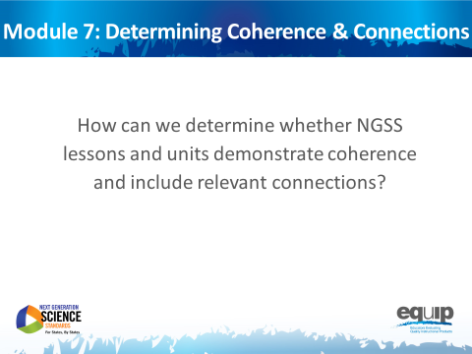
Slide 78
Talking Points
- In this module we’re going to move to the next part of Category I and look at coherence and connections in longer lessons or units.
- By the end of this module, you should be able not only to explain coherence in terms of the EQuIP Rubric, but also to explain how a graphic representation of a series of lessons demonstrates coherence, and to determine whether or not the common lesson shows explicit evidence of coherence.
- And you should be able to determine whether or not a lesson or unit includes connections to other science disciplines and/or to ELA/literacy or mathematics.
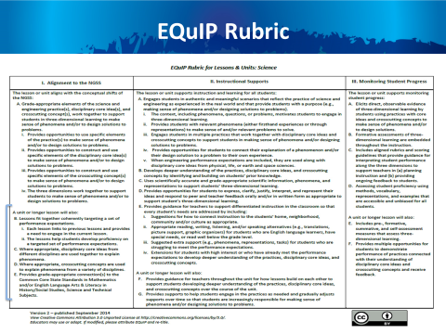
Slide 79
Talking Points
- Locate the criteria for coherence and connections on your rubric toward the bottom of the first column.
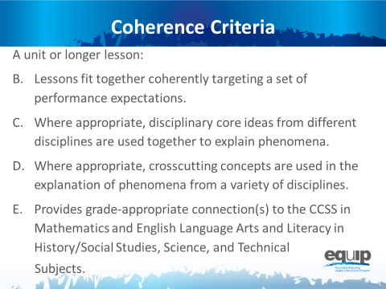
Slide 80
Talking Points
- Note how each of the bullets delineates different possibilities for coherence and connections:
  - [Note to facilitator: Click for animation.] Coherence can refer to how lessons fit together coherently to target a set of performance expectations.
  - [Note to facilitator: Click for animation.] Where appropriate, disciplinary core ideas from different disciplines are used together to explain phenomena.
  - [Note to facilitator: Click for animation.] Where appropriate, crosscutting concepts are used in the explanation of phenomena from a variety of disciplines.
  - [Note to facilitator: Click for animation.] Provide grade-appropriate connection(s) to the CCSS in ELA/literacy and mathematics and in history/social studies, science and technical subjects.

What is Coherence?
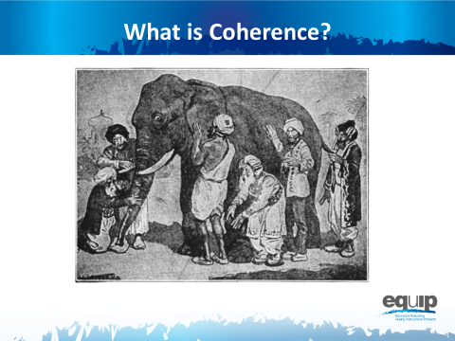
Slide 81

Talking Points
- Who knows the story of the blind men and the elephant? [Note to facilitator: Have someone share the story with the whole group. If no one volunteers, the facilitator should retell the story.]
- Although the men in this story certainly examined the parts of the elephant, their individual explanations did not depict a coherent representation of the elephant. Their various descriptions of the parts of an elephant did not fit together to create a picture of an entire elephant that made sense. Their individual descriptions, when examined as a whole, lacked coherence.
- So what is coherence? Take a few minutes to talk about what you think coherence might look like in a longer lesson, a series of lessons, or a unit in science. [Note to facilitator: Allow approximately five minutes before asking for volunteers to share. Allow several people to share. Facilitator should guide this discussion to ensure that s/he brings everything together to define coherence as intended in the EQuIP Rubric.]
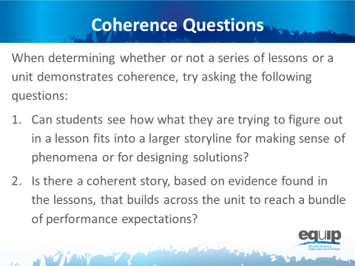
Slide 82
Talking Points
- As you examine lessons and units to determine whether they meet the rubric criteria for coherence, keep these two questions in mind:
  - Can students see how what they are trying to figure out in a lesson fits into a larger storyline for making sense of phenomena and/or for designing solutions to problems?
  - Is there a coherent story that, based on explicit evidence found in the lessons, builds across the unit to reach a bundle of— a set of more than one — performance expectations?
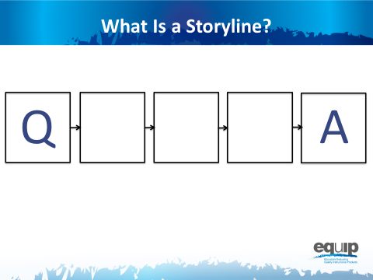
Slide 83
Talking Points
- So what exactly do we mean by a storyline or a coherent story?
- Think of your favorite episode of Law and Order or another TV mystery series you watch regularly. The episode begins with a question: “Who committed the crime?” From here the plot proceeds logically as evidence is collected, suspects are questioned, and a case is built. The show ends when everything comes together, the question we began with is answered, and the perpetrator of the crime is revealed.
- This exemplifies a coherent storyline.
- Now think back to a TV show or movie you’ve watched where you’ve reached the end only to discover that the answer to the question of who committed the crime comes straight out of left field. There was no way you could have figured out the ending because either it wasn’t logical or the crime ended up being committed by someone who wasn’t even present in the earlier portion of the show. You feel as if you’ve wasted your time because the storyline wasn’t coherent; one thing did not follow from another.
Note to facilitator: Make sure each table group has an envelope with the Storyline Cards for this task.
Slide 84
Talking Points
- In the center of your table you’ll find an envelope. Inside are five slips of paper, each with a question on it.
- As a group, read through these questions and then put them in the order that you believe to be the most coherent storyline.
- As you work to make a coherent storyline from these cards, think about what this process would look like in a classroom where students are trying to make sense of phenomena and/or design solutions to problems.
- As you arrange the cards, ask yourself the following questions:
  - Can students see how what they are trying to figure out in a lesson fits into a larger storyline for making sense of phenomena and/or for designing solutions to problems?
  - Is there a coherent story that, based on explicit evidence found in the lessons, builds across the unit to reach a bundle of performance expectations?
- Can you arrange the questions on the cards so that students see how what they are trying to figure out in a lesson fits into a larger storyline for making sense of phenomena and/or for designing solutions?
- Can the questions be organized to build a series of lessons or a unit to reach a bundle of performance expectations? [Note to facilitator: Allow five minutes for the groups to work and then have two to three tables share.]
- Now let’s look at these same questions in a graphic representation of coherence.

Lessons That Fit Together Coherently
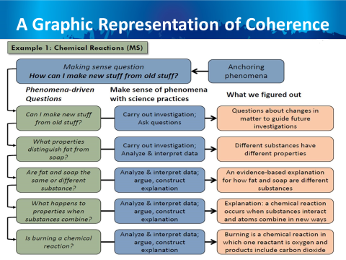
Note to facilitator: Refer participants to Handout 8, Module 7, Slide 85, “Graphic Example of Coherence.”
Slide 85
Talking Points
- Please refer to the handout entitled, “Graphic Example of Coherence,” which provides a larger version of this slide.
- Notice the “making sense question” at the top — the anchoring phenomenon.
- Now look at the order of the phenomena-driven questions — the questions in the green boxes.
- Take a minute or two at your tables to compare how you ordered the cards from the envelope with the order of these phenomena-driven questions. [Note to facilitator: Allow one to two minutes.]
- In this example, we can see coherence just by virtue of the fact that each subsequent phenomena-driven question relates directly back to our attempt to answer the making sense question.
- In other words, if we assume that each phenomena-driven question relates to one lesson in a series of lessons, all of which are designed to address the making sense question, then each lesson connects and builds onto the previous as students work to answer the making sense question.
- Here students engage in science practices to answer each of the phenomena-driven questions.
- And, since the phenomena-driven questions logically and sequentially build on one another, what the students figure out — the meaning they make — logically and sequentially builds as well. In other words, their learning is coherent because the students can see how what they are trying to figure out in one lesson fits into a larger storyline for making sense of phenomena.

Connections
Slide 86
Talking Points
- Just as coherence occurs in a series of lessons, where appropriate, disciplinary core ideas from different science disciplines can be used together to explain phenomena.
- Likewise, where appropriate, crosscutting concepts can be used in the explanation of phenomena from a variety of science disciplines.
- Again, here we’re looking for connections that enable students to see the bigger picture or see how different science disciplines relate to form a larger storyline for making sense of the natural world or the human-designed world.
- As you look for this evidence, ask yourself the following questions:
  - Are students using what they have figured out in other disciplines of science to make sense of the phenomena and/or to design solutions to problems in current lessons and units?
  - Are students crosscutting concepts in the explanation of phenomena from different science disciplines?
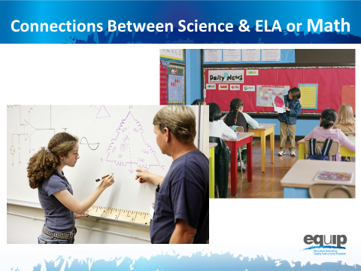
Slide 87
Talking Points
- Finally, connections can occur between science and ELA/literacy and science and mathematics.
- For example, students could create mathematical models to explain science phenomena, or write arguments to show how they reason from evidence to reach a logical conclusion in science.
- As before, we’re looking for connections that enable students to see the bigger picture or see how different areas of study relate to form a larger storyline for making sense of the natural world or the human-designed world.
- As you look for evidence of connections between science and mathematics and/or ELA/literacy, ask yourself the following questions:
  - Are students using what they have learned or are learning in ELA/literacy or mathematics as a tool to make sense of new phenomena and/or design solutions to problems? Or to express or convey the sense they make of phenomena and/or the solutions they design?
  - Are the students reflecting on the ELA/literacy and mathematics skills they are using and thus improving their skills in these areas?

Coherence and Connections Practice
Note to facilitator: At this point, if participants have access to an electronic version of the rubric, you may wish to suggest that the note takers record their group’s findings electronically on the response form. In addition, if available, provide each group with a small projector so that the information being inputted can be seen by all group members. A screen-sharing application could also be used.
Slide 88
Talking Points
- For this task, you will need:
  - The Common Lesson;
  - The EQuIP Rubric response sheet; and
  - A pen or pencil.
- As you work, keep in mind:
  - You’re working individually on the first two parts of the process, so don’t begin sharing and comparing until after you have completed these first two parts of the process.
  - Use the Arabic and Roman numerals associated with the rubric criteria to code the evidence you locate.
  - It’s exceedingly important to locate explicit evidence in the lessons first before you use reasoning to think about how this evidence connects to the rubric criteria.
  - The evaluations you then make as a group are based on the evidence you located and thought about as individuals.
  - All determinations are criteria-based.
  - As a group you are working to develop a common understanding of alignment and quality.
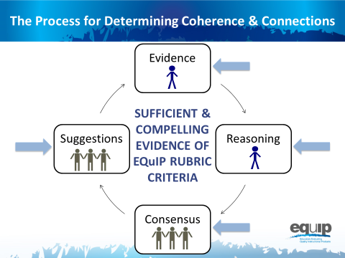
Notes to facilitator: If you made extra copies of the response sheet for Category I, page 5 of the rubric document for the previous task, participants can use those copies again now.
In addition, refer participants to Handout 9, Module 7, Slide 89, “Debriefing Questions for Module 7.”
Slide 89
Talking Points
- In addition to the specific materials for this task, you will need the three debrief questions for this module, which you have on Handout 9, “Debriefing Questions for Module 7.”
- If you or your group finishes any part of this examination process early, please begin reflecting on or discussing these three debriefing questions.
- The process you will use to examine the common lesson for coherence and/or connections is the same as the process you used in an earlier module to examine the common lesson to determine whether or not it met the criteria for three-dimensional learning. You will have a specific amount of time for each part of the process.
  - First, look for the evidence in the lessons or unit individually. Use the Arabic and Roman numerals associated with the rubric criteria to code the evidence you locate. You have seven minutes for this part. [Note to facilitator: Set timer for seven minutes.]
  - Now, still individually, determine how the evidence fits together and connects to one or more criteria. You have four minutes for this part of the process. [Note to facilitator: Set timer for four minutes.]
  - Next, as a group, designate one person to record the group’s responses, and then share and discuss this evidence and reasoning and collaboratively make evaluations about whether or not the lesson or unit provides sufficient and compelling evidence of the criteria. You have 15 minutes for this part of the process. [Note to facilitator: Set timer for 15 minutes.]
  - Finally, make suggestions for how the lesson or unit might be improved. You have four minutes for this part of the process. [Note to facilitator: Set timer for four minutes.]
  - [Note to facilitator: At the conclusion of the practice, ask several groups to share their evidence and reasoning. After several groups have shared, ask one or two to share a suggestion for improvement.]
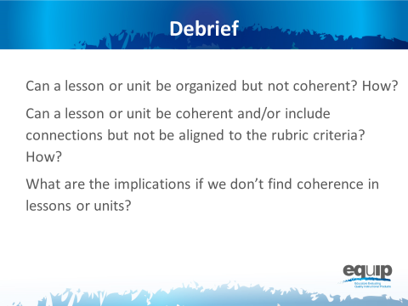
Slide 90
Talking Points
- So, now that you’ve examined a lesson for coherence and connections, what do you think?
  - Can a lesson or unit be organized but not coherent? How? [Note to facilitator: Allow participants to respond.]
  - Can a lesson or unit be coherent and/or include connections but not be aligned to the rubric criteria? How? [Note to facilitator: Allow participants to respond.]
  - What are the implications if we don’t find coherence in lessons or units? [Note to facilitator: Allow participants to respond.]
- [Note to facilitator: Ask each of the following questions separately and allow participants to respond.]
  - Was this easier or harder than determining three-dimensional learning?
  - Do you have any takeaways that might be useful for other groups to hear?
  - Are you beginning to feel more confident in using the rubric to examine science materials?

Concluding Slide for Module 7
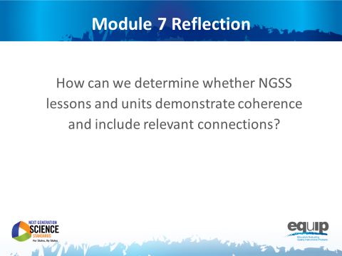
Slide 91
Talking Points
- Coherence and connections are criteria we use to evaluate whether or not a longer lesson or a unit aligns to the NGSS.
- While it may seem that we’re spending a lot of time working with Category I of the rubric, remember, if a lesson or unit is not closely aligned to the NGSS, it may not be appropriate to move on to the second and third categories. So, it’s important that we spend sufficient time here to build educator capacity, sharpen our professional judgment, and develop a common understanding of alignment and quality among reviewers.
- If you still have questions about what coherence and/or connections look like, please ask them now.
- Does anyone still have questions about using Category I of the rubric to determine alignment with the NGSS, including determining coherence? [Note to facilitator: Address any questions that arise.]
- In the next module, we’ll be moving on to Category II and using the rubric criteria for Instructional Supports.

MODULE
NGSS EQuIP
8

Category II:
Instructional Supports
Module 8: Category II: Instructional Supports
Module 8 builds on Modules 6 and 7 by having participants continue examining the Common Lesson, this time using the criteria in Category II: Instructional Supports. Category II: Instructional Supports focuses on examining lessons and units to determine whether they include the kinds of instructional practices and supports necessary to allow all students to access the NGSS successfully.
Materials Needed
- Module 8 PowerPoint slides or slides 92–99 of the full PowerPoint
- Handout 6: Module 4, Slide 43, “EQuIP Rubric, Version 2” (4 pages)* or a computer or tablet with the electronic version of the rubric (at least one person per table should record their group’s findings electronically)

*Introduced in a previous module.

Introduction to Module 8
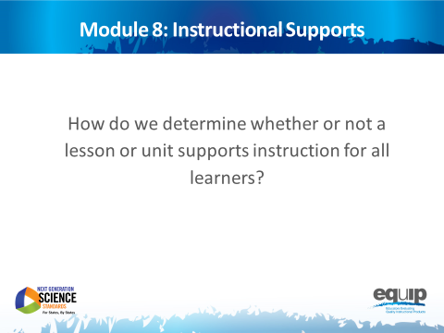
Slide 92
Talking Points
- In this module, we’ll be looking at Category II: Instructional Supports.
- By the conclusion of this module, you should be able to use the EQuIP Rubric to determine whether or not a lesson or unit supports instruction for all learners.
- Now, locate Category II on page 5 of your rubric.
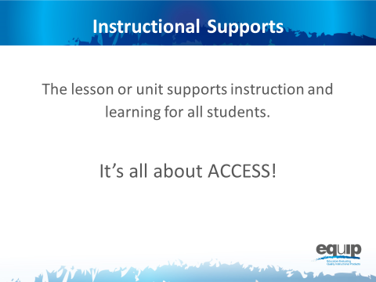
Slide 93
Talking Points
- Category II: Instructional Supports focuses on examining lessons and units to determine whether they include the kinds of instructional practices and supports necessary to allow all students to access the NGSS successfully.
- Take a few minutes to read through all of Category II quickly. [Note to facilitator: Allow three to five minutes.]
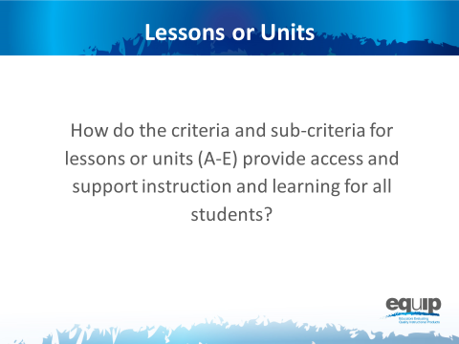
Slide 94
Talking Points
- Now that you’ve read through all of Category II, let’s look more closely at specific sections.
- First, read back through the first four criteria: A, B, C and, D, along with their sub-criteria, and circle key words. You have three minutes to do this. [Note to facilitator: Allow 3 minutes.]
- Noting what you’ve circled, what might evidence of criteria A through D look like in a lesson or unit? [Note to facilitator: Allow a few participants to share.]
- All of the EQuIP Rubric criteria are important, but in Category II, Criterion E, along with its sub-criteria, is particularly deep.
- So, take a few minutes at your tables just to discuss Criterion E and its sub-criteria. [Note to facilitator: Allow five minutes.]
- What are some of the points you discussed regarding Criterion E? And, based on what you see in Criterion E, what might evidence of Criterion E, along with its sub-criteria, look like in a lesson or unit? [Note to facilitator: Allow a few groups to share.]
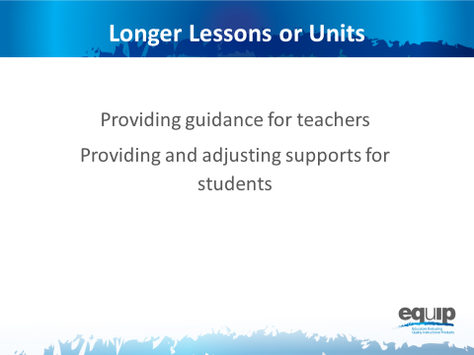
Slide 95

Talking Points
- In Category I the focus for a unit or longer lessons is on the coherence of the lessons — whether they were designed in a coherent way.
- In Category II, the first criterion for a unit or longer lessons focuses on whether there is built-in support for the teachers to ensure that students see the coherence and that this deepens their understanding. Consequently, some of the evidence you identified when looking for coherence in Category I may also provide evidence here.
- The second criterion for longer lessons and units focuses on providing and then gradually adjusting supports for students over time so that the students become increasingly responsible for making sense of phenomena and/or designing solutions to problems.

Instructional Supports Practice
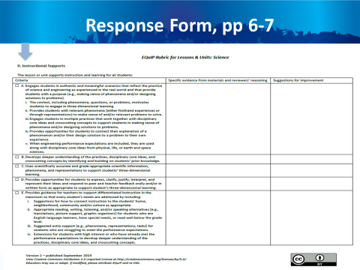
Note to facilitator: Consider making extra copies of the response sheet for Category II, pages 6 and 7 of the rubric document, for the participants to use with this task.
Slide 96
Talking Points
- The response form for Category II is located on pages 6 and 7 of your rubric document. Please note that this slide only shows page 6 of the response form, but you will need both page 6 and page 7.
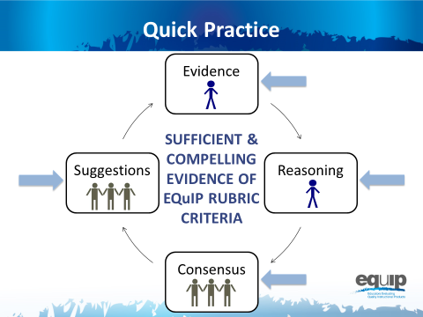
Slide 97
Talking Points
- For this quick practice you will need:
  - The response sheet for Category II;
  - The common lesson provided for this practice; and
  - A pen or pencil to code the evidence you find with the Arabic or Roman numerals associated with the specific criteria and/or sub-criteria that the evidence supports.
- Please note that for this practice you will be examining the lesson for both criteria A through E for a lesson or unit and for criteria F and G for a unit or longer lesson.
- As you work through this practice, follow the same process you used earlier when examining a lesson or unit for three-dimensional learning and coherence:
  - [Note to facilitator: Click for animation.] First, individually look for the evidence in the lessons or unit. Use the Arabic and Roman numerals associated with the rubric criteria to code the evidence you locate.
  - [Note to facilitator: Click for animation.] Next, still individually, determine how the evidence fits together and connects to one or more criteria.
  - [Note to facilitator: Click for animation.] Then, as a group, examine this evidence and reasoning and collaboratively make evaluations about whether or not the lesson or unit provides sufficient and compelling evidence of the criteria.
  - [Note to facilitator: Click for animation.] Finally, make suggestions for how the lesson or unit might be improved.
- You have 30 minutes for this task. Remember, you’re examining the lesson for criteria A through G for Category II.
- If your group finishes early, use the extra time to think about and/or discuss this question: “What are the implications if a lesson or unit does not meet the criteria for Category II?” [Note to facilitator: Set the timer for thirty minutes, but monitor the groups to determine if they need more or less time to complete the practice before moving on.]
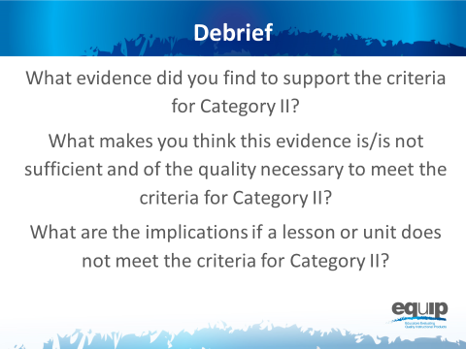
Slide 98
Talking Points
- So what determinations did you make at your tables? Does this lesson meet the criteria in Category II for criteria A through D?
- How? Why or why not? [Note to facilitator: Allow several tables to share.]
- What about for Criterion E? How or why not? [Note to facilitator: Allow a few tables to share.]
- Now, what did you determine for criteria F and G for a unit or longer lesson? Does the lesson meet these criteria? How or why not? [Note to facilitator: Allow a few tables to share.]
- What are the implications if a lesson or unit does not meet the criteria for Category II? [Note to facilitator: Allow a few tables to share.]

Concluding Slide for Module 8
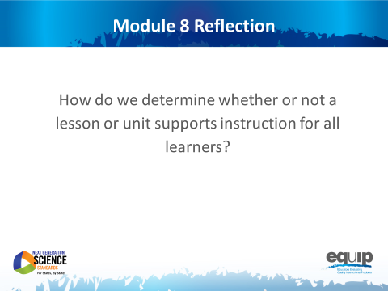
Slide 99

Talking Points
- Providing the kinds of instructional supports that allow all students to access the NGSS and engage in three-dimensional learning is very important.
- As a result of this module, you should feel comfortable using the rubric to determine whether or not a lesson or unit meets the criteria in Category II.
  - Are there any questions or additional comments before we move on? [Note to facilitator: Address question or comments if they arise.]

MODULE
NGSS EQuIP
9

Category III:
Monitoring Student Progress
Module 9: Category III: Monitoring Student Progress
Module 9 builds on Modules 6, 7 and 8 by having participants continue examining the Common Lesson, this time using the criteria in Category III: Monitoring Student Progress. As with all standards, teaching to the NGSS is not sufficient. It’s about students learning — in the case of the NGSS, three-dimensional learning. Examining a lesson or unit against the criteria in Category III determines whether a lesson or unit includes the kinds of assessments that allow all students to demonstrate understanding and that allow all teachers to monitor the progress and performance of all students.
If the meeting participants are not going to continue on to Module 10 to examine additional lessons and units, consider pulling reflection questions and closing ideas from slides 119–121.
Materials Needed
- Module 9 PowerPoint slides or slides 100–112 of the full PowerPoint
- Handout 10: Module 9, Slide 105, “Formative Assessment Vignettes.”
- Handout 6: Module 4, Slide 43, “EQuIP Rubric, Version 2” (4 pages)* or a computer or tablet with the electronic version of the rubric (at least one person per table should record their group’s findings electronically)

*Introduced in a previous module.

Introduction to Module 9
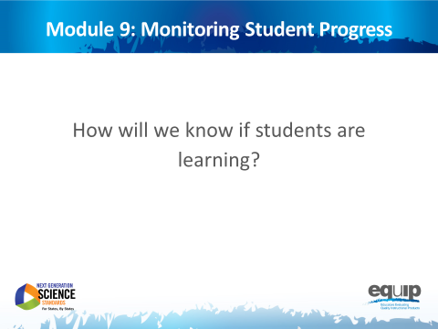
Slide 100
Talking Points
- In this module, we’ll be looking at Category III: Monitoring Student Progress.
- By the conclusion of this module, you should be able to use the EQuIP Rubric to determine whether a lesson or unit includes a variety of assessments that align to three-dimensional learning and provides multiple opportunities to elicit observable, unbiased evidence of student understanding through performance.
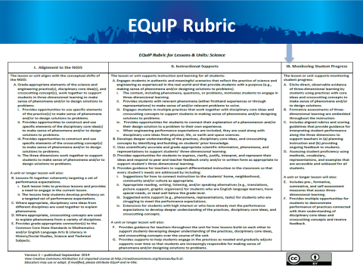
Slide 101
Talking Points
- Now, locate Category III on page four of your rubric document.
- Category III: Monitoring Student Progress focuses on examining lessons and units to determine whether they include the kinds of assessments necessary to assess student mastery of the NGSS accurately.
- Take a few minutes to read through Category III. [Note to facilitator: Allow three to five minutes.]
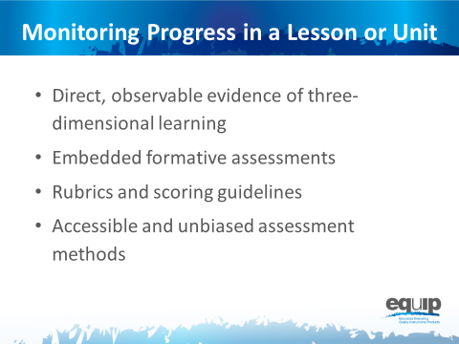
Slide 102
Talking Points
- The four criteria at the top of Category III focus on monitoring student progress in a lesson or unit.
- We’ve focused extensively on direct, observable evidence of three-dimensional learning; but before we can examine lessons or units to look for evidence of embedded formative assessments, we need to determine just what that looks like.

Formative Assessment
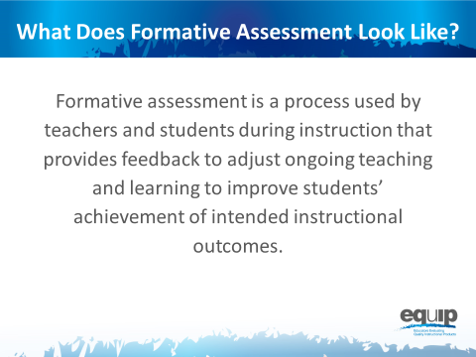
Slide 103
Talking Points
- According to a paper initiated by the Council of Chief State School Officers (CCSSO) in 2008 entitled, “Formative Assessment: Examples of Practice,” formative assessment is:
  - A process used by teachers and students during instruction that provides feedback to adjust ongoing teaching and learning to improve students’ achievement of intended instructional outcomes.
- Dylan Wiliam, who you may recall co-authored “Inside the Black Box,” the groundbreaking research report on the impact of formative assessment on student learning, says this about formative assessment in his 2011 book, “Embedded Formative Assessment”:
  - “An assessment functions formatively to the extent that evidence about student achievement is elicited, interpreted, and used by teachers, learners, or their peers to make decisions about the next steps in instruction that are likely to be better, or better founded, than the decisions they would have made in absence of that evidence.” (43)
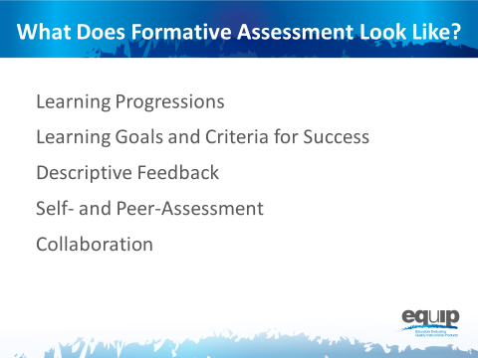
Slide 104
Talking Points
- According to the CCSSO paper, five attributes are associated with effective formative assessment:
  - [Note to facilitator: Click for animation.] Learning Progressions that clearly articulate the sub-goals of the ultimate learning goal [for a lesson or unit];
  - [Note to facilitator: Click for animation.] Learning Goals and Success Criteria that are clearly identified and communicated to students;
  - [Note to facilitator: Click for animation.] Descriptive Feedback provided to students that is evidence-based and linked to the intended instructional outcomes and criteria for success;
  - [Note to facilitator: Click for animation.] Self- and Peer-Assessment that provide students with opportunities to think meta-cognitively about their learning; and
  - [Note to facilitator: Click for animation.] Collaboration exemplified by a classroom culture in which teachers and students are partners in learning.
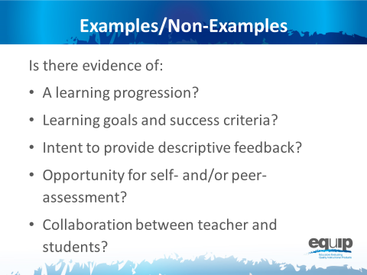
Note to facilitator: Refer participants to Handout 10, Module 9, Slide 105, “Formative Assessment Vignettes.”

Slide 105
Talking Points
- You have a handout entitled, “Formative Assessment Vignettes,” which you need to take out.
- Read through the different vignettes to determine what evidence you see of the five attributes delineated by CCSSO and/or evidence you see that supports Wiliam’s definition of formative assessment. Please note that the examples presented in the vignettes are not necessarily three-dimensional.
- Once you’ve read through the vignettes individually, discuss your findings as a group to determine which vignettes are examples of formative assessment and which are non-examples. [Note to facilitator: These vignettes, as well as additional information about formative assessment, are available in the paper from the Council of State School Officers. Allow seven to ten minutes.]
- Now let’s take a look at these examples and non-examples.
- The first vignette is “Thumbs Up and Thumbs Down.” What do you think? Let’s see your thumbs up if you think this example provides evidence of formative assessment or thumbs down if you do not.
- What’s your reasoning? [Note to facilitator: Allow one or two people to share.]
- Here’s what the experts say about this first vignette: “This teacher is using a formative assessment approach to collect evidence to adjust instruction. This is, therefore, an instance of formative assessment.”
- Moving on to the second vignette, “Structured Pair Work,” again, let’s see your thumbs up if you think this example provides evidence of formative assessment or thumbs down if you do not.
- What’s your reasoning for this one? [Note to facilitator: Allow one or two people to share.]
- Here’s what the experts say about this second vignette: “This is an example of formative assessment where the posed questions and the peer conversations are used to elicit evidence of the students' understandings. In this context, the formative assessment process is embedded into the learning activity itself due to the teacher’s careful engineering of the activity. The students are able to self-reflect and get feedback from their peers. The teacher is able to listen to the conversations between students to note the current level of understanding for the class and for individual students. The teacher uses the information immediately to assist students in their learning by redirecting thinking, reinforcing ideas or providing cues.”
- Now for the third vignette, “Classroom Quizzes,” again, let’s see your thumbs up if you think this example provides evidence of formative assessment or thumbs down if you do not.
- What’s your reasoning for this one? [Note to facilitator: Allow one or two people to share.]
- Here’s what the experts say about this third vignette: “This is not an example of formative assessment because the teacher does not use the evidence from the quizzes to adjust instruction, nor does the teacher provide direction to students for them to think meta-cognitively about their own learning. The only information the students receive is a score for the number of correct answers. This is an example of ongoing summative assessment, not formative assessment.”
- Continuing on to the fourth vignette, “Shared Thinking,” again, let’s see your thumbs up if you think this example provides evidence of formative assessment or thumbs down if you do not.
- What’s your reasoning for this one? [Note to facilitator: Allow one or two people to share.]
- Here’s what the experts say about this fourth vignette: “In this example of formative assessment the teacher is provided with information about student learning, and the process used to gather that information also requires students to reflect on their own learning. This activity provides the teacher with information about how well the students understand the concept and how best to demonstrate that understanding. To fully participate in the activity, students must reflect on their own level of understanding as they analyze the work of others and provide reasons why they think there are gaps in understanding.”
- Finally, for vignette number five, “District-Developed Assessments,” let’s see your thumbs up if you think this example provides evidence of formative assessment or thumbs down if you do not.
- What’s your reasoning for this one? [Note to facilitator: Allow one or two people to share.]
- Here’s what the experts say about this fifth vignette: “In this example, we see neither teachers’ adjustment of their instruction nor students’ adjustment of their learning tactics. Thus, this probably well-intentioned distribution of the monthly exams’ results to parents would constitute a counter-example of formative assessment.”
- So, determining whether evidence of embedded formative assessment is present in a lesson or unit is not easy. Misconceptions regarding what is and what is not formative assessment are common. Hopefully these examples and non-examples from the CCSSO document, along with the expert commentary, help identify some of the more common misconceptions and clarify what we’re looking for in terms of evidence of embedded formative assessment.

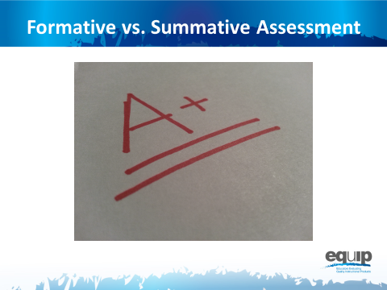
Slide 106
Talking Points
- Overall, whether an assessment is formative or summative depends on the purpose for which that assessment is being used.
- As Wiliam states, “An assessment functions formatively to the extent that evidence about student achievement is elicited, interpreted and used by teachers, learners or their peers to make decisions about the next steps in instruction.”
- Summative assessments, on the other hand, are those whose purpose is evaluation. Summative assessments provide grades or scores denoting overall mastery of the material.
Slide 107
Talking Points
- As we prepare to look for evidence of the Category III criteria in an actual lesson, let’s quickly review criteria A through D for Category III.
- Keep in mind that you’ll be looking for direct, observable evidence of these criteria. This evidence must be explicitly stated in the lesson.
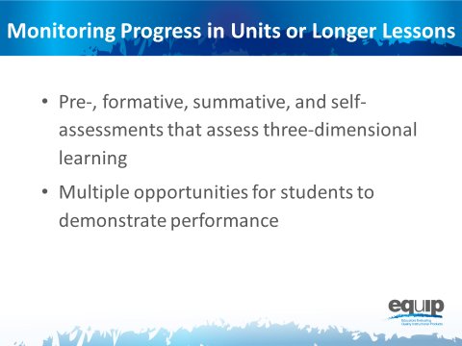
Slide 108
Talking Points
- The criteria at the bottom of Category III focus on monitoring student progress in a longer lessons or in a unit of instruction.
- Note that these criteria require multiple forms of assessment as well as multiple opportunities for students to demonstrate performance.
- Again, keep in mind that you’re always looking for direct, observable evidence of these criteria.
Monitoring Student Progress Practice
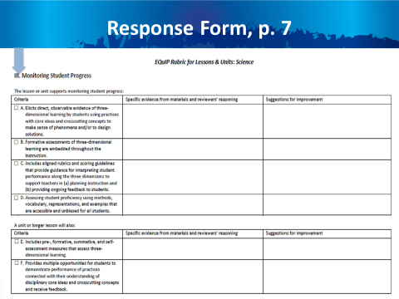
Slide 109
Talking Points
- For this quick practice you will need:
  - The response sheet for Category III, which is located on page seven of your rubric document;
  - The Common Lesson (COMING SOON); and
  - A pen, pencil, or a tablet or laptop with the electronic version of the rubric to record your findings.
Slide 110
Talking Points
- As you work through this category, follow the same process you used earlier when examining a lesson or unit for Categories I and II:
  - First, work individually to look for the evidence in the Common Lesson.
  - Use the Arabic and Roman numerals associated with the rubric criteria to code the evidence you locate.
  - Next, still individually, determine how the evidence fits together and connects to one or more criteria.
  - Once you’ve made your individual determinations, work with your group to share and compare the evidence you’ve located in the Common Lesson.
  - Then, as a result of this evidence and reasoning, collaboratively evaluate whether or not the lesson or unit provides sufficient and compelling evidence of the criteria.
  - Finally, make suggestions for how the lesson or unit might be improved.
- You have 30 minutes for this task. [Note to facilitator: Set the timer, but monitor the groups to determine if they need more or less time to complete the practice before moving on.]
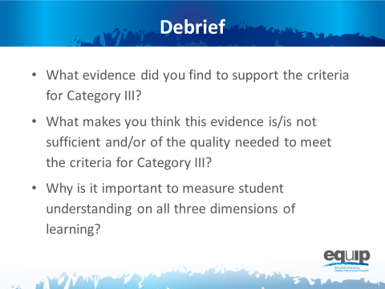
Slide 111
Talking Points
- So what determinations did you make at your tables? Does this lesson meet the criteria in Category III?
- How? Why or why not? [Note to facilitator: Allow several tables to share.]
- Why is it important to measure student understanding on all three dimensions of learning? [Note to facilitator: Allow several tables to share.]
Concluding Slide for Module 9
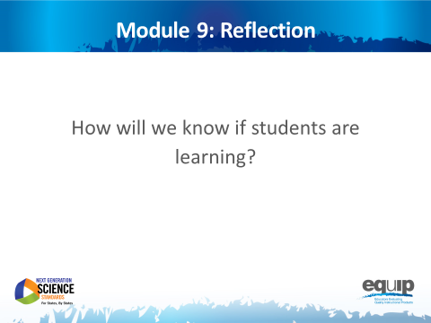
Slide 112
Talking Points
- As with all standards, teaching to the NGSS is not sufficient. It’s about students learning — in the case of the NGSS, three-dimensional learning. Examining a lesson or unit against the criteria in Category III determines whether that lesson or unit includes the kinds of assessments that allow all students to demonstrate understanding and for all teachers to monitor the progress and performance of all students.
- As a result of this module, you should feel comfortable using the rubric to determine whether or not a lesson or unit meets the criteria in Category III.
- Are there any questions or additional comments about the criteria in Category III? [Note to facilitator: Address question or comments if they arise.]
- You have now completed the first nine modules of this professional learning.
- You’ve applied the EQuIP Rubric criteria to examine a common lesson to determine whether this lesson contains evidence of sufficient quality to meet the criteria for:
  - Alignment to the NGSS;
  - Instructional Supports; and
  - Monitoring Student Progress.
- Now that you’ve had practice with each category of the rubric separately, you’re ready for the culminating task where you will put what you’ve learned into practice to examine a lesson or unit that has been developed for your grade, grade band and/or specific science discipline.
- [Note to facilitator: Ask each of the following questions one at a time, allow participants to answer, and provide follow up as needed before proceeding to the culminating task.]
  - Do you feel ready to use the EQuIP Rubric to examine NGSS instructional materials?
  - What have been the strengths of the training?
  - Is there anything you need to review or revisit before the culminating task?

MODULE
NGSS EQuIP
10
Culminating
Task
Module 10: Culminating Task
Module 10 provides participants an opportunity to examine a lesson or unit specific to their grade, grade band and/or science discipline. Participants also have a chance to reflect on this task as well as the overall professional learning encompassed by the ten modules.
Materials Needed
- Module 10 PowerPoint slides or slides 113–121 of the full PowerPoint
- Locally-developed or identified lessons and units for participants to examine
- Handout 11: Module 10, Slide 119, “Culminating Task Debrief Questions”
- Additional copies of Handout 6: Module 4, Slide 43, “EQuIP Rubric, Version 2” (4 pages)* or a computer or tablet with the electronic version of the rubric (at least one person per table should record their group’s findings electronically)

*Introduced in a previous module.
Introduction to Module 10
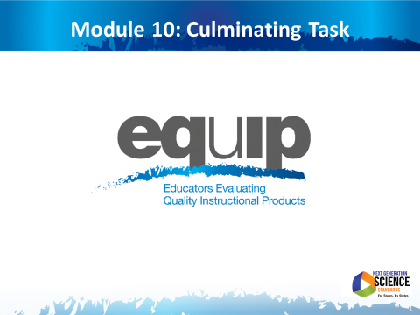
Slide 113
Talking Points
- We’re now ready for the culminating task where you will apply all of the learning from the previous nine modules of this professional learning to examine instructional materials directly related to a specific grade, grade band and/or science discipline.
- This is an opportunity for you as reviewers to examine locally-developed or identified instructional materials.

The Task
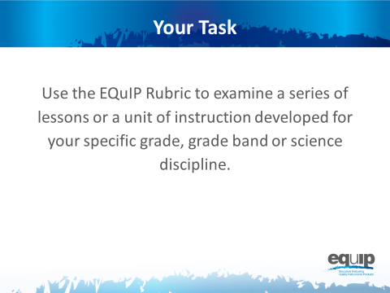
Slide 114
Talking Points
- For this task, each group has a different set of instructional materials to examine.
- In addition, you will need:
  - The EQuIP Rubric, specifically the response forms for Categories I, II and III;
  - A computer loaded with an electronic version of the EQuIP Rubric to record group responses;
  - If available, a small projector to allow group members to view the group responses as they are recorded. A screen-sharing application could also be used.
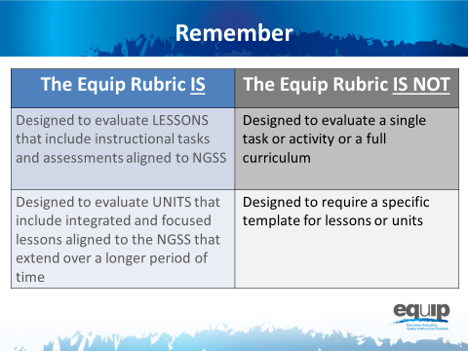
Slide 115
Talking Points
- Remember, as defined by the EQuIP Rubric:
!
  - A lesson is a coherent set of instructional activities and assessments aligned to the NGSS that may extend over a few to several class periods or days; and
  - A unit is a coherent set of lessons aligned to the NGSS that extend over a longer period of time.
- An integrated instructional sequence is rooted in an explanatory question aimed at making sense of a phenomenon and/or designing a solution to a problem.
- With these definitions in mind, it is important to note that the lessons the EQuIP Rubric is designed to evaluate may extend over a few to several class periods or days.
- Any single task, activity, or mini-lesson would not be suitable for use with the EQuIP Rubric as it would likely not include instructional supports and assessments, two of the categories of the rubric.
- Likewise, the EQuIP Rubric is not appropriate for reviewing a full curriculum; however, the rubric could be used to review specific lessons or units within the curriculum. A tool is currently being developed to look at full curricula.
- Finally, the EQuIP Rubric does not require that lessons or units be put into a specific format in order to be evaluated against the rubric criteria.
!
- [Note to facilitator: If participants bring lessons or units that do not list the targeted performance expectations, take time to consider what performance expectations the lesson may be building toward.]
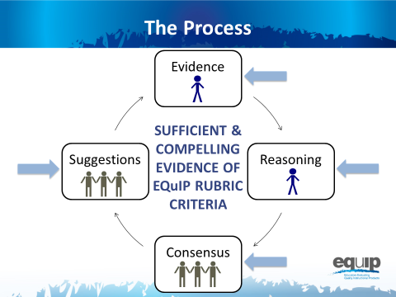
Slide 116
Talking Points
- Follow the same process you used during the previous practice sessions.
  - Individually, closely examine the materials through the lens of the criteria for the EQuIP Rubric and record this evidence on the response form. Use the Arabic and Roman numerals associated with the rubric criteria to code the evidence you locate.
  - Individually, use reasoning to connect the evidence you locate to the rubric criteria and record your reasoning on the response form.
  - As a group, share, discuss, and work collaboratively toward consensus as to whether there is sufficient clear and compelling evidence to say that the rubric criteria have been met.
  - As a group, provide suggestions for improvement on the response form.
- Keep in mind that the comments you make on the response form will provide feedback, evaluation, and guidance for the developer(s) and/or user(s) of these instructional materials.
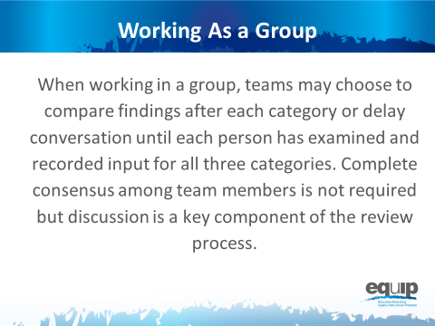
Slide 117

Talking Points
- For this culminating task you will be working through all three categories of the rubric with a lesson or unit specific to your group’s discipline and grade band.
- Prior to beginning, decide how your group would like to approach this task.
- You may elect to work through the process as a group one category at a time, or you may choose to work through all three categories individually before beginning your discussion as a group.
- Before you begin the group discussion, designate a recorder for your group.
- Your recorder should use an electronic version of the EQuIP Rubric response form to record your comments electronically.
- You also may find it helpful to designate other roles for members of your group. These roles might include:
  - One group member to monitor time,
  - One group member to facilitate the discussion, etc.
- [Note to facilitator: Pass out lessons and units if participants do not already have them.]
Slide 118
Talking Points
- Each group should now have a packet of instructional materials that includes copies of these materials for each member of your group.
- Here again is the examination process.
- Be thoughtful about your time. You have approximately two hours of relatively uninterrupted time to complete your examination. Pace yourself so you can make it through the entire rubric.
- Allow approximately one hour for Category I, 30 minutes for Category II, and 30 minutes for Category III.
- We’ll keep you posted periodically regarding how much time is remaining.
- Because you have a limited amount of time for this task, you may not be able to list all of the evidence that supports a criterion; rather, you may need to cite examples.
- If your examination does not take the full time allotted, you may begin responding to the debriefing questions for the training, which are located on Handout 11.
- Please remember that the comments you record on the response sheet will provide feedback, evaluation, and guidance for the developer(s) and/or user(s) of these instructional materials.
- [Notes to facilitator: 1) Leave this slide up and set a separate timer or alarm. Provide frequent time updates to allow groups to monitor progress. Allow more or less time as needed to complete the task before moving on to the reflection. 2) If, as you monitor the progress of the groups, you notice common issues or places where multiple groups are having difficulty, briefly interrupt the process and address all the groups simultaneously to clarify or get groups back on track.]

Reflecting on the Culminating Task
Note to facilitator: Refer participants to Handout 11, Module 10, Slide 119, “Culminating Task Debrief Questions.”
Slide 119
Talking Points
- So how did it go?
- Take a few minutes to reflect on your experience using the EQuIP Rubric for the culminating task.
- At your tables you should have a list of questions to discuss as you debrief on this culminating task. You have ten minutes to discuss these questions before we share our reflections. [Note to facilitator: Allow ten minutes.]
- Let’s share some of your thoughts. [Note to facilitator: Ask each set of questions separately, allow several tables to share, and then move on to the next set of questions.]
  - On a scale of one to four, to what extent did your group share a common language and understanding of EQuIP criteria as you reviewed this lesson? Why this rating?
  - Are there any criteria or evidence about which you disagreed? If so, did you disagree about what you considered evidence of a criterion, about whether the evidence was sufficient to meet a criterion, or about both?
  - What differences arose among your group members when checking criteria? How did you resolve those differences? What do you think caused those differences? Were there differences that remained unresolved? What were some of those unresolved differences?
  - Where in the review process did you experience the most difficulty or the greatest disagreements? What suggestions do you have regarding resolving differences among reviewers?
  - How did having collaborative discussions move individual group members or the group as a whole toward a decision?

Reflecting on this Professional Learning
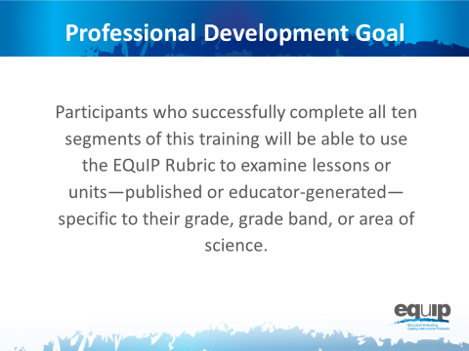
Slide 120
Talking Points
- Overall, what has been your experience with this professional learning?
- [Note to facilitator: Ask each of the questions below, one at a time, and allow groups/individuals to respond.]
  - What will be your next steps as a group?
  - How will you use this professional learning in your role/job/position?
    - What are your plans for using the EQuIP Rubric and the review process to examine instructional materials?
    - How will you use the EQuIP Rubric to inform the development of new instructional materials?
    - Will you be redelivering this professional learning to other science educators? If so, when and to whom?
    - How else might you use this professional learning?

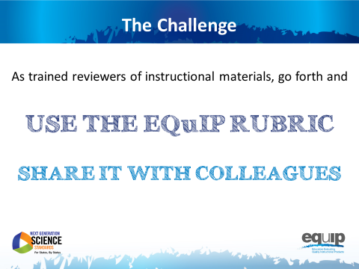
Slide 121

Talking Points
- As we conclude this training, we’d like to challenge each of you newly trained reviewers of instructional materials to:
  - [Note to facilitator: Click for animation.] Use the Equip Rubric to examine instructional materials for use with the NGSS; and
  - [Note to facilitator: Click for animation.] Share your knowledge and expertise in using the EQuIP Rubric to examine instructional materials with your colleagues.
- For more information about NGSS resources, visit www.nextgenscience.org/resources.
- This concludes the EQuIP Rubric training.

